Step1:
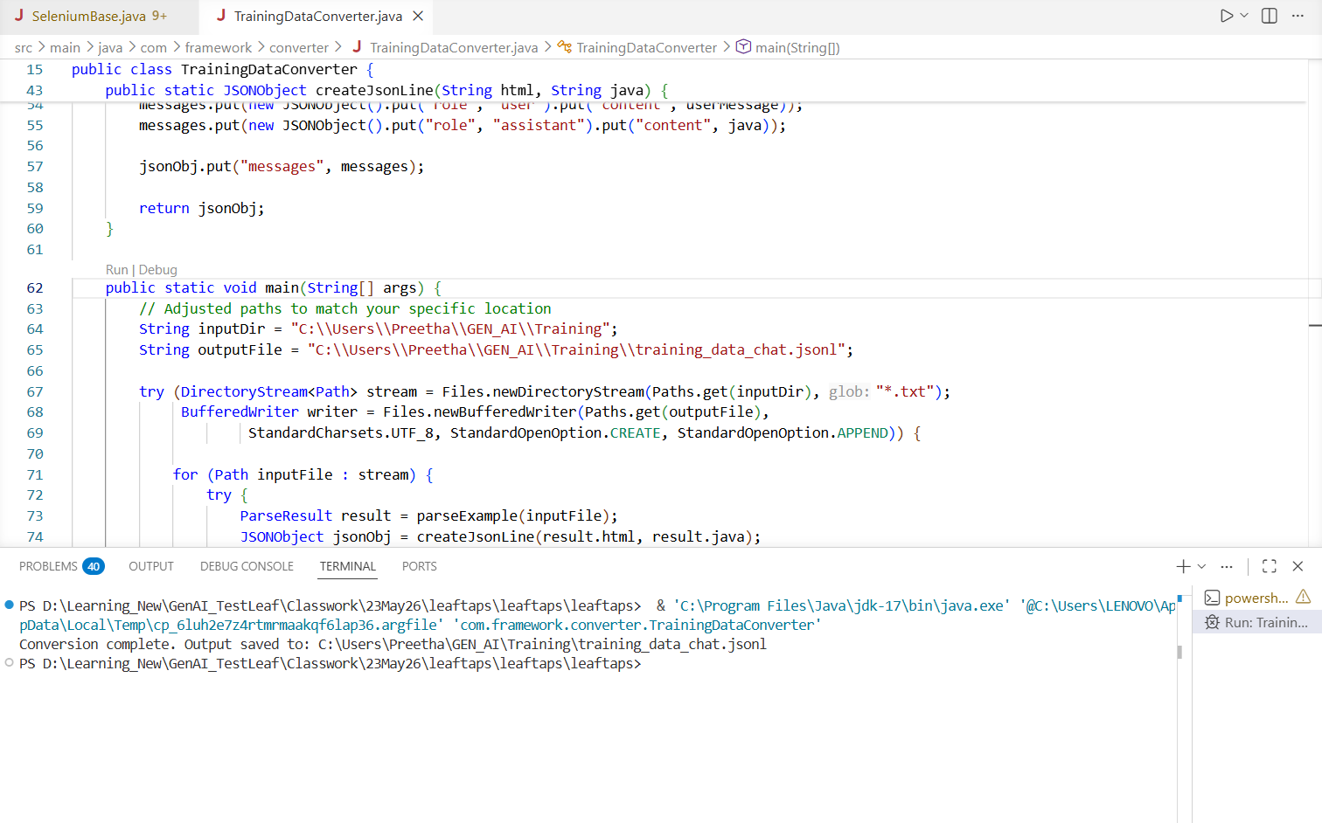
Step 2:
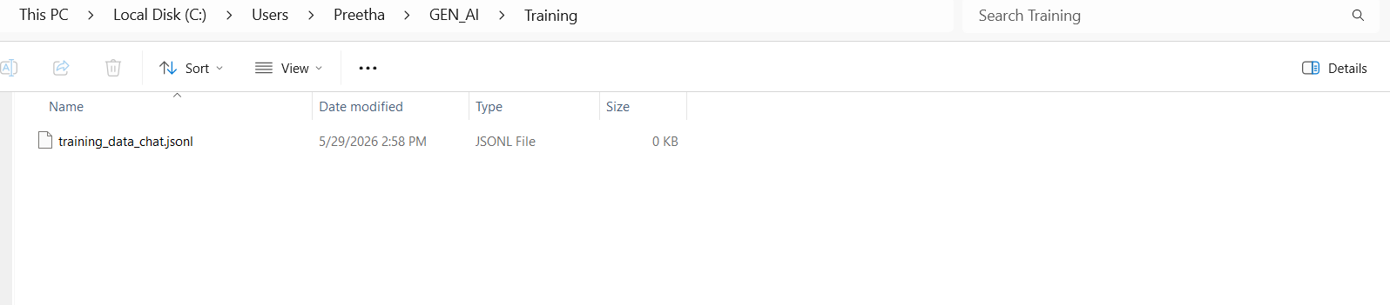

Step 3:
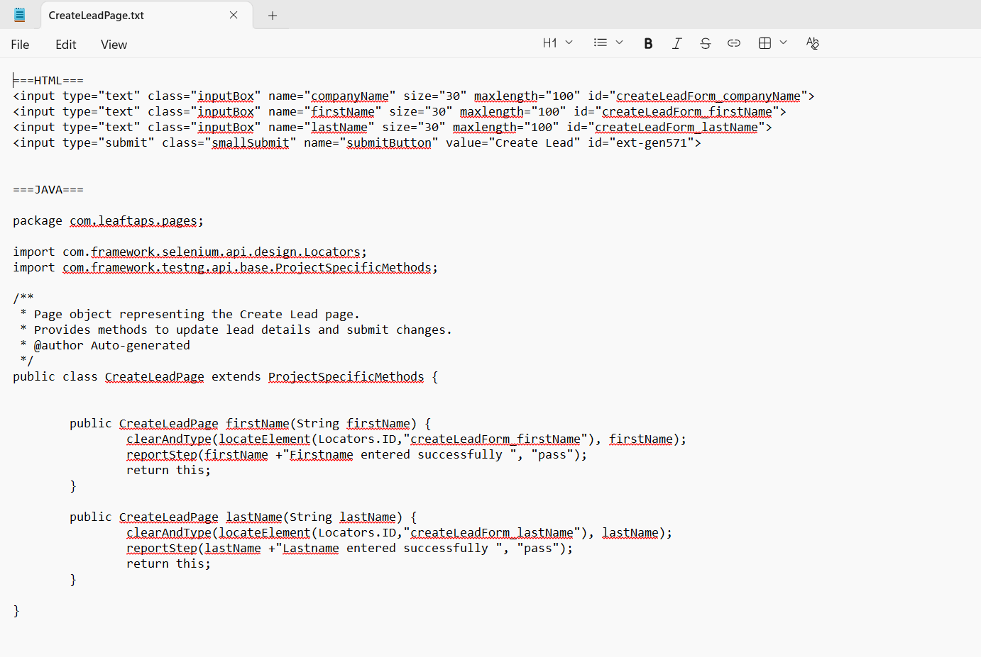
Step 4:
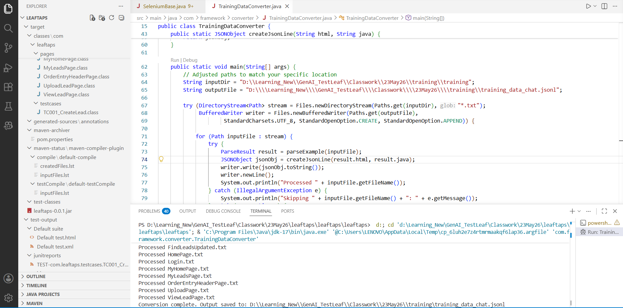

Step 5:
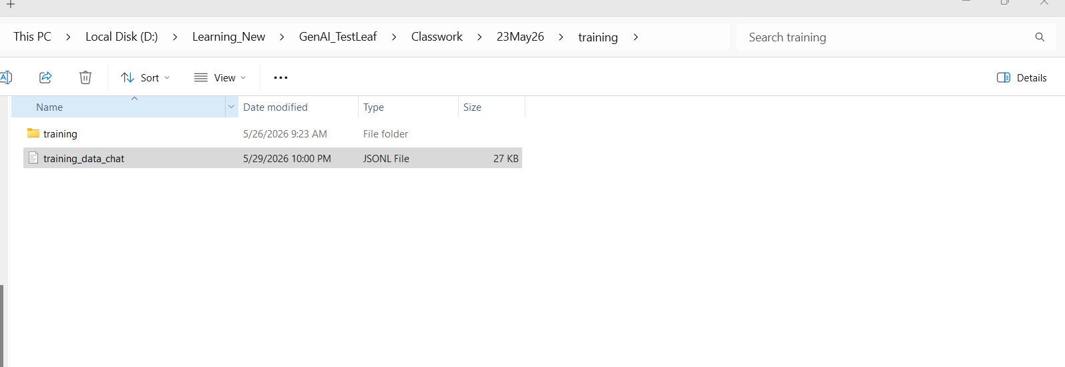
Step 6:
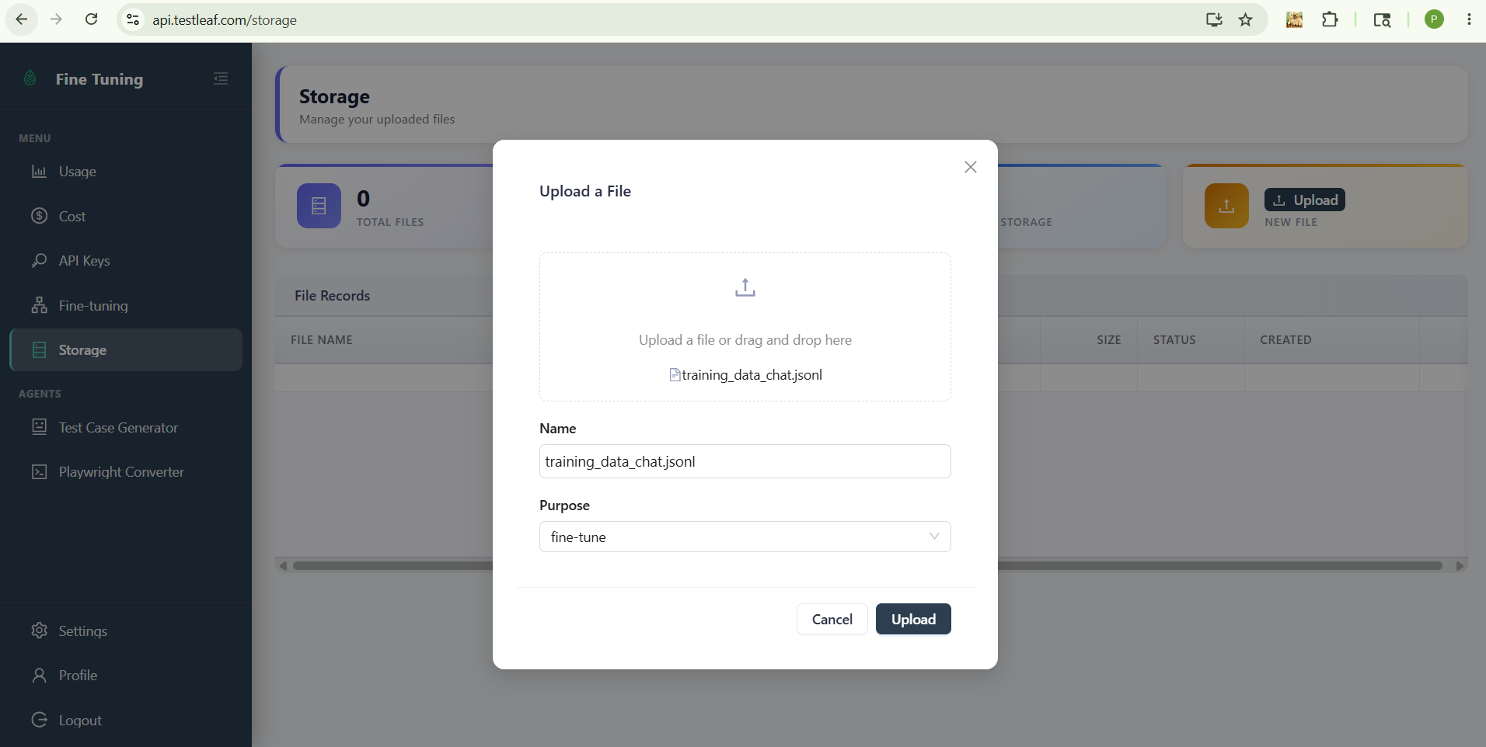

Step 7:
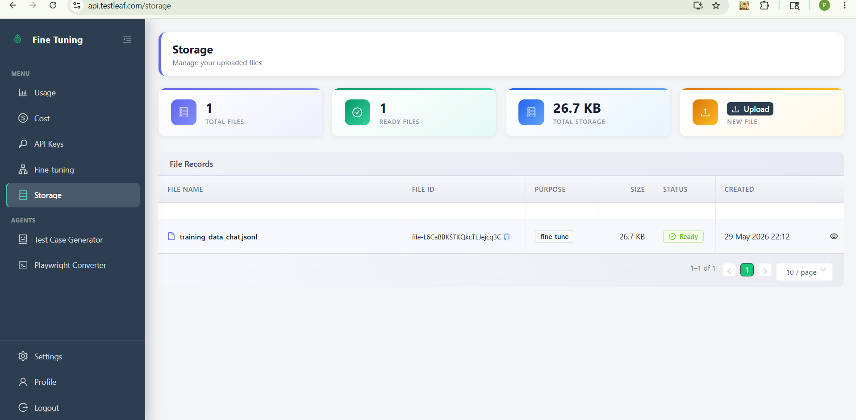
Copy this File name: file-L6CaBBKSTKQkcTLJejcq3C
Step 8:
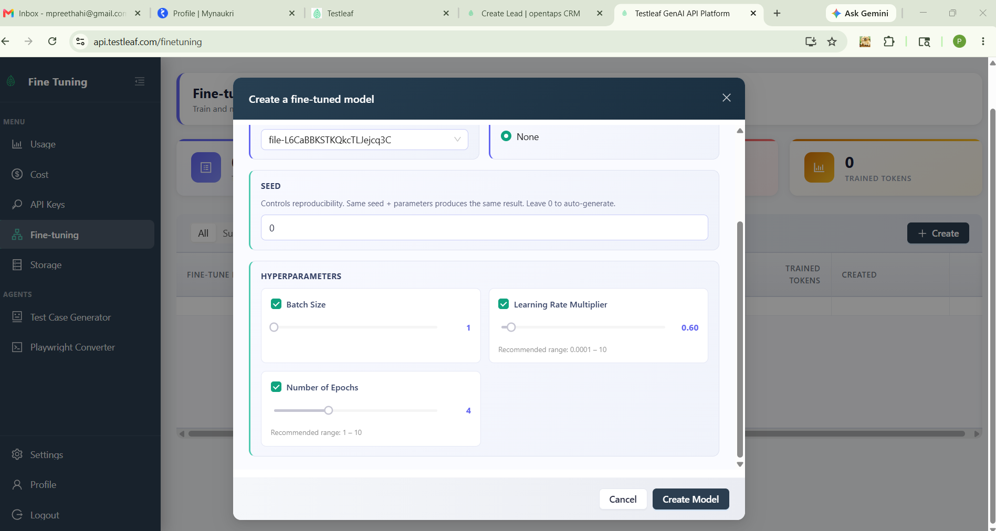
Step 9:
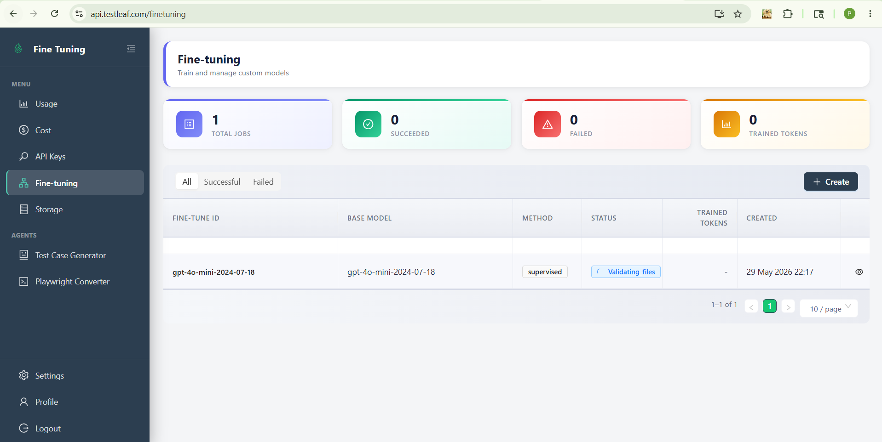

Step 10:
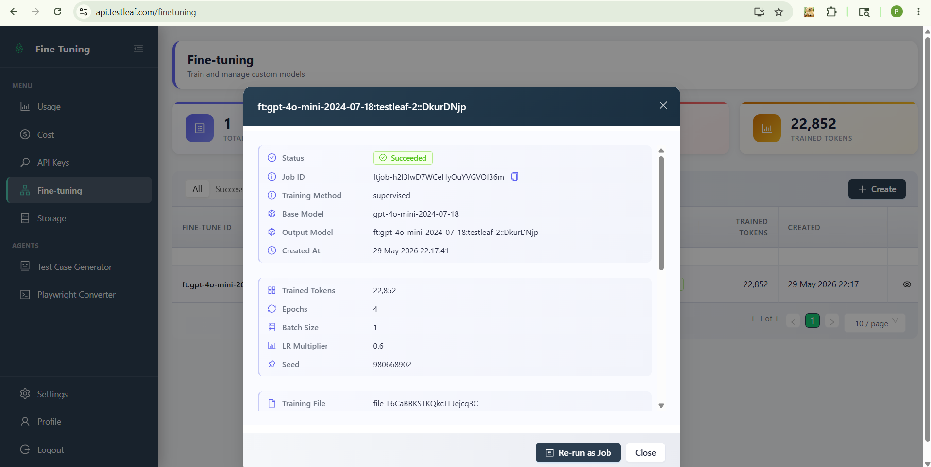
ft:gpt-4o-mini-2024-07-18:testleaf-2::DkurDNjp
Step 11:
API Key generated in testleaf: OVAvaECVKJR6
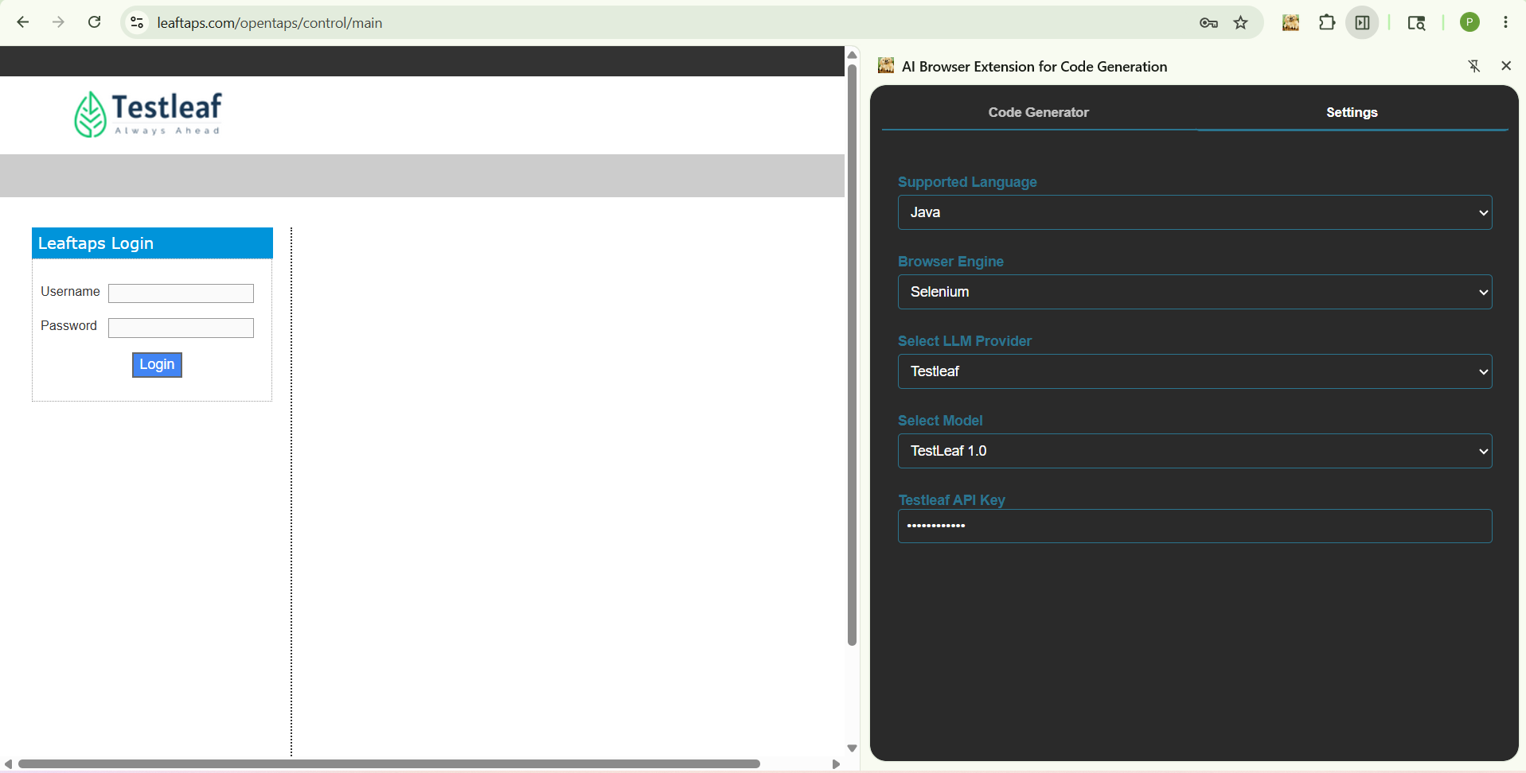
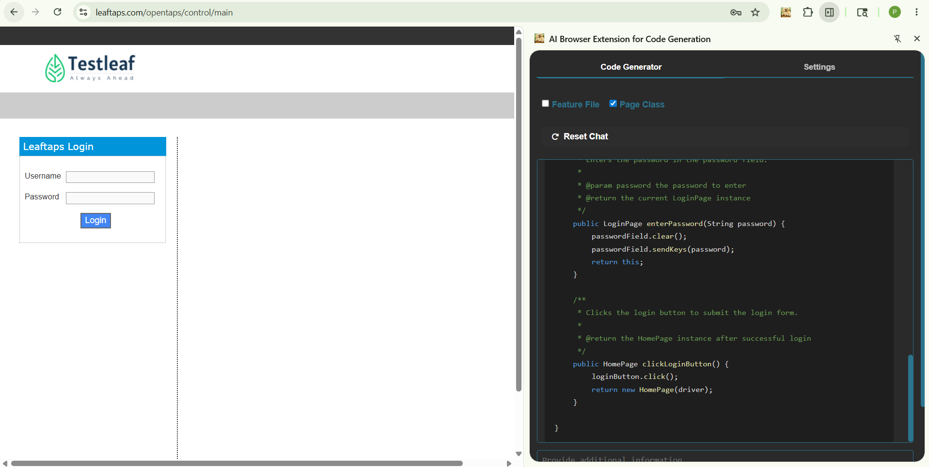
package com.testleaf.pages;

import org.openqa.selenium.WebElement;
import org.openqa.selenium.support.FindBy;
import org.openqa.selenium.support.PageFactory;
import org.openqa.selenium.remote.RemoteWebDriver;

/**
* Page Object for Login Page
*/
public class LoginPage {

private RemoteWebDriver driver;

/**
* Initializes the LoginPage with the given driver.
*
* @param driver the WebDriver instance
*/
public LoginPage(RemoteWebDriver driver) {
this.driver = driver;
PageFactory.initElements(driver, this);
}

@FindBy(id = "username")
private WebElement usernameField;

@FindBy(id = "password")
private WebElement passwordField;

@FindBy(className = "decorativeSubmit")
private WebElement loginButton;

/**
* Enters the username in the username field.
*
* @param username the username to enter
* @return the current LoginPage instance
*/
public LoginPage enterUsername(String username) {
usernameField.clear();
usernameField.sendKeys(username);
return this;
}

/**
* Enters the password in the password field.
*
* @param password the password to enter
* @return the current LoginPage instance
*/
public LoginPage enterPassword(String password) {
passwordField.clear();
passwordField.sendKeys(password);
return this;
}

/**
* Clicks the login button to submit the login form.
*
* @return the HomePage instance after successful login
*/
public HomePage clickLoginButton() {
loginButton.click();
return new HomePage(driver);
}

}
Step 12: Salesforce:
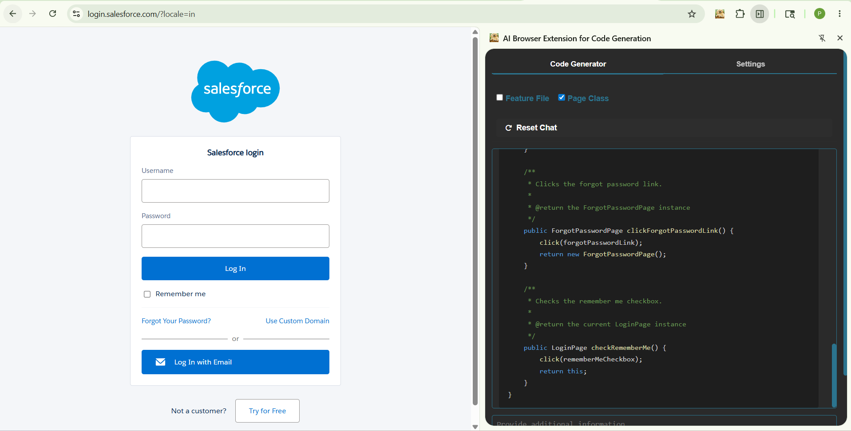
package com.testleaf.pages;

import org.openqa.selenium.WebElement;
import org.openqa.selenium.support.FindBy;
import org.openqa.selenium.support.PageFactory;

/**
* Page Object representing the Salesforce Login Page.
* Provides methods to interact with the login form elements.
*/
public class LoginPage extends BasePage {

/**
* Initializes the LoginPage object.
*/
public LoginPage() {
PageFactory.initElements(driver, this);
}

@FindBy(id = "username")
private WebElement usernameField;

@FindBy(id = "password")
private WebElement passwordField;

@FindBy(id = "Login")
private WebElement loginButton;

@FindBy(id = "forgot_password_link")
private WebElement forgotPasswordLink;

@FindBy(id = "rememberUn")
private WebElement rememberMeCheckbox;

/**
* Enters the username into the username field.
*
* @param username the username to enter
* @return the current LoginPage instance
*/
public LoginPage enterUsername(String username) {
clearAndType(usernameField, username);
return this;
}

/**
* Enters the password into the password field.
*
* @param password the password to enter
* @return the current LoginPage instance
*/
public LoginPage enterPassword(String password) {
clearAndType(passwordField, password);
return this;
}

/**
* Clicks the login button to submit the login form.
*
* @return the HomePage instance after successful login
*/
public HomePage clickLoginButton() {
click(loginButton);
return new HomePage();
}

/**
* Clicks the forgot password link.
*
* @return the ForgotPasswordPage instance
*/
public ForgotPasswordPage clickForgotPasswordLink() {
click(forgotPasswordLink);
return new ForgotPasswordPage();
}

/**
* Checks the remember me checkbox.
*
* @return the current LoginPage instance
*/
public LoginPage checkRememberMe() {
click(rememberMeCheckbox);
return this;
}
}
Step 13:
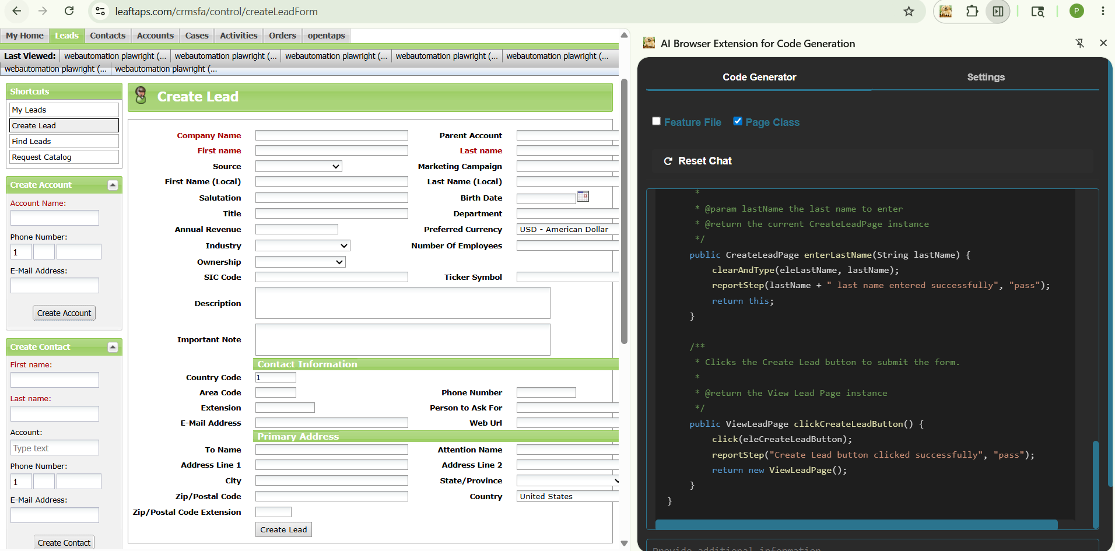
package com.testleaf.pages;

import org.openqa.selenium.WebElement;
import org.openqa.selenium.support.FindBy;
import org.openqa.selenium.support.PageFactory;
import com.testleaf.selenium.api.base.ProjectSpecificMethods;

/**
* Page Object for Create Lead Page
* Provides methods to interact with the Create Lead form.
*
* @author Auto-generated
*/
public class CreateLeadPage extends ProjectSpecificMethods {

/**
* Initializes the CreateLeadPage with the current driver.
*/
public CreateLeadPage() {
PageFactory.initElements(driver, this);
}

@FindBy(id = "createLeadForm_companyName")
private WebElement eleCompanyName;

@FindBy(id = "createLeadForm_firstName")
private WebElement eleFirstName;

@FindBy(id = "createLeadForm_lastName")
private WebElement eleLastName;

@FindBy(className = "smallSubmit")
private WebElement eleCreateLeadButton;

/**
* Enters the company name in the Create Lead form.
*
* @param companyName the company name to enter
* @return the current CreateLeadPage instance
*/
public CreateLeadPage enterCompanyName(String companyName) {
clearAndType(eleCompanyName, companyName);
reportStep(companyName + " company name entered successfully", "pass");
return this;
}

/**
* Enters the first name in the Create Lead form.
*
* @param firstName the first name to enter
* @return the current CreateLeadPage instance
*/
public CreateLeadPage enterFirstName(String firstName) {
clearAndType(eleFirstName, firstName);
reportStep(firstName + " first name entered successfully", "pass");
return this;
}

/**
* Enters the last name in the Create Lead form.
*
* @param lastName the last name to enter
* @return the current CreateLeadPage instance
*/
public CreateLeadPage enterLastName(String lastName) {
clearAndType(eleLastName, lastName);
reportStep(lastName + " last name entered successfully", "pass");
return this;
}

/**
* Clicks the Create Lead button to submit the form.
*
* @return the View Lead Page instance
*/
public ViewLeadPage clickCreateLeadButton() {
click(eleCreateLeadButton);
reportStep("Create Lead button clicked successfully", "pass");
return new ViewLeadPage();
}
}

