Test case generator RAG - Backend
Step 1: Health Check
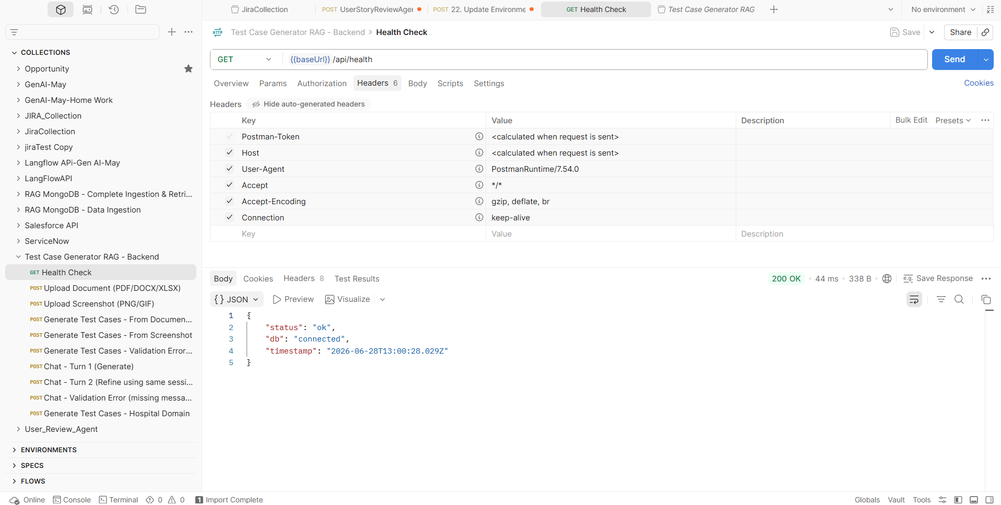
Step 2: Upload Document
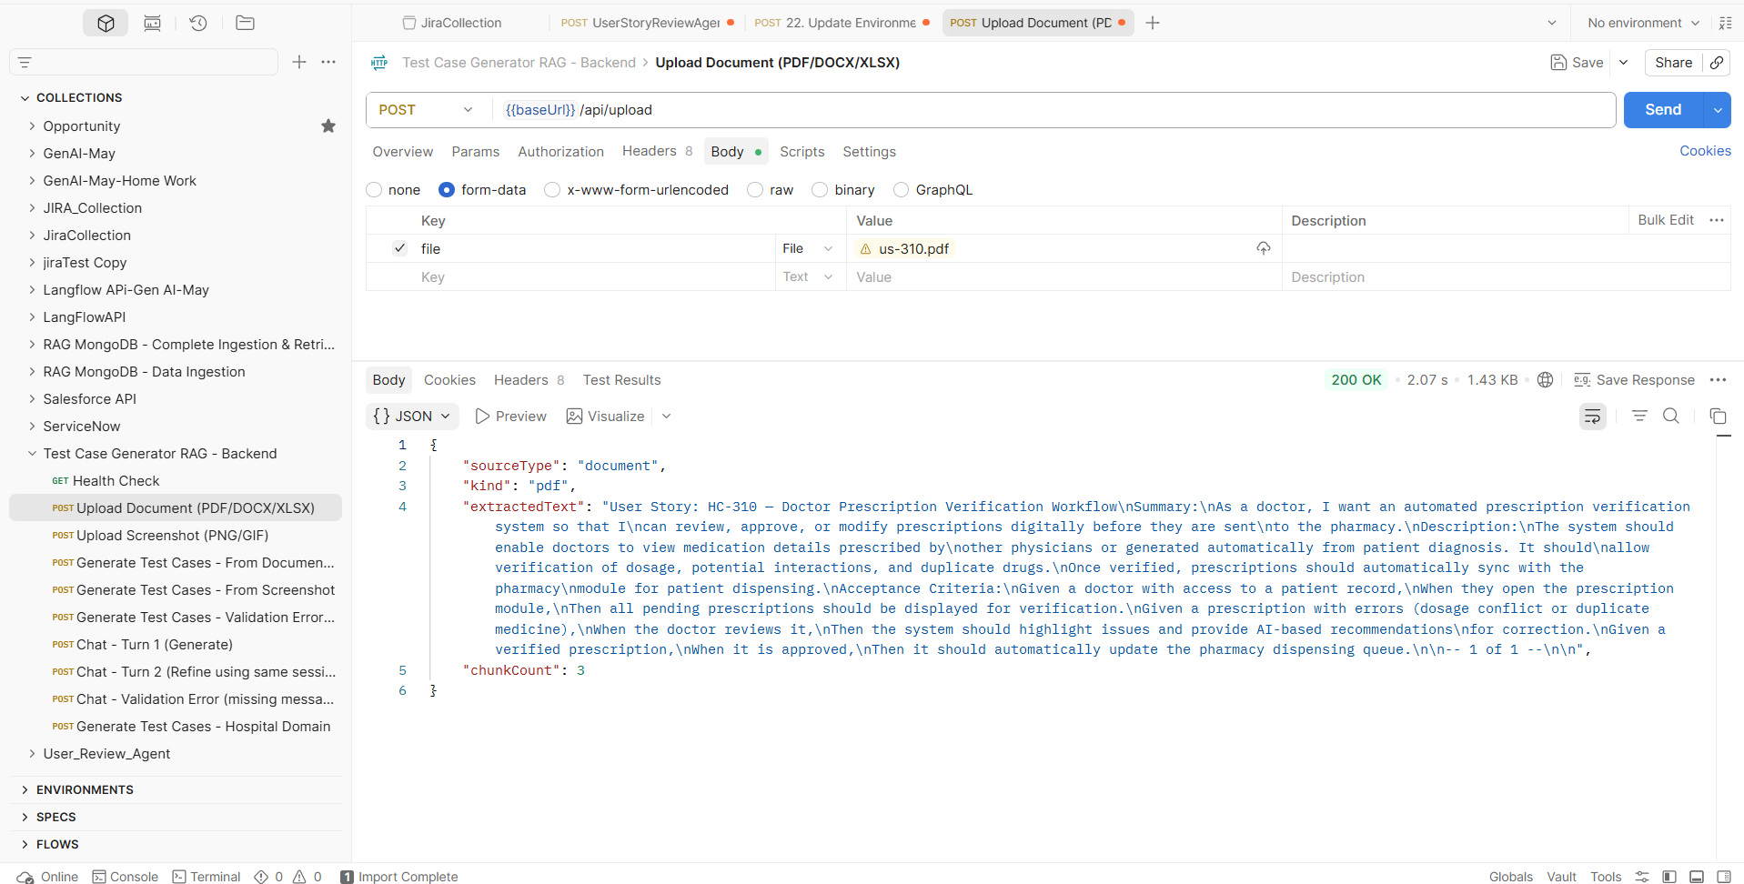
Step 3: Upload Screenshot
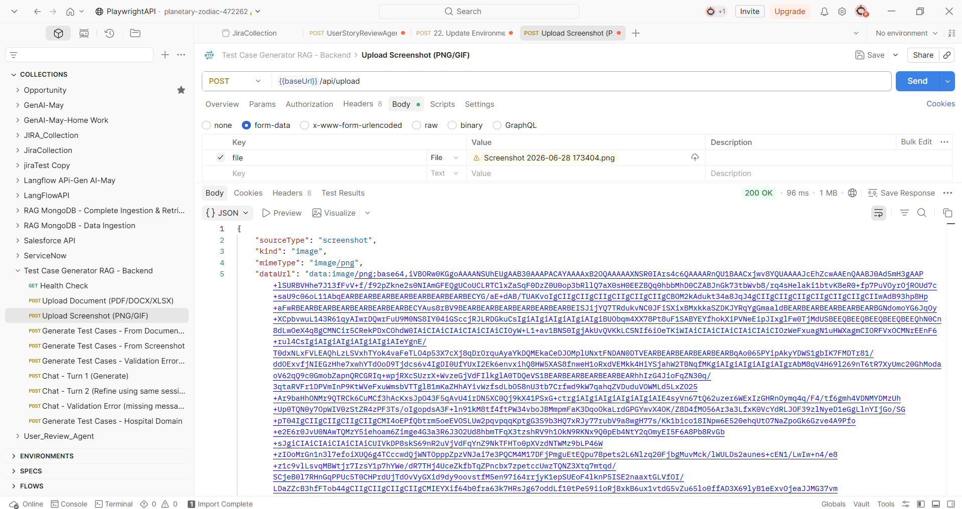
Step 4: Generate Test Cases - From Document Text
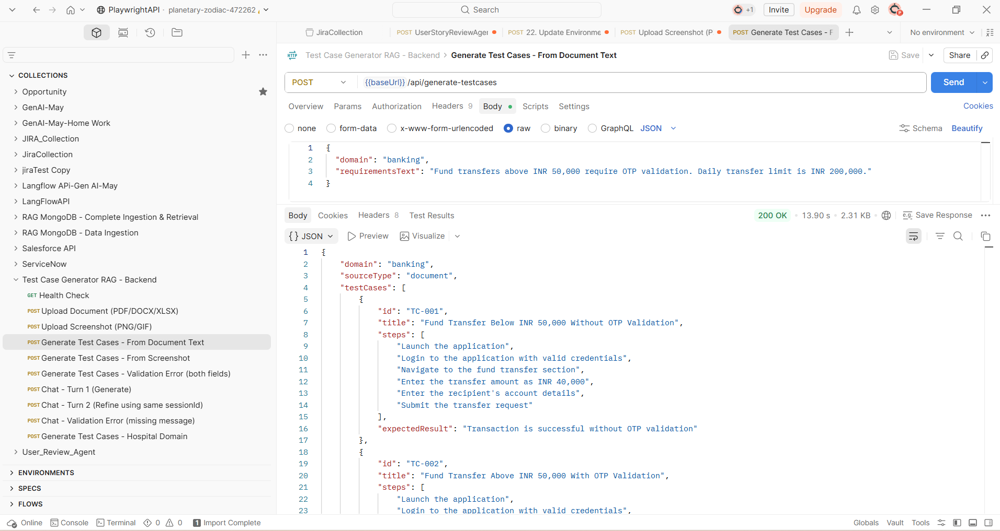

Step 5: Generate Test Cases - From Screenshot
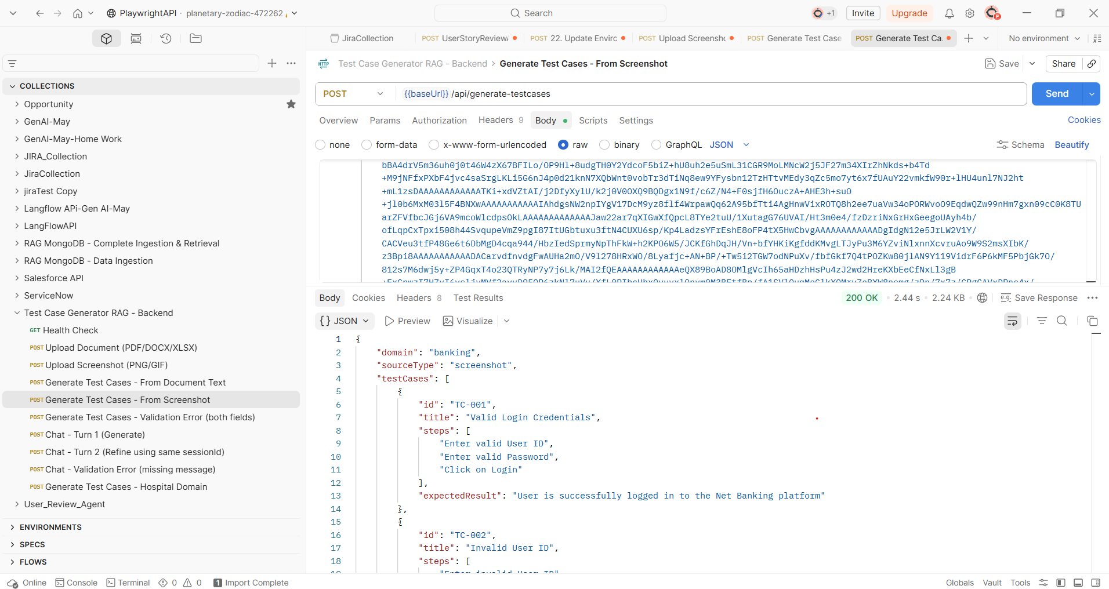
Step 6: Generate Test Cases - Validation Error (both fields)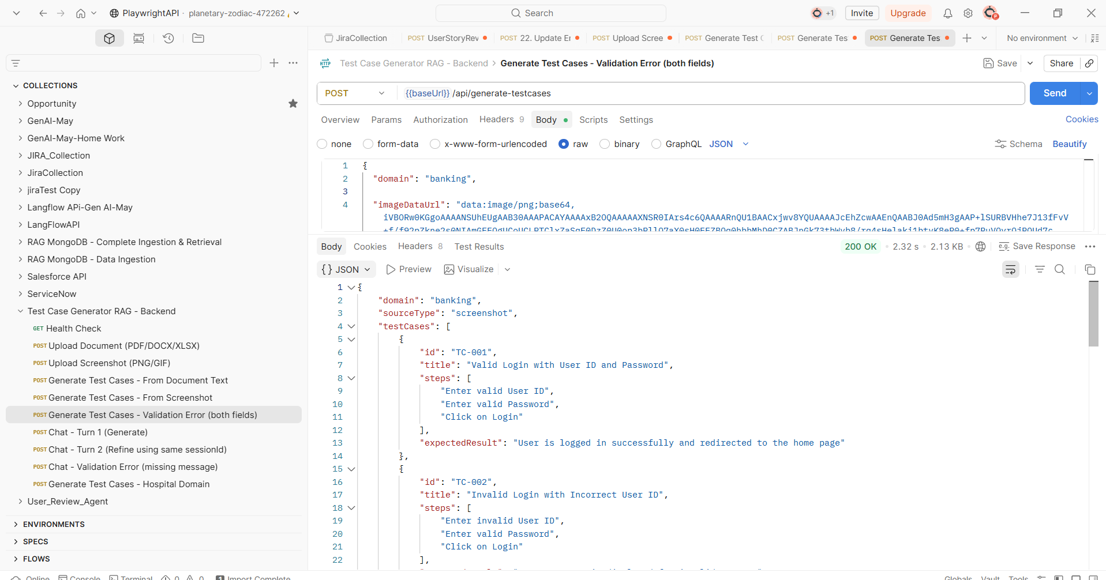

Step 7: Chat - Turn 1 (Generate)
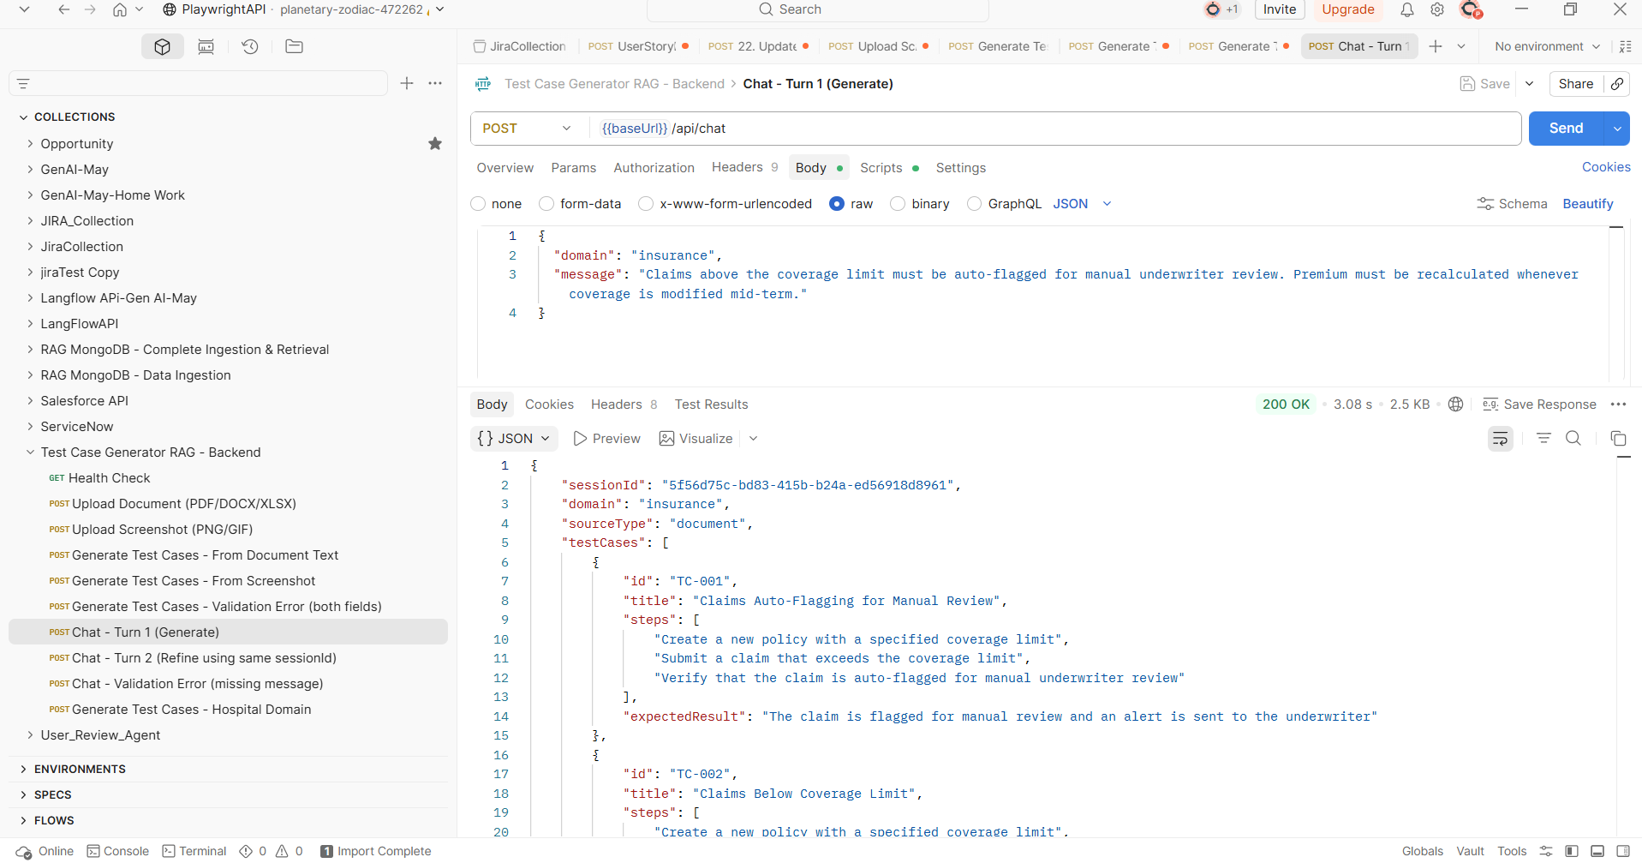
Step 8: Chat - Turn 2 (Refine using same sessionId)
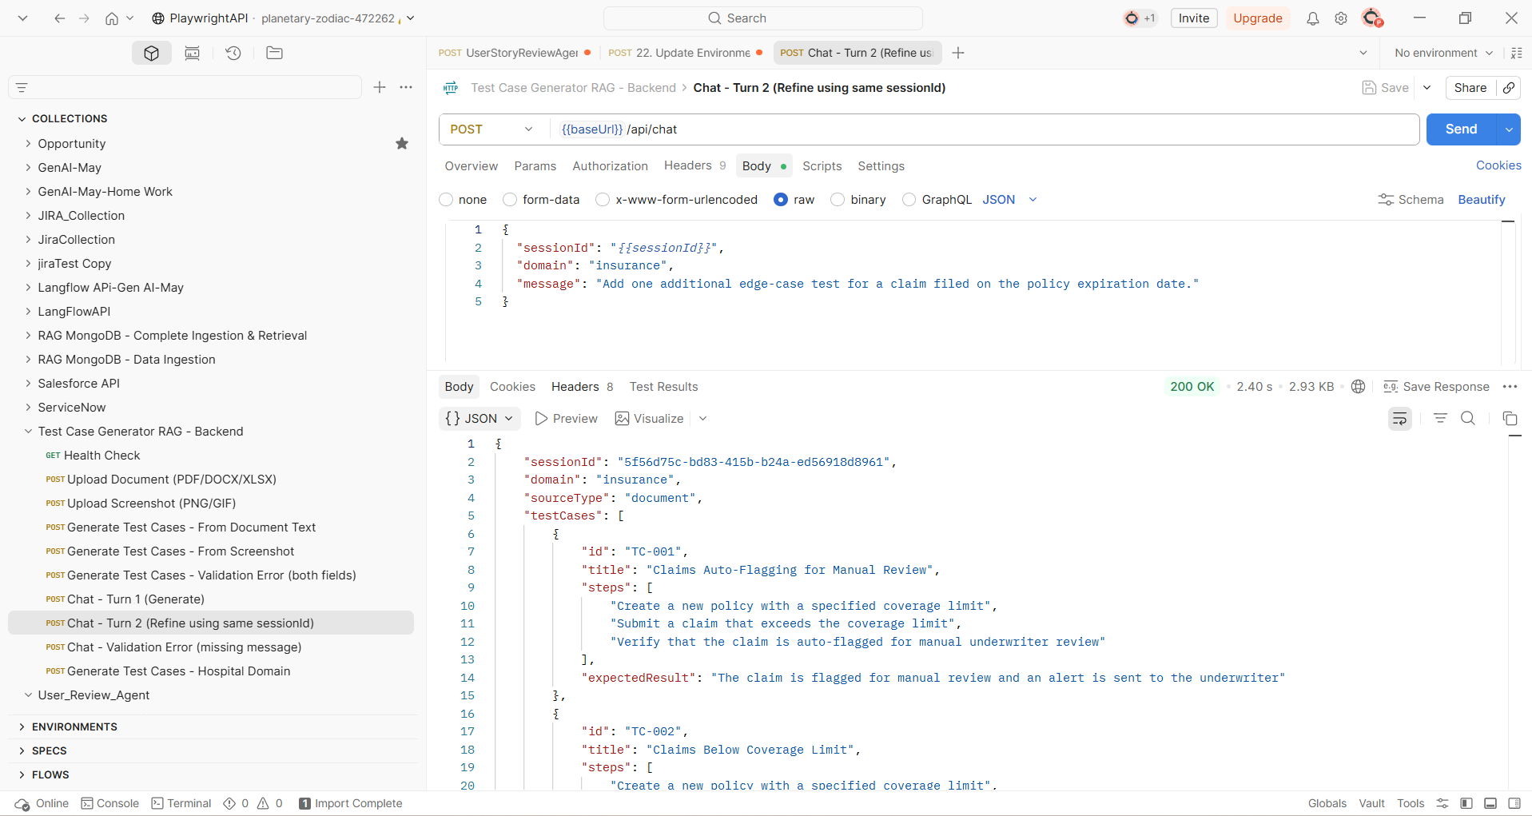
Step 9: Chat - Validation Error (missing message)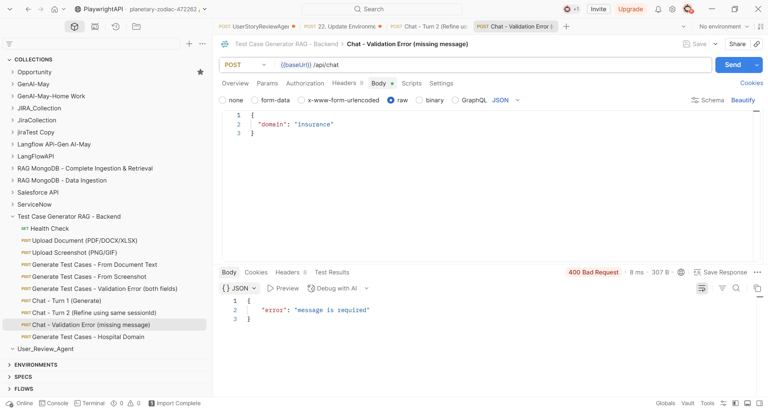
Step 10: Generate Test Cases - Hospital Domain