Step 1: The traces implemented for BM search and Hybrid Search
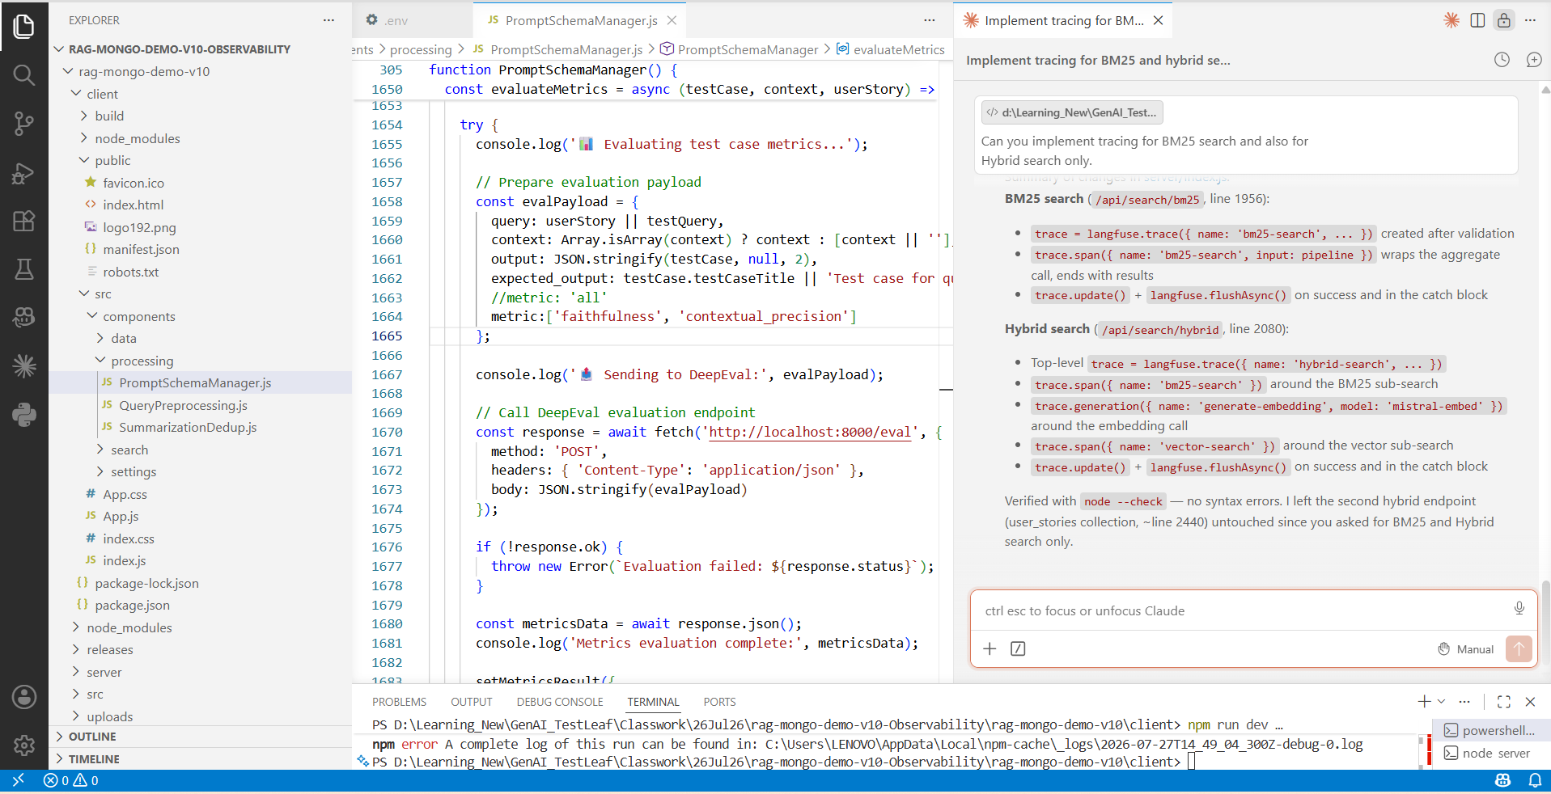
Step 2: Run the command “npm install” and “npm run dev” in the root node
Step 3: Click search in the “BM25 Search” and check the console
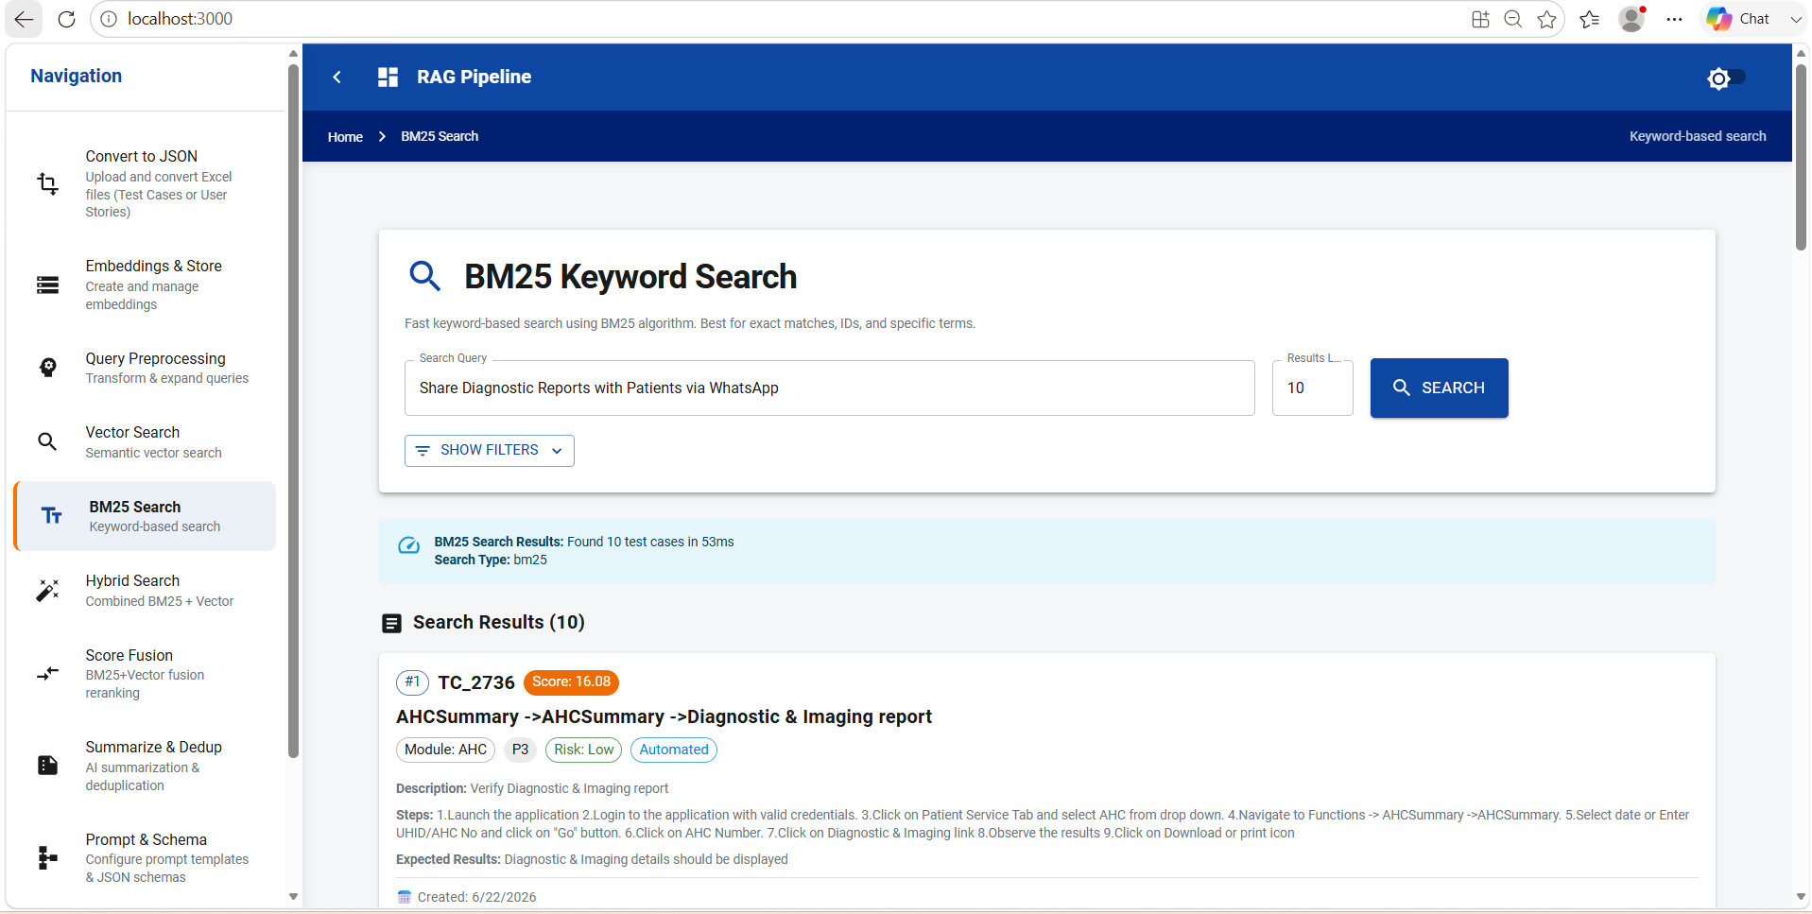

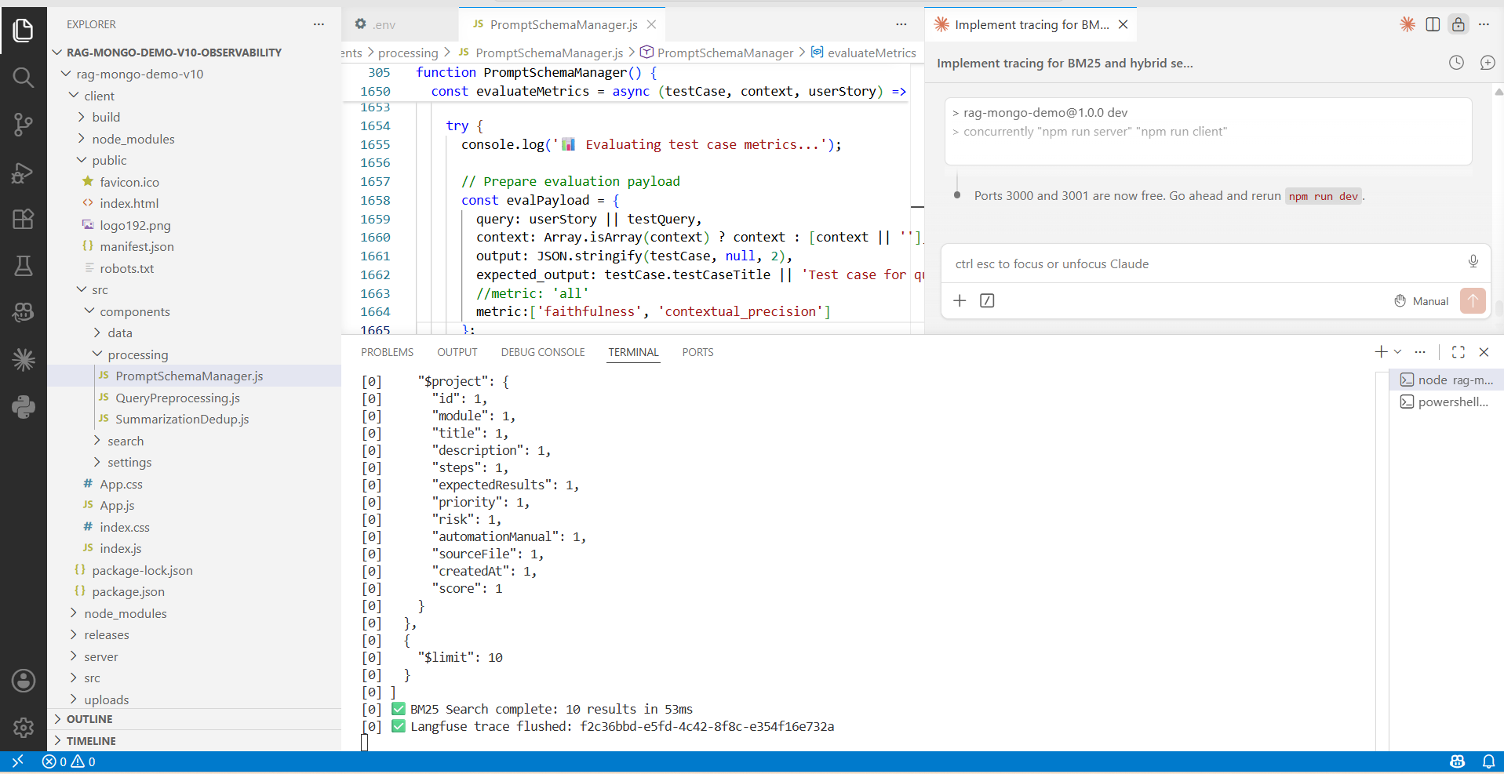
Step 4: Click search in the “Hybrid Search” and check the console
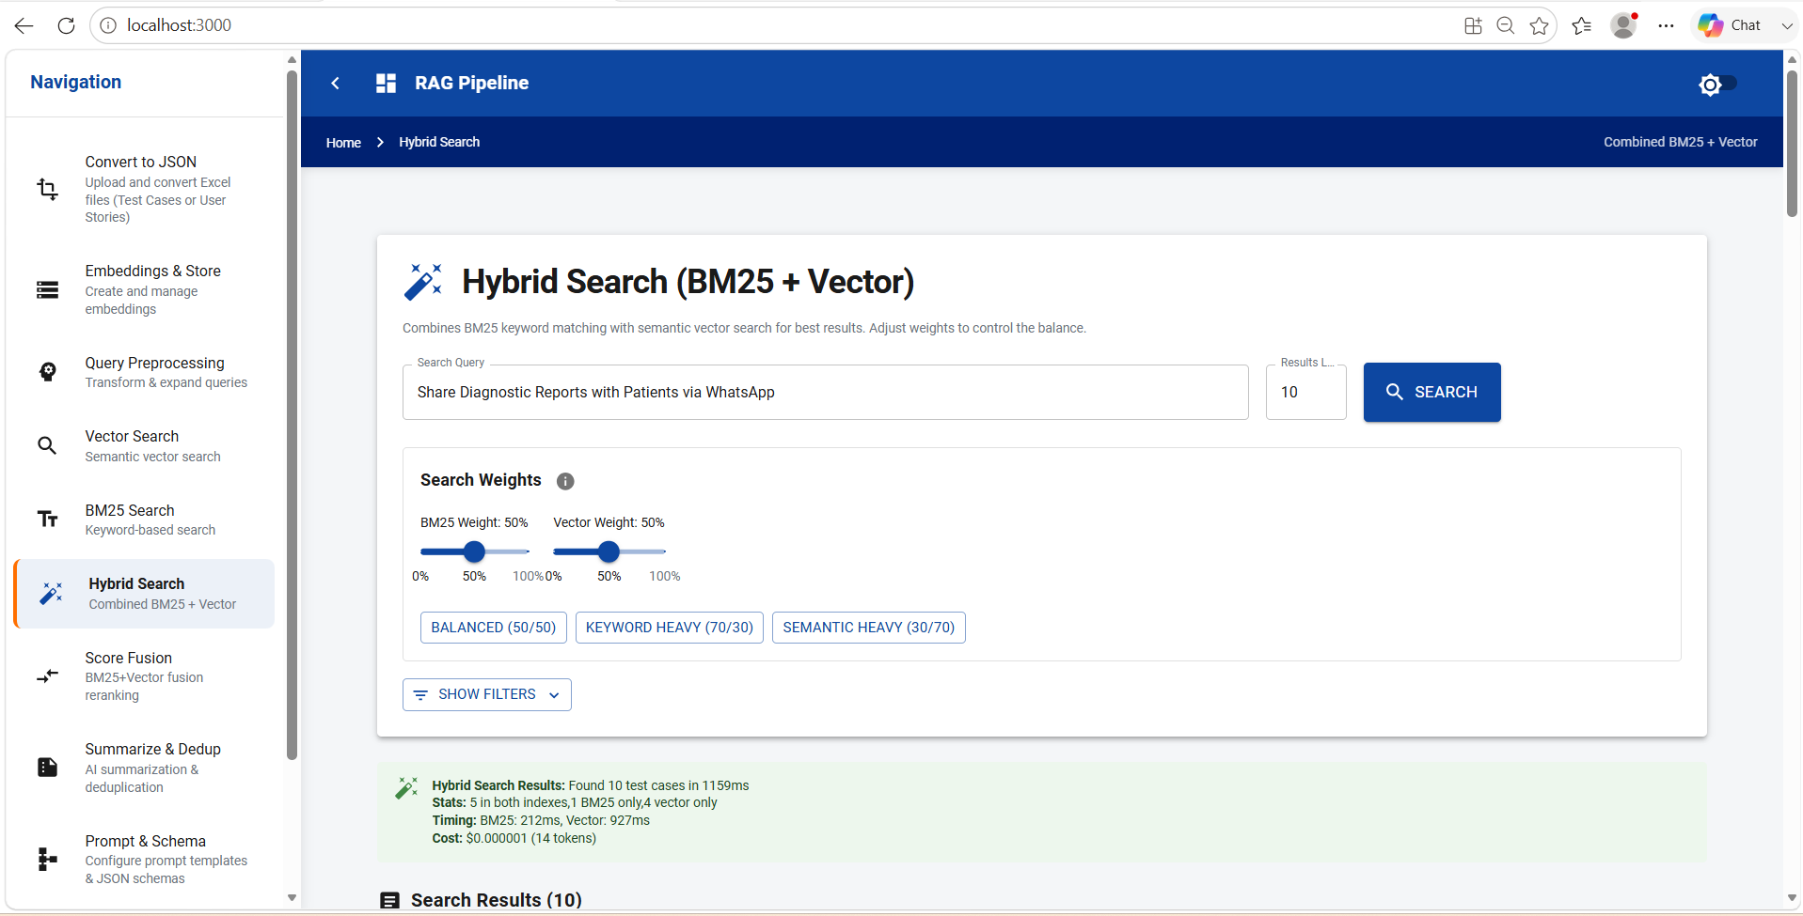

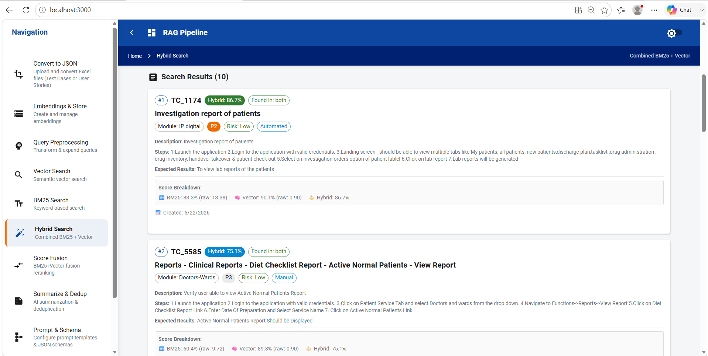
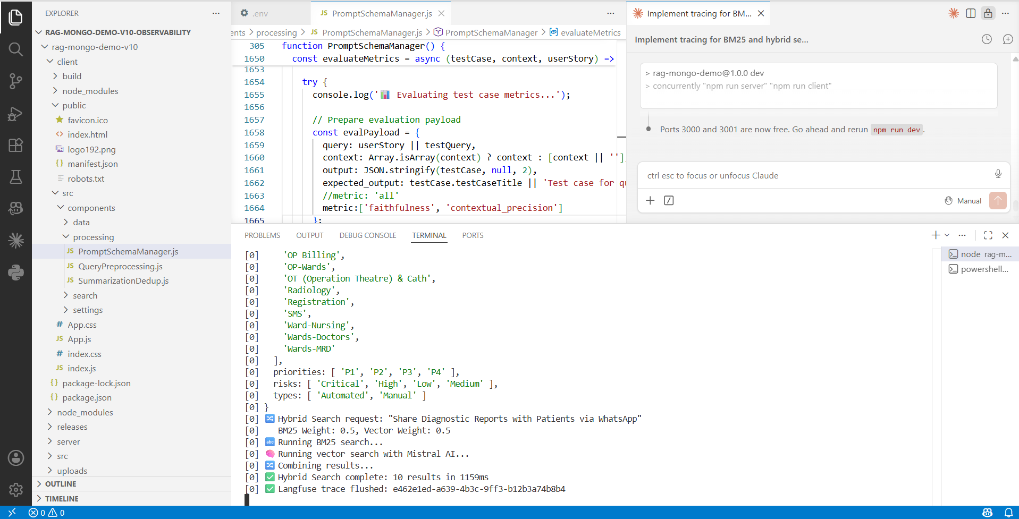

Step 5: Traces captured in Langfuse for both BM25 search and Hybrid Search
