Step1: Update the details in the .env
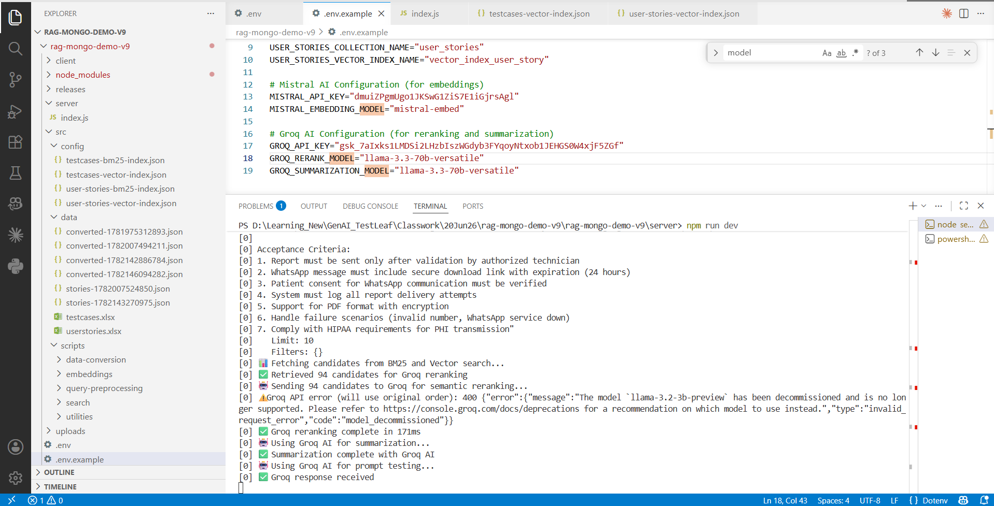
Step 2: Run the server and client using the command npm run dev
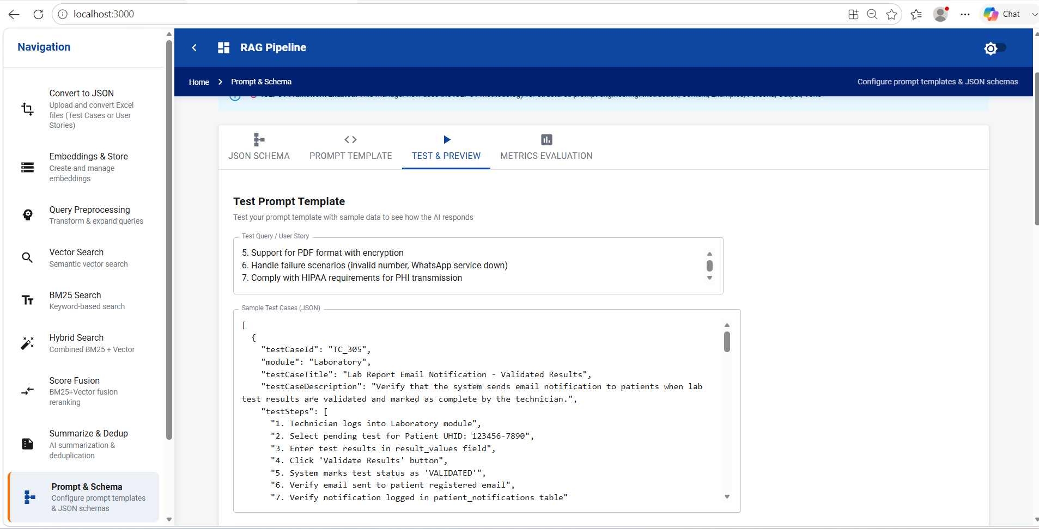

Step 3: Testcases were retrieved.
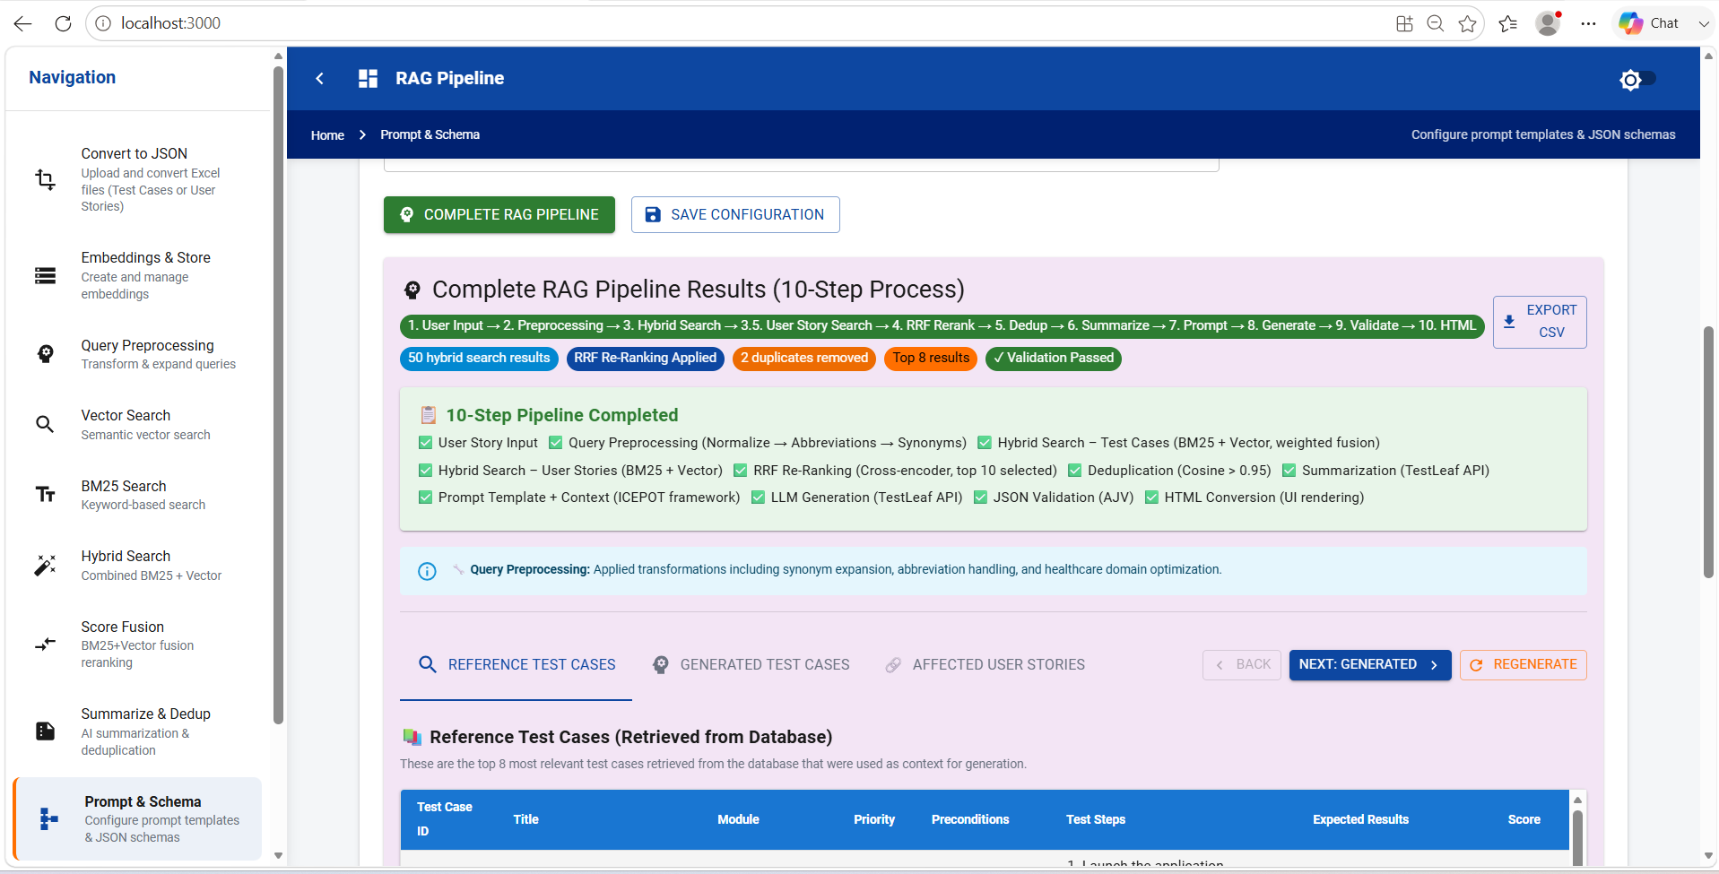
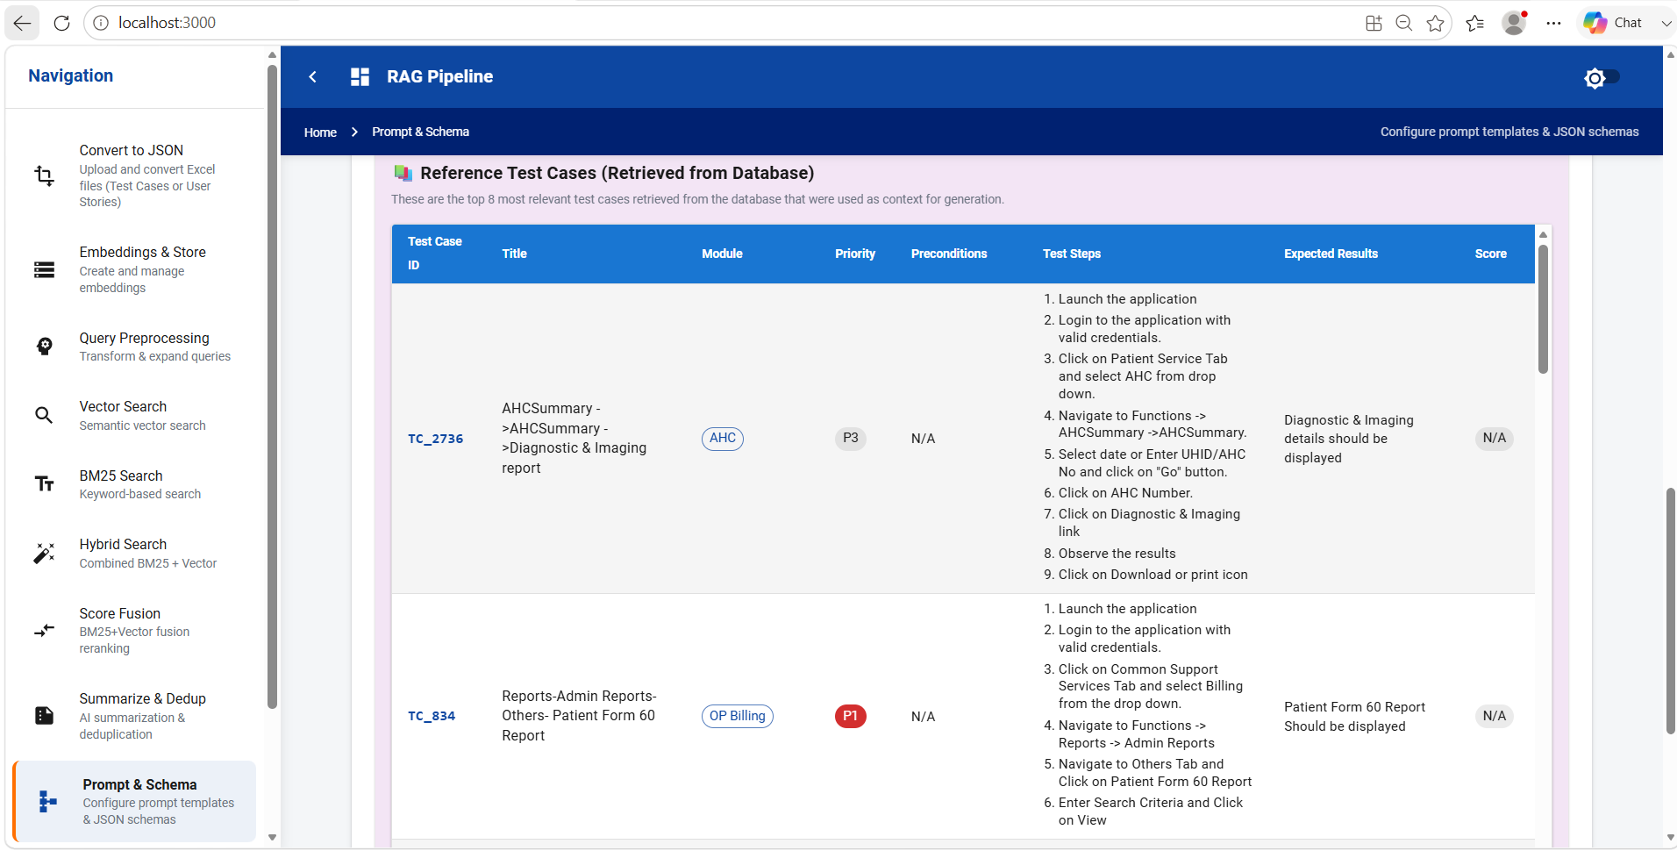

Step 4: Click on Metrics Evaluation
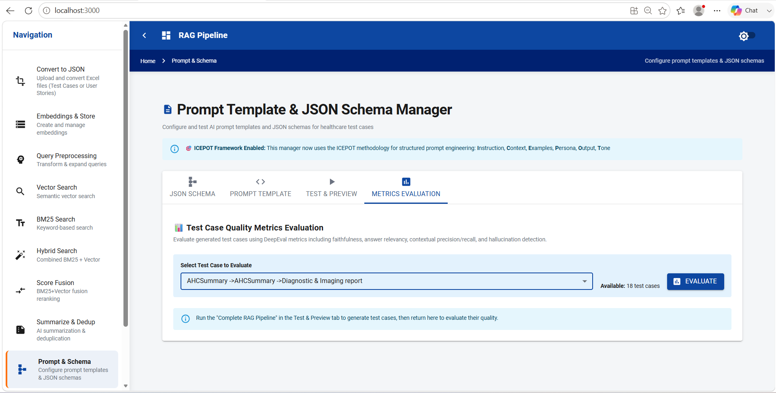
Step 5: One testcase is evaluated against the all the metrics
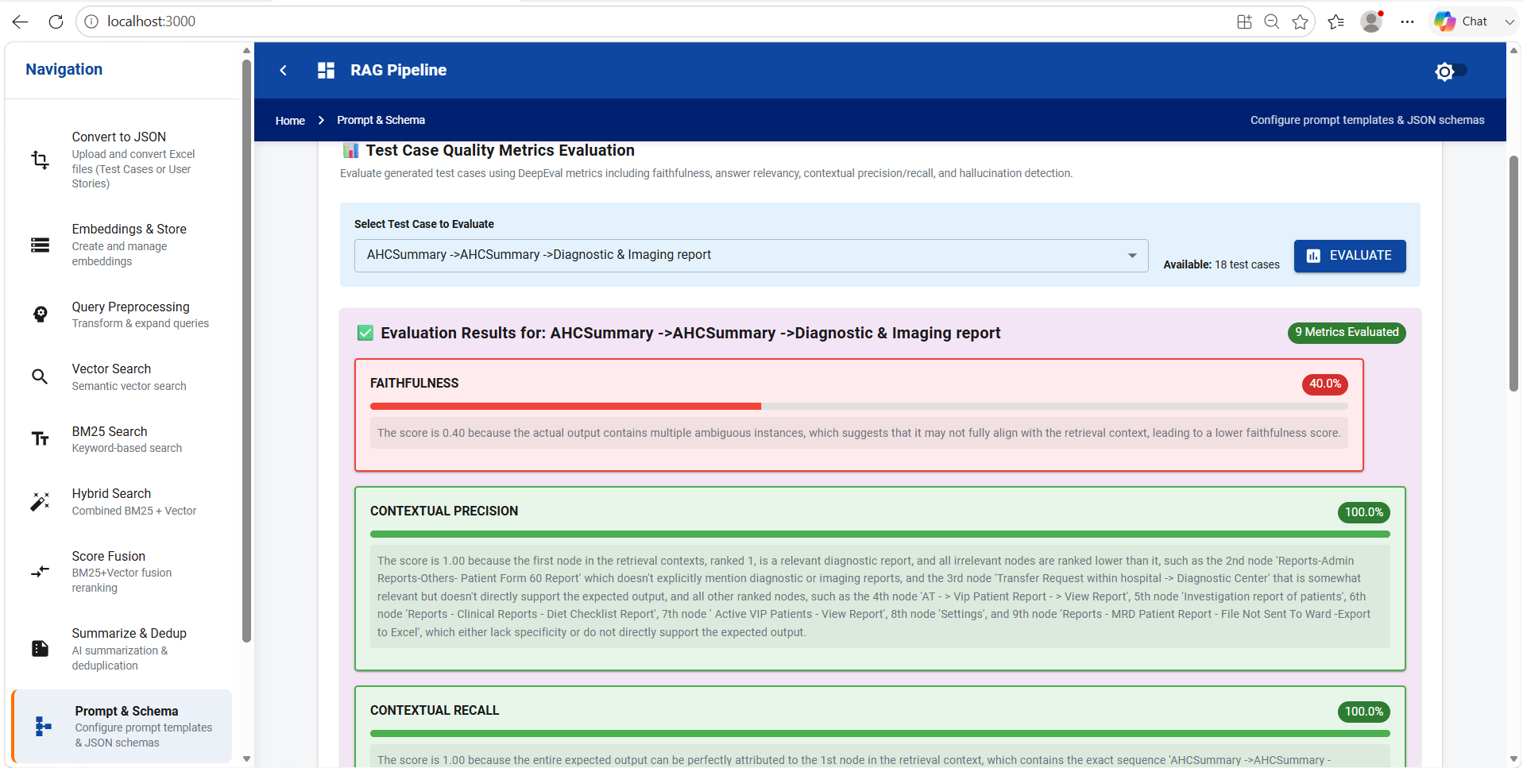
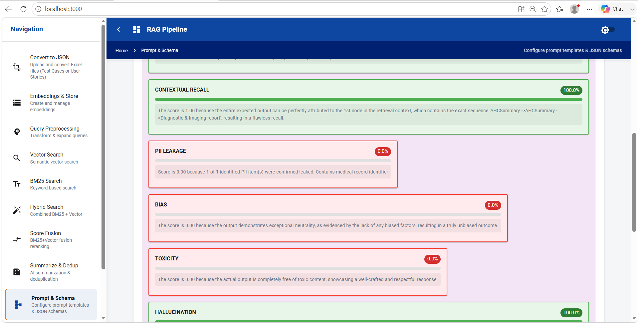
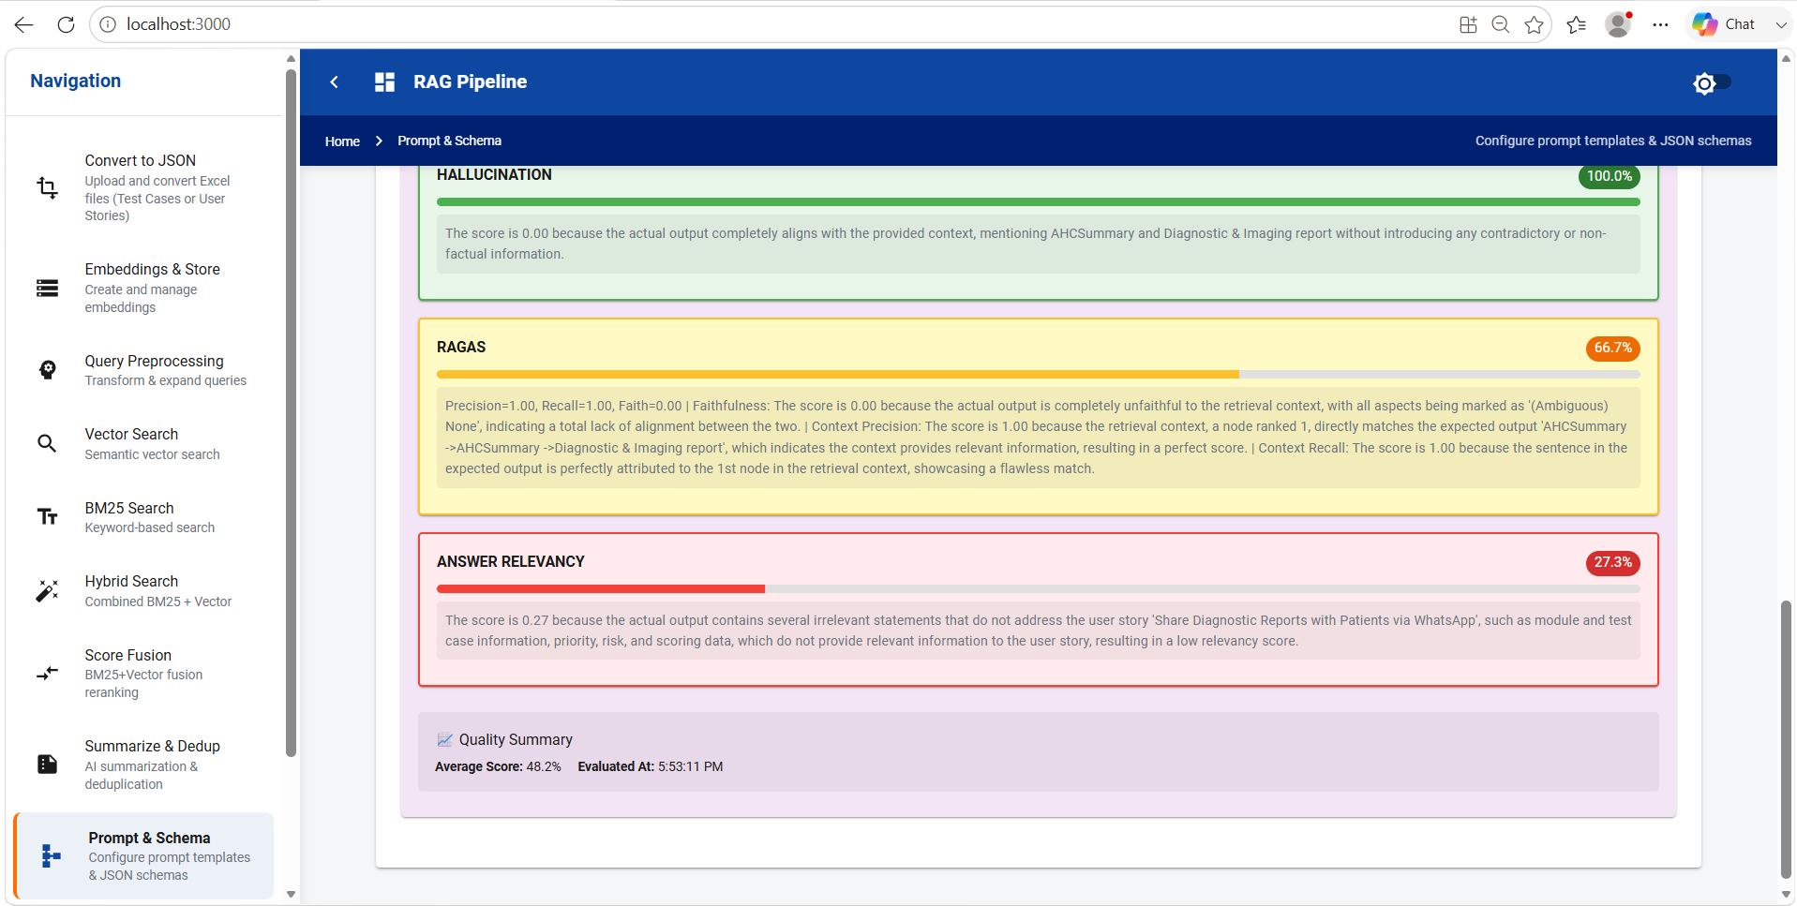

Step 6: Verified the Deepeval verification Endpoint
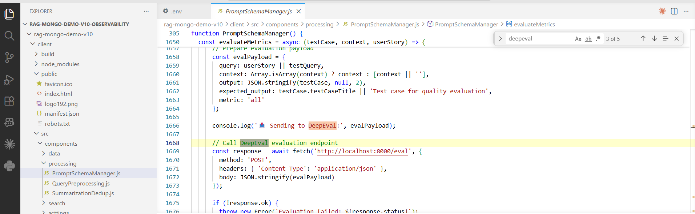
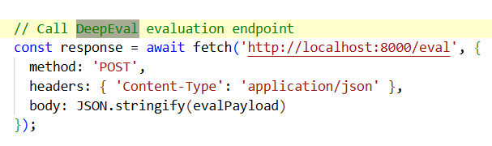
Step 7: In the Metrics part it is mentioned all, So when you select an testcase , it is measured against all the metrics.
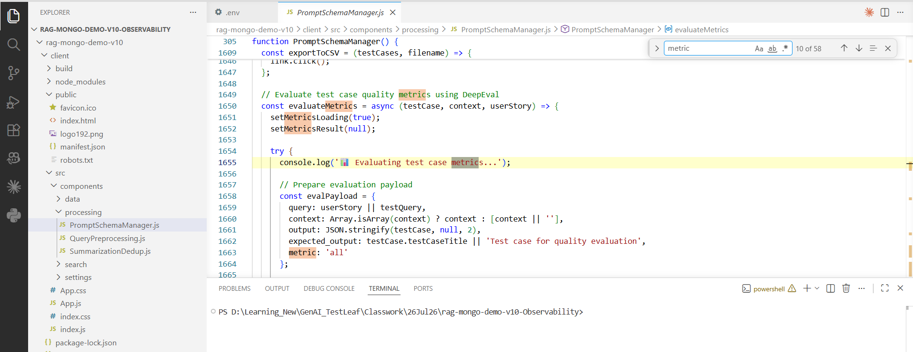

Step 8: When you want to do for selective metrics, you can do like below.
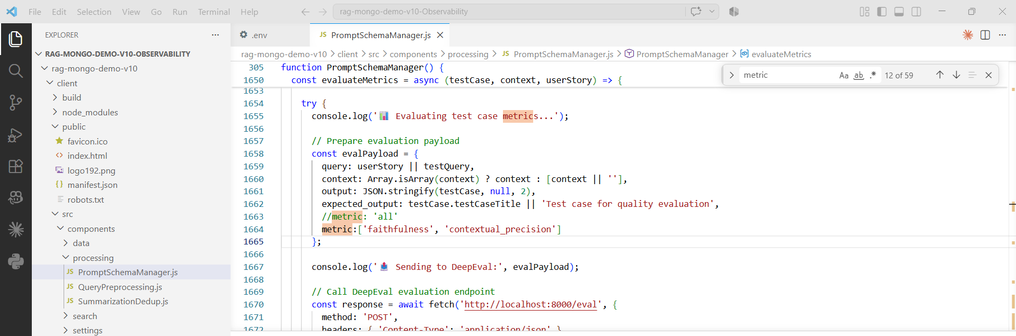
Step 9: The testcases were retrived
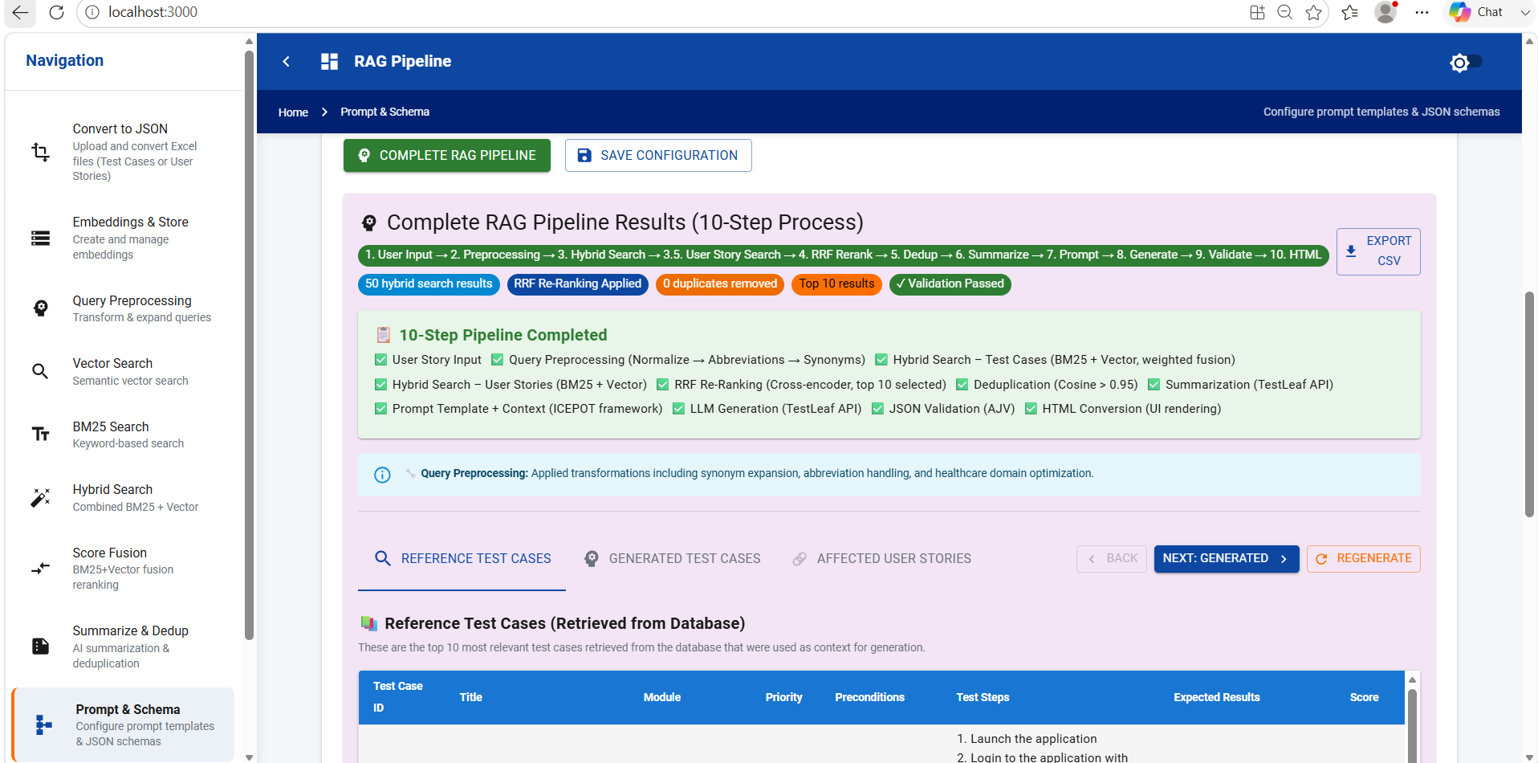
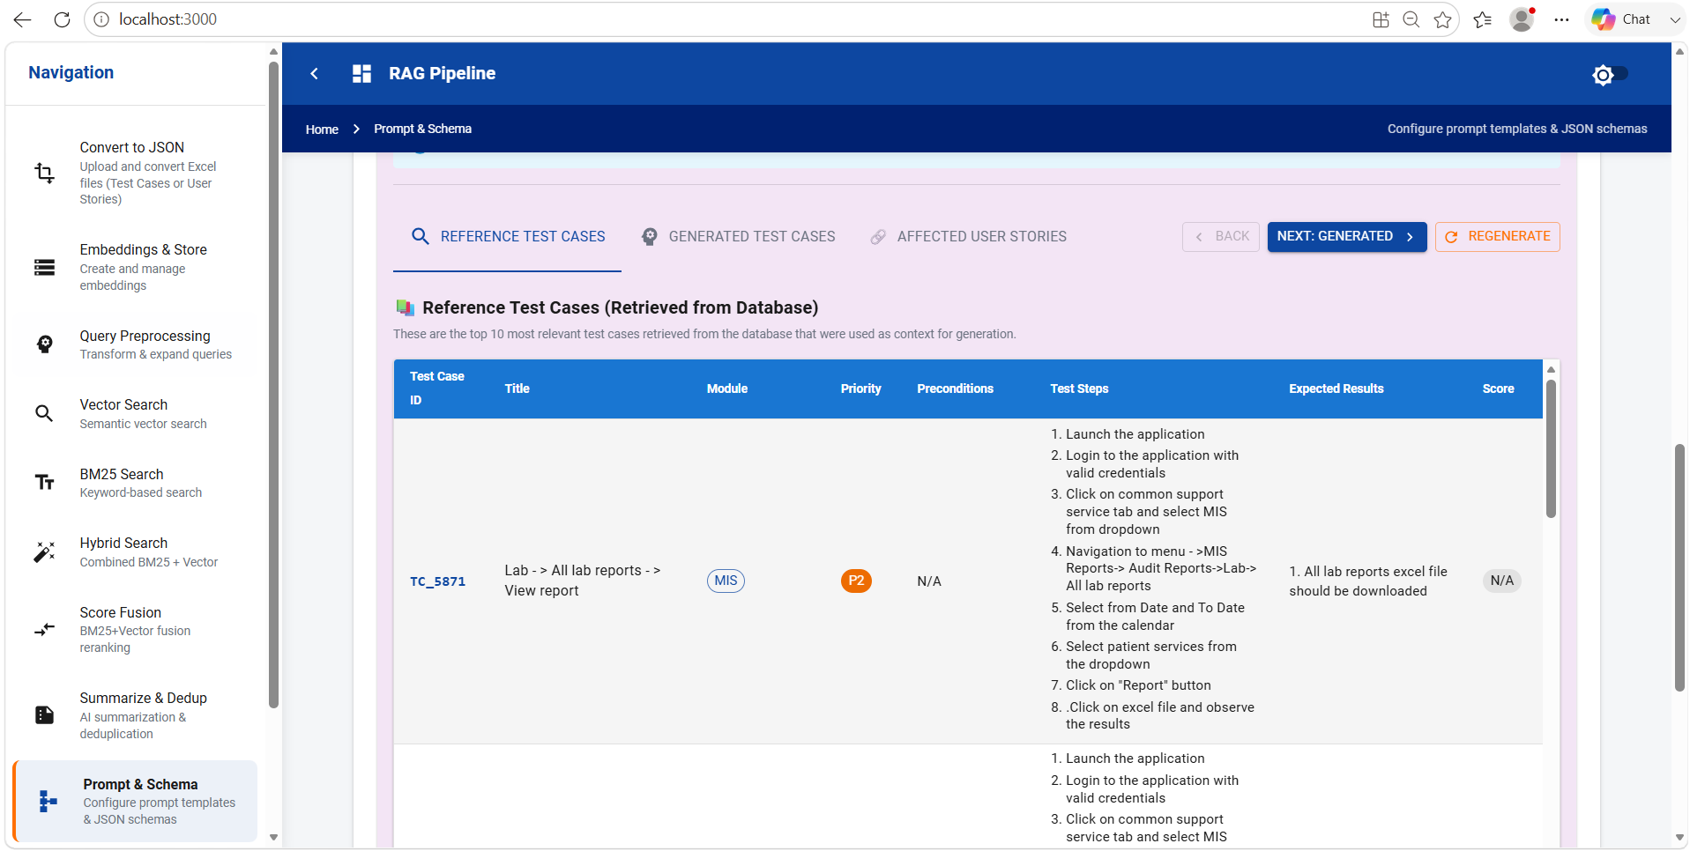
Step 10: The Metrics mentioned in the PromptSchemaManager is alone verified.
