Health:
GET /health
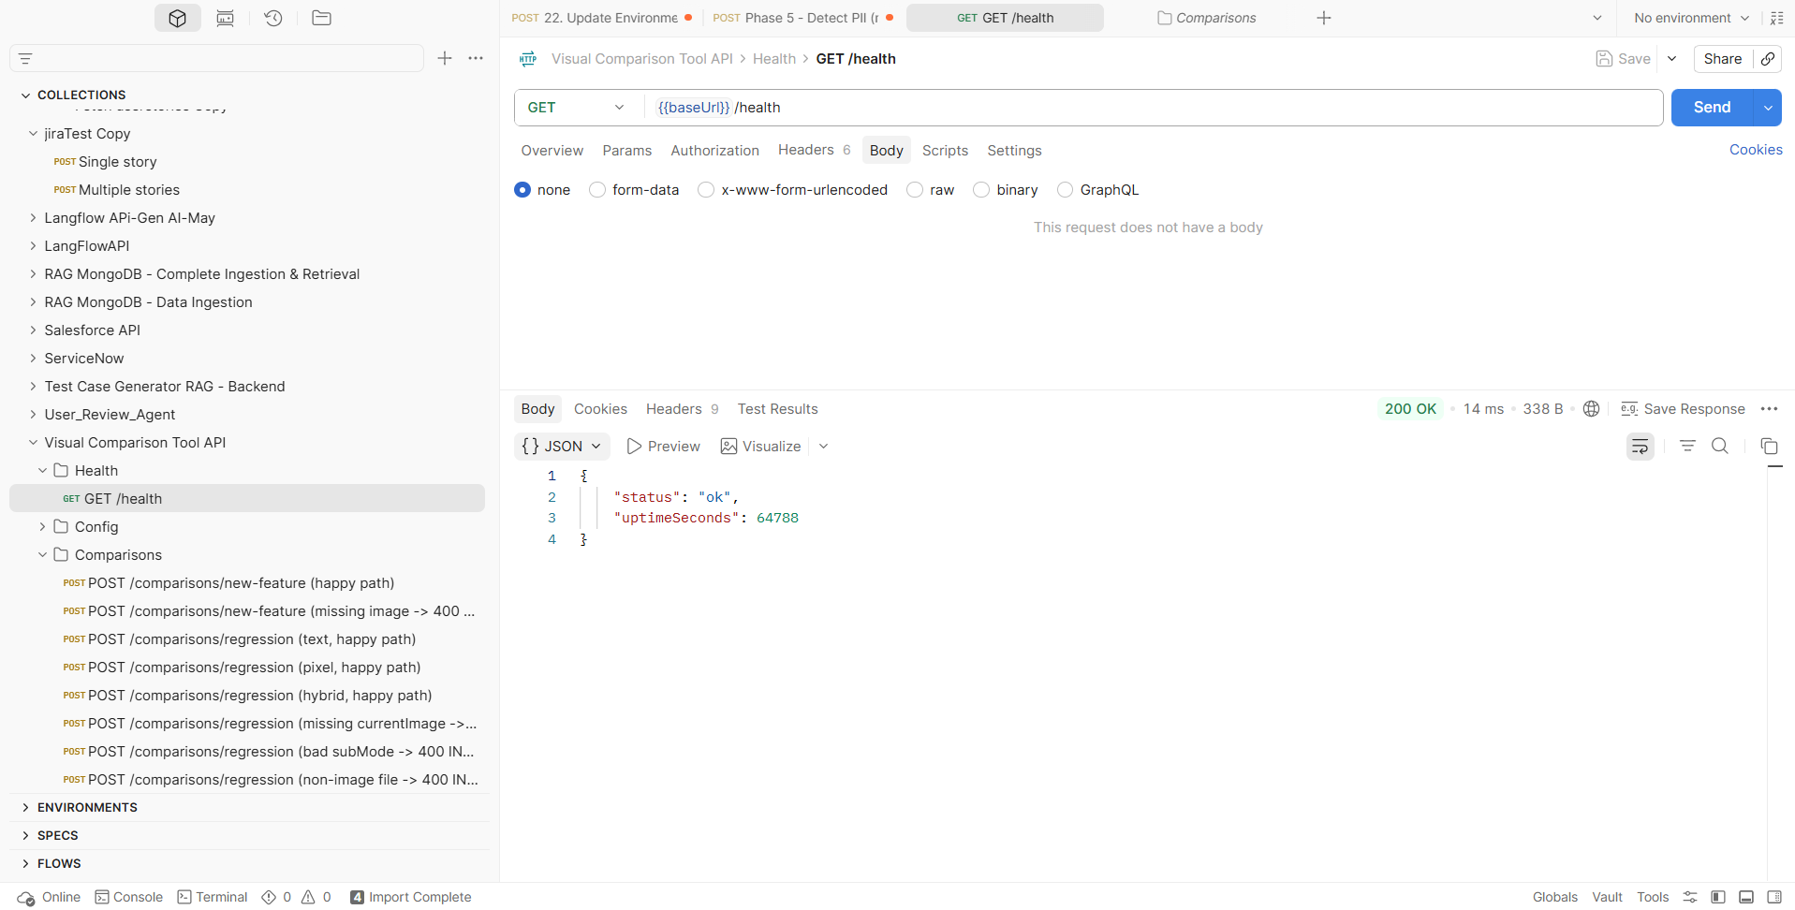
Config: GET /config/modes
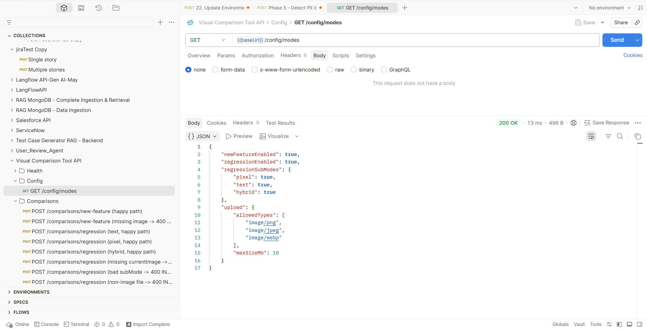

POST /comparisons/new-feature (happy path)
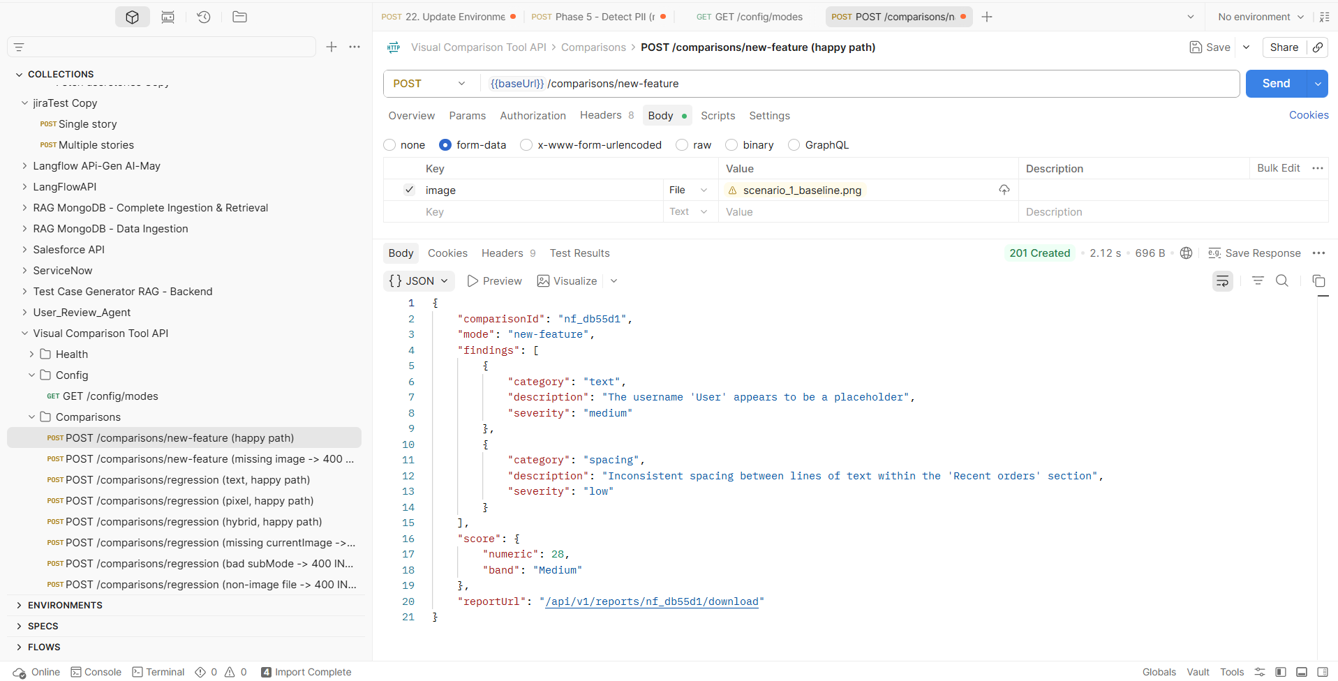
POST /comparisons/new-feature (missing image -> 400 MISSING_REQUIRED_FIELD)
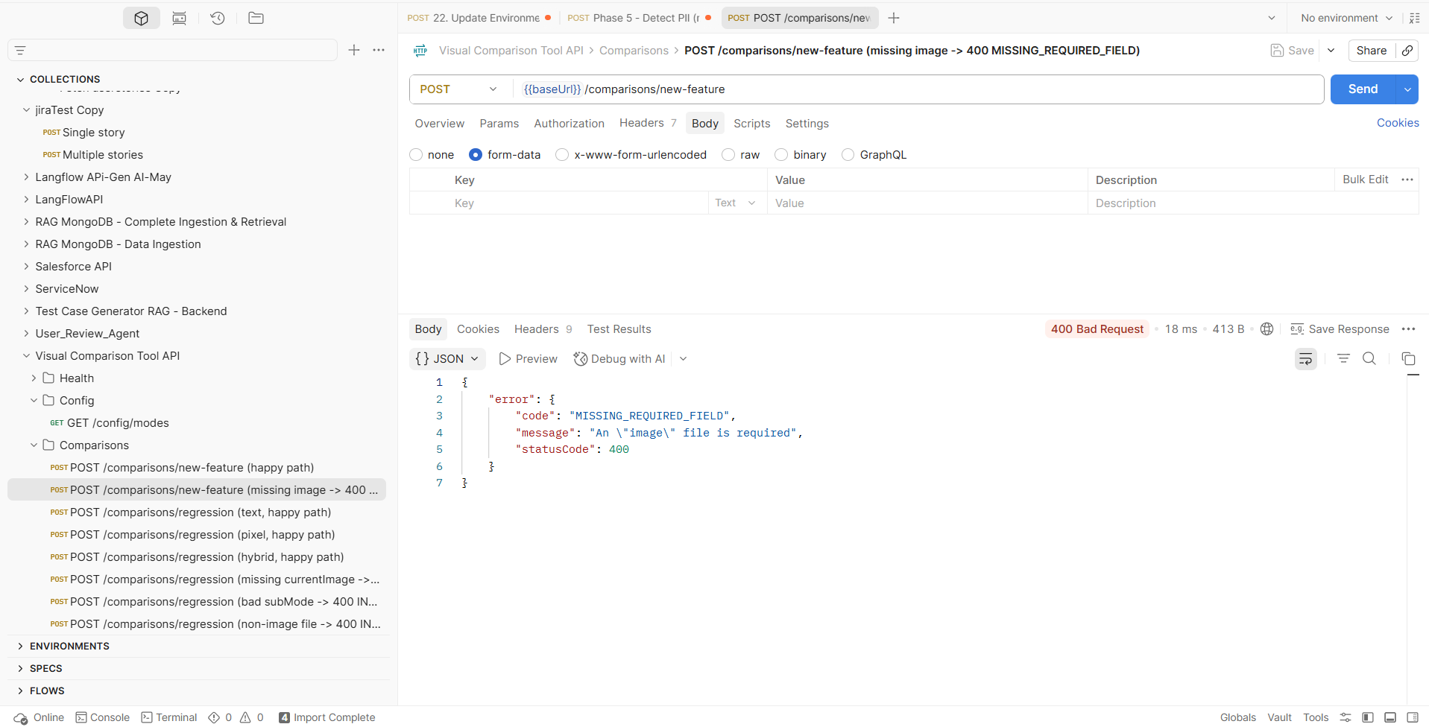
POST /comparisons/regression (text, happy path)
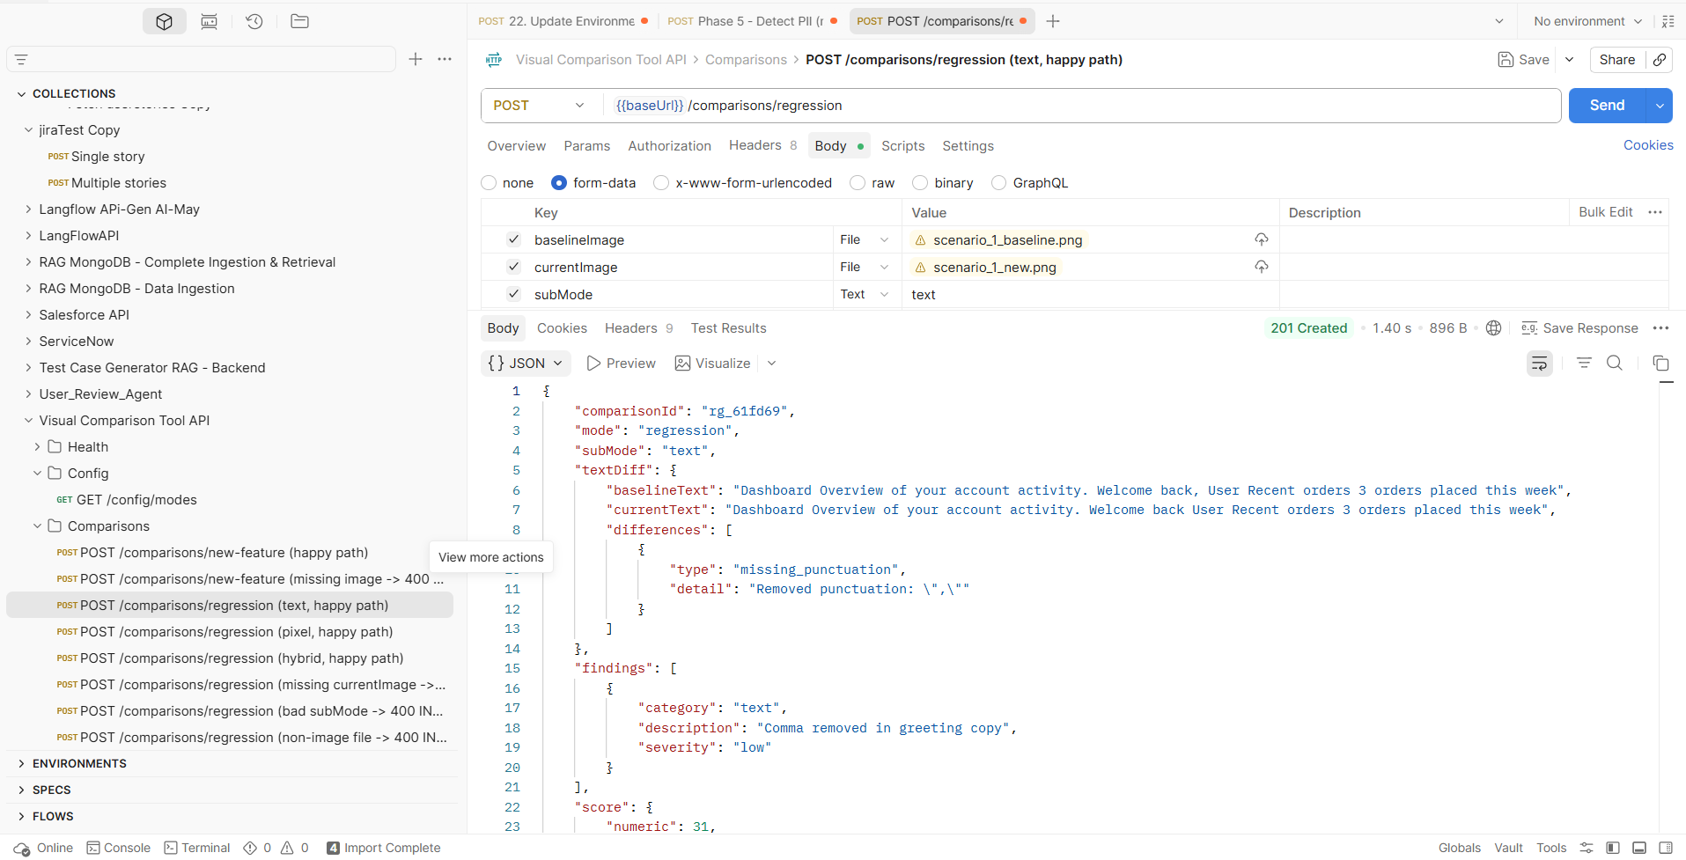
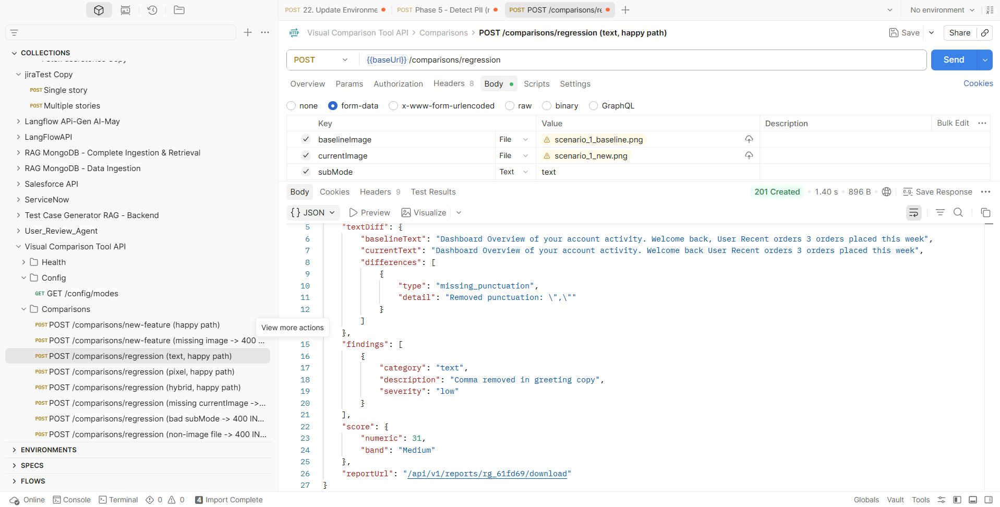

POST /comparisons/regression (pixel, happy path)
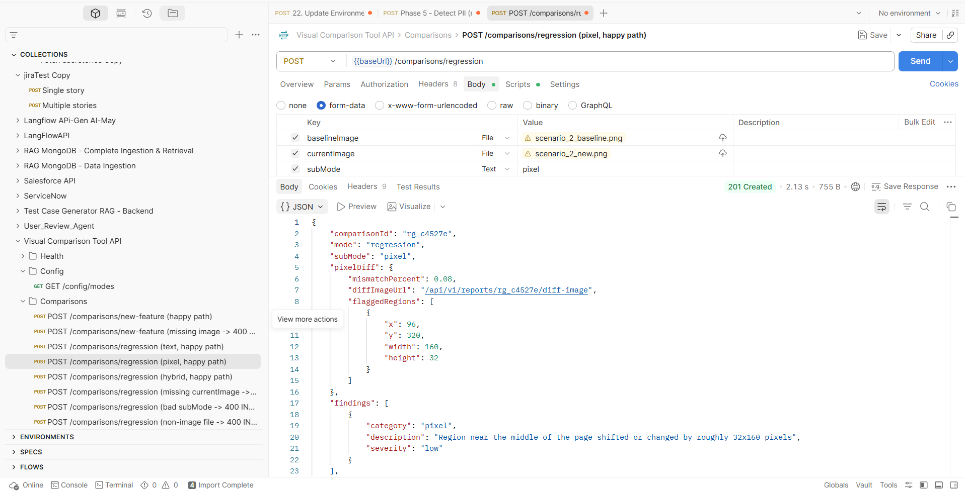
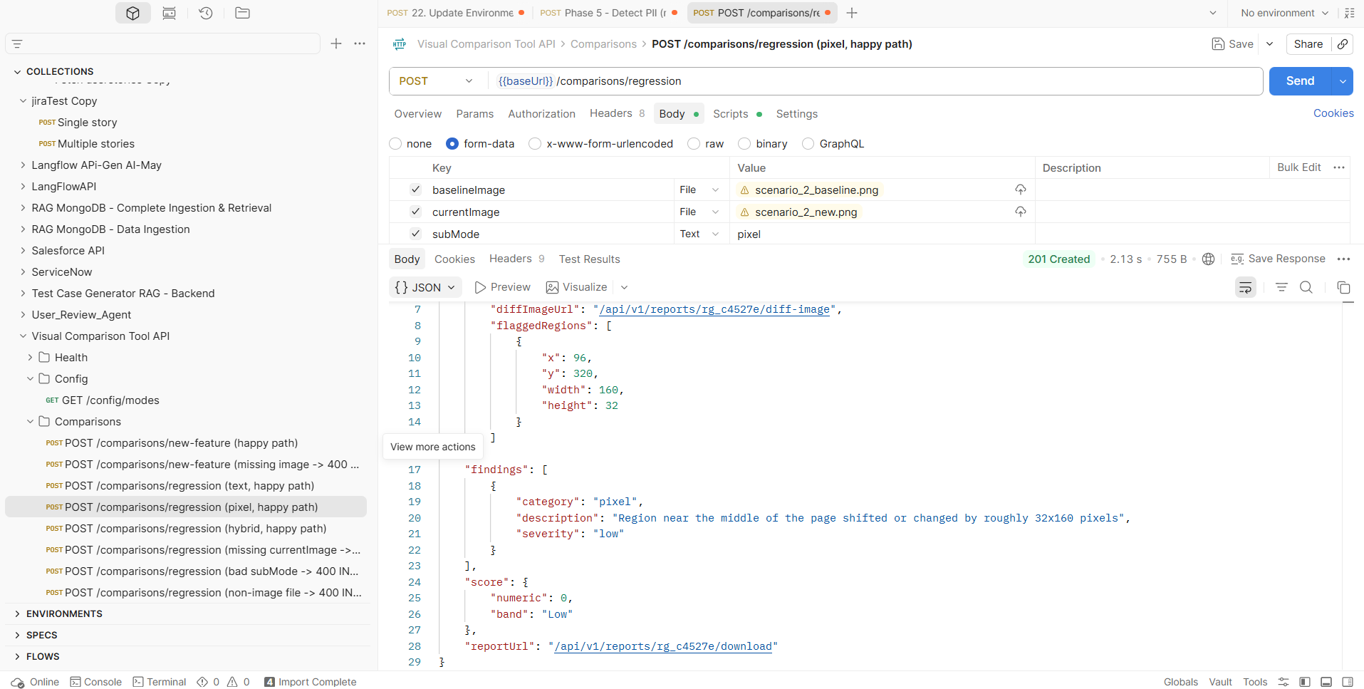

POST /comparisons/regression (hybrid, happy path)
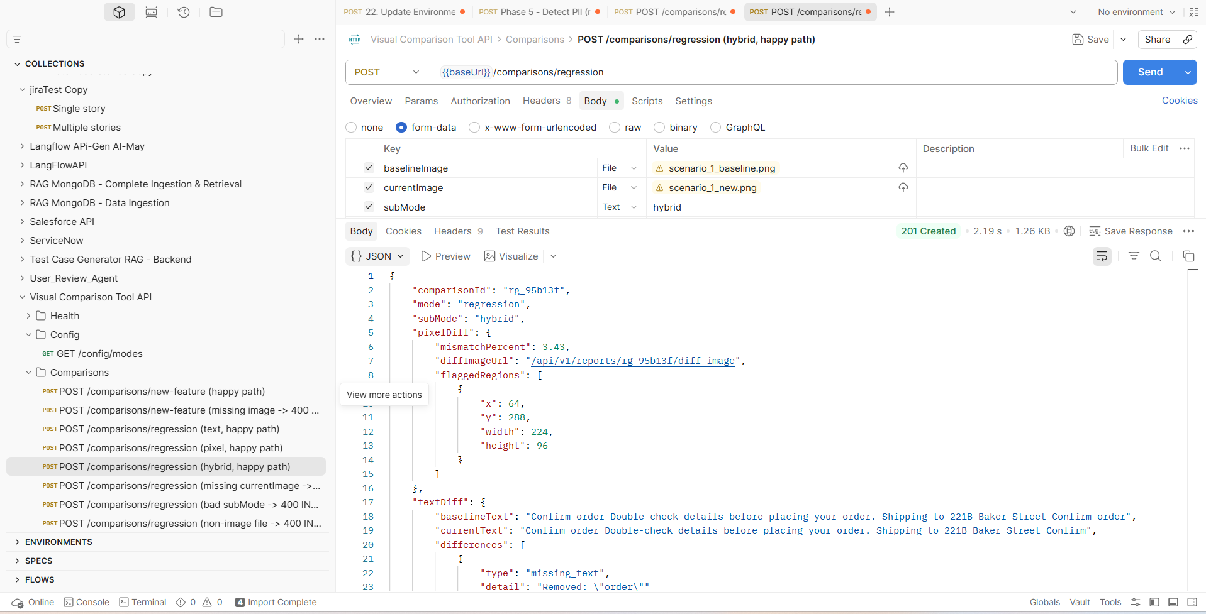
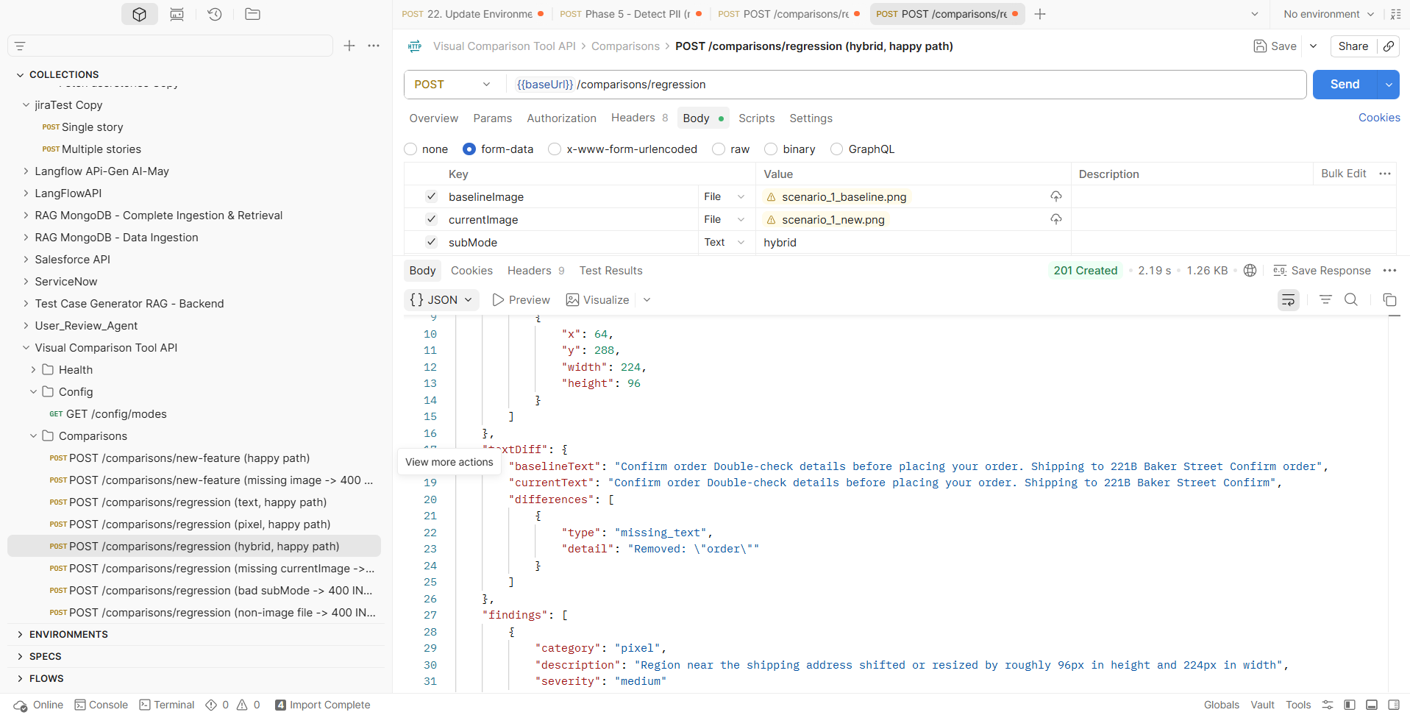
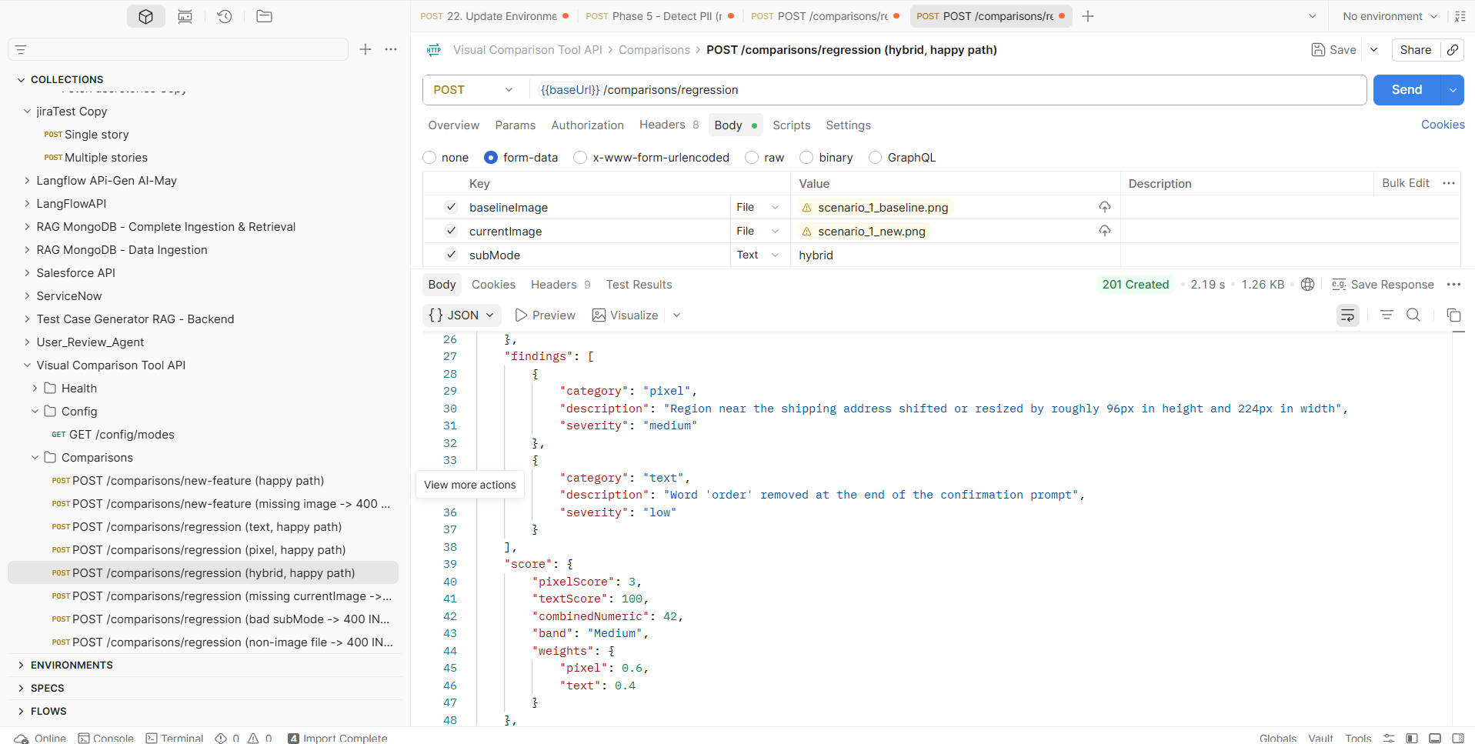
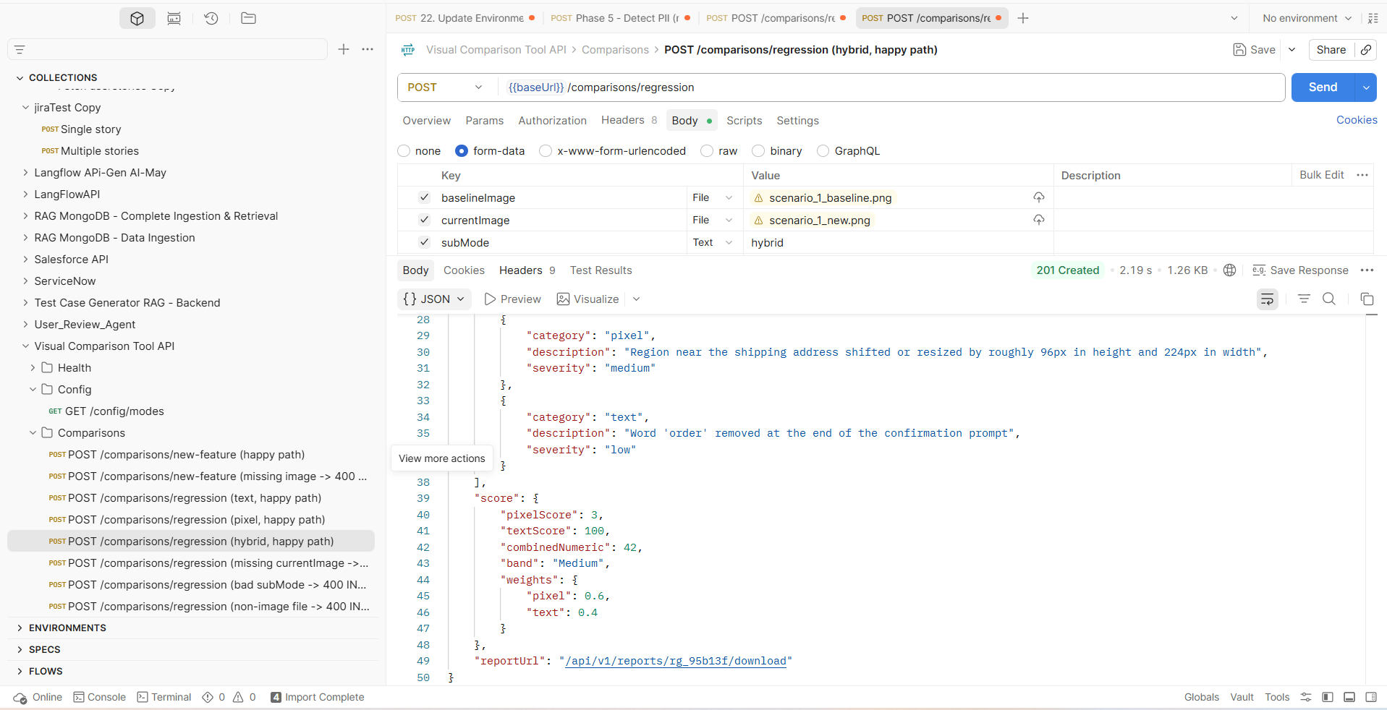

POST /comparisons/regression (missing currentImage -> 400 MISSING_REQUIRED_FIELD)
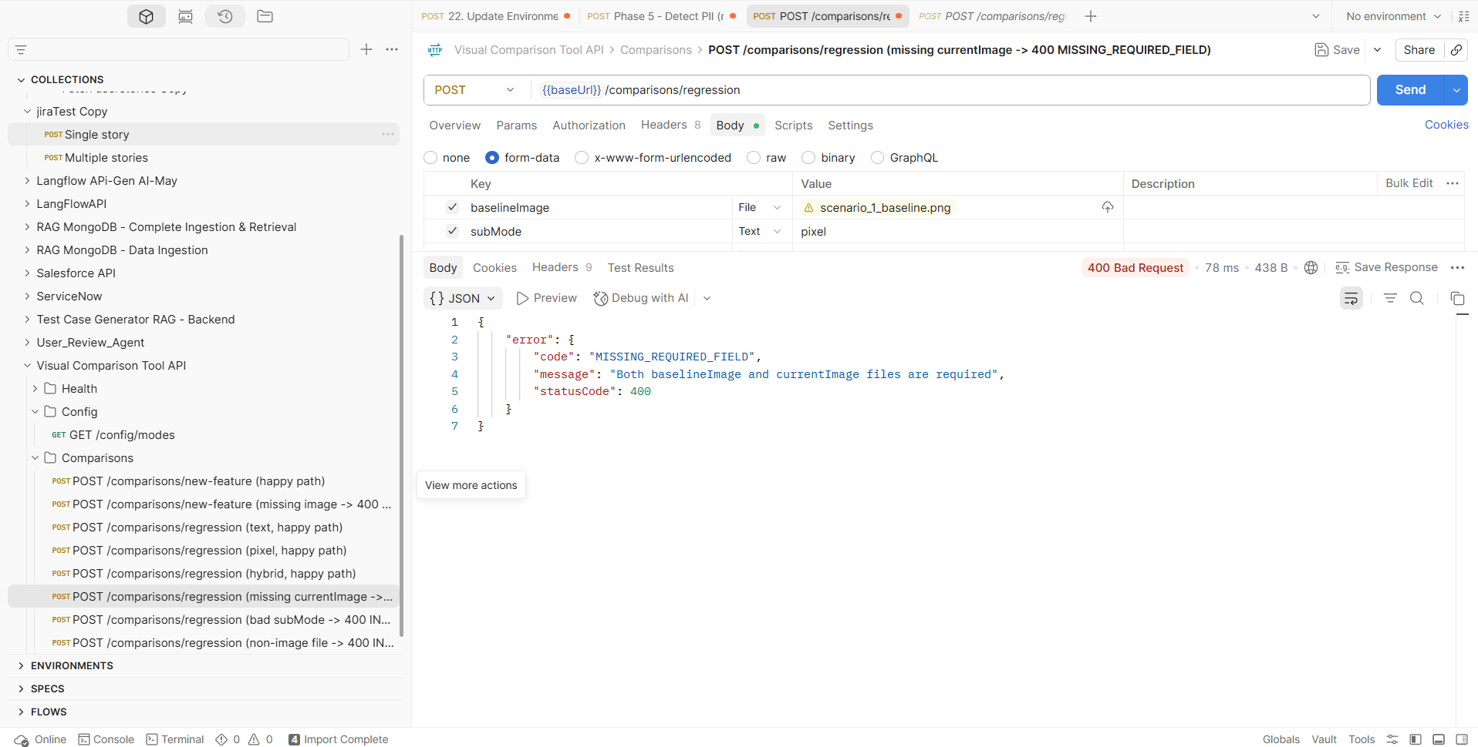
POST /comparisons/regression (bad subMode -> 400 INVALID_SUBMODE)
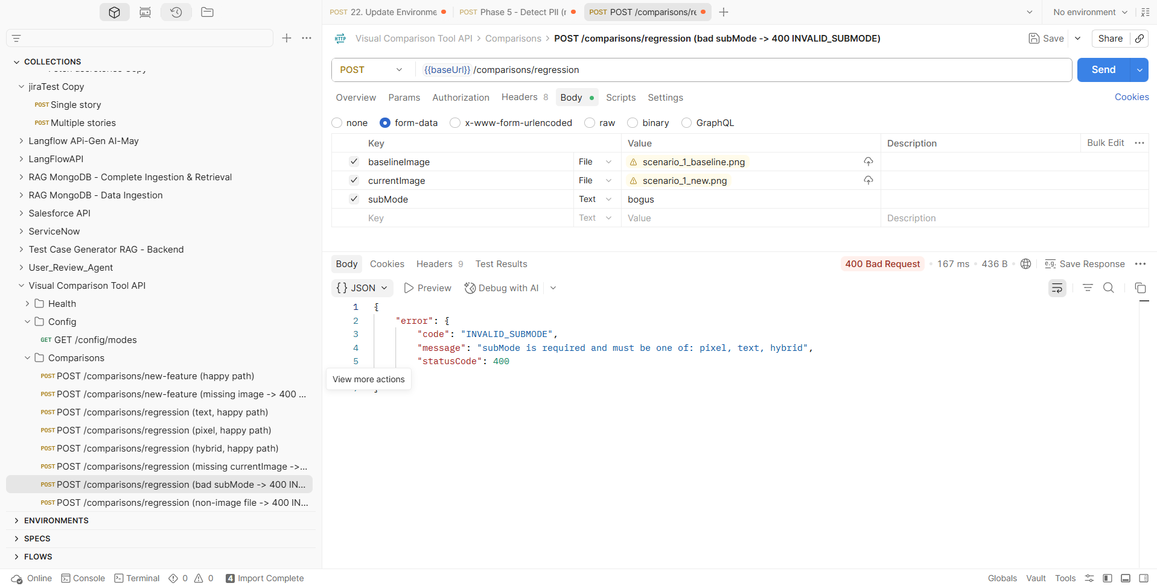

POST /comparisons/regression (non-image file -> 400 INVALID_FILE_TYPE)
