Step 1: Follow the below steps strictly
*Add in claude code*
1) npm install -g @anthropic-ai/claude-code (one time installation in vscode)
2) Check for claude version
claude --version
3) Add the mcp by running the below command
claude mcp add --transport http atlassian https://mcp.atlassian.com/v1/mcp/authv2
4) Authenticate the atlassian login
claude mcp login atlassian
5) To find the list of mcps in claude
claude mcp list
*Claude code*
1) /mcp servers
---Check for teh status --it should be connected
2) Ask for query in natural language
List the user stories
Generate the testcases
*To remove jira mcp from vscode*
uninstall the extension
*To remove jira mcp from claude*
claude mcp remove atlassian

Authentication should be successful as shown below
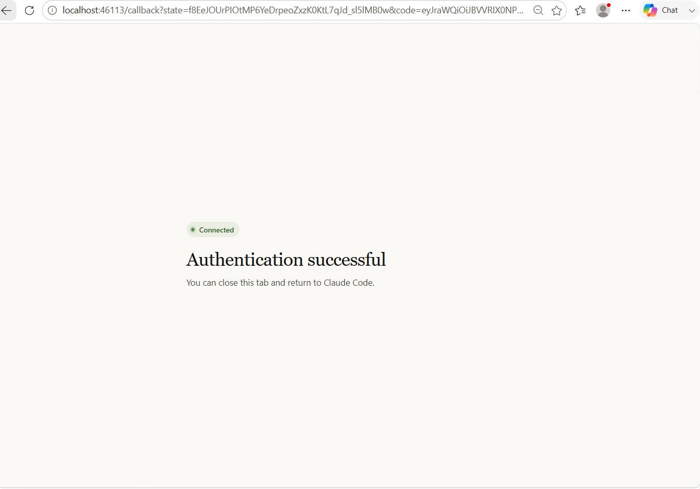Step 2: After the authentication, the JIRA user stories is fetched from the JIRA.
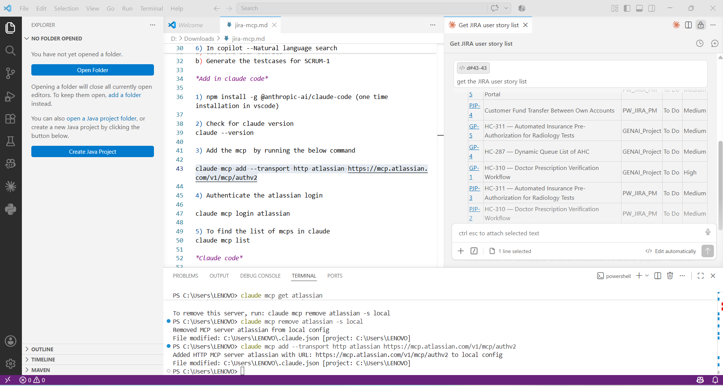
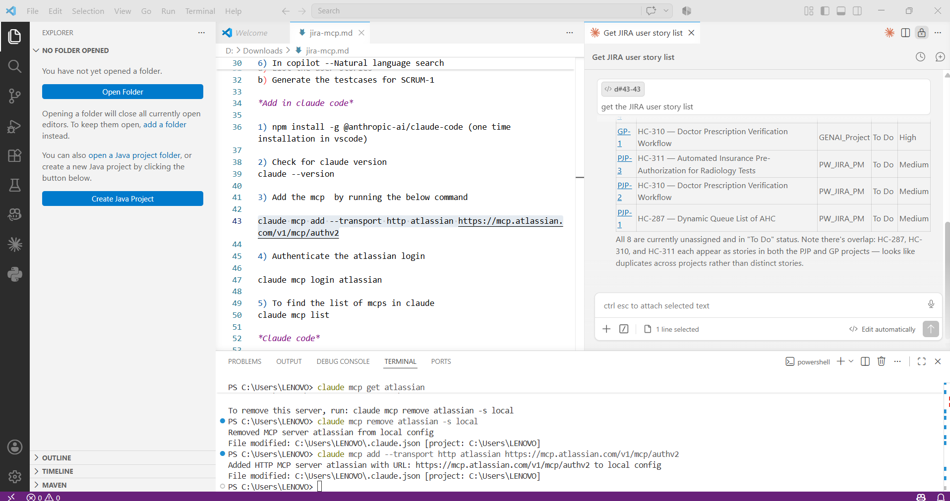

Step 3: Generate testcase by specifying the User story
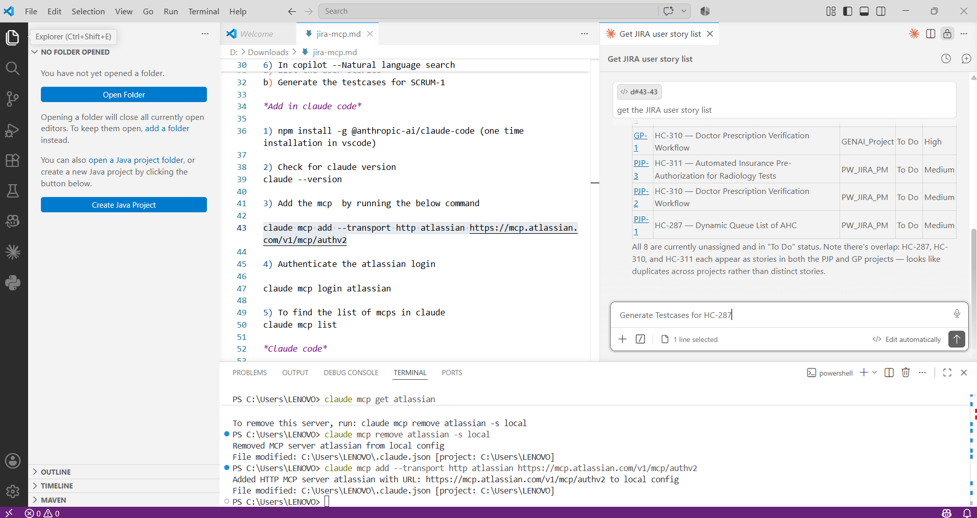
Step 4: Testcases generated for the User story HC-287
