Step 1: Follow the below steps to establish a connection with the remote postman collection
Postman remote MCP Installation for claude*
*One time claude installation -ignore if already done*
1) npm install -g @anthropic-ai/claude-code (one time installation in vscode)
2) Check for claude version
claude --version
*Add postman remote mcp for claude*
*windows
open .claude.json from c:/users/<yourusername> or
run the below in power shell
notepad $env:USERPROFILE\.claude.json
mac try he below
1) From terminal
open ~/.claude.json
2) with VS Code
code ~/.claude.json
*Add postman under the existing mcpServers object*
"postman": {
"type": "http",
"url": "https://mcp.postman.com/mcp"
}
1) Claude code type the below and click
/mcp server servers
2) Connect to Postman cloud for Authrozation
3)Approve all the request to Authorize claude access

*Local mcp vscode*
https://learning.postman.com/docs/reference/postman-api/postman-mcp-server/postman-mcp-local-server#visual-studio-code
Step 2: Add the postman json under the MCP servers.
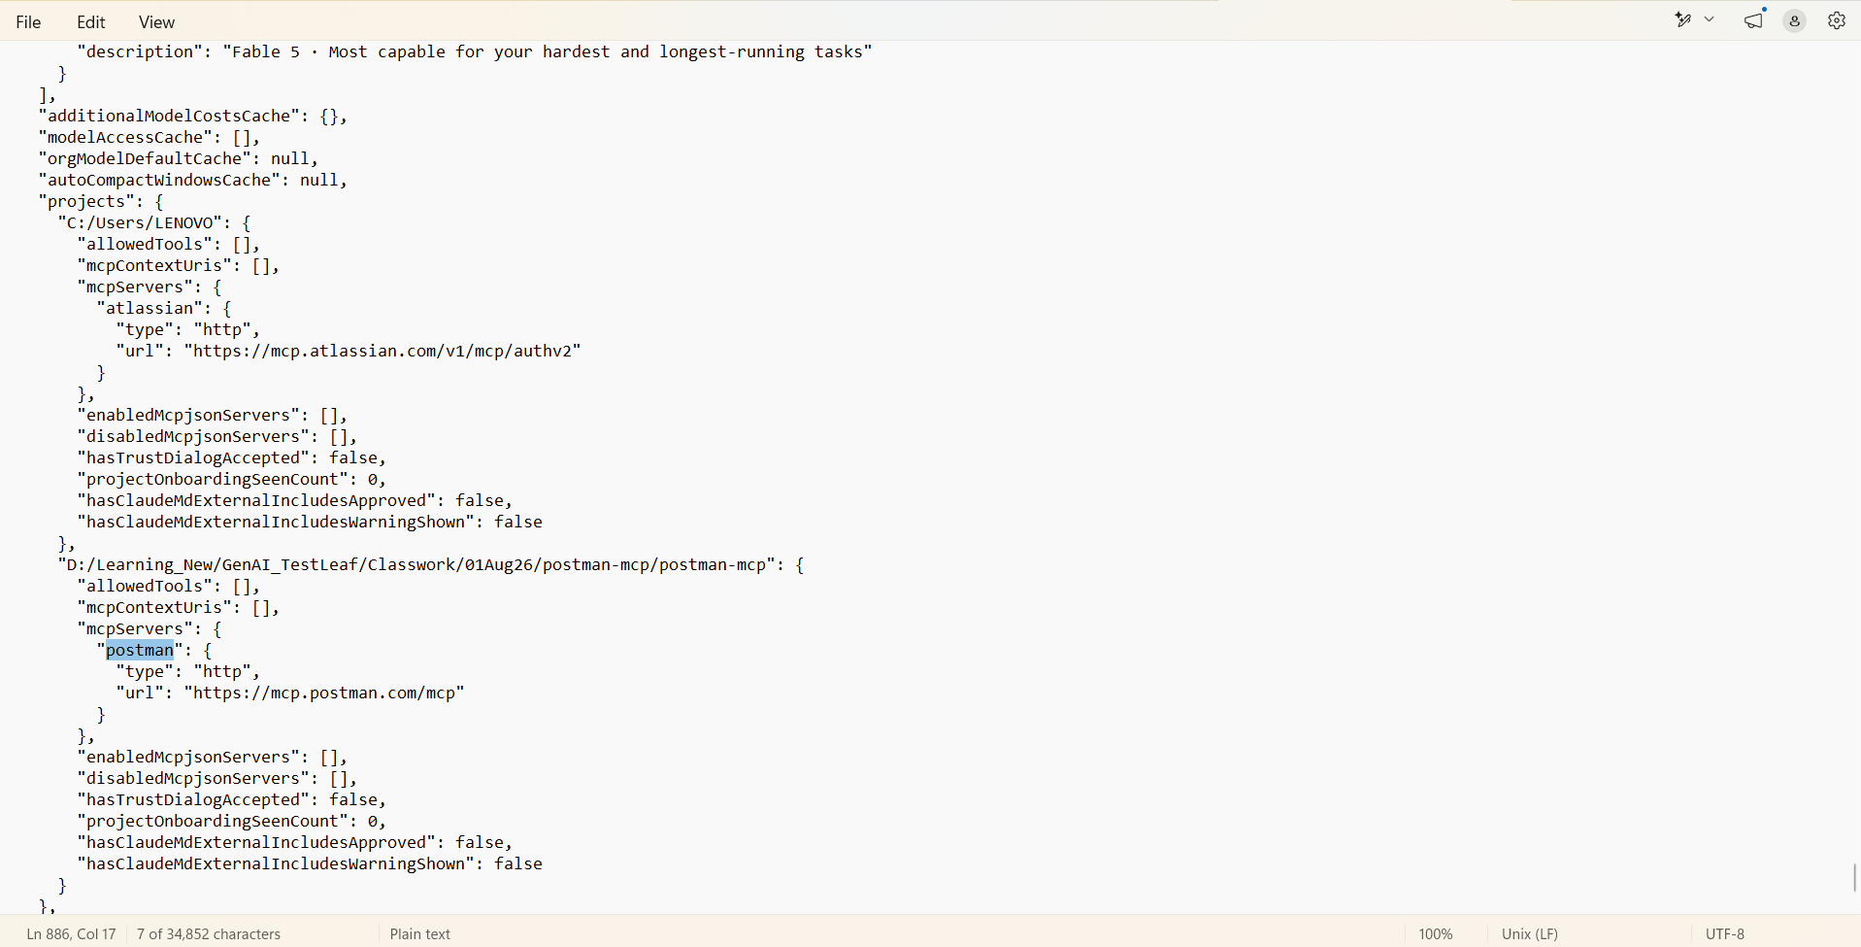

Step 3: Once the Authentication is successful
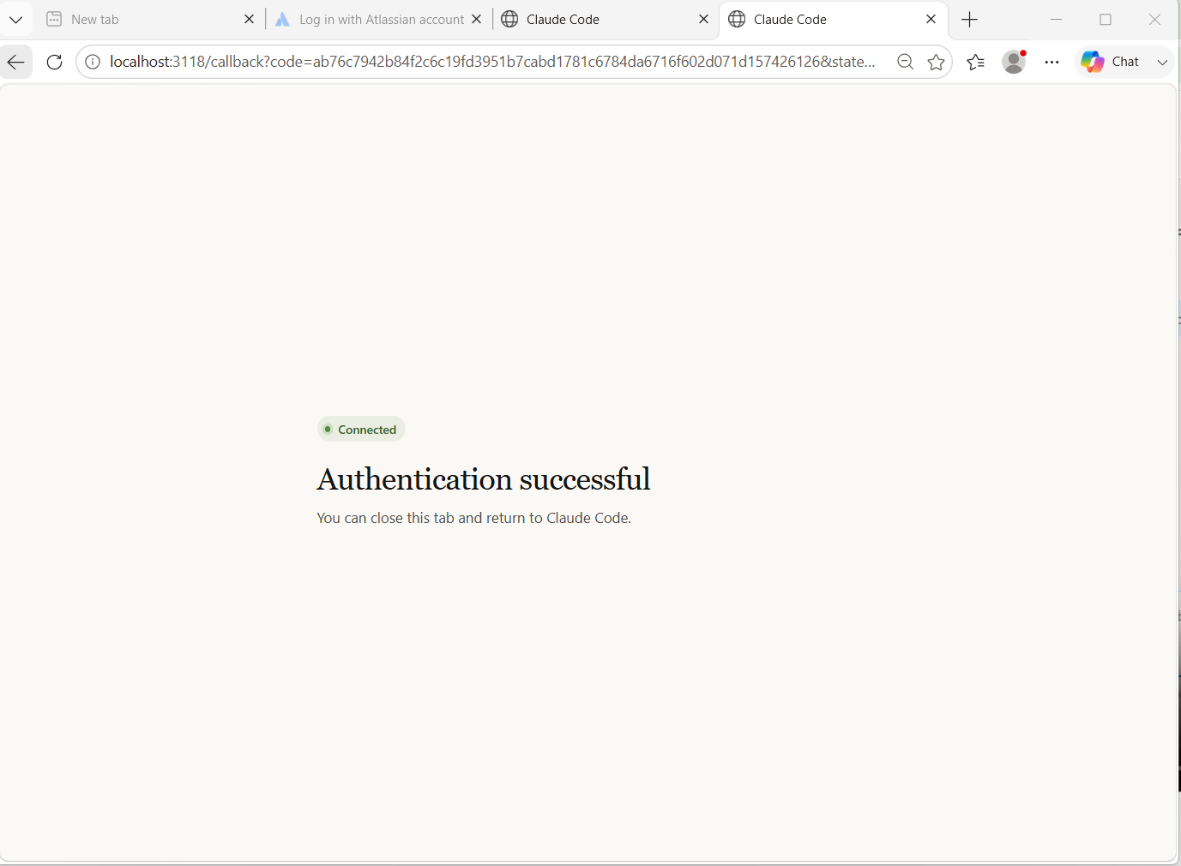
Step 3: Enter the cmd “/mcp”
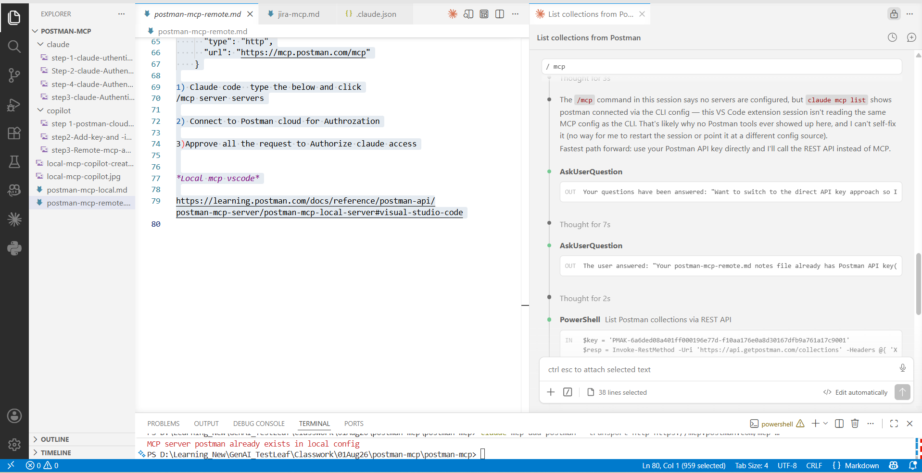Step 4: Retrieve the collections
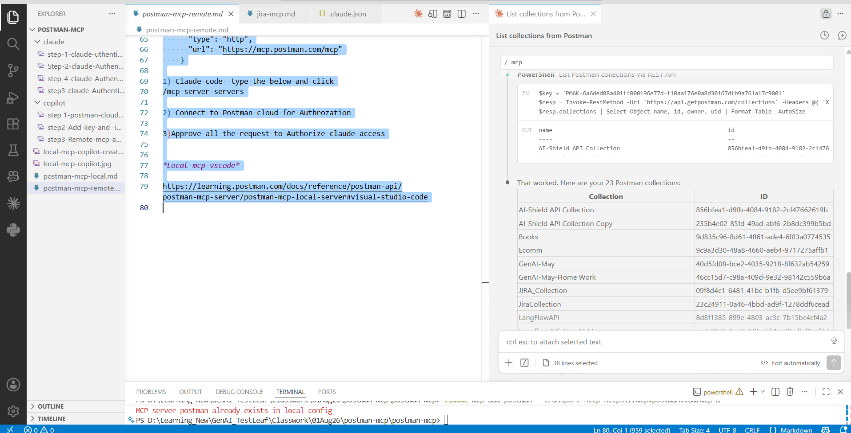

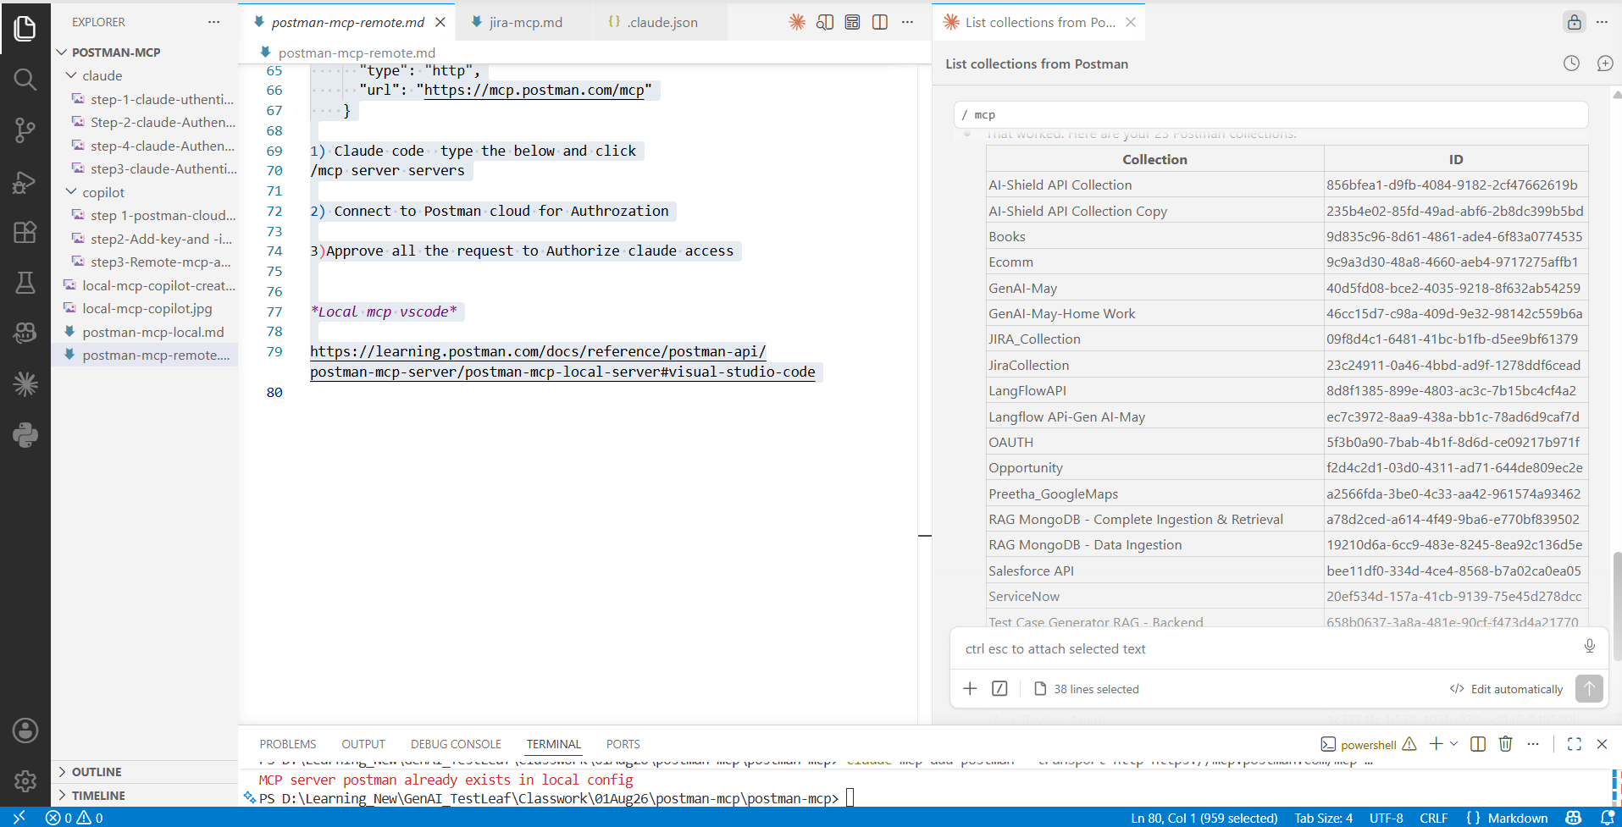

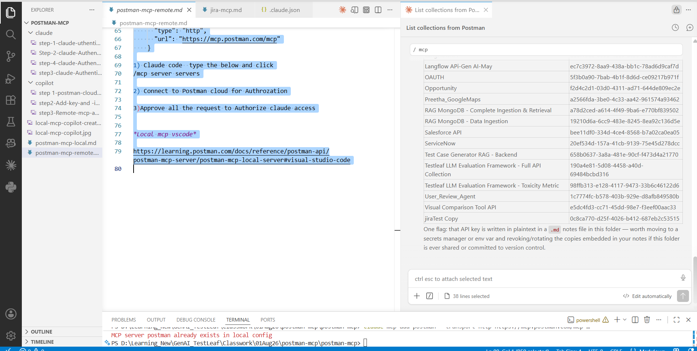
Step 5: Execute the collection by specifying the name
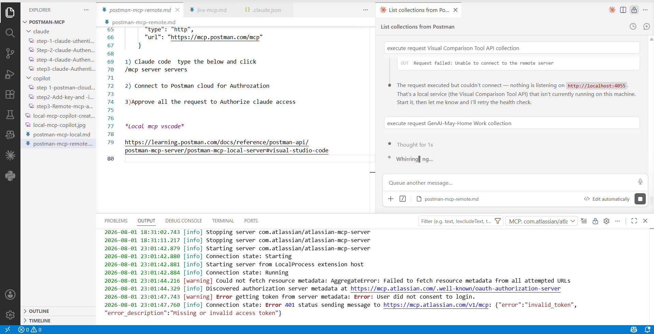
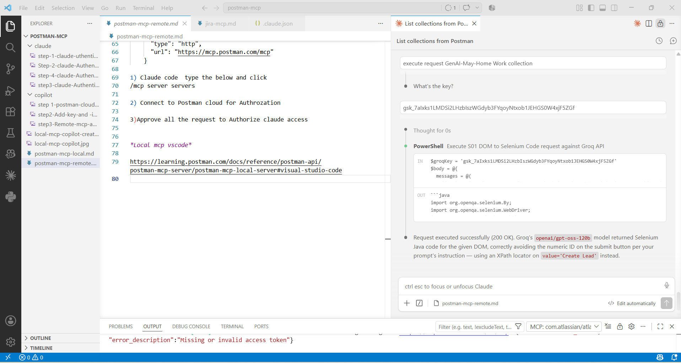
Step 6: Results of the requests within the collection are displayed.
