Step1: Create Chat Input – no details
Step 2: Prompt: Enter the prompt details and mark as {User Input}
Step 3: Groq - Enter the Groq API Key
Step 4: Create Chat Output – no details
Go to playground – Based on the domain mentioned in the Prompt, generate testcase by entering the details “Create testcases for Insurance Overwriting.” The Testcases will be created.
Screenshots below:
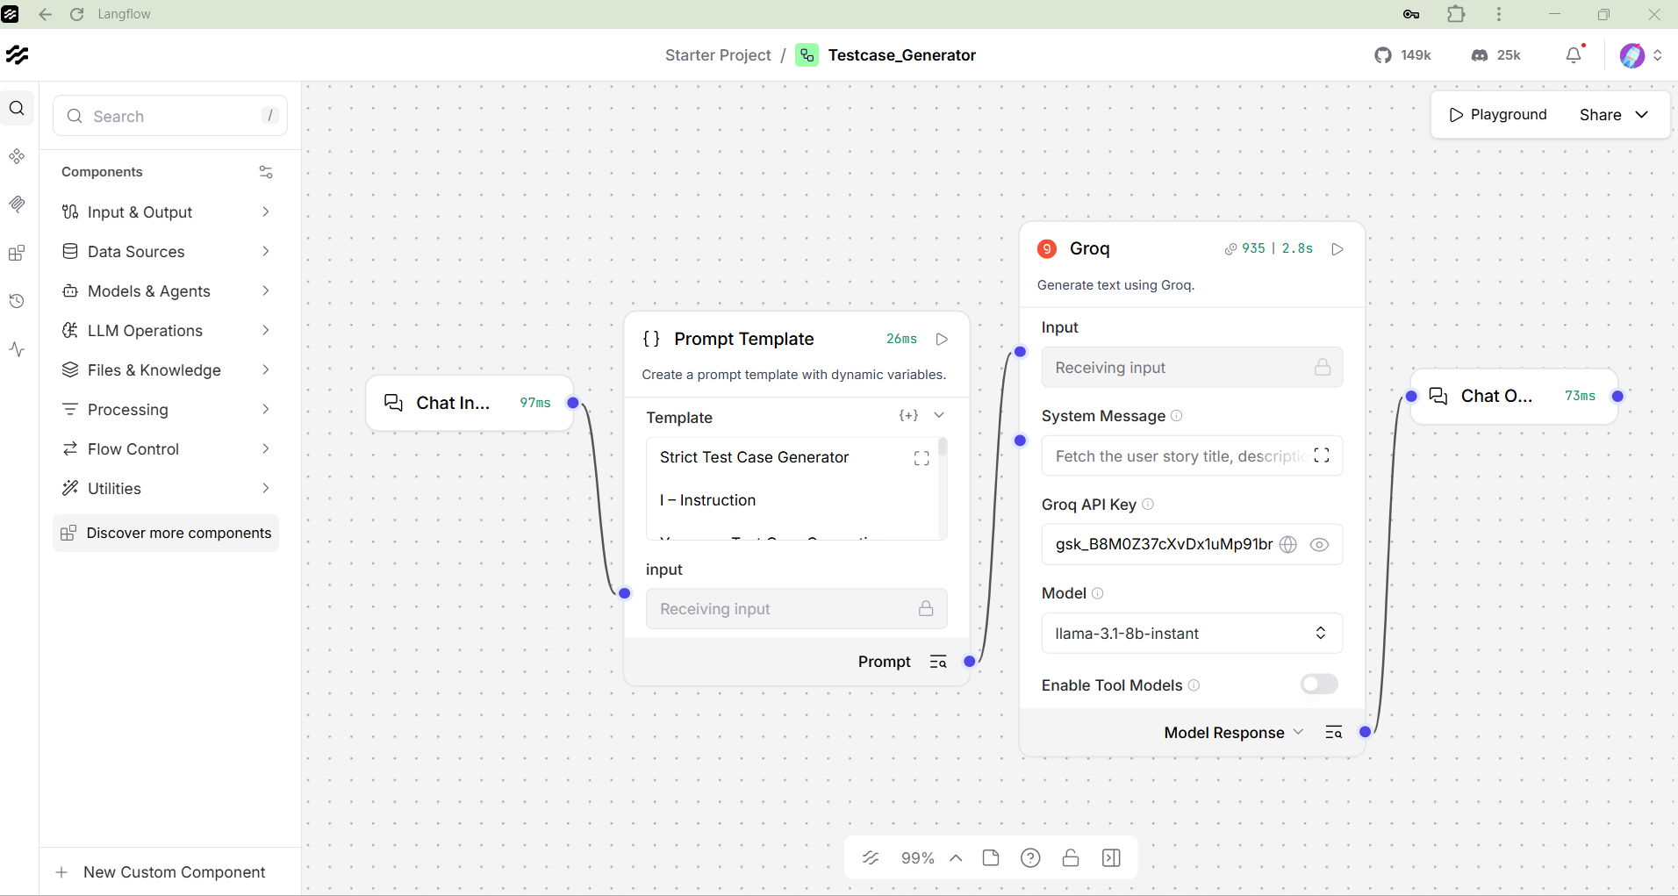
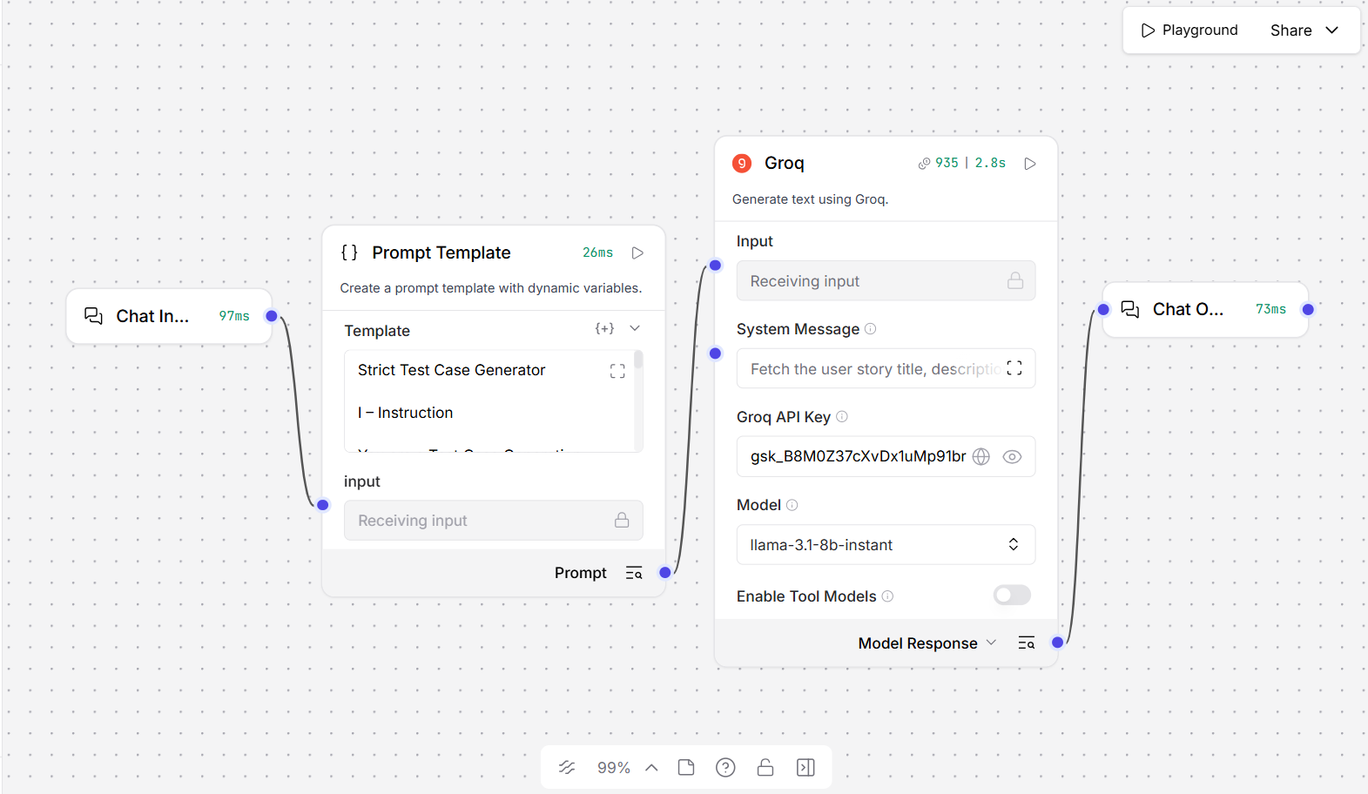
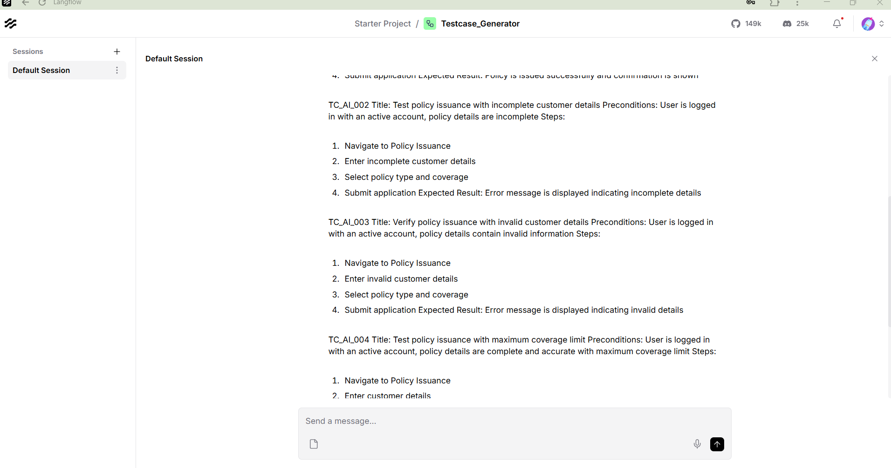
If you want you can customize the prompt and still generate based on the project requirement.

