Golden data set:
Example 1:
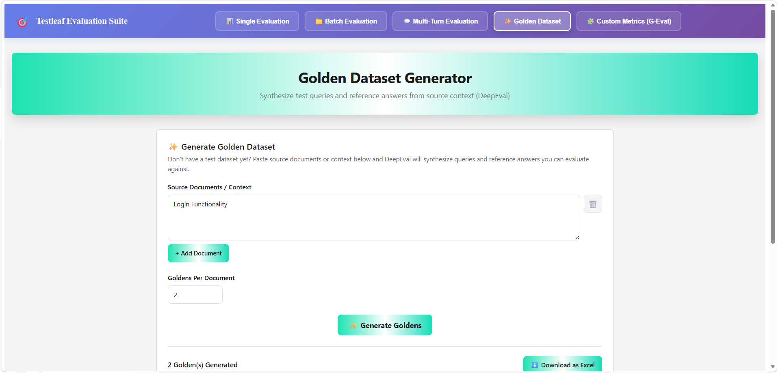
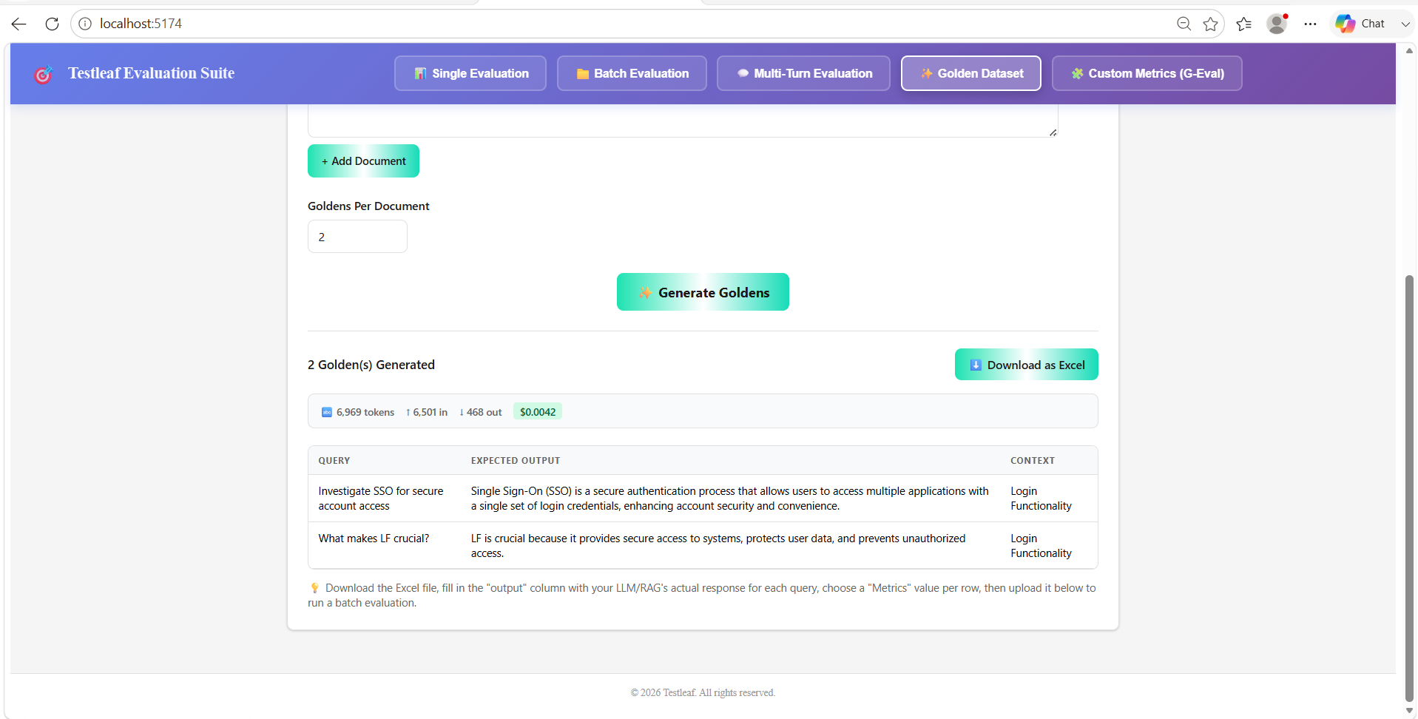
Step1: Entered the User story in the Golden dataset
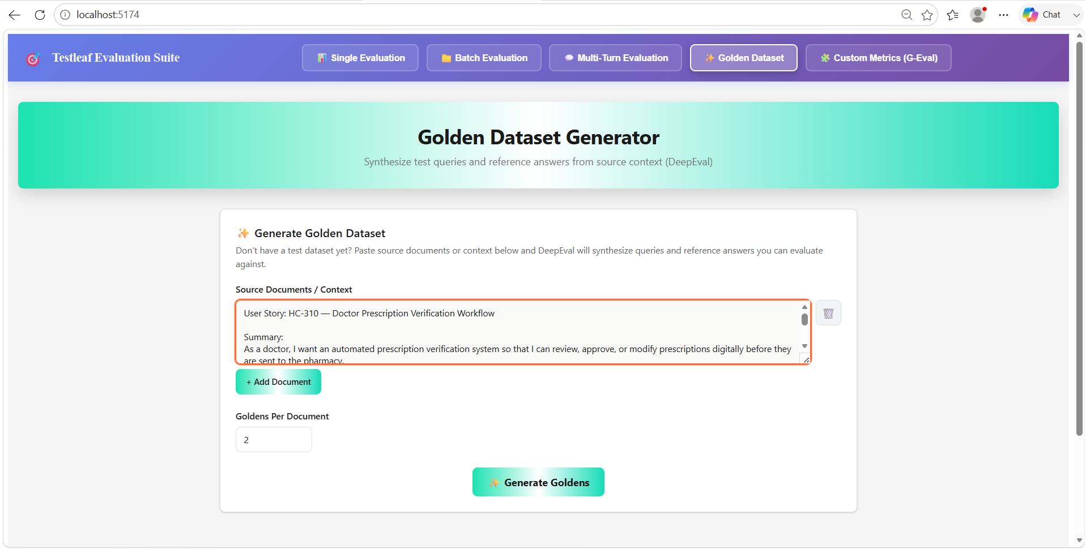
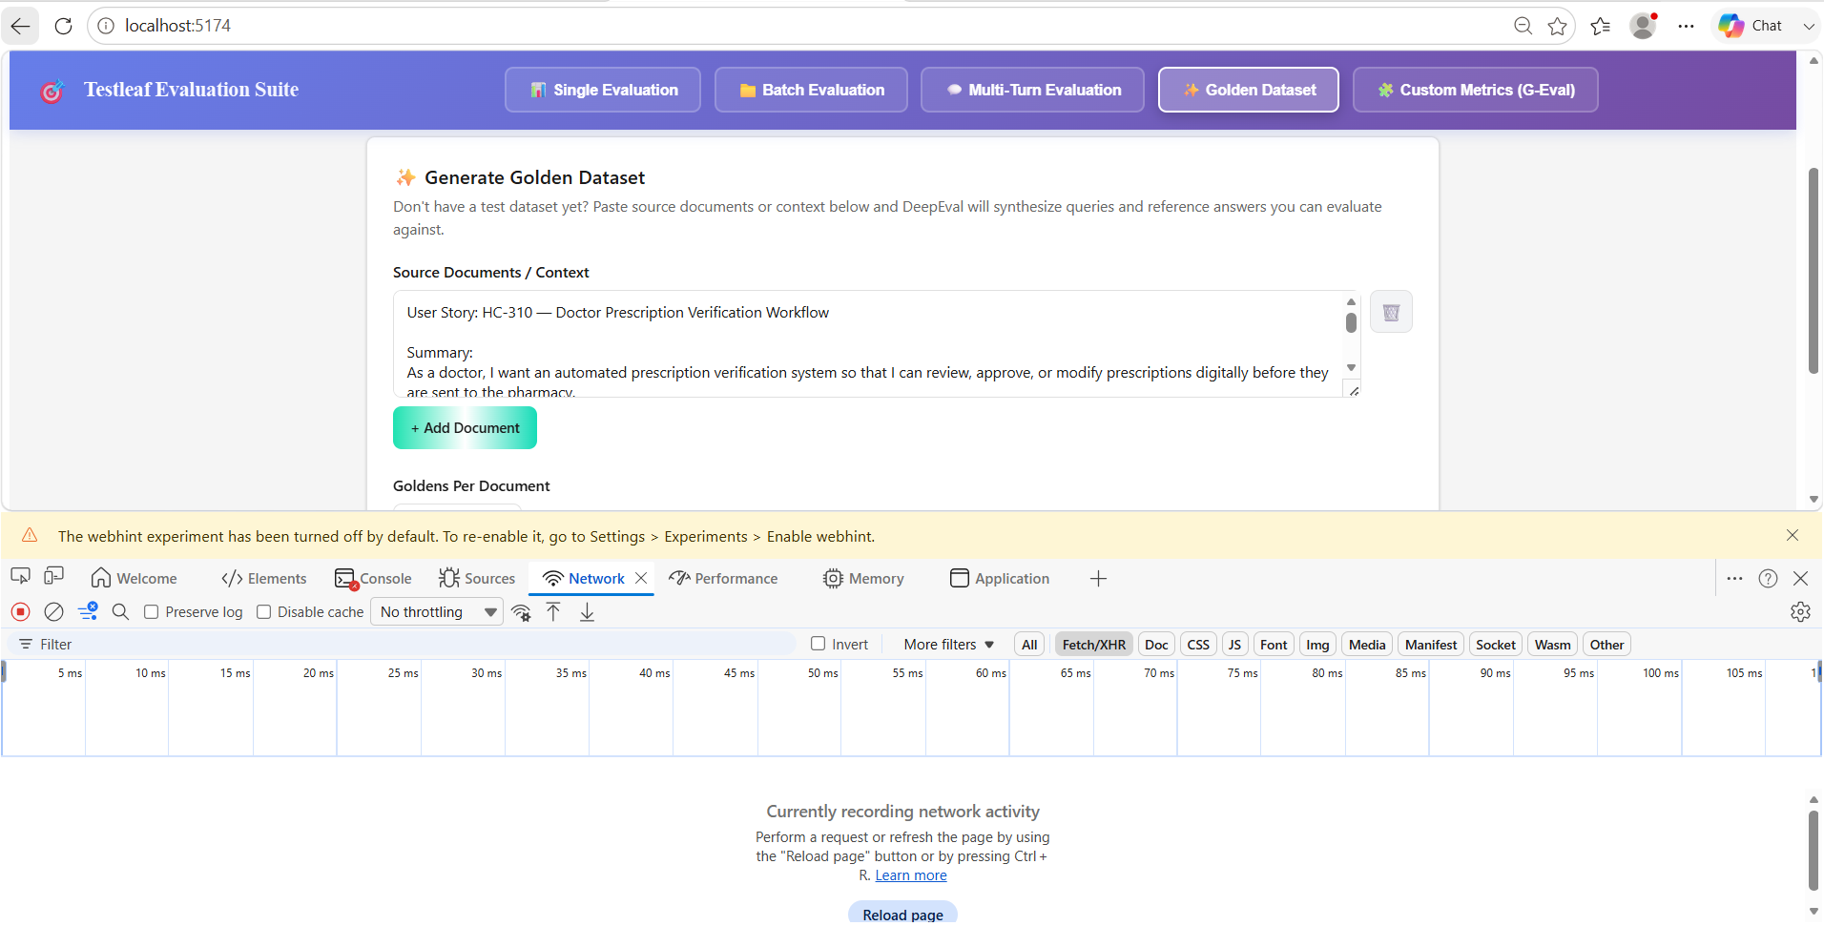
Step 2: Click on Inspect “Generate Goldens”
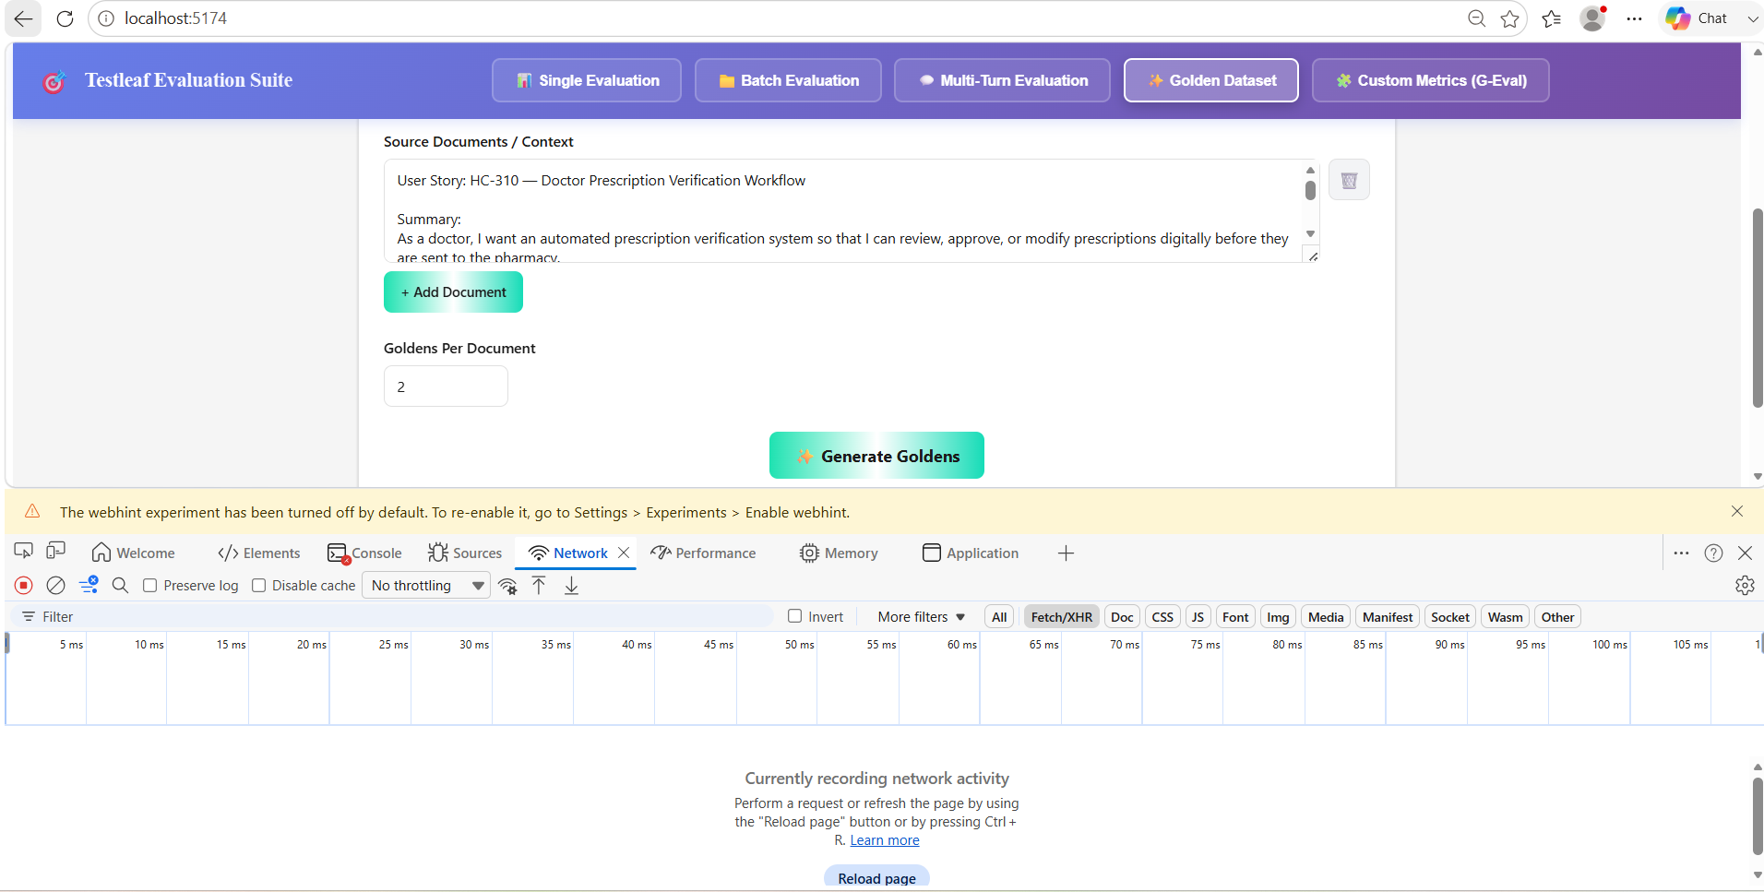
Step 3: Click on the Generate Goldens Button
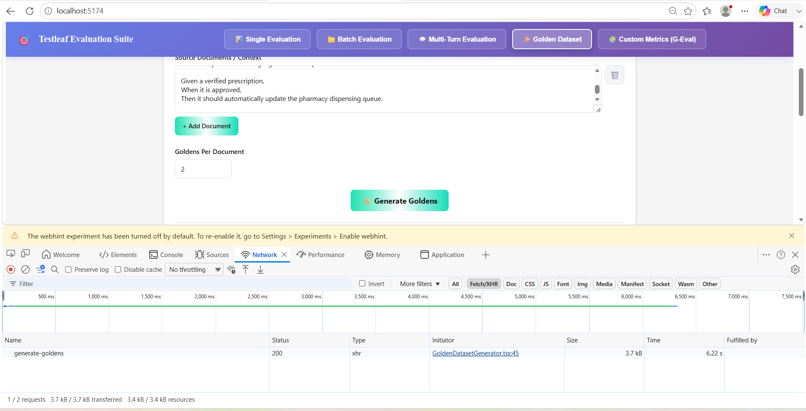
200 response is received

Step 4: The Golden data set is generated
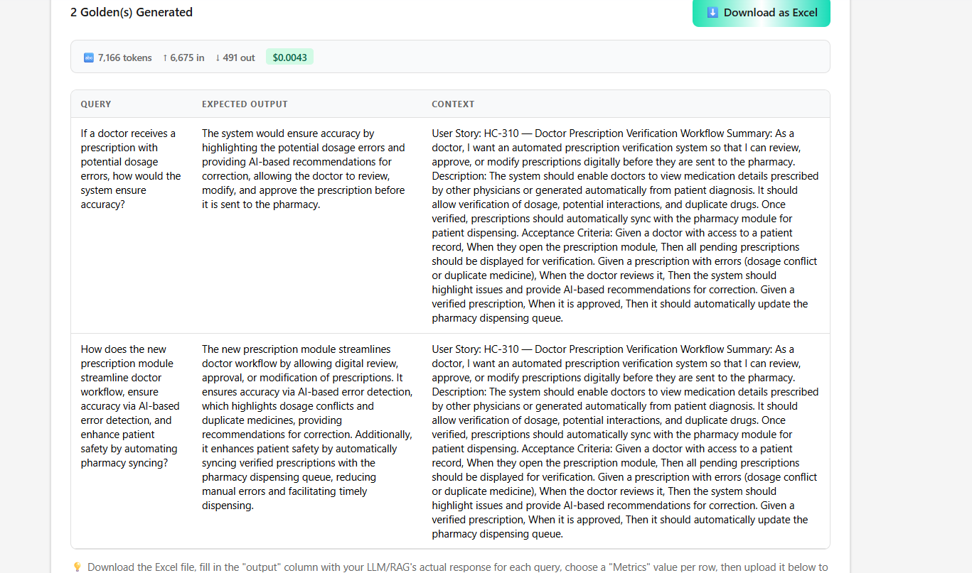
This the baseline information that needs to be verified manually against the first set of testcases when generated from RAG, for a new project from a scratch where there is no sample Testcases available.

