# Getting started with RDS and MySQL Workbench

After selecting create database , choose the following configurations.

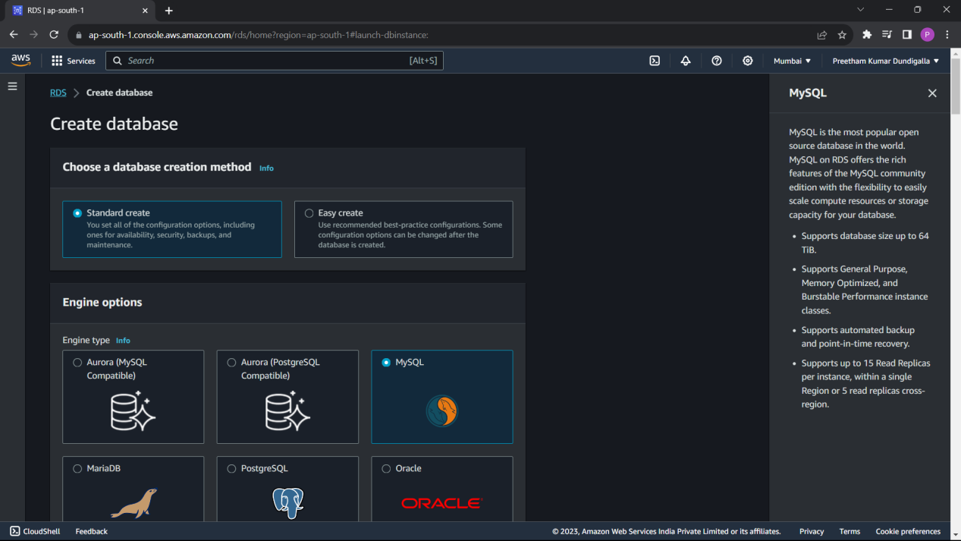

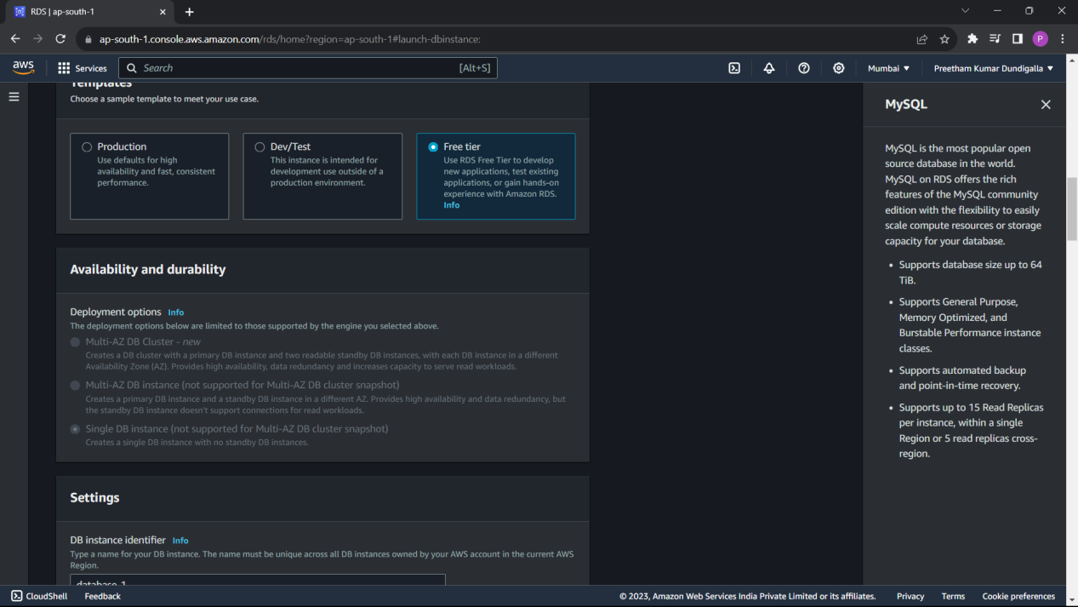

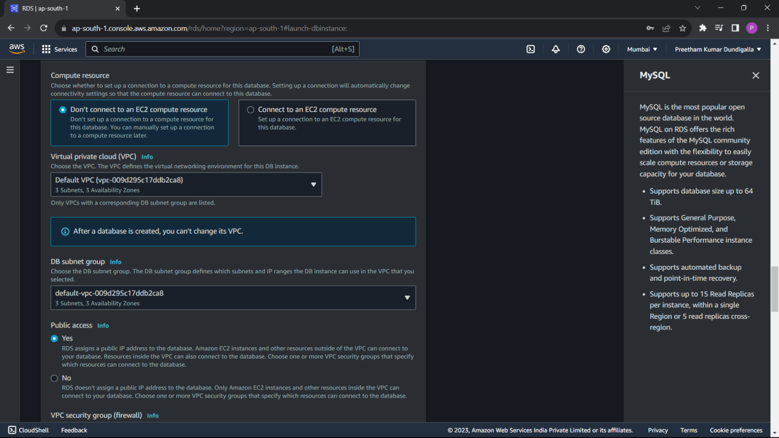

Then click on create database.

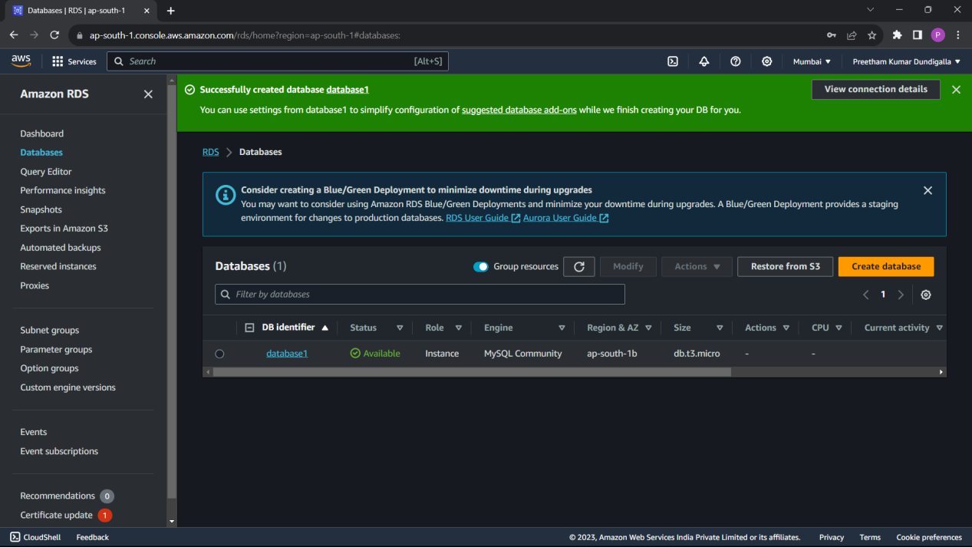

Select endpoint from the database

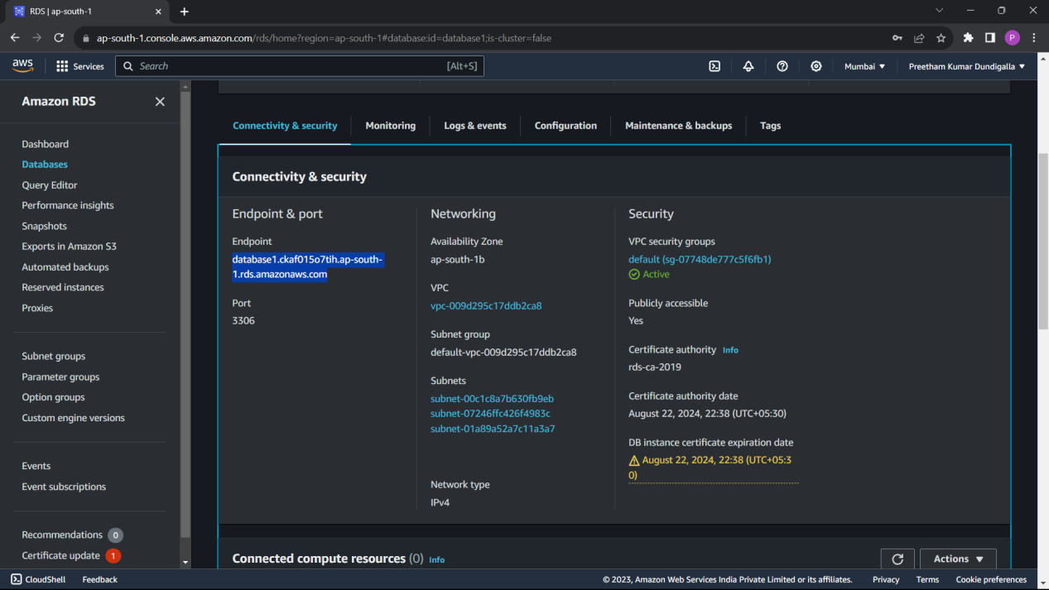

Open MySQL Workbench

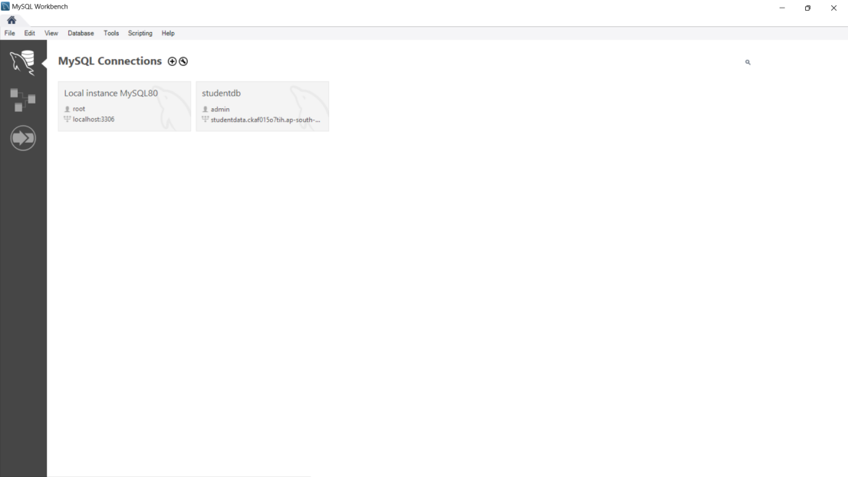

Click on “+” at connections

Give name for the connection

At host name past the end point.

At user type admin and give the password which you have set.

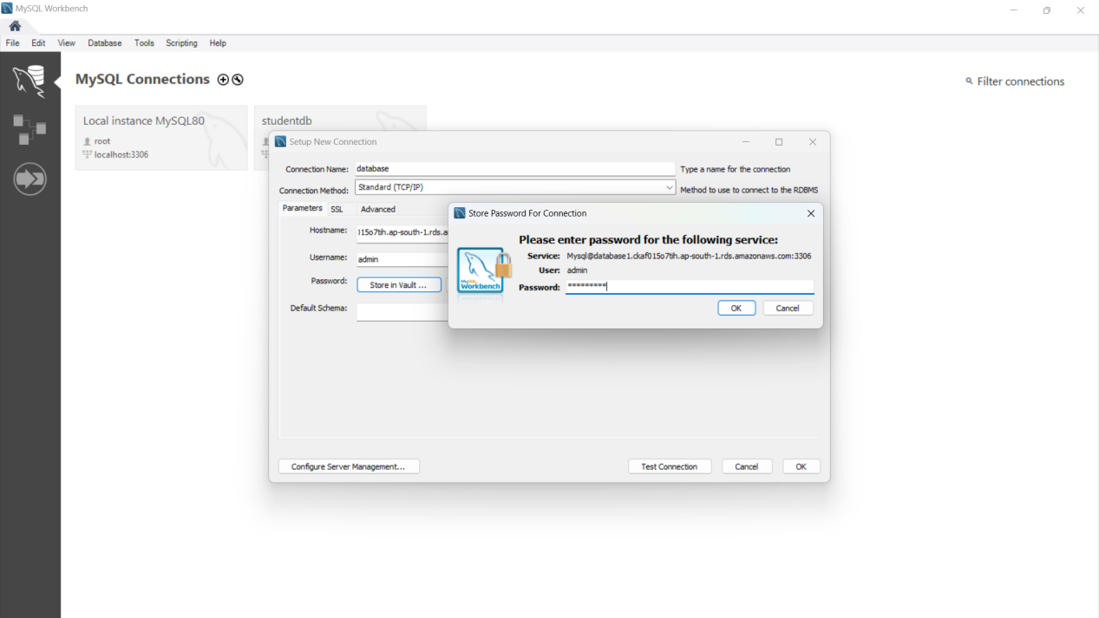

Click on Test Connections

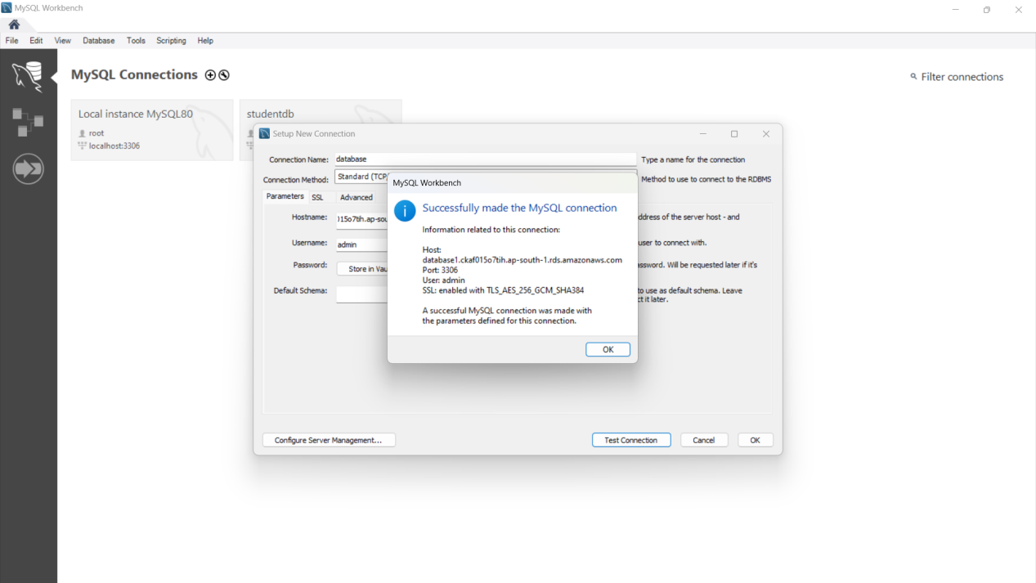

Select ok at both of the places.

Now the connection is established.

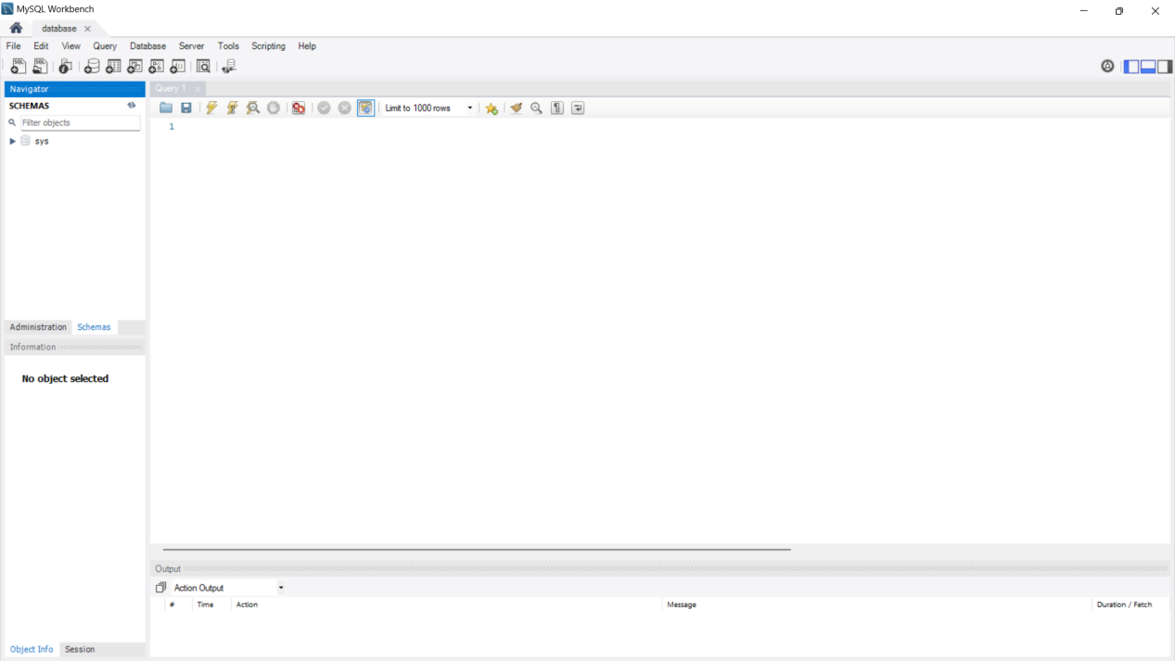

Now you can create database here and manage both through AWS RDS.

Create Student Table.

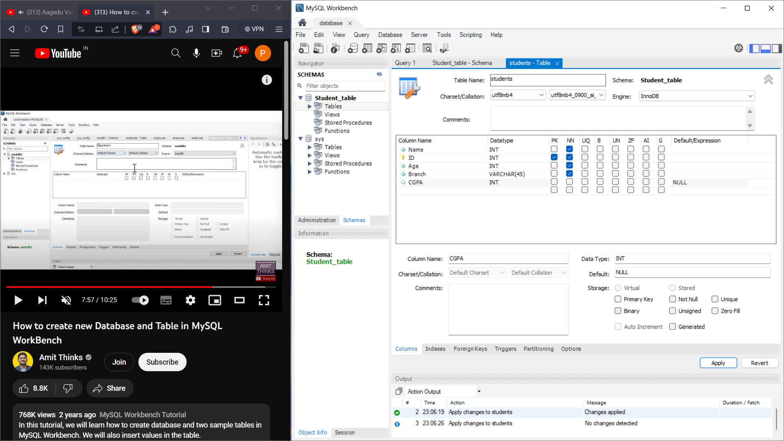

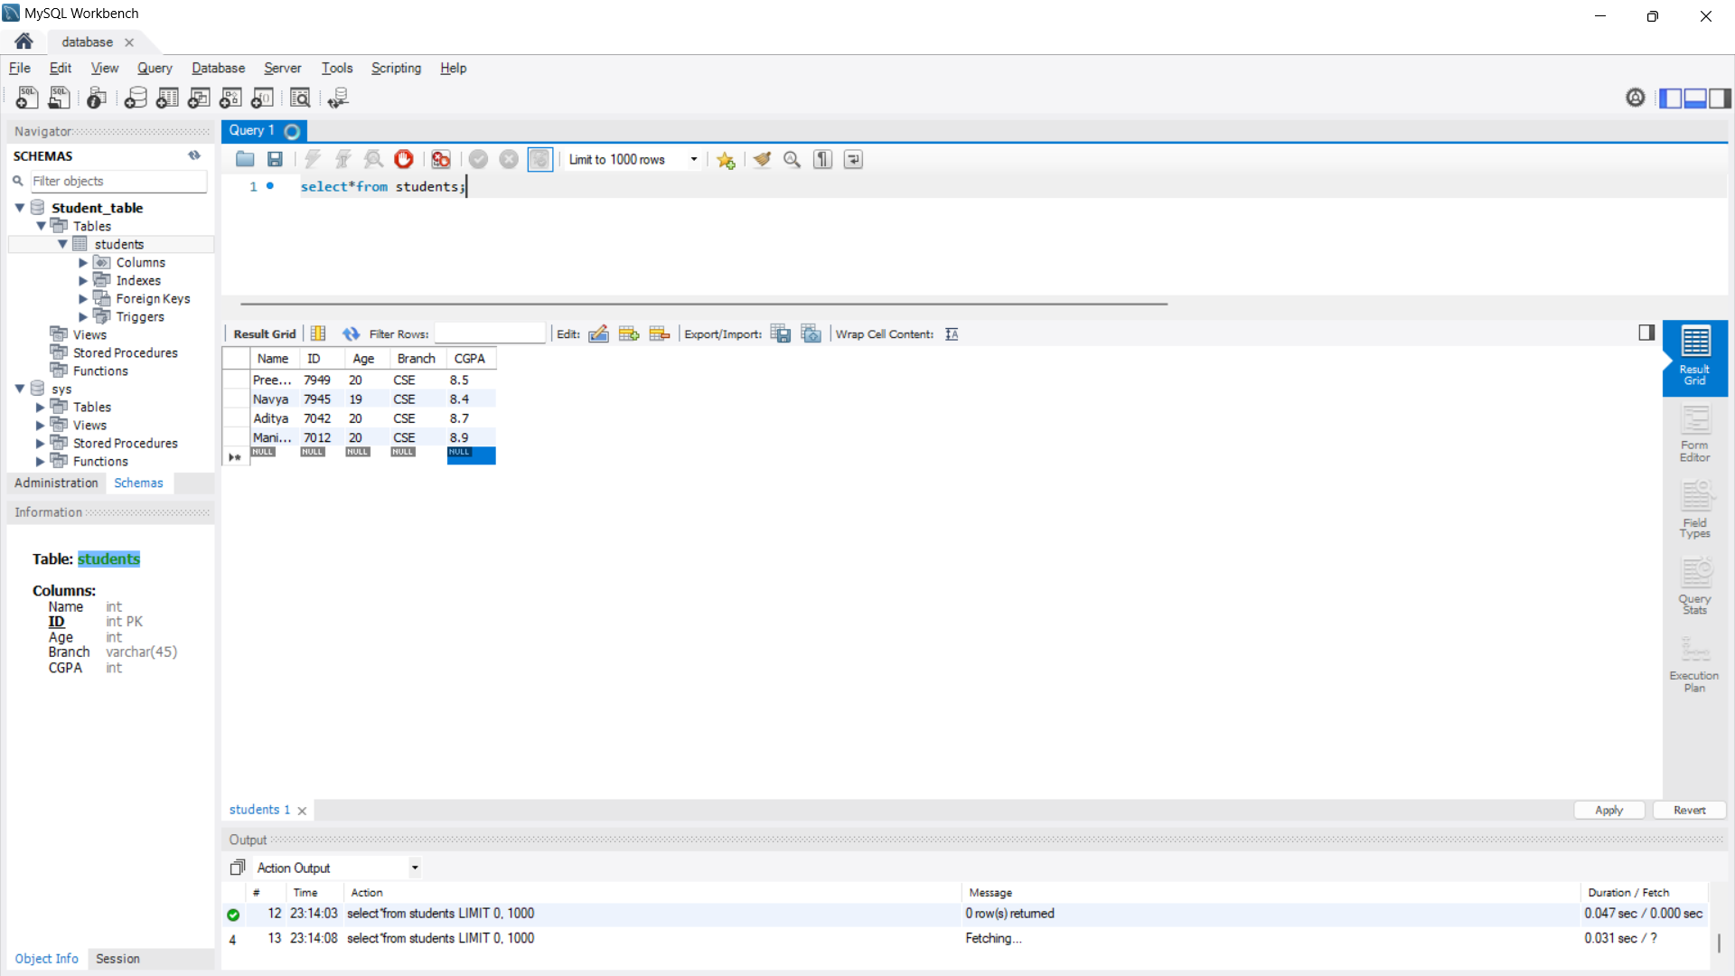

Now the data is stored with the help of AWS RDS.

\