# Deploy your web application in EC2

Launch an ec2 instance

# 

After providing name for your instance, create a key pair and download it(It will be used during creating passward for virtual desktop)

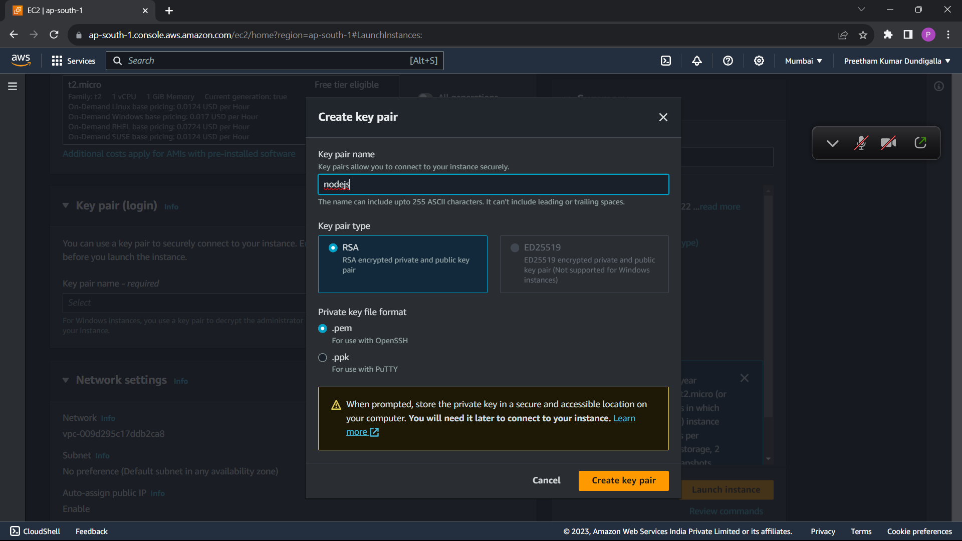

Your ec2 instance is created succefully

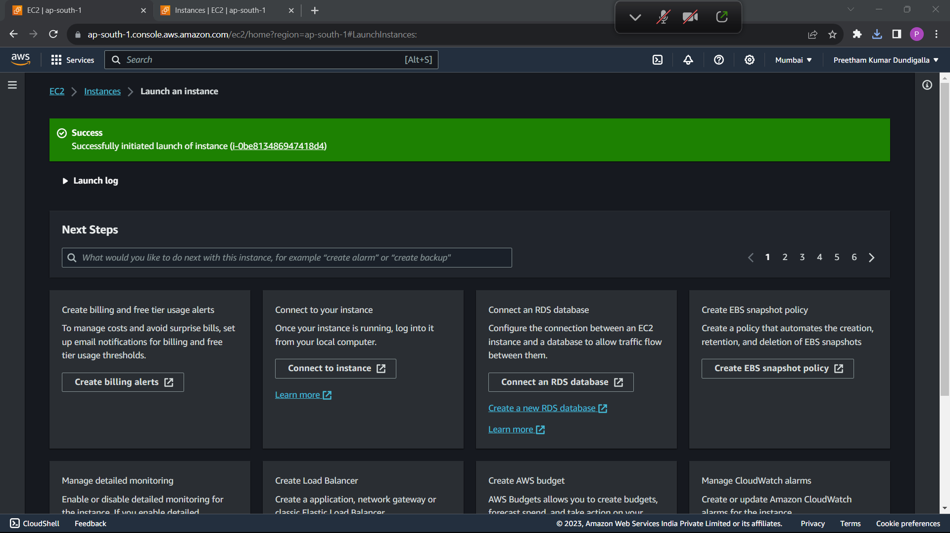

Wait until state is running

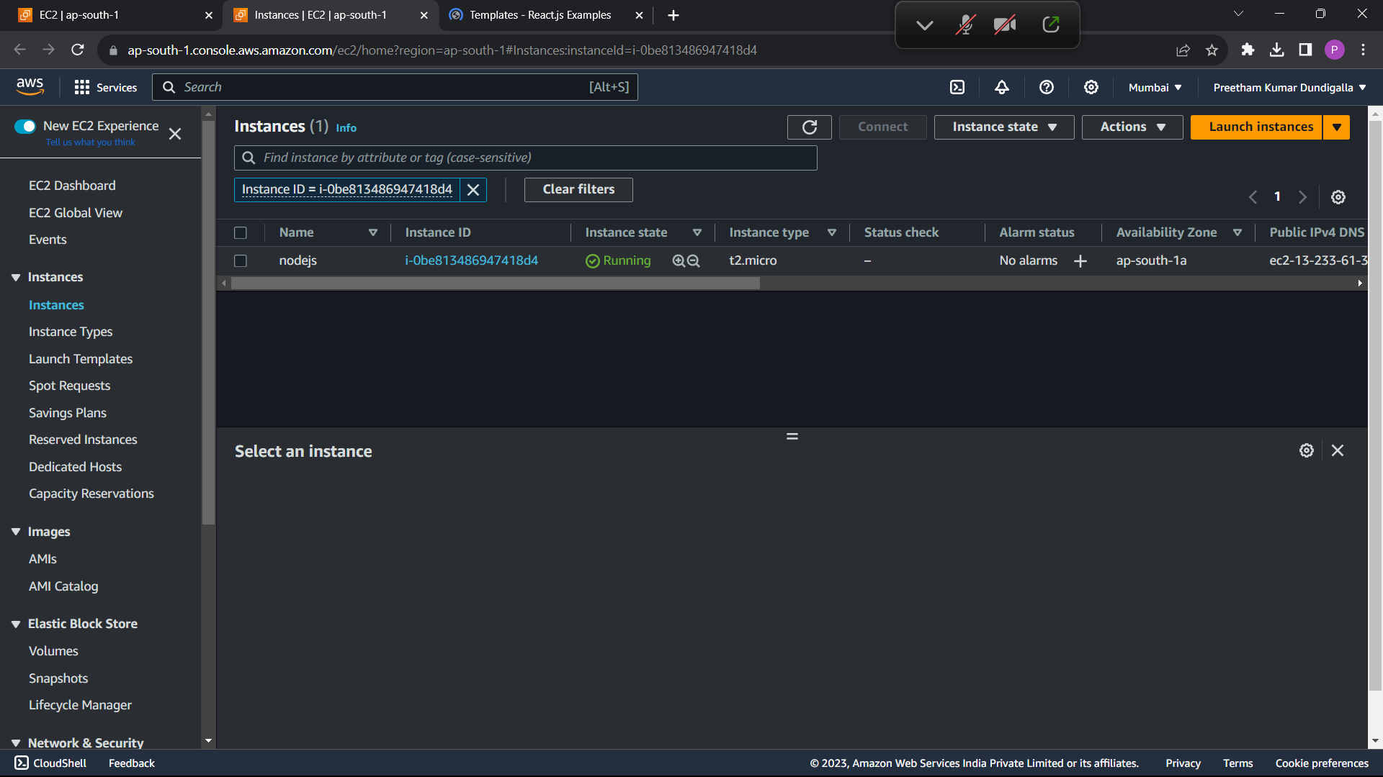

Click on connect

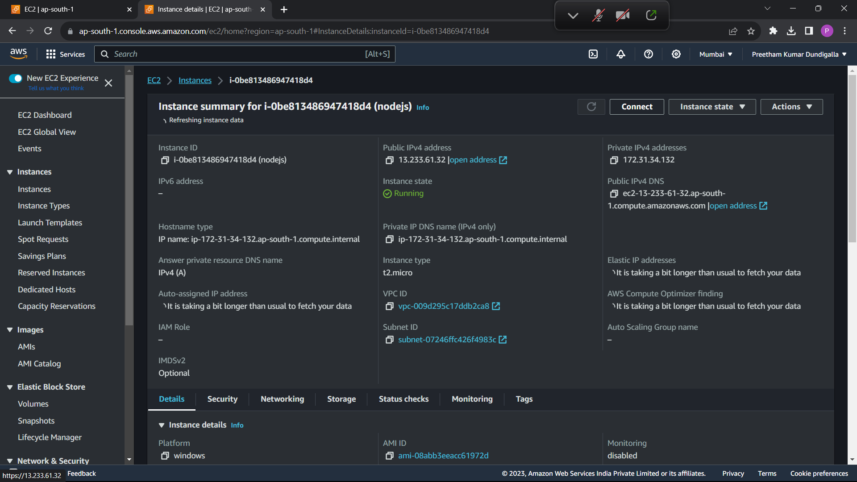

Upload the key pair and get the passward and then download remote desktop file

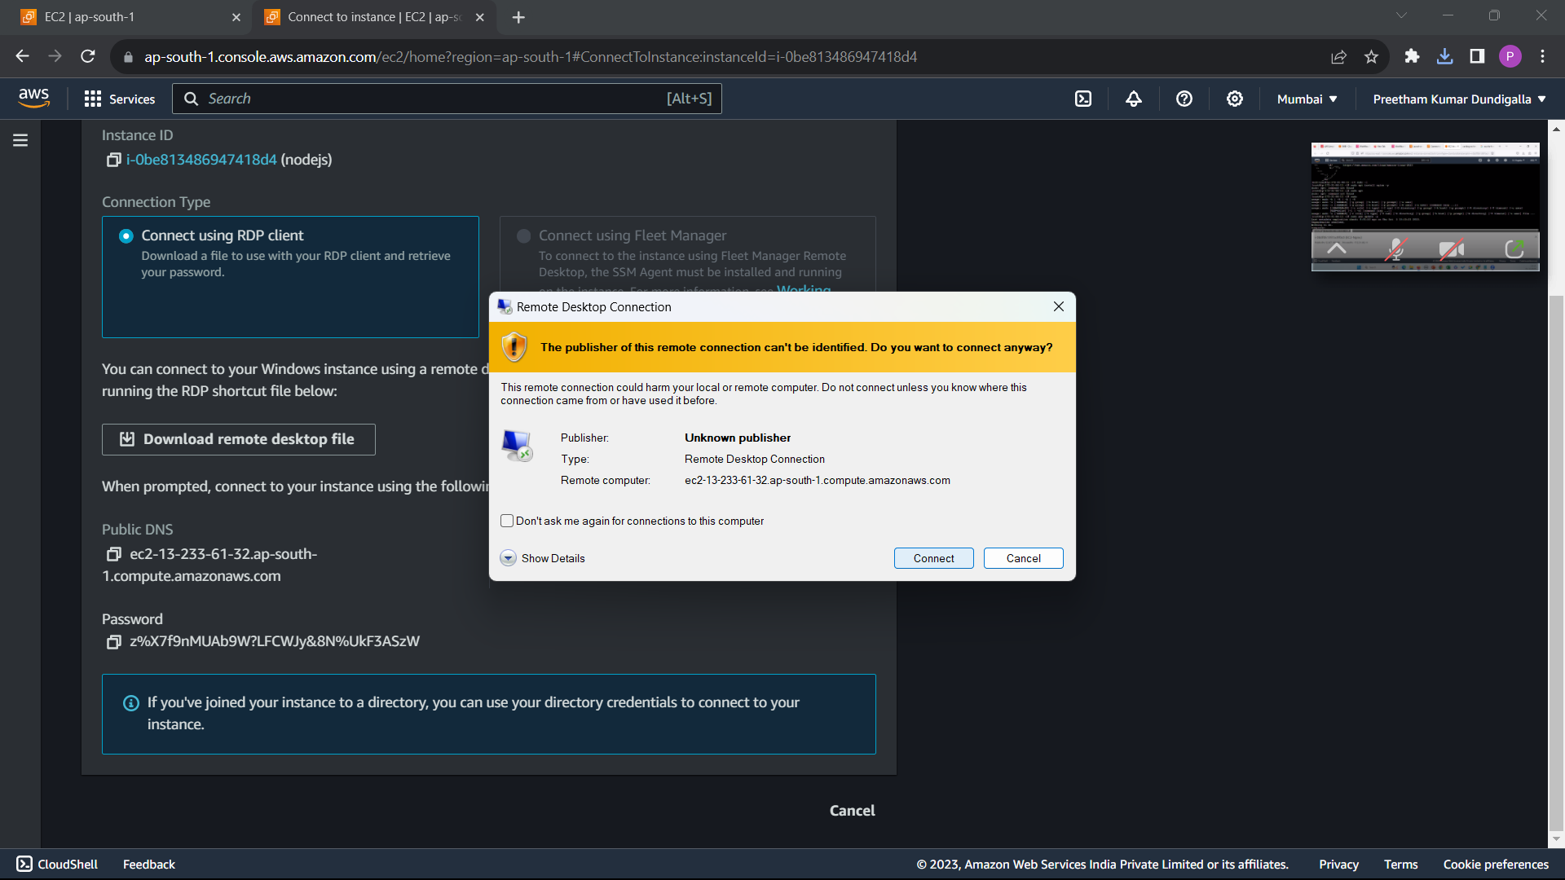

Copy and past the password

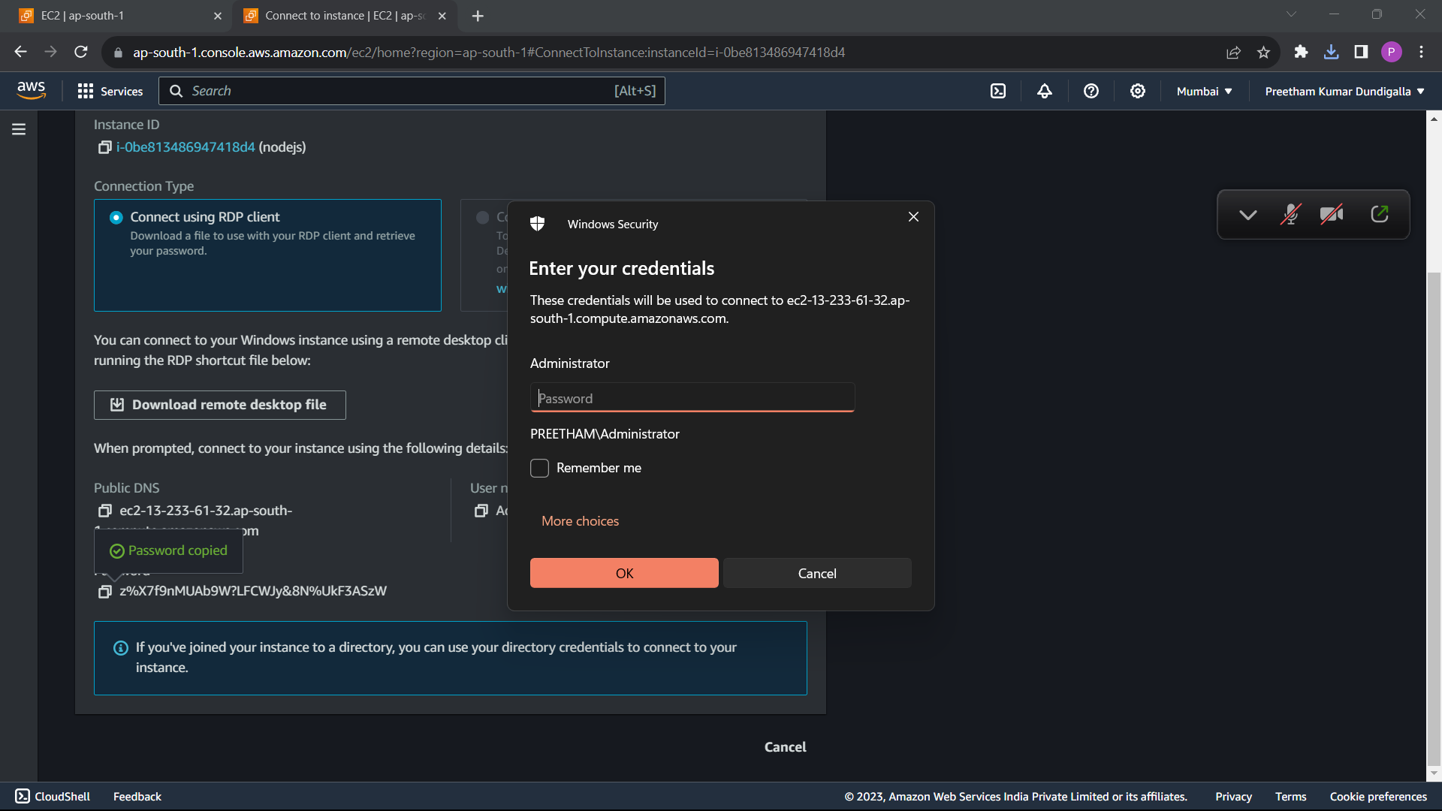

A virtual desktop will be opened

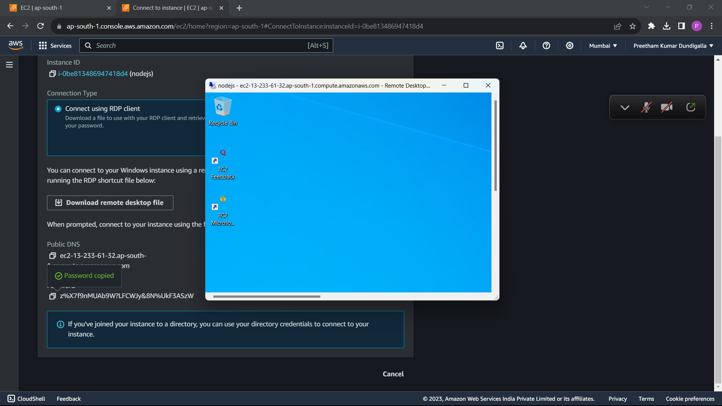

Under server managmenr click on manage -> add roles and features.

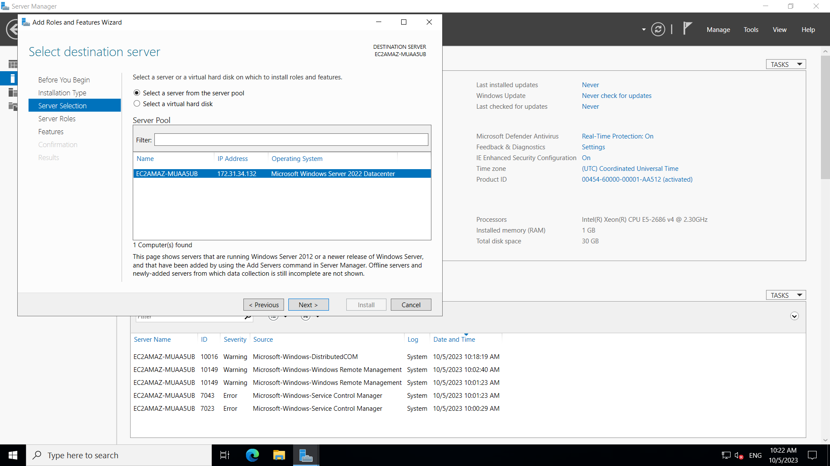

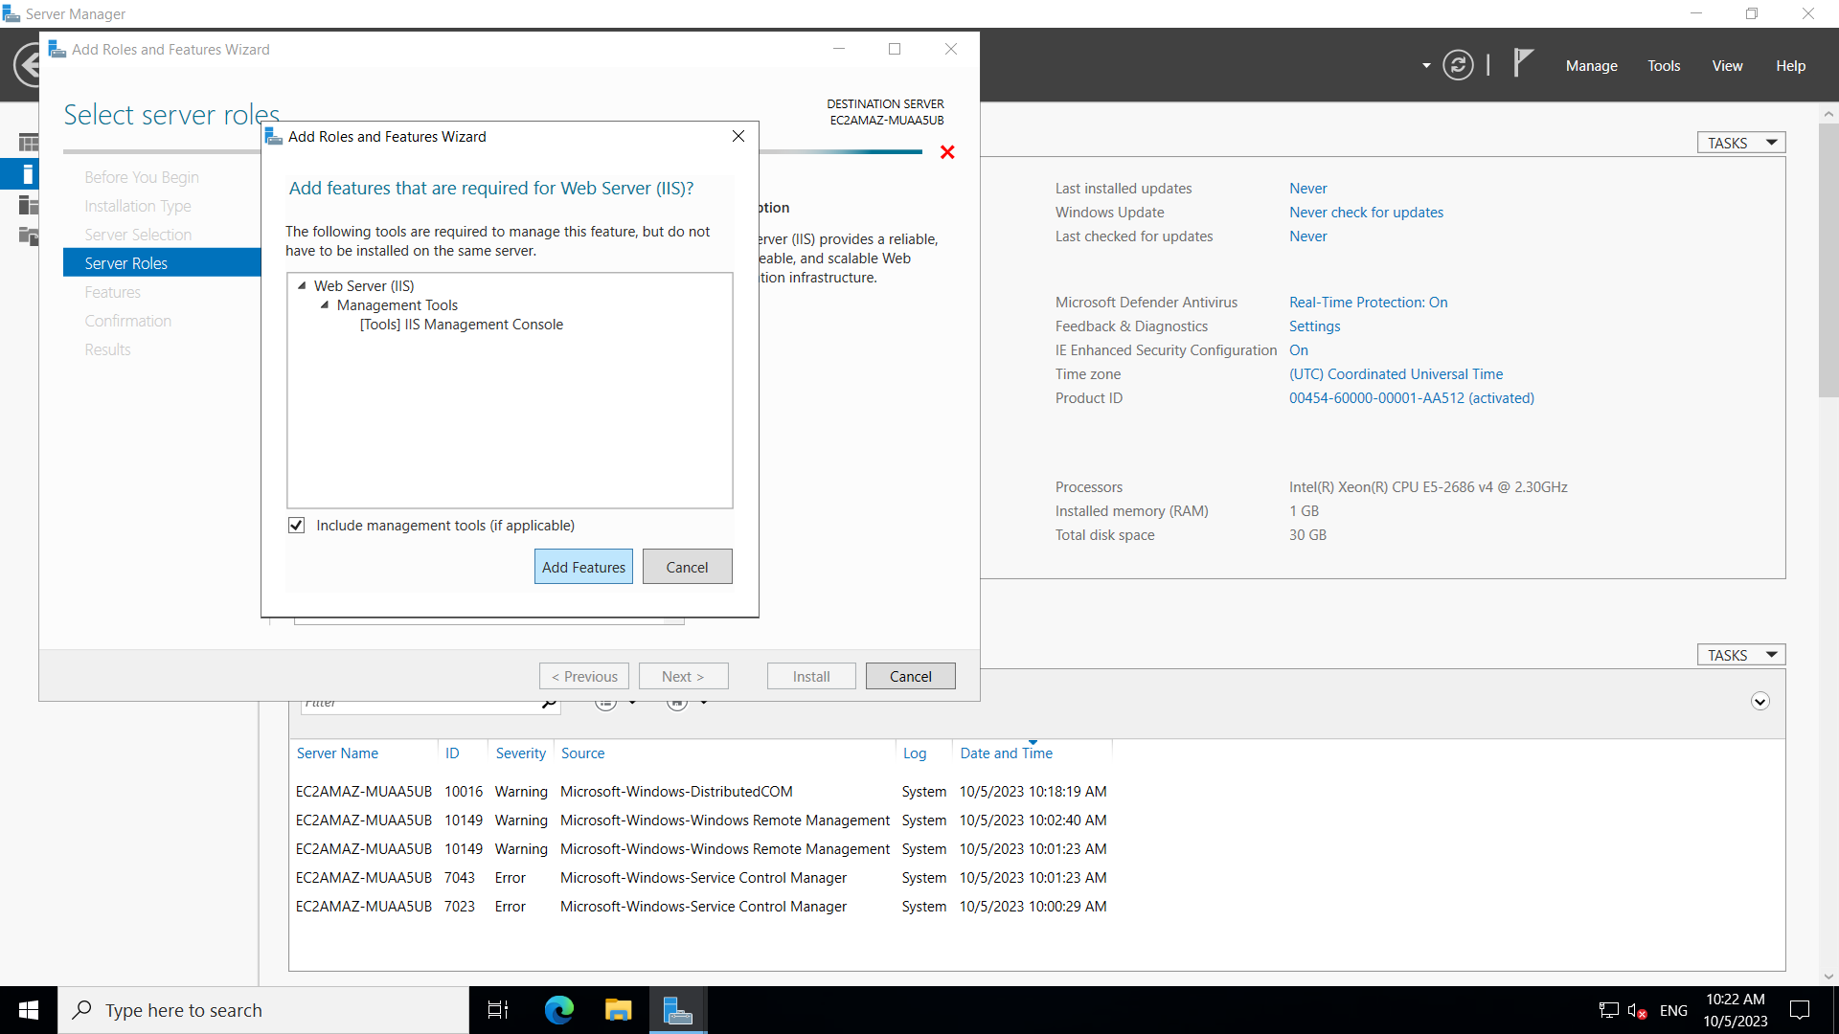

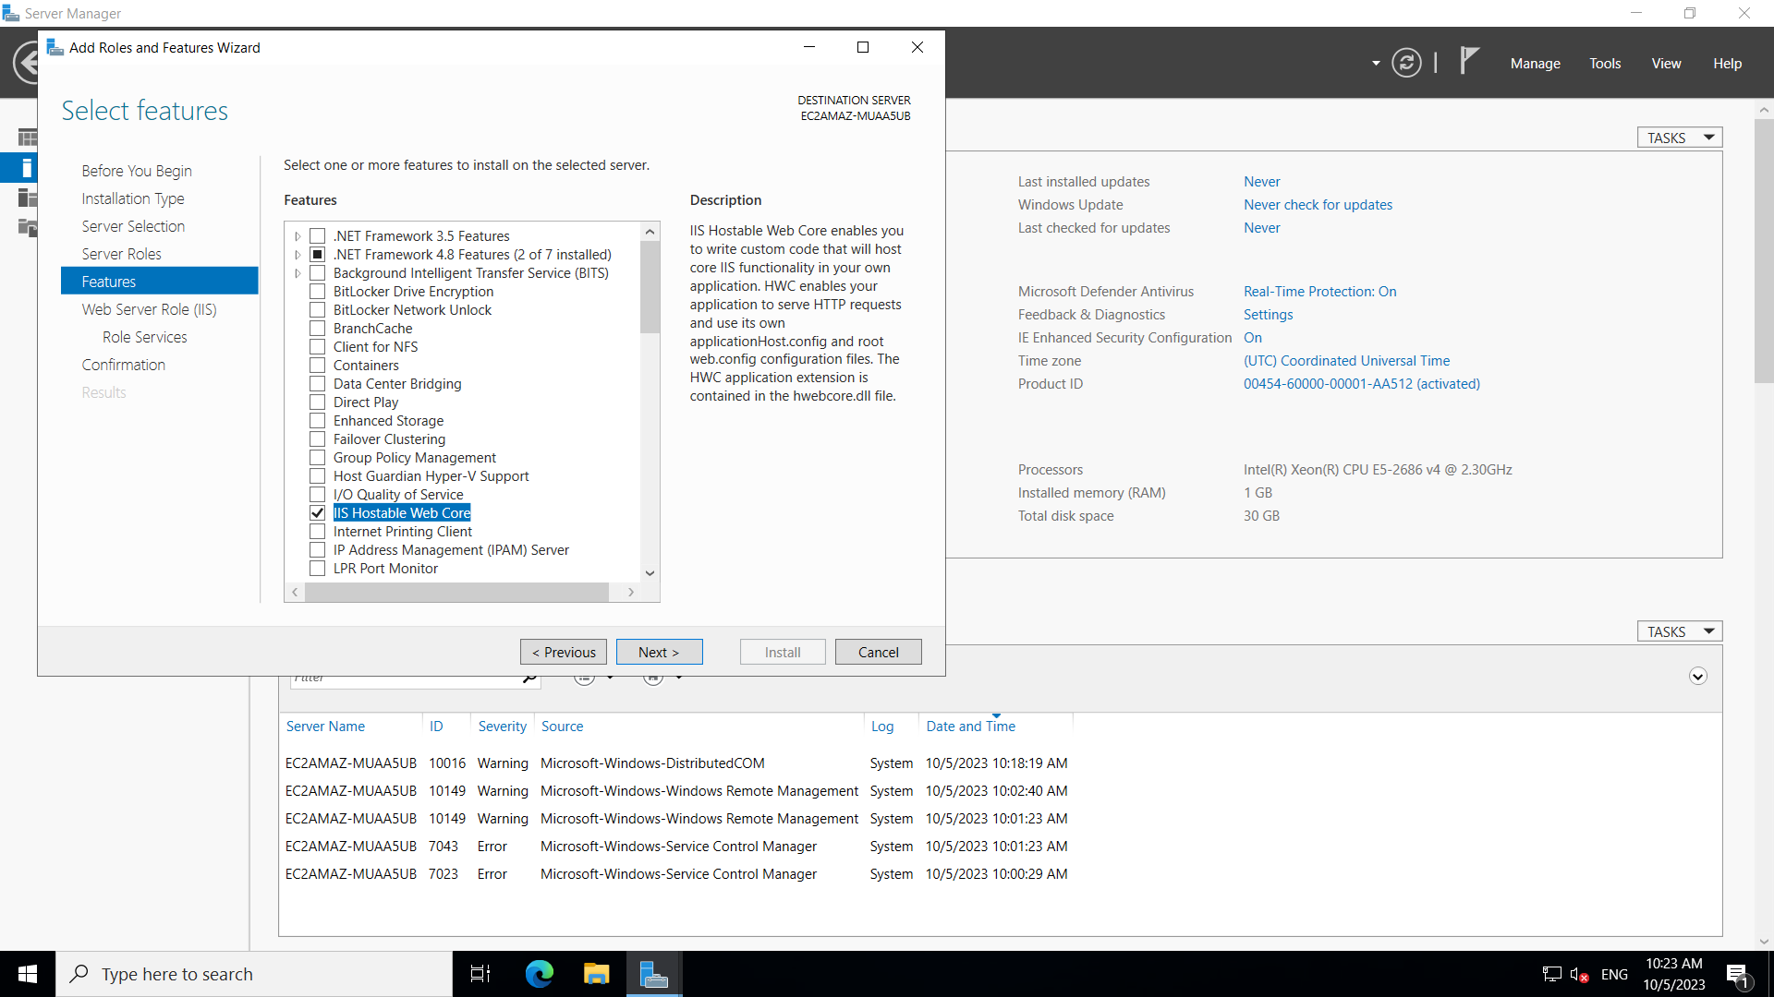

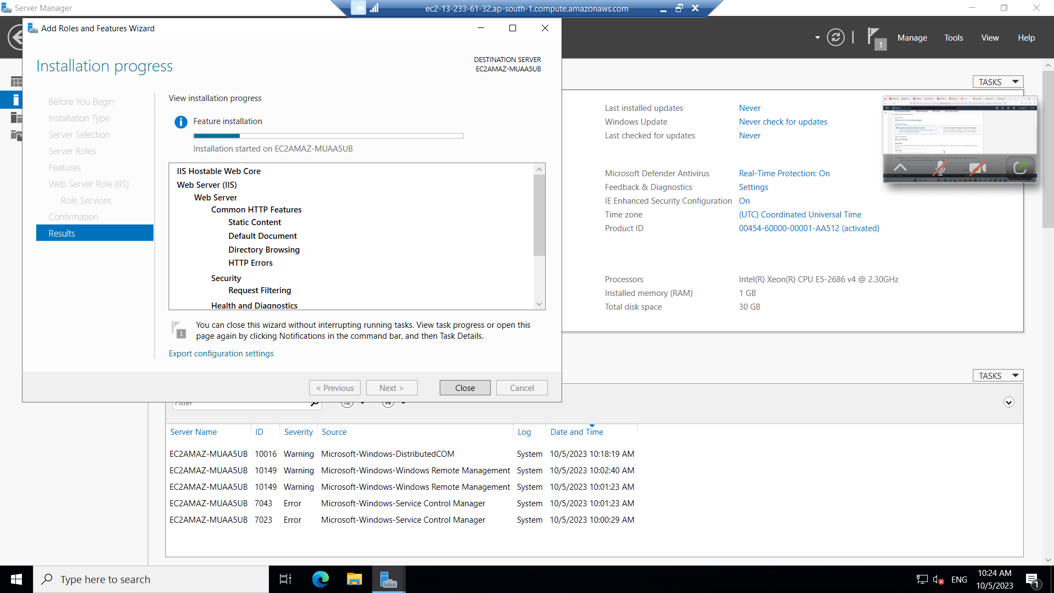

After adding the roles and feature. Past your files in filemanager in a server directory. Go to the browser and search localhost. Your website must be visible there. Come out of the virtual desktop.

Click in public ipv4 address. Then in new tab remove “s” from https, your website is hosted

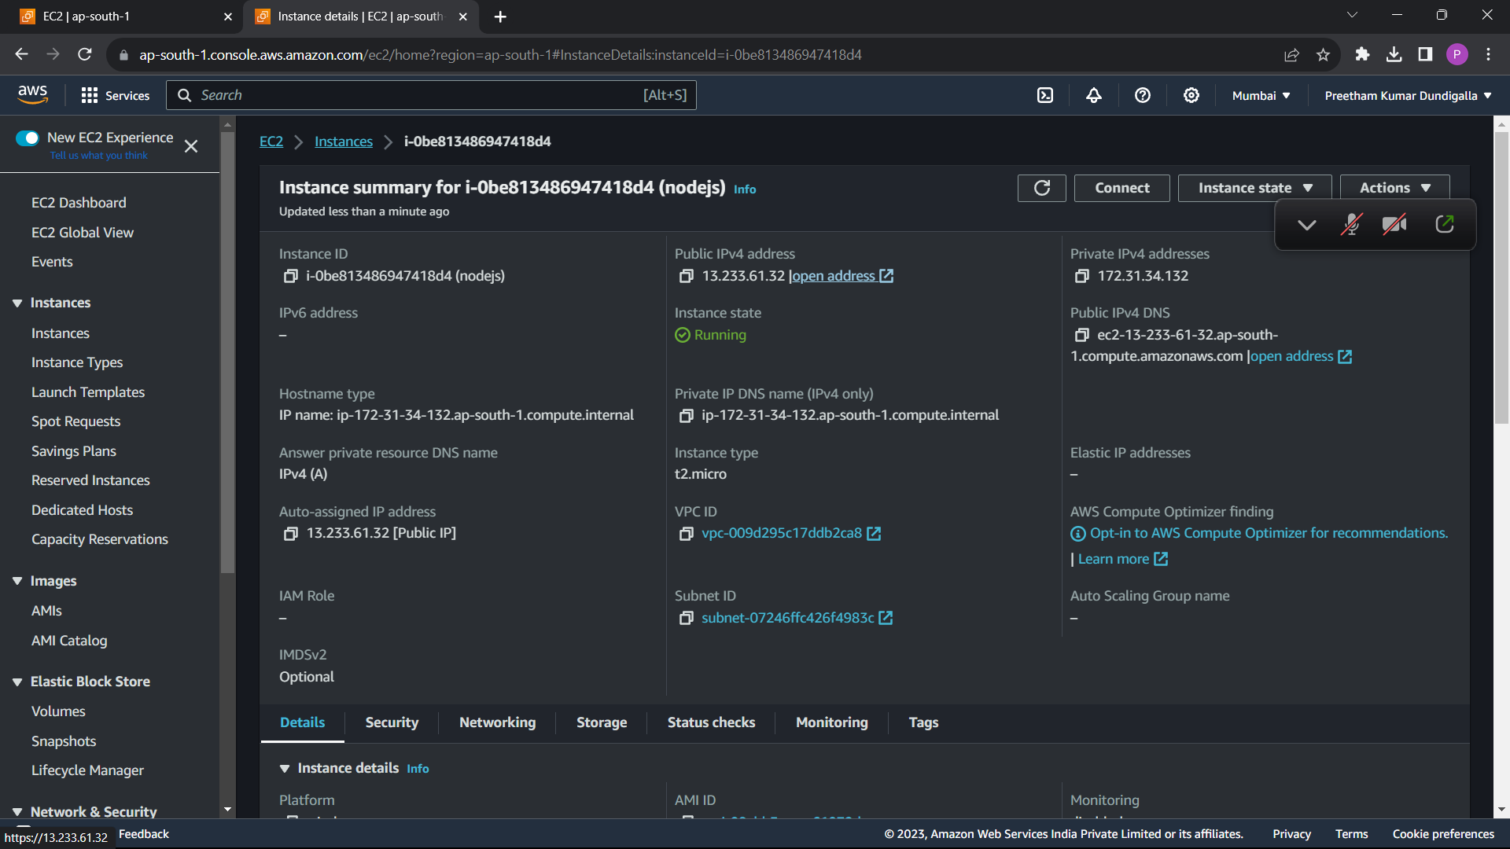

Don’t forget to stop the instance after your work is done.

