# Simple Perceptron and MLP

Using Titanic dataset

* Create a S3 bucket to upload the train.csv and test.cs files
* Open s3 bucket -> create s3 bucket -> allow access to the root user for edit -> allow public access -> after successful launch create a folder and upload files in it.

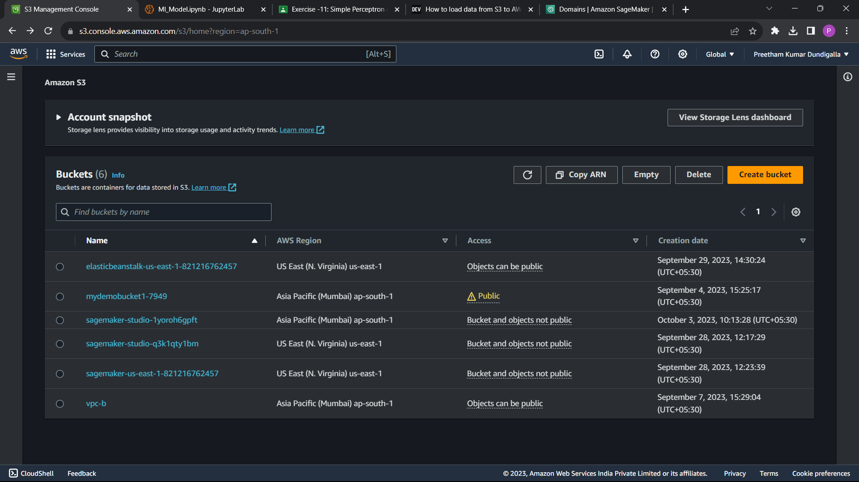

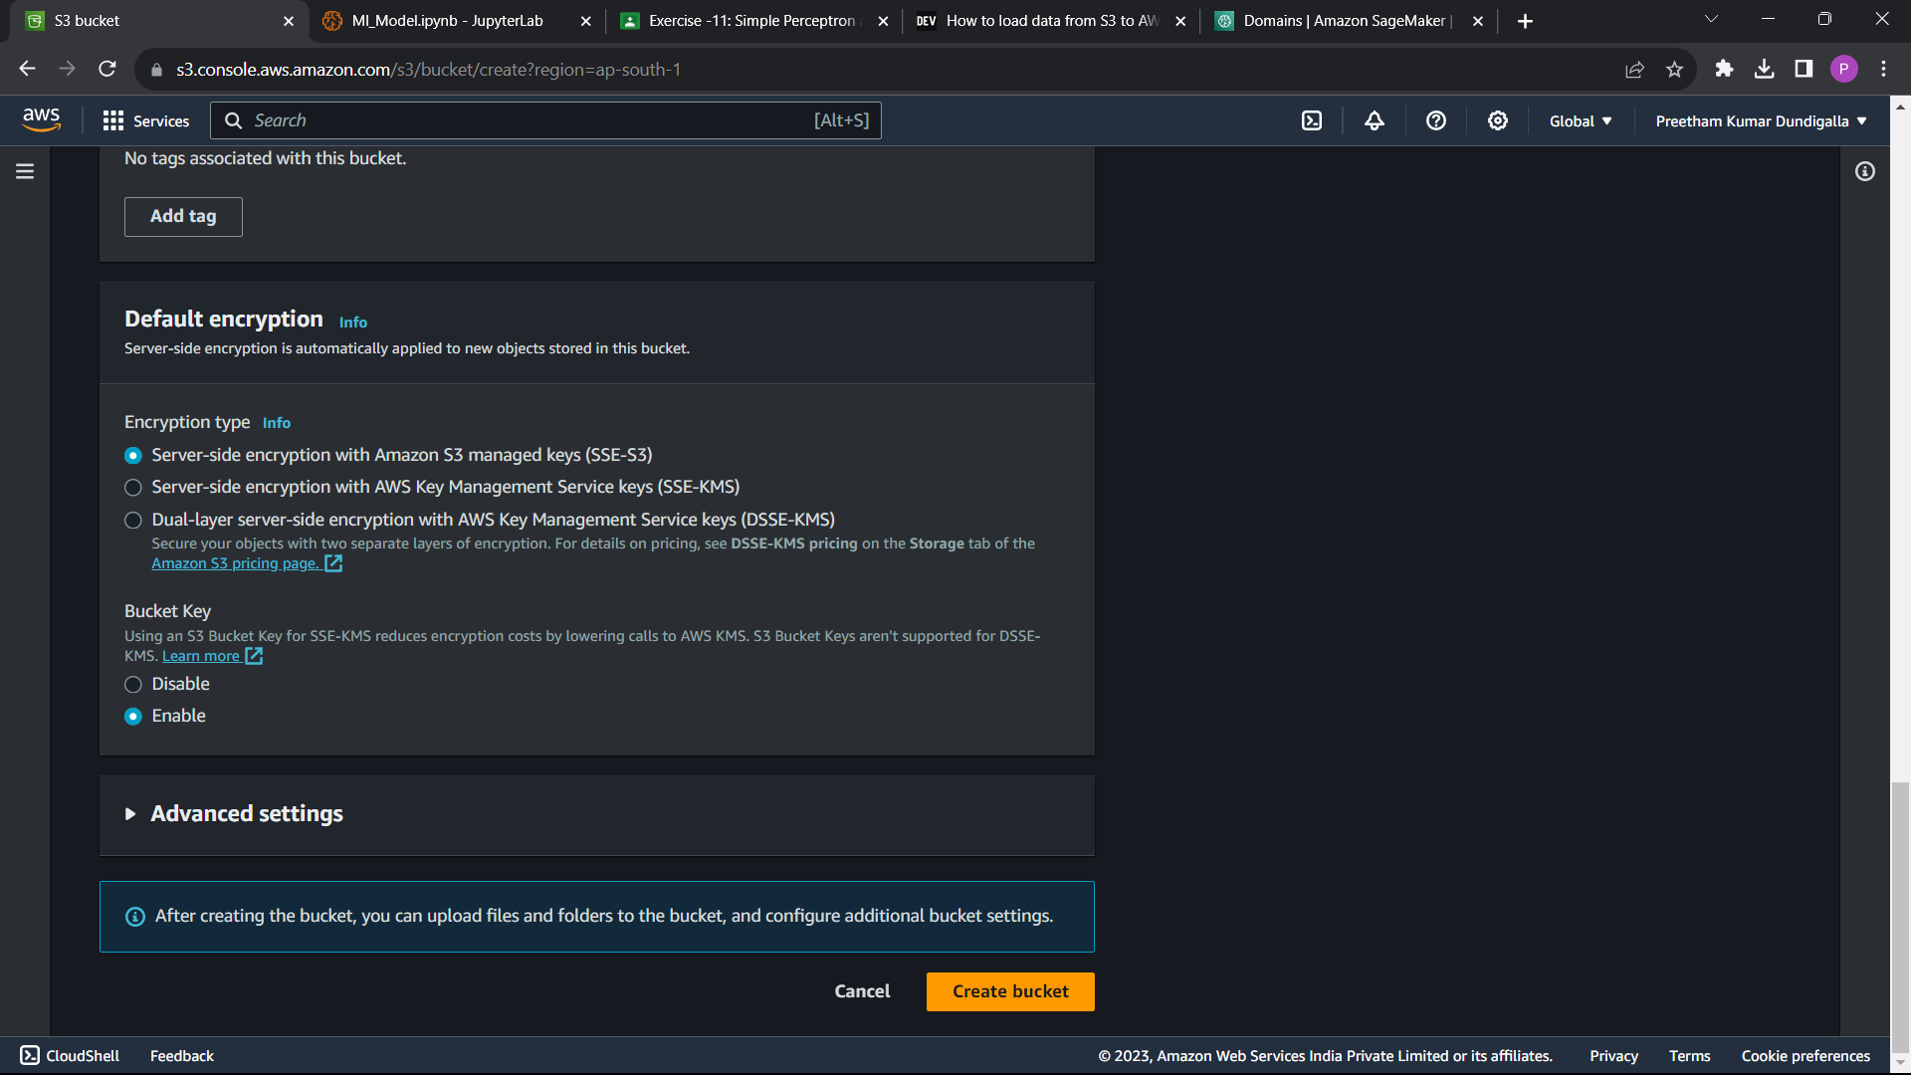

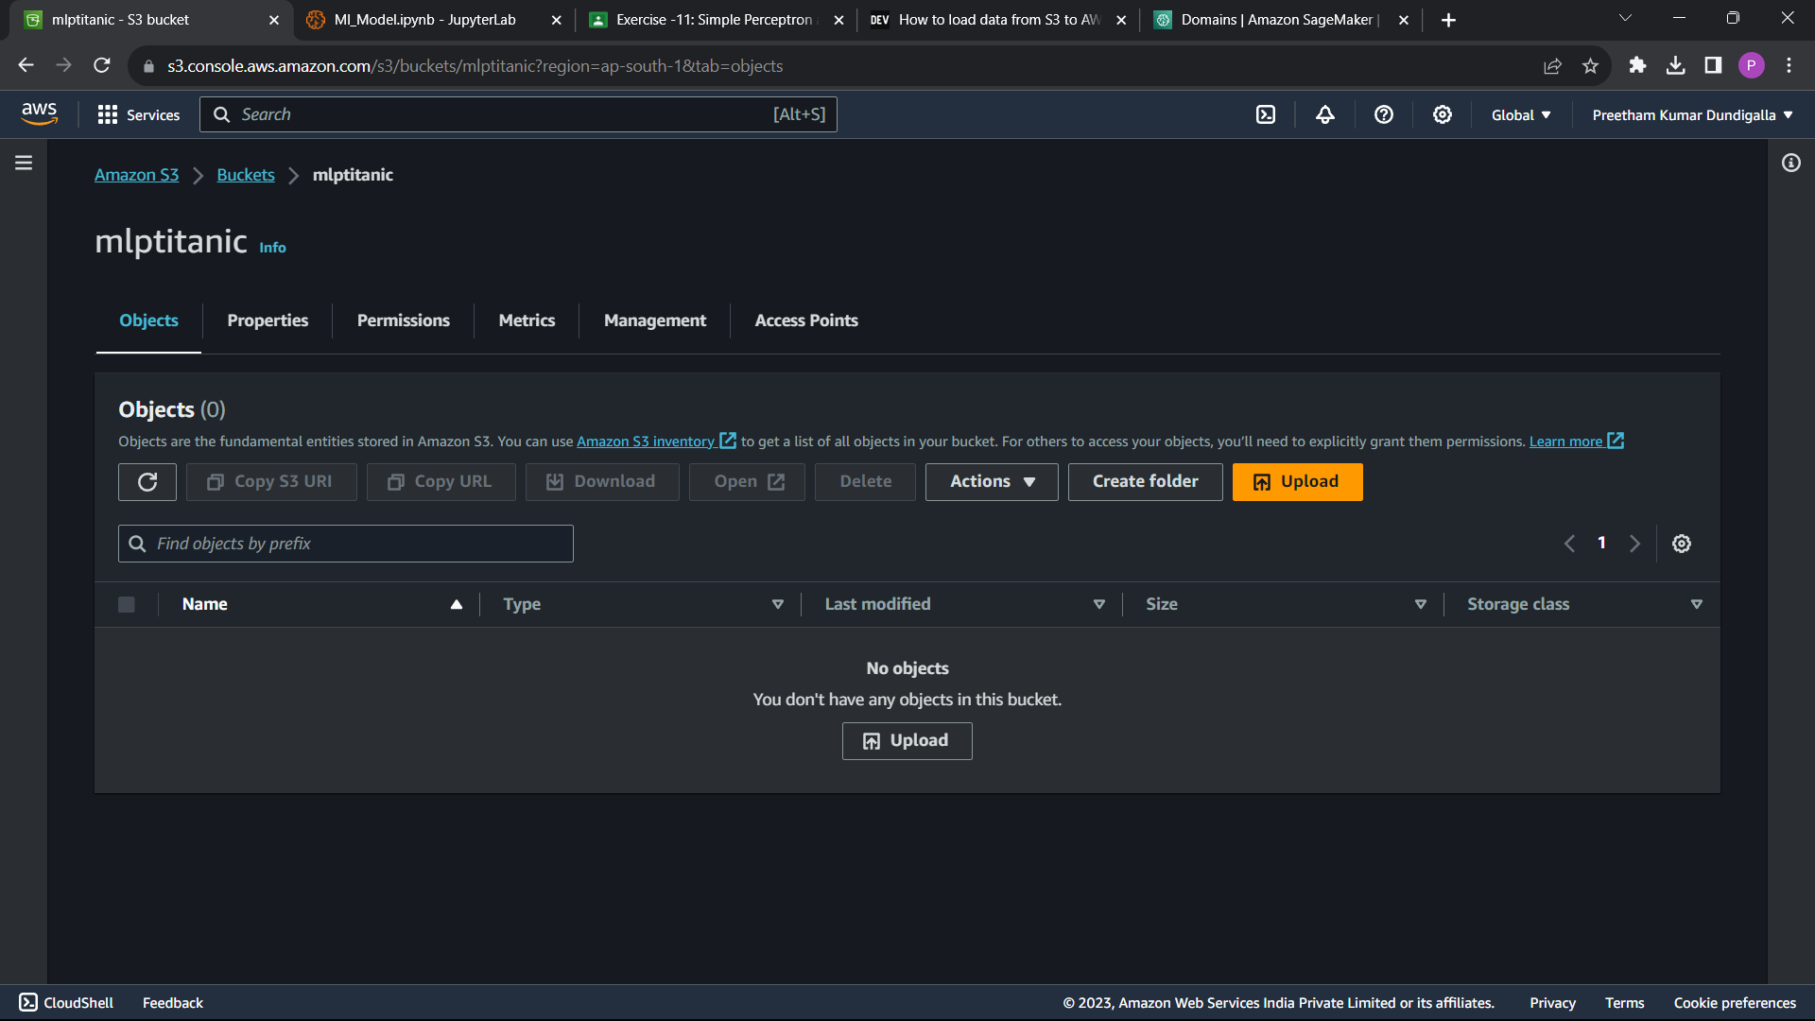

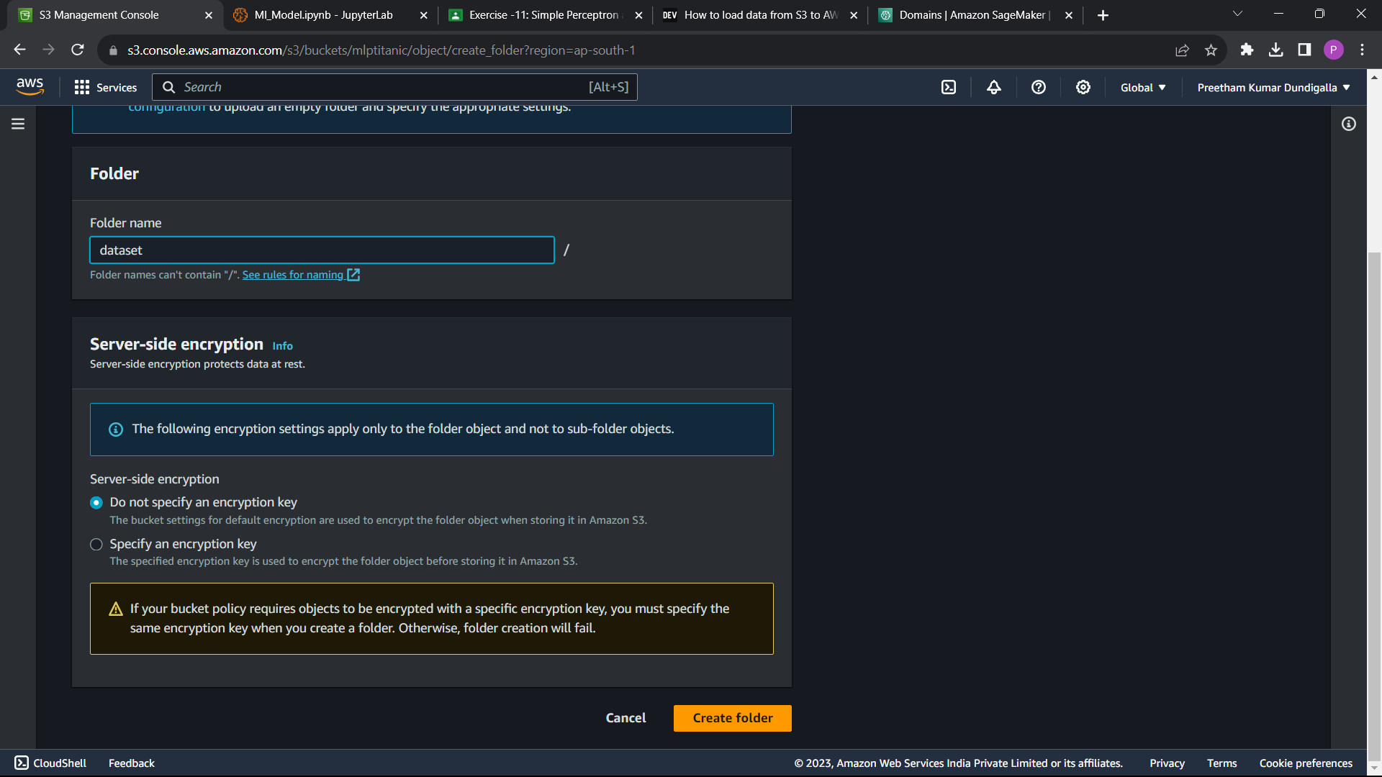

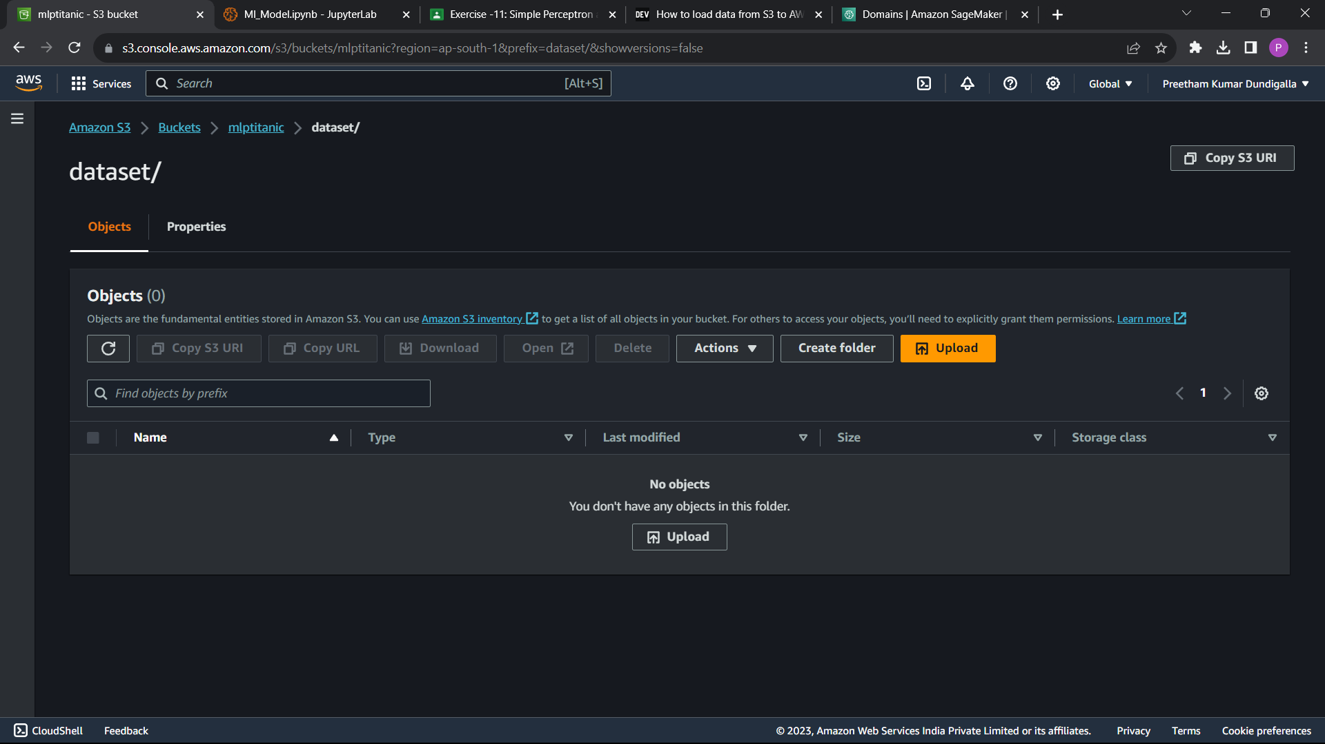

* Create sagemaker studio demo

->launch studio

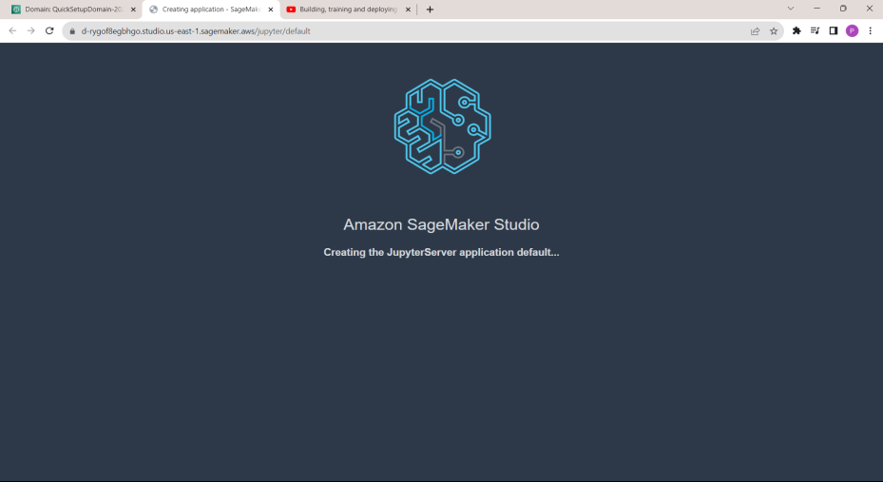

->Open getting started notebook

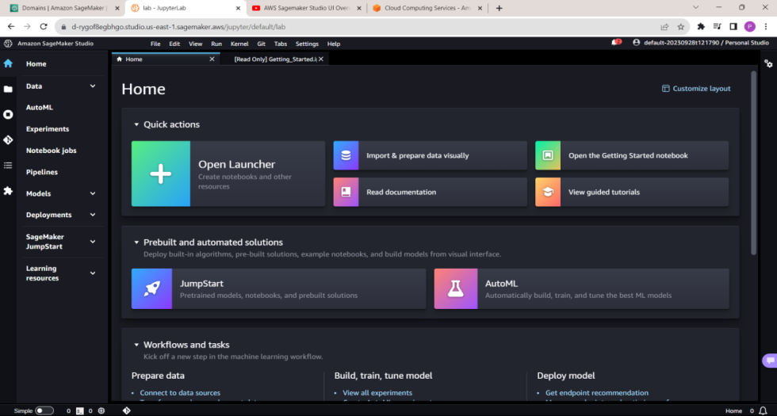

->Create NoteBook

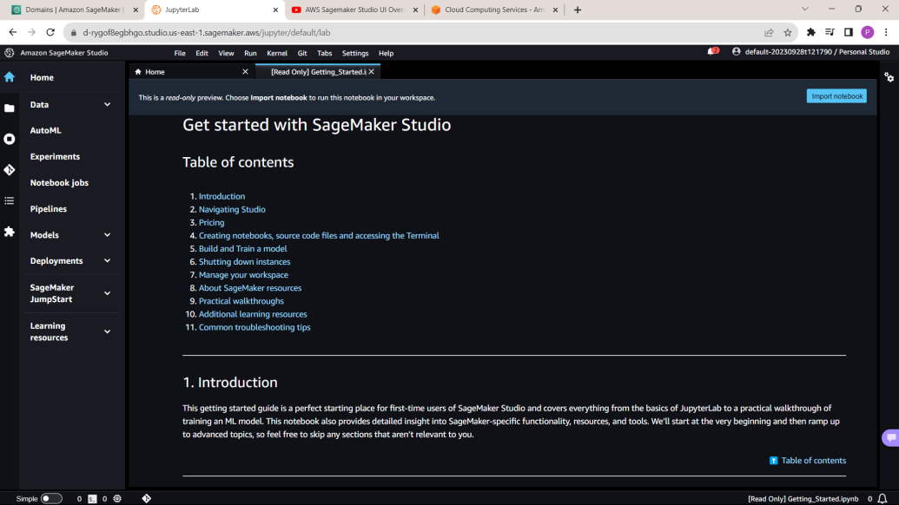-

Start Coding in the editor. But before coding check the enivronment.

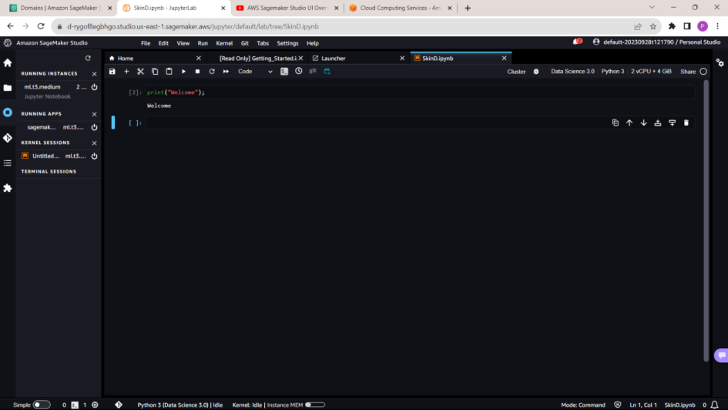

* I imported boto3 library which help in accessing the data in s3 bucket.
* Also keep an eye on the kernal utility.

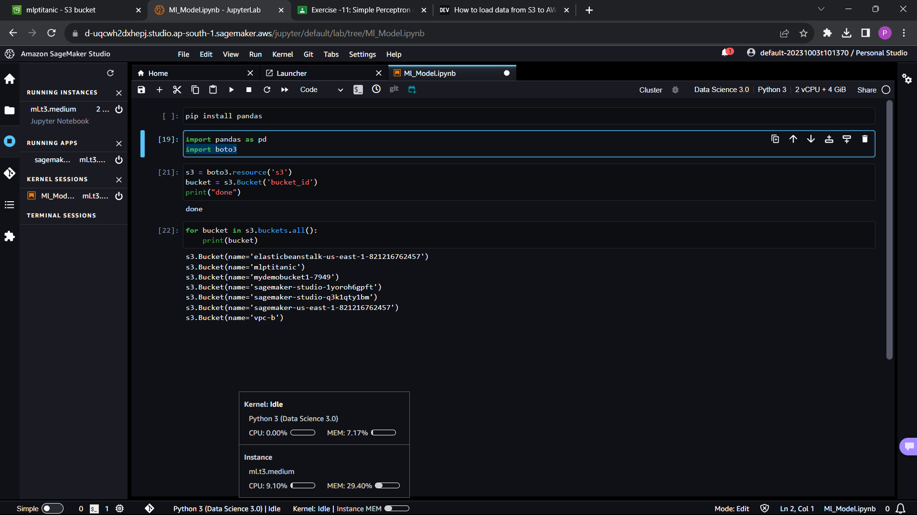

My kernal configurations are :-

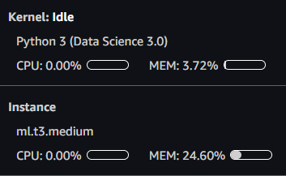

This is the sample data

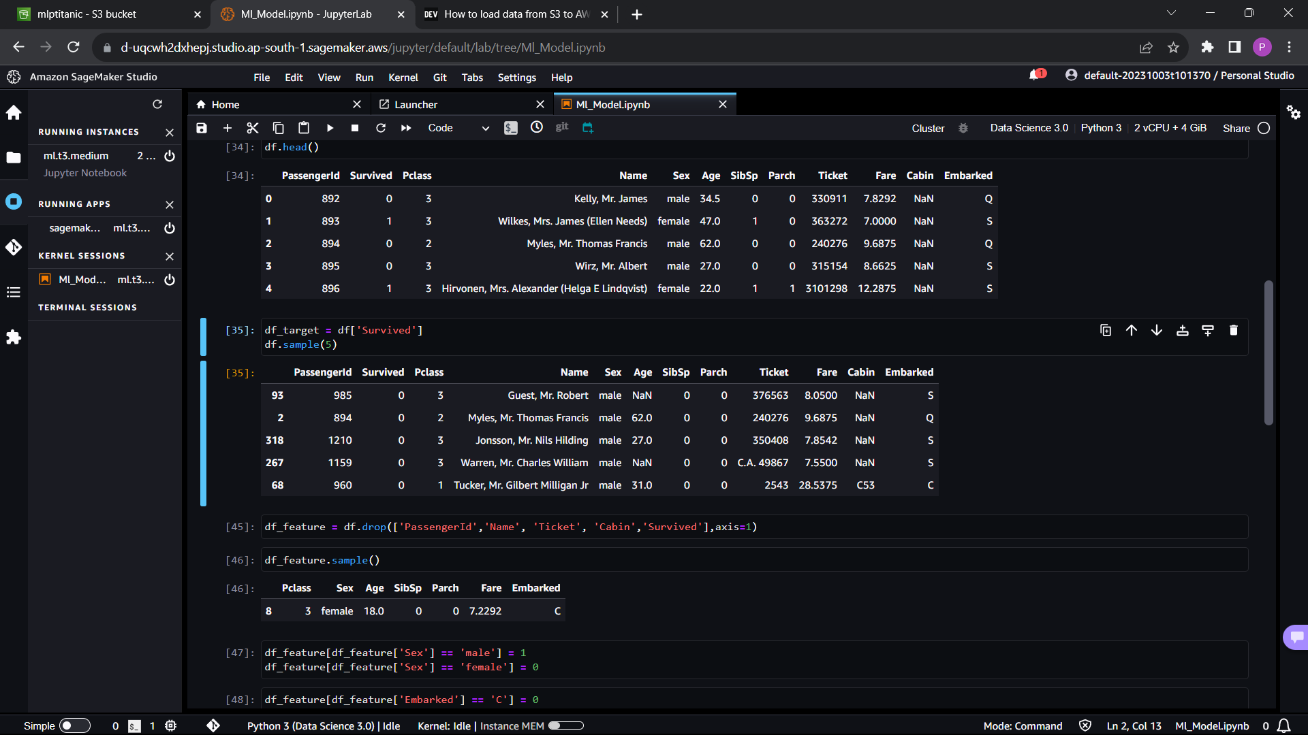

Score and Accuracy of the model: -

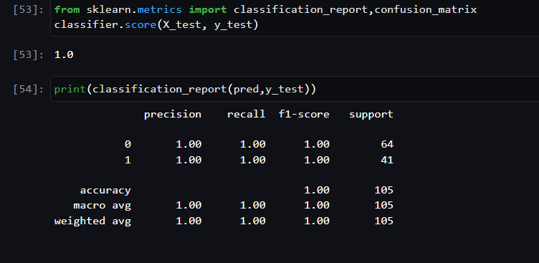

* After comleting the model, shut down all the running kernel, terminal and instances to avoid charges.
* Check the endpoints and running instances in the dashboard

Thank you !!

LinkedIn post link :-

https://www.linkedin.com/posts/preetham-dundigalla-b77283228_aws-sagemaker-machinelearning-activity-7114907752392495105-m4si?utm_source=share&utm_medium=member_android