AI Assisted Coding
Lab_Assignment_2.3

2303A51387
Batch-06

PROMPT:
Task 1: Word Frequency from Text File
❖ Scenario:
You are analyzing log files for keyword frequency.
❖ Task:
Use Gemini to generate Python code that reads a text file and counts word
frequency, then explains the code.
❖ Expected Output:
➢ Working code
➢ Explanation
➢ Screenshot

Code:
# First, let's create a dummy text file for demonstration purposes.
file_content = """This is a sample text file.
This file will be used to count word frequencies.
Sample text, sample words, sample frequency."""
with open('sample_log.txt', 'w') as f:
f.write(file_content)

print("Created 'sample_log.txt' with sample content.")

import re
from collections import Counter
def count_word_frequency(filepath):
"""
Reads a text file and counts the frequency of each word.
Args:
filepath (str): The path to the text file.
Returns:
collections.Counter: A Counter object where keys are words and values are their frequencies.
"""
words = []
with open(filepath, 'r') as f:
for line in f:
# Convert to lowercase and remove punctuation, then split into words
# re.findall('\b\\w+\\b', ...) finds all word characters
words.extend(re.findall(r'\b\w+\b', line.lower()))

return Counter(words)

# Specify the path to the text file
file_path = 'sample_log.txt'

# Count word frequencies
word_counts = count_word_frequency(file_path)

# Display the top 10 most common words
print("\nWord Frequencies (Top 10):")
for word, count in word_counts.most_common(10):
print(f"'{word}': {count}")

OUTPUT:

Word Frequencies (Top 10):
'sample': 4
'this': 2
'text': 2
'file': 2
'is': 1
'a': 1
'will': 1
'be': 1
'used': 1
'to': 1

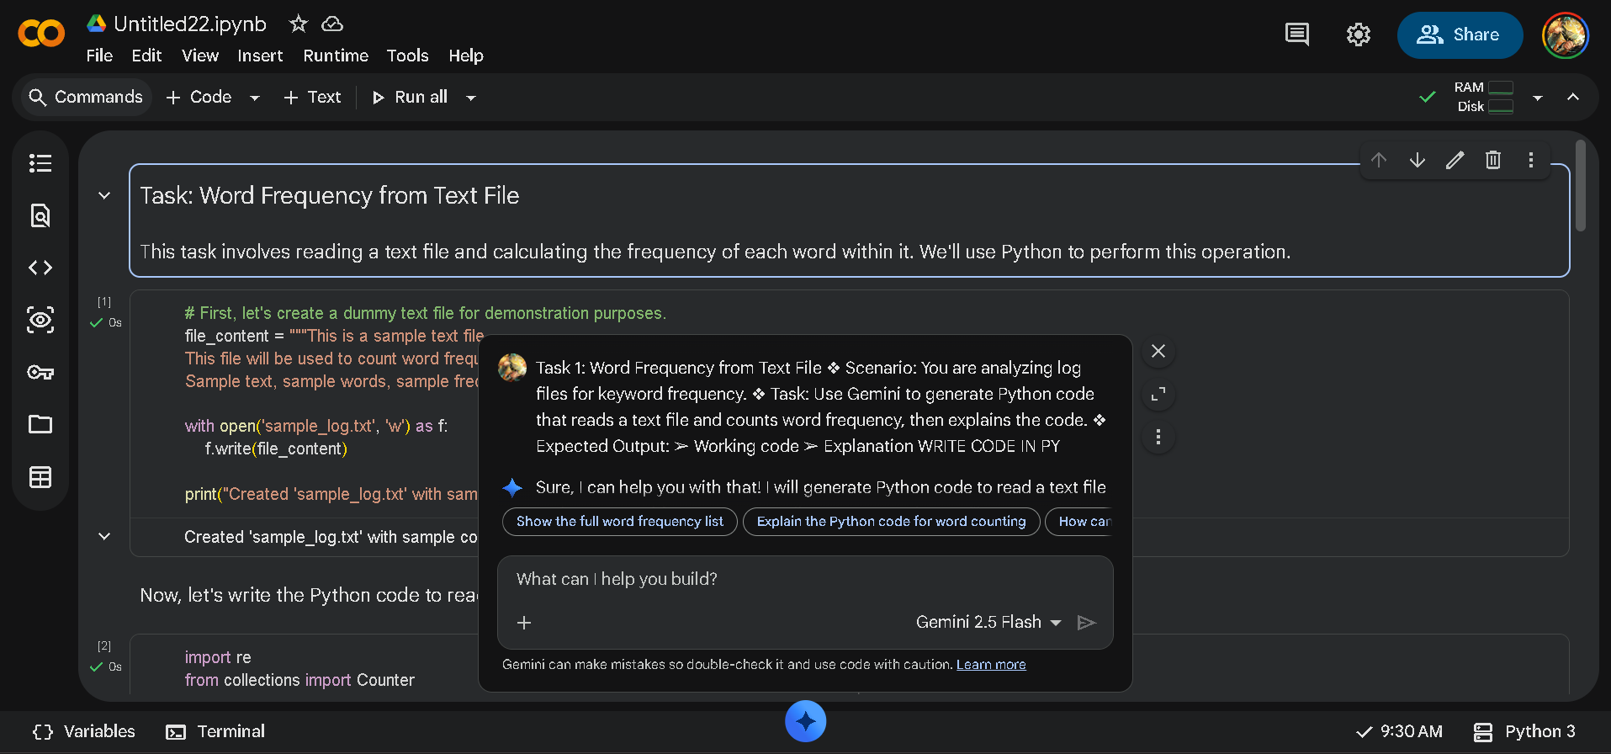

### Explanation of the Code:

1. **Import necessary libraries:**
* `re`: The regular expression module is used for robust word extraction (splitting text into words while handling punctuation). `re.findall(r'\b\w+\b', ...)` finds all sequences of word characters. `\b` matches a word boundary, and `\w+` matches one or more alphanumeric characters (letters, numbers, and underscores).
* `collections.Counter`: This is a specialized dictionary subclass for counting hashable objects. It's very efficient for frequency counting tasks.

2. **`count_word_frequency(filepath)` function:**
* Takes `filepath` as an argument.
* Initializes an empty list `words` to store all extracted words.
* Opens the specified file in read mode (`'r'`). The `with` statement ensures the file is properly closed even if errors occur.
* Iterates through each `line` in the file.
* For each line:
* `line.lower()`: Converts the line to lowercase to ensure that words like "The" and "the" are counted as the same word.
* `re.findall(r'\b\w+\b', ...)`: Uses a regular expression to find all words. This effectively removes punctuation and splits the text into individual words.
* `words.extend(...)`: Adds the list of words found in the current line to the overall `words` list.
* Finally, `return Counter(words)` creates and returns a `Counter` object from the collected list of words, which automatically calculates their frequencies.

3. **Execution Block:**
* `file_path = 'sample_log.txt'`: Defines the name of the file to be analyzed.
* `word_counts = count_word_frequency(file_path)`: Calls the function to get the word frequencies.
* The code then prints the top 10 most common words and their counts using `word_counts.most_common(10)`.

Task 2: File Operations Using Cursor AI
❖ Scenario:
You are automating basic file operations.
❖ Task:
Use Cursor AI to generate a program that:
➢ Creates a text file
➢ Writes sample text
➢ Reads and displays the content
❖ Expected Output:
➢ Functional code
➢ Cursor AI screenshots

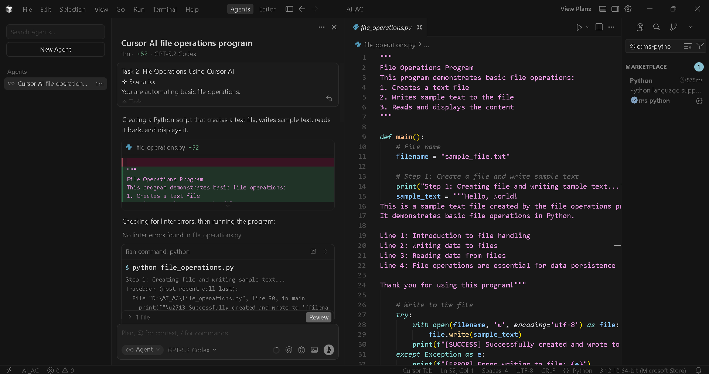

CODE:
"""
File Operations Program
This program demonstrates basic file operations:
1. Creates a text file
2. Writes sample text to the file
3. Reads and displays the content
"""

def main():
# File name
filename = "sample_file.txt"

# Step 1: Create a file and write sample text
print("Step 1: Creating file and writing sample text...")
sample_text = """Hello, World!
This is a sample text file created by the file operations program.
It demonstrates basic file operations in Python.

Line 1: Introduction to file handling
Line 2: Writing data to files
Line 3: Reading data from files
Line 4: File operations are essential for data persistence

Thank you for using this program!"""

# Write to the file
try:
with open(filename, 'w', encoding='utf-8') as file:
file.write(sample_text)
print(f"[SUCCESS] Successfully created and wrote to '{filename}'")
except Exception as e:
print(f"[ERROR] Error writing to file: {e}")
return

# Step 2: Read and display the content
print("\nStep 2: Reading and displaying file content...")
try:
with open(filename, 'r', encoding='utf-8') as file:
content = file.read()

print(f"\n--- Content of '{filename}' ---")
print(content)
print("--- End of file content ---")
print(f"\n[SUCCESS] Successfully read '{filename}'")
except FileNotFoundError:
print(f"[ERROR] File '{filename}' not found")
except Exception as e:
print(f"[ERROR] Error reading file: {e}")

if __name__ == "__main__":
main()

OUTPUT:

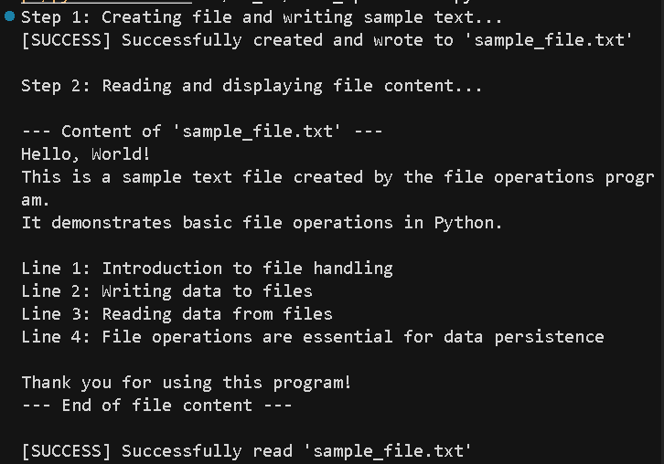

EXPLANATION:
Code Explanation: file_operations.py
Python script that demonstrates basic file operations. Here's what it does:
Overall Structure
The program performs two main tasks:
- Create and write to a text file
- Read and display the file's contents
Breakdown by Section
Lines 1-7: Documentation
- Module-level docstring describing the program's purpose
Lines 9-33: File Writing Section
Lines 11-24:
- filename: Target file name ("sample_file.txt")
- sample_text: Multi-line string containing sample content
Lines 27-33: Write Operation
with open(filename, 'w', encoding='utf-8') as file:
file.write(sample_text)
- Uses a context manager (with) for automatic file handling
- Mode 'w' opens for writing (creates or overwrites)
- encoding='utf-8' ensures proper character handling
- try/except: Handles errors (e.g., permission issues)
Lines 35-48: File Reading Section
Lines 37-44: Read Operation
with open(filename, 'r', encoding='utf-8') as file:
content = file.read()
- Mode 'r' opens for reading
- file.read() reads the entire file into a string
- Displays the content with formatting
Lines 45-48: Error Handling
- FileNotFoundError: Handles missing file
- Generic Exception: Handles other read errors
Lines 50-51: Program Entry Point
if __name__ == "__main__":
main()
- Runs main() when executed directly
- Allows importing as a module without running
Key Concepts Demonstrated
- Context managers: Automatic file closing
- Error handling: Uses try/except blocks
- File modes: 'w' (write) and 'r' (read)
- UTF-8 encoding: Ensures international character support
This is a solid introduction to file I/O in Python with proper error handling.

Task 3: CSV Data Analysis
❖ Scenario:
You are processing structured data from a CSV file.
❖ Task:
Use Gemini in Colab to read a CSV file and calculate mean, min, and max.
❖ Expected Output:
➢ Correct output
➢ Screenshot

Load CSV Data
Subtask:
Load the CSV file into a pandas DataFrame.

Reasoning: To load the CSV file into a pandas DataFrame and display its head, I need to import the pandas library and use its read_csv function, then call the head() method on the resulting DataFrame.
import pandas as pd
df = pd.read_csv('data.csv')
df.head()
index,id,name,value

OUTPUT:

0,1,Alpha,10.0
1,2,Beta,20.0
2,3,Gamma,15.0
3,4,Delta,25.0
4,5,Epsilon,12.0
**Reasoning**:
The previous attempt to load `data.csv` failed because the file was not found. To resolve this, I will create a dummy `data.csv` file with some sample data using a shell command, and then retry loading it into a pandas DataFrame.

OUTPUT:

%%writefile data.csv

id,name,value
1,Alpha,10
2,Beta,20
3,Gamma,15
4,Delta,25
5,Epsilon,12

import pandas as pd
df = pd.read_csv('data.csv')
df.head()

Calculate Statistics
Subtask:
Calculate the mean, minimum, and maximum for all numerical columns in the DataFrame.

Reasoning: To calculate the mean, minimum, and maximum for all numerical columns, I will use the .mean(), .min(), and .max() methods on the DataFrame df.
df_mean = df.select_dtypes(include='number').mean()
df_min = df.select_dtypes(include='number').min()
df_max = df.select_dtypes(include='number').max()

print("Mean values:\n", df_mean)
print("\nMinimum values:\n", df_min)
print("\nMaximum values:\n", df_max)

OUTPUT:

Mean values:
value 16.4
dtype: float64

Minimum values:
value 10.0
dtype: float64

Maximum values:
value 25.0
dtype: float64

**Reasoning**:
The previous cell failed because the DataFrame `df` was not defined. Although `data.csv` exists, the code to load it into `df` was not executed. Therefore, I need to include the necessary steps to load `df` from `data.csv` before calculating the statistics.
import pandas as pd
df = pd.read_csv('data.csv')

df_mean = df.select_dtypes(include='number').mean()
df_min = df.select_dtypes(include='number').min()
df_max = df.select_dtypes(include='number').max()

print("Mean values:\n", df_mean)
print("\nMinimum values:\n", df_min)
print("\nMaximum values:\n", df_max)

OUTPUT:

Mean values:
value 16.4
dtype: float64

Minimum values:
value 10.0
dtype: float64

Maximum values:
value 25.0
dtype: float64
Final Task
Subtask:
Summarize the calculated statistics from the CSV file.

CODE EXPLANATOIN:

Certainly! The last code block you executed calculates and prints the mean, minimum, and maximum values for the numerical columns in your DataFrame df. Here's a breakdown:
- import pandas as pd: This line imports the pandas library, which is essential for working with DataFrames, and gives it the alias pd for convenience.
- df = pd.read_csv('data.csv'): This reads the data from your data.csv file and loads it into a pandas DataFrame named df.
- df_mean = df.select_dtypes(include='number').mean(): This selects all columns in df that have a numerical data type, and then calculates the mean for each of those numerical columns. The result is stored in df_mean.
- df_min = df.select_dtypes(include='number').min(): Similar to the mean, this selects numerical columns and calculates the minimum value for each, storing it in df_min.
- df_max = df.select_dtypes(include='number').max(): This selects numerical columns and calculates the maximum value for each, storing it in df_max.
- print(...): These lines then print out the calculated mean, minimum, and maximum values to the console, making them easy to view.

Task 4: Sorting Lists – Manual vs Built-in
❖ Scenario:
You are reviewing algorithm choices for efficiency.
❖ Task:
Use Gemini to generate:
➢ Bubble sort
➢ Python’s built-in sort()
➢ Compare both implementations.
❖ Expected Output:
➢ Two versions of code
➢ Short comparison
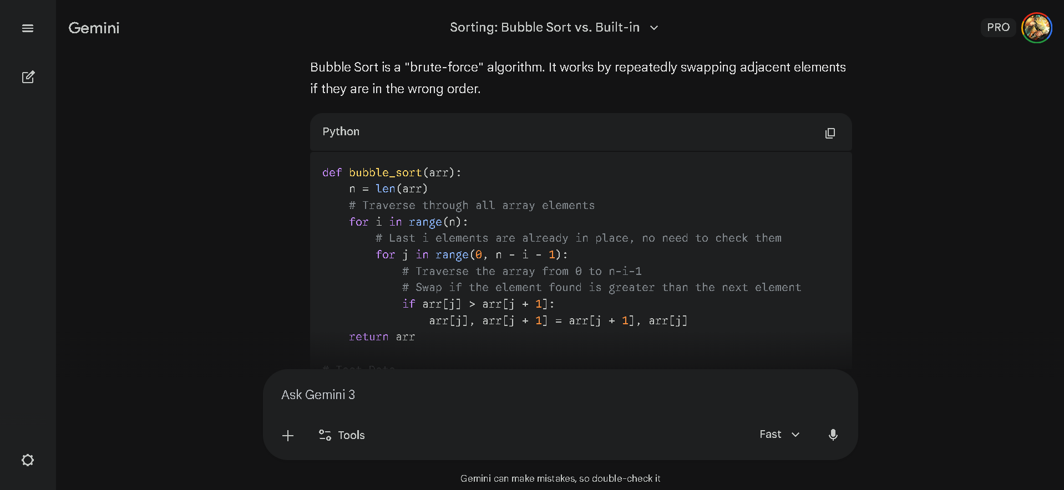

1. Manual Implementation: Bubble Sort
Bubble Sort is a "brute-force" algorithm. It works by repeatedly swapping adjacent elements if they are in the wrong order.
Python
def bubble_sort(arr):
n = len(arr)
# Traverse through all array elements
for i in range(n):
# Last i elements are already in place, no need to check them
for j in range(0, n - i - 1):
# Traverse the array from 0 to n-i-1
# Swap if the element found is greater than the next element
if arr[j] > arr[j + 1]:
arr[j], arr[j + 1] = arr[j + 1], arr[j]
return arr

# Test Data
unsorted_list = [64, 34, 25, 12, 22, 11, 90]
result = bubble_sort(unsorted_list)
print(result)
Output:
Plaintext
[11, 12, 22, 25, 34, 64, 90]

2. Built-in Implementation: sort()
Python uses an algorithm called Timsort. It is a hybrid approach that is significantly faster and more memory-efficient than Bubble Sort.
Python
# Test Data
unsorted_list = [64, 34, 25, 12, 22, 11, 90]

# Use the built-in sort() method (modifies the list in place)
unsorted_list.sort()

print(unsorted_list)
Output:
Plaintext
[11, 12, 22, 25, 34, 64, 90]

3. Comparison Summary
Feature | Bubble Sort | Python sort()
Complexity | $O(n^2)$ (Slow) | $O(n \log n)$ (Fast)
Effort | Manual logic required | Optimized built-in function
Usage | Educational / Theory | Real-world applications

4. Code Explanation
Bubble Sort Explanation:
- Nested Loops: The outer loop (i) keeps track of how many passes we have made. The inner loop (j) compares side-by-side numbers.
- The "Bubble" Mechanism: In every pass, the largest unsorted number "bubbles up" to its correct position at the far right of the list.
- Efficiency Issue: Because it uses nested loops, if you double the number of items in a list, the time it takes to sort them quadruples.
Built-in sort() Explanation:
- Timsort Logic: Instead of just swapping, it identifies small segments of the data that are already sorted (called "runs") and merges them efficiently.
- Optimization: It is written in C, making it hundreds of times faster than a manual Python loop for large datasets.
- In-place Mutation: The .sort() method changes the original list directly, which is highly memory-efficient.
Would you like me to demonstrate how to use sorted() instead, if you want to keep your original list unchanged?

