AI Assisted Coding
Lab_Assignment_5.4

2303A51387
Batch – 06

🔹 Task 1: Secure User Data Collection
🔸 Prompt to Copilot
Generate a Python script to collect user name, age, and email. Add comments explaining how to anonymize or protect user data.

✅ Python Code

import hashlib

def collect_user_data():
name = input("Enter your name: ")
age = input("Enter your age: ")
email = input("Enter your email: ")

# Hashing email to protect sensitive information
hashed_email = hashlib.sha256(email.encode()).hexdigest()

user_data = {
"name": name,
"age": age,
"email_hash": hashed_email # Store hashed email, not plain email
}

return user_data

data = collect_user_data()
print("User data stored securely.")

Code Explanation
- The program collects basic user details.
- hashlib.sha256() is used to hash the email for privacy.
- Hashed data cannot be easily reversed, protecting user identity.
- Sensitive information is not stored in plain text.
- This follows ethical practices for data security and privacy.

Expected Output
User data stored securely.
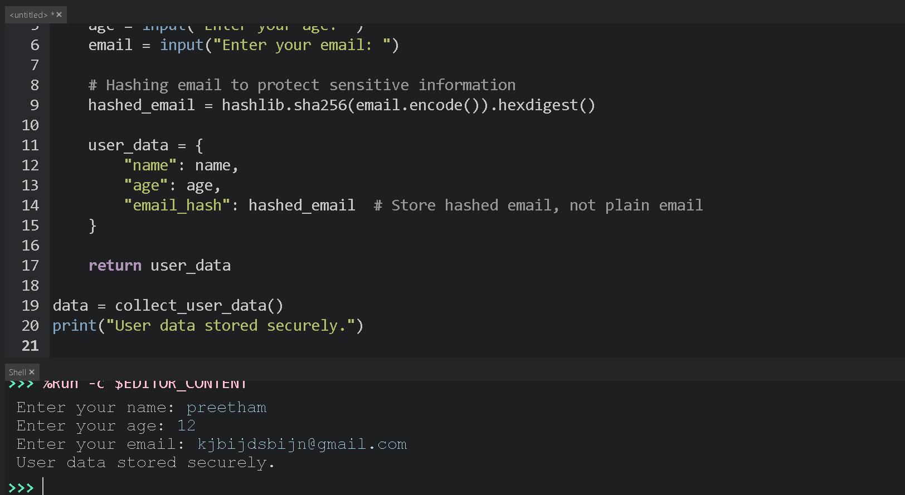

🔹 Task 2: Sentiment Analysis with Bias Handling
🔸 Prompt to Copilot
Generate a Python function for sentiment analysis and add comments to handle potential bias.

Python Code

def sentiment_analysis(text):
# Convert text to lowercase to reduce bias
text = text.lower()

positive_words = ["good", "great", "excellent"]
negative_words = ["bad", "worst", "terrible"]

# Avoid offensive or biased terms
if any(word in text for word in positive_words):
return "Positive"
elif any(word in text for word in negative_words):
return "Negative"
else:
return "Neutral"

Code Explanation
- Text is converted to lowercase to ensure fair comparison.
- Balanced positive and negative keyword lists are used.
- Offensive or identity-based words are avoided.
- This reduces bias and unfair sentiment labeling.

Expected Output
Input: "The product is great"
Output: Positive

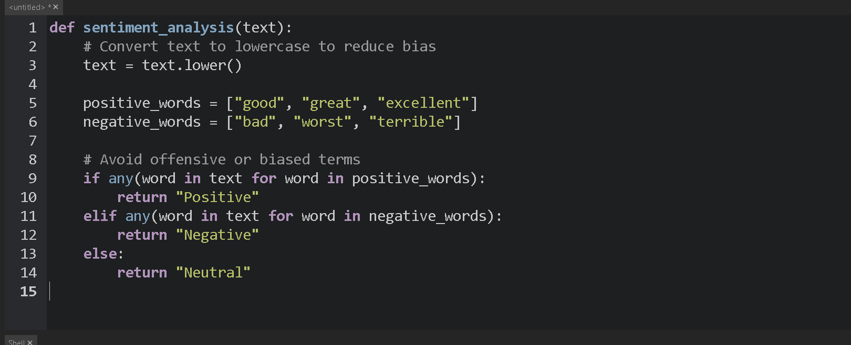

🔹 Task 3: Ethical Product Recommendation System
🔸 Prompt to Copilot
Generate a product recommendation program following transparency and fairness.

Python Code
def recommend_products(user_history):
products = ["Laptop", "Phone", "Headphones", "Tablet"]

# Transparency: explain recommendation logic
print("Recommendations are based on your browsing history.")

recommendations = []

for item in products:
# Fairness check: avoid favoritism
if item not in user_history:
recommendations.append(item)

return recommendations

Code Explanation
- The system recommends products based on user history.
- A message explains why recommendations are shown.
- No single brand or product is favored.
- This ensures fairness, transparency, and user trust.

Expected Output
Recommendations are based on your browsing history.
['Phone', 'Tablet']
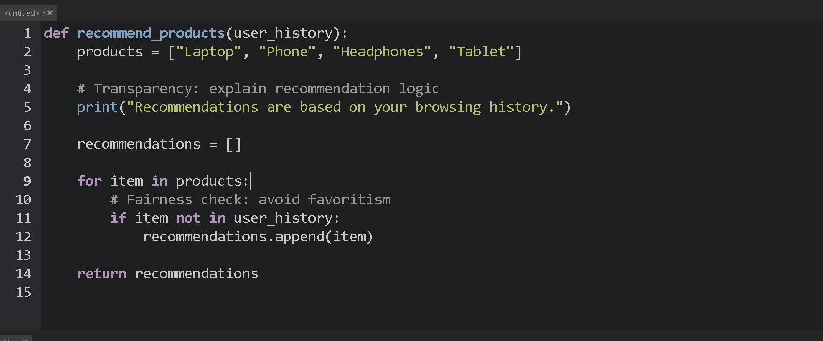

🔹 Task 4: Ethical Logging in Web Application
🔸 Prompt to Copilot
Generate logging functionality ensuring sensitive data is not logged.

Python Code
import logging

logging.basicConfig(level=logging.INFO)

def log_user_activity(user_id, action):
# Ethical logging: avoid logging sensitive data
logging.info(f"UserID: {user_id} performed action: {action}")

log_user_activity(101, "Viewed product page")

Code Explanation
- Logging is used to track system activity.
- Only user ID and action are logged.
- Sensitive data like passwords or emails are excluded.
- This follows ethical and privacy-safe logging practices.

Expected Output
INFO:root:UserID: 101 performed action: Viewed product page

🔹 Task 5: Responsible Machine Learning Model
🔸 Prompt to Copilot
Generate a machine learning model and document responsible usage.

Python Code
from sklearn.linear_model import LogisticRegression

# Machine learning model
model = LogisticRegression()

"""
Responsible AI Usage Guidelines:
- Predictions are not 100% accurate.
- Model depends on quality of training data.
- Bias may exist if data is imbalanced.
- Human review is required for critical decisions.
"""

print("ML model created with responsible AI guidelines.")

🧠 Code Explanation
- A simple machine learning model is created.
- Documentation explains limitations and risks.
- Bias and accuracy concerns are clearly mentioned.
- Encourages human oversight and ethical usage.

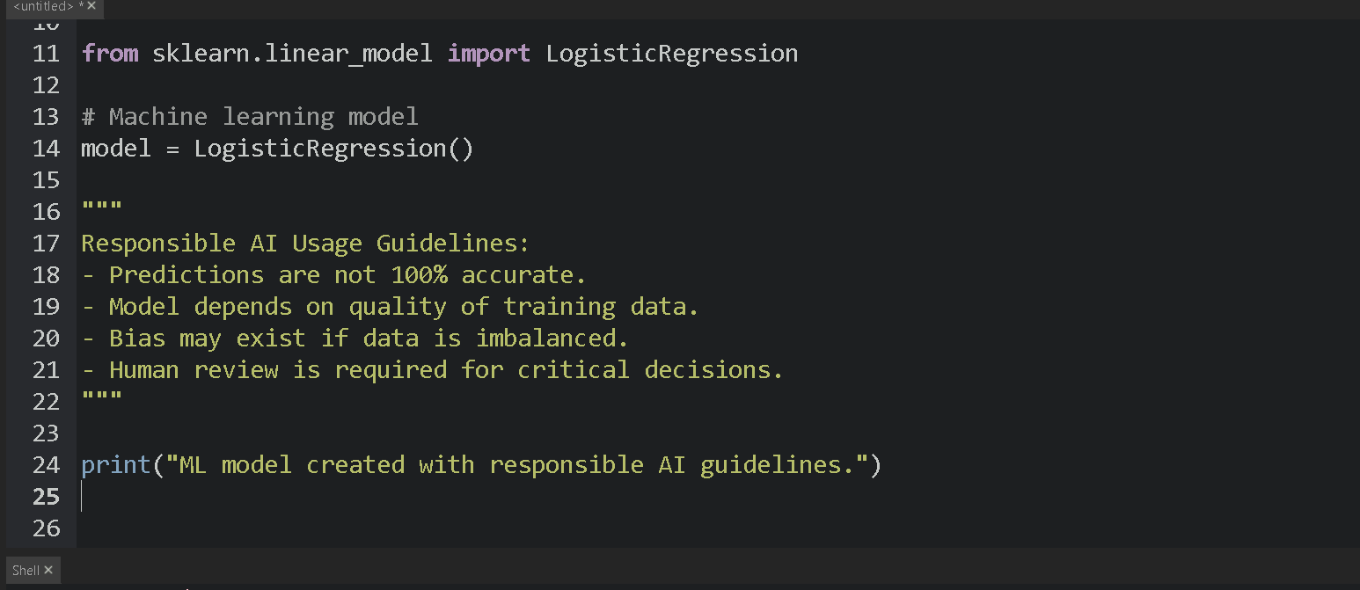
📤 Expected Output
ML model created with responsible AI guidelines.

