AI Assisted Coding
PREETHAM VOORUGONDA
2303A51387
BATCH - 06

Lab 1: Environment Setup – GitHub Copilot and VS Code Integration +
Understanding AI-assisted Coding Workflow
Lab Objectives:
Week1 -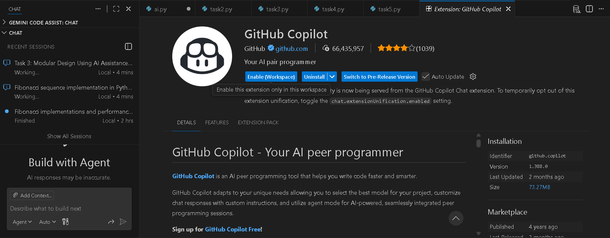

Task 1: AI-Generated Logic Without Modularization (Fibonacci Sequence
Without Functions)
PROMPT:
Task 1: AI-Generated Logic Without Modularization (Fibonacci Sequence
Without Functions)
❖ Scenario
You are asked to write a quick numerical sequence generator for a learning
platform prototype.
❖ Task Description
Use GitHub Copilot to generate a Python program that:
➢ Prints the Fibonacci sequence up to n terms
➢ Accepts user input for n
➢ Implements the logic directly in the main code
➢ Does not use any user-defined functions
❖ Expected Output
➢ Correct Fibonacci sequence for given n
➢ Screenshot(s) showing Copilot-generated suggestions
➢ Sample inputs and outputs
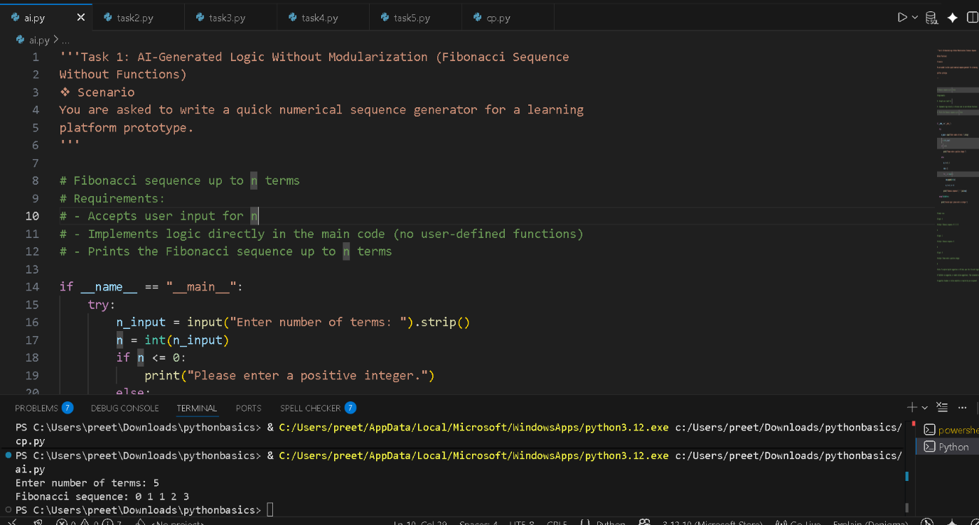

OUTPUT: Enter number of terms: 5
Fibonacci sequence: 0 1 1 2 3

Code Explanation (Fibonacci without functions)
- input() → takes number of terms from user
- int() → converts input to integer
- if n <= 0 → checks for invalid (non-positive) input
- a, b = 0, 1 → starting Fibonacci numbers
- for _ in range(n) → runs loop n times
- seq.append(str(a)) → stores current Fibonacci number
- a, b = b, a + b → updates values for next term
- " ".join(seq) → prints numbers in one line
- try / except → handles invalid (non-integer) input safely
Output: Prints Fibonacci sequence up to n terms.

Task 2: AI Code Optimization & Cleanup (Improving Efficiency)
PROMPT: Task 2: AI Code Optimization & Cleanup (Improving Efficiency)
❖ Scenario
The prototype will be shared with other developers and needs
optimization.
❖ Task Description
➢ Examine the Copilot-generated code from Task 1 and improve it by:
➢ Removing redundant variables
➢ Simplifying loop logic
➢ Avoiding unnecessary computations
➢ Use Copilot prompts such as:
▪ “Optimize this Fibonacci code”
▪ “Simplify variable usage”
Hint:
Prompt Copilot with phrases like
“optimize this code”, “simplify logic”, or “make it more readable”
❖ Expected Output
➢ Original vs improved code
➢ Written explanation of:
▪ What was inefficient
▪ How the optimized version improves performance and readability
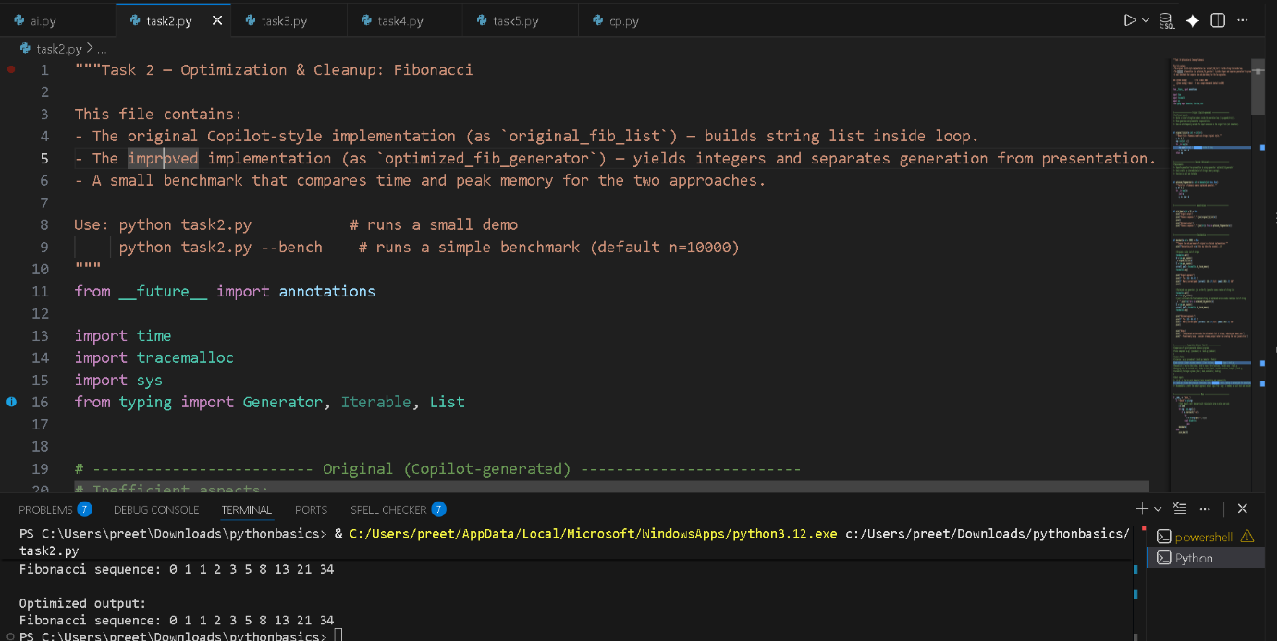
OUTPUT:

Fibonacci sequence: 0 1 1 2 3 5 8 13 21 34

Optimized output:
Fibonacci sequence: 0 1 1 2 3 5 8 13 21 34

CODE EXPLANATION
Optimization & Cleanup (Fibonacci)
Original version (original_fib_list)
- Generates Fibonacci numbers
- Converts each number to string inside the loop
- Stores all values in a list
➡️ More memory usage, mixed logic (generation + formatting)
Optimized version (optimized_fib_generator)
- Uses a generator (yield)
- Produces numbers one-by-one
- Conversion to string happens only when printing
➡️ Less memory, cleaner design, reusable
Demo
- Prints Fibonacci using both methods
- Output is the same
Benchmark
- Measures time and memory
- Optimized version:
  - Uses less peak memory
  - Scales better for large n
Key takeaway
- Generator = better performance + cleaner code
- Separate logic (generation) from presentation (printing)

Task 3: Modular Design Using AI Assistance (Fibonacci Using Functions)
PROMPT:
Task 3: Modular Design Using AI Assistance (Fibonacci Using Functions)
❖ Scenario
The Fibonacci logic is now required in multiple modules of an application.
❖ Task Description
Use GitHub Copilot to generate a function-based Python program that:
➢ Uses a user-defined function to generate Fibonacci numbers
➢ Returns or prints the sequence up to n
➢ Includes meaningful comments (AI-assisted)
❖ Expected Output
➢ Correct function-based Fibonacci implementation
➢ Screenshots documenting Copilot’s function generation
➢ Sample test cases with outputs

Code Explanation:
Optimization & Cleanup (Fibonacci)
Original version (original_fib_list)
- Generates Fibonacci numbers
- Converts each number to string inside the loop
- Stores all values in a list
➡️ More memory usage, mixed logic (generation + formatting)
Optimized version (optimized_fib_generator)
- Uses a generator (yield)
- Produces numbers one-by-one
- Conversion to string happens only when printing
➡️ Less memory, cleaner design, reusable
Demo
- Prints Fibonacci using both methods
- Output is the same
Benchmark
- Measures time and memory
- Optimized version:
  - Uses less peak memory
  - Scales better for large n
Key takeaway
- Generator = better performance + cleaner code
- Separate logic (generation) from presentation (printing)

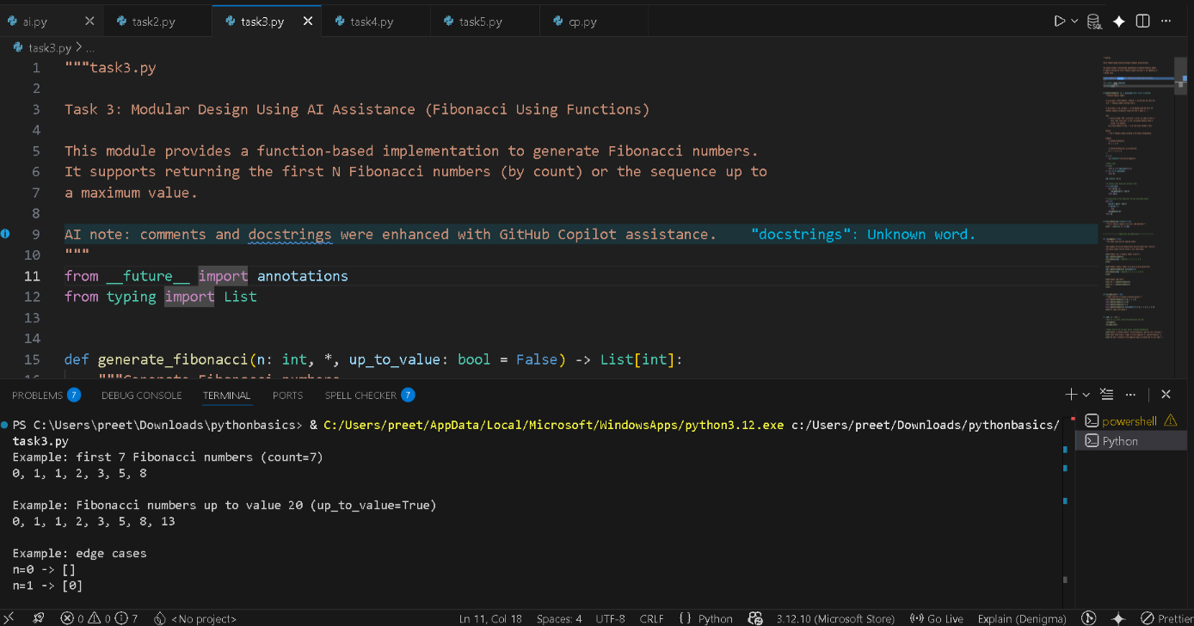

OUTPUT:
Example: first 7 Fibonacci numbers (count=7)
0, 1, 1, 2, 3, 5, 8

Example: Fibonacci numbers up to value 20 (up_to_value=True)
0, 1, 1, 2, 3, 5, 8, 13

Example: edge cases
n=0 -> []
n=1 -> [0]

All simple tests passed.

Notes: To document Copilot's function generation, open this file in VS Code,
enable GitHub Copilot, trigger an inline suggestion for `generate_fibonacci`,
and take a screenshot of the suggestion popup or accepted code for your report.

Task 4: Comparative Analysis – Procedural vs Modular Fibonacci Code
PROMPT:
Task 4: Comparative Analysis – Procedural vs Modular Fibonacci Code
❖ Scenario
You are participating in a code review session.
❖ Task Description
Compare the Copilot-generated Fibonacci programs:
➢ Without functions (Task 1)
➢ With functions (Task 3)
➢ Analyze them in terms of:
▪ Code clarity
▪ Reusability
▪ Debugging ease
▪ Suitability for larger systems
❖ Expected Output
Comparison table or short analytical report
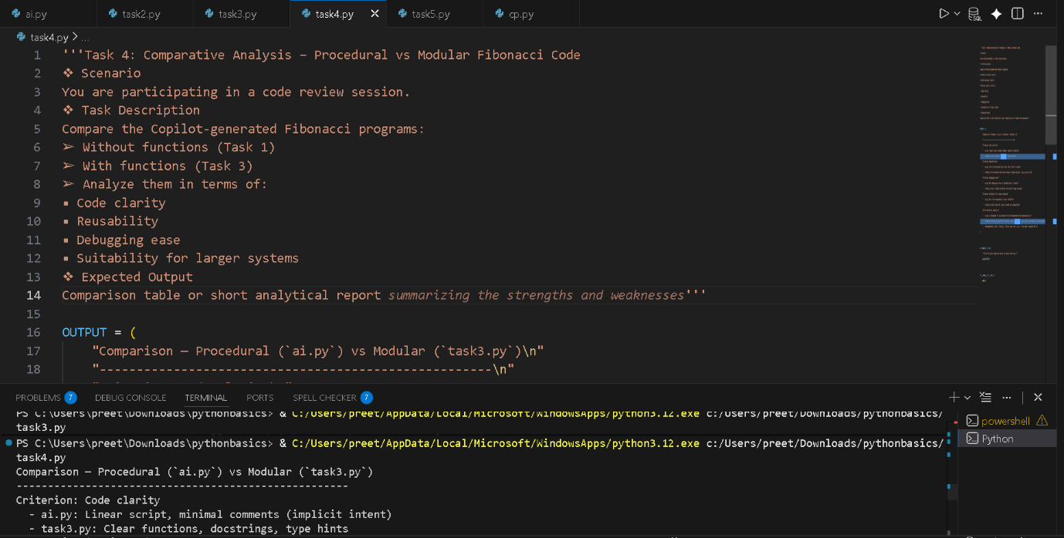
OUTPUT:
Comparison — Procedural (`ai.py`) vs Modular (`task3.py`)
-----------------------------------------------------
Criterion: Code clarity
- ai.py: Linear script, minimal comments (implicit intent)
- task3.py: Clear functions, docstrings, type hints

Criterion: Reusability
- ai.py: Tied to stdin/stdout and script flow — hard to reuse
- task3.py: Pure functions that return values, flexible options (`up_to_value`)

Criterion: Debugging ease
- ai.py: Must debug main flow; no isolated units or tests
- task3.py: Small, testable functions with explicit edge cases

Criterion: Suitability for larger systems
- ai.py: Poor — not composable or easily testable
- task3.py: Good — clear API, easy to extend and integrate

Short analytical summary:
- ai.py is acceptable for quick demos but lacks documentation and composability.
- task3.py follows best practices (functions, types, docstrings, tests) and is preferable for maintainability and production.
- Recommendation: prefer `task3.py`. Extract logic from `ai.py` if you need a reusable API.

Task 5: AI-Generated Iterative vs Recursive Fibonacci Approaches (Different
Algorithmic Approaches for Fibonacci Series)

PROMPT :
Task 5: AI-Generated Iterative vs Recursive Fibonacci Approaches (Different
Algorithmic Approaches for Fibonacci Series)
❖ Scenario
Your mentor wants to assess AI’s understanding of different algorithmic
paradigms.
❖ Task Description
Prompt GitHub Copilot to generate:
An iterative Fibonacci implementation
A recursive Fibonacci implementation
❖ Expected Output
➢ Two correct implementations
➢ Explanation of execution flow for both
➢ Comparison covering:
▪ Time and space complexity
▪ Performance for large n
▪ When recursion should be avoided

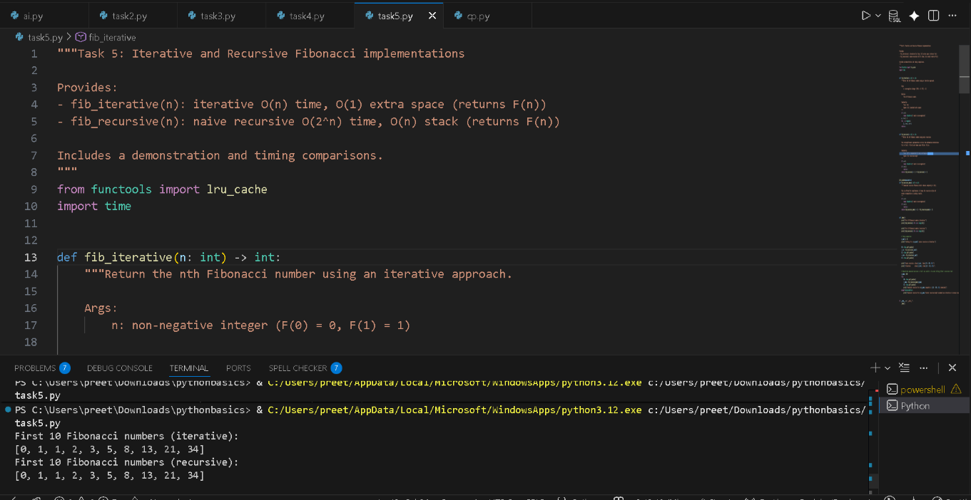
OUTPUT:

First 10 Fibonacci numbers (iterative):
[0, 1, 1, 2, 3, 5, 8, 13, 21, 34]
First 10 Fibonacci numbers (recursive):

[0, 1, 1, 2, 3, 5, 8, 13, 21, 34]

Timing for n=30 (naive recursive vs iterative):
naive recursive: value=832040, time=0.185535s
iterative: value=832040, time=0.000009s
memoized recursive for n=500 computed in 0.001015s (memoized)

CODE EXPLANATION
Task 5: Iterative vs Recursive Fibonacci
fib_iterative(n)
- Uses a loop to calculate Fibonacci
- Updates values using a, b = b, a + b
- Time: O(n)
- Space: O(1)
✔️ Fast and memory-efficient
fib_recursive(n)
- Follows the formula F(n) = F(n-1) + F(n-2)
- Repeats many calculations
- Time: O(2ⁿ)
- Space: O(n) (call stack)
❌ Very slow for large n
fib_recursive_memo(n)
- Uses @lru_cache to store previous results
- Avoids repeated work
- Time: O(n)
- Space: O(n)
✔️ Fast but still uses recursion
Demo & Timing
- Prints first 10 Fibonacci numbers
- Compares execution time of iterative vs recursive
- Shows memoized recursion is much faster than naive recursion
Conclusion
- Iterative → best for performance
- Naive recursive → only for learning
- Memoized recursive → good balance, but iterative is safest for large n

