

National College of Ireland

Masters in Data Analytics
MSCDAD_A&B_JAN26I

Release: Week of 25th of May
Submission: Week of 3rd of August

________________________________________________________________

Business Intelligence & Business Analytics
Mr Vikas Sahni
Mr Sean Heeney
Dr. Nikola Nikolov

Continuous Assessment (CA) Type:
Project

Weight: 80% of Module Grade
The assignment will be marked out of 100.

Instructions: Students MUST work in Groups of 3 Students

SUBMISSION DETAILS:
All Submissions will be made on Moodle
One Report is Required encapsulating all project objectives
Specification and Implementation Reports Composed in One Single Document
Presentation / Demonstration of project deliverables will be provided in a URL embedded within your report at the top of page.
Submission of all requirements due the week of 3rd of August.
All documents to be submitted as PDF

Late Submissions: Late submissions will be subject to a late submission penalty except where a student has applied and been approved for an extension through NCI360.

TURNITIN: All report submissions will be electronically screened for evidence of academic misconduct (i.e., plagiarism and collusion)

Sustainable Development Goals (SDG) Addressed in Assessment:
If possible address key UN SDG objectives within your project

Assessment Description:

Project Outline

Project Scenario:
You are currently working for a professional services company of your choosing e.g Accenture, Deloitte, SAP, Salesforce etc. As part of your role as a Business Intelligence and Business Analytics specialist you and your team* have been embedded with a business, company and/or client which is either:
A Company which is experiencing severe issues and without action will cease operations
“A company which is in a time of financial and operational trouble and require your BI and BA skillsets to help identify issues with the business, both operational and technological and support the implementation of Tools and Methodologies and support the re-opening or re-establishment of the existing business “
OR
A Company with an Expansion plan but facing issues
“A Company which is in a time of change, they have seen recent successes as a small enterprise and are looking for your BI and BA skills to support the transformation of the company from a small enterprise to a medium to large enterprise. The company ultimately will be experiencing issues and are lacking in a technological infrastructure to support the business transformation”

It is advised that students focus on a company which is experiencing severe issues, rather than option 2 which is the company with an expansion plan.

Students are expected to implement Both a Dashboard Infrastructure and a CRM implementation.
The choice of which software are to be implemented are given to the students:
For Dashboard Infrastructure: Tableau OR Power BI
For CRM Implementation: Salesforce OR HubSpot OR Zoho

Only the above-mentioned toolsets are allowed, no alternatives will be considered.

Specification Report 40%

- Prepare a project specification report (40%), with headings seen below in bold:

  - Background information and business goals of the organisation. The marketplace in which they participate and business goals. Include EDA and Gap/SWOT analysis to see where they are and where they want to be (15%)

  - An appropriate system design, showing data capture points, analytics requirements etc. Discuss how the solution might integrate customers in the process. Your design should also consider the key analytical requirements for reports, views and dashboards (10%)

  - A database design, including entity-relationship diagrams and a data dictionary, showing the data structures, fields and relationships (5%)

  - Mock up data and data structures to accommodate your database design. Use Mockaroo or similar tools to create datasets. Show any pre-processing steps required to populate your proposed design (10%)

  - The specification document (in PDF) should not exceed 12 pages (including references & NCI Project Submission Coversheet).

Implementation Report 40%

- Produce an implementation report (40%), aligned with the project specifications that:

  - Describes the development process from conceptualisation to implementation. Describe elements that were not initially considered, but were added as the project progressed (10%)

  - Includes screenshots and appropriate explanations from your system implementation, with Objects (including access controls), Custom Fields, Field Checks, Relationships, Layouts, Validation Rules, Record Types, Lookups, Filters, and Triggers, showing how they fulfil the data management portion of the solution (10%)

  - Includes screenshots and propriate explanations of reports and dashboards that address the business needs and requirements of the solution (5%)

  - Mocks up an initial response to the deployed solution. To what degree: has the business gap closed? has the business process improved? has the intended performance been achieved? (10%)

  - Reflects on things you have learnt. In conclusions: describe the most difficult part of this project; and what you could have done differently. In future work: discuss possible mitigation plans and/or potential ideas for further improvement of business goals (5%)

  - The implementation report (in PDF) should not exceed 12 pages (including references & NCI Project Submission Coversheet). Every extra page will incur a penalty of 20%. Please indicate who worked on what of the implementation part.

Comparative Analysis of AI-Generated Dashboard and Originally created dashboard. 5%

You are required as part of this assignment to originally and authentically create 3 dashboards.

Additionally, to your 3 originally created dashboards you are to create one additional dashboard which has been generated using an AI-Tool of your choosing.

In total you will have 4 dashboards, 3 originally created by your team, with 1 being generated using your desired AI Tool.

The Miro whiteboard summarized below will help with transparency and understanding regarding the expectation , formatting and layout for the delivery of your teams submission.

https://miro.com/app/board/uXjVOKYaSGw=/?share_link_id=972511404887

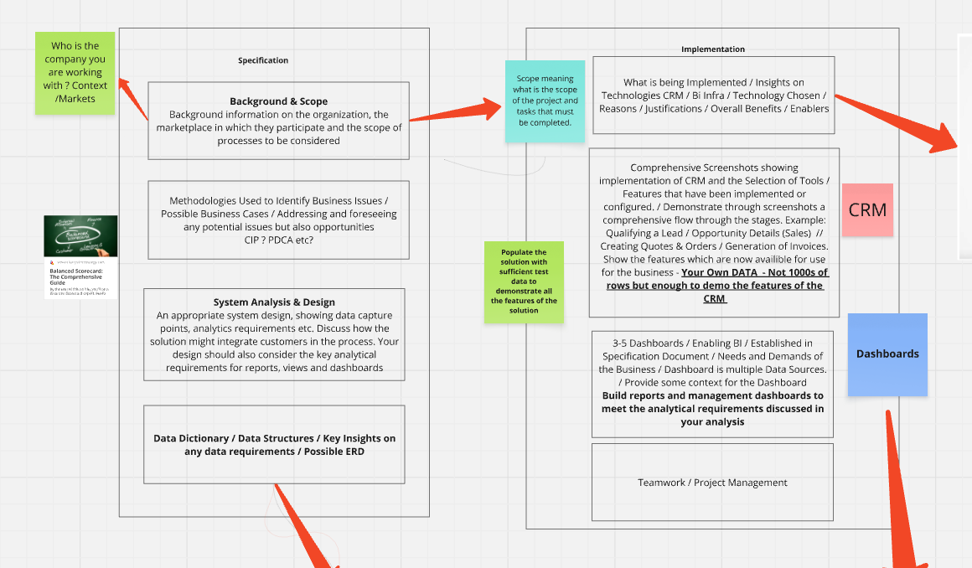

Your Report Submission will consist of 2 sperate parts (Specification Report) & (Implementation Report) Both parts should be submitted on the same document but will have a clear divider between both reports.

Three Dashboards will be expected to be created by the team, additionally A choice selection of features and workflows should be selected from the chosen CRM solution to be demonstrated both in the implementation report and also as part of the Teams presentation. E.g Marketing Campaign / Dealing with Customer issues / Orchestration of Communications with suppliers or any other features and workflows provided by a successful CRM implementation)

Additionally, you will provide a pre-recorded teams presentation as described below, and upload the video as an unlisted YouTube Video.

Project Presentation & Demonstration (15%)

The project will be presented and demonstrated to the lecturer via a single MAX 15-minute video. Turn on your camera. Show all developed workflows live and talk through the main insights of the project (Dashboards / CRM / Team Management etc)
Describe in detail what you consider to be the most difficult part to implement.
Any extra time taken in the video beyond the 15 minute Max will be penalised.

Notes

- Submissions not made through Moodle cannot be accepted!
- The Presentation/Demonstration Video is mandatory. A link to the video must be included in the specification report. If you do not submit it, the project report will NOT be assessed, and you would be awarded ZERO marks.
- You have to submit the following items: specification & implementation reports (in a single PDF), and code/data (in ZIP) developed for the project.
- You may be asked to attend a live presentation. If asked, attendance is compulsory else you will be marked ABSENT

BI and BA –Project Grading Rubric
 | 0-39% (Fail) | 40-49% (Pass) | 50-59% (H2.2) | 60-69% (H2.1) | 70%+ (H1)
Background &  Business goals (15%) | Little or no information on the organisation and/or project scope. Draws on none of the material presented in the module. | Basic and incomplete information on the organisation. The project scope is described but ill-defined. Draws on very little of the material presented during the module. | A good description of the organisation and the scope of the project, drawing on some of the material presented during the module. | A comprehensive description of the organisation and the scope of the project drawing on all of the relevant material delivered as part of the module. | A very thorough description of the organisation and the business environment in which it operates. Draws on material delivered during the module. Evidence of additional relevant reading outside the scope of the module.
Systems Analysis  & Design (10%) | The design is largely incomplete or is based on a seriously flawed analysis. | A partially incomplete design based on an analysis that exhibits a number of defects. | A design that is largely complete and is based on reasonable but limited analysis. | A design that covers most of the major elements well and builds on a sound analysis. | A detailed and comprehensive system design
Database Design  (5%) | No database design or one that lacks the majority of the expected elements. | A basic design that is missing many required elements. | A good design that supplies most of the major required elements. | A very good design missing only a small number of required elements. | A thorough and exhaustive database design incorporating all of the required elements.
Mock up data and structures (10%) | No evidence that test data was created or where test data is present it is insufficient to adequately demonstrate the features of the solution. | Some test data present but is missing for most objects. | An adequate set of test data is present for key objects but is missing or incomplete for the bulk of other objects. | A fairly complete set of test data shown but is missing or inadequate for a small number of minor objects. | A complete set of data was present for all the objects in the solution.
Development process (10%) | Alternative methodologies not considered, and method selected not justified. Significant errors in the application of methodology. | Alternative methodologies have not been considered and only limited justification for selected methods. Some errors in application. | Alternative methodologies have not been fully considered, though a reasonable attempt made at justifying its use. The methodology has been completely carried out. | Alternative methodologies have been considered and the methodology selected has been justified. The methodology has been competently carried out. | Alternative methodologies have been fully considered and the chosen methodology fully justified. The application has been rigorously carried out.
CRM  System Implementation  (10%) | No screenshots included in the report, or where supplied, are either missing most of the required information or fail to show that any the supplied design has been implemented. | A small number of screenshots provided but demonstrate only a minor portion of the system and database designs or are missing most of the required information. | A reasonable number of screenshots provided that demonstrate that most of the important elements of the design have been correctly implemented. | Most of the requested elements have been adequately demonstrated by means of the provided screenshots and largely agree with the system and database designs. | The supplied screenshots include all the elements requested and demonstrate that the system/database design have been completely implemented.
Reports , Dashboards & Visualizations (10%) | No reports/dashboards provided or supplied examples do not agree with analytical requirements identified during design phase. | A small number of reports/dashboards provided, which only demonstrate that a part of the analytical requirements has been implemented. | A reasonable but incomplete selection of reports and dashboards, which demonstrate that most of the requirements identified during the analysis phase have been met. | A very good selection of reports and dashboards, demonstrating that a significant majority of the previously identified requirements have been implemented. | A full set of management reports and dashboards that completely demonstrate that the requirements identified during the analysis phase have been met.
Initial response to implemented solution (10%) | Pedestrian or poor attempt to mock up the post-deployment scenario and analyse the findings. Implications and limitations not understood. | Some attempt at mocking up the post-deployment scenario and analysing the findings although with some problems. Implications and limitations not well understood. | A reasonable attempt to mock up the post-deployment scenario and analyse the findings. However, the synthesis of data collected, and theory is not fully achieved. Implications not fully appreciated. | Rigorous scenario & analysis of findings. Demonstrates the ability to synthesise data collected and relevant theory. Shows an understanding of implications of the study. | Rigorous and creative scenario & analysis of findings. Demonstrated ability to synthesise data and relevant theory. Insightful conclusions which appreciate limitations and implications of the study.
Conclusions & future work (10%) | Very limited use of theory and concepts | Limited use of theory and concepts | Reasonable use of theory and concepts but lack of breadth in relevant problem-solving literature. | Comprehensive use of relevant theory and concepts. Evidence of breadth in relevant problem-solving literature. | Critical application and critique of relevant theory and concepts. Evidence of breadth and depth of relevant problem-solving literature.
Presentation (10%) | Presentation/Demo was incomplete and unsatisfactory, Questions were inadequately answered. | Presentation/Demo was incomplete, some questions were adequately answered. | Presentation/Demo was adequate, Questions were adequately answered | Presentation/Demo was satisfactory, Questions were well answered. | Presentation/Demo was of a calibre beyond the expectation of the programme, Questions were answered beyond the expectation of the programme.

