DelightOn Garments Ltd.
Data & Database Design Pack — BIBA Specification Report Inputs
School-uniform manufacturer, Dublin · Dataset: delighton_data (23 tables, ~13,600 rows) · All figures computed directly from the mock data

1. System Architecture & Data Capture Flow
DelightOn's operational data enters the business at four physical points: the sales office (CRM), the measurement visit at each school, the factory floor, and the dispatch dock. Every downstream table is generated by one of these capture events, and each stage carries the keys of the stage before it, giving an unbroken lineage from first enquiry to the individual delivered garment.
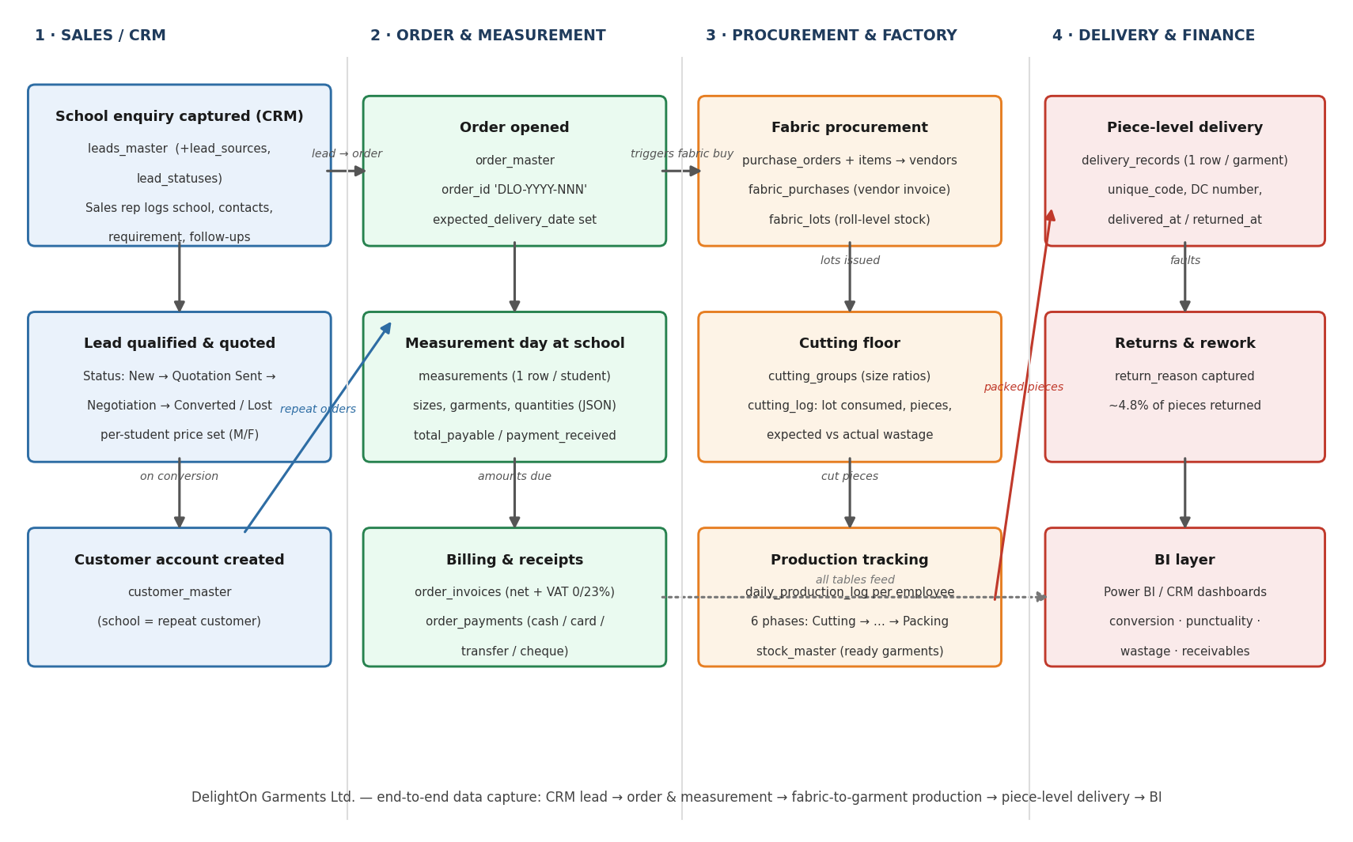
Figure 1 — End-to-end data capture flow across the four operating lanes.

Capture workflow, step by step
- Lead captured (CRM). A school enquiry arrives (website, referral, trade fair…) and a sales rep creates a row in leads_master, classified by lead_sources and lead_statuses and assigned to a user.
- Qualification & quotation. The lead moves New → Contacted → Quotation Sent → Negotiation. Per-student prices for male and female uniform sets are recorded on the lead (male_payment_amount / female_payment_amount, EUR).
- Conversion → order. On winning, the school is created (or matched) in customer_master and an order is opened in order_master with a human-readable business key order_id (e.g. DLO-2026-014) and an expected_delivery_date.
- Measurement day. Staff visit the school on measurement day: one measurements row per student captures garments, sizes and quantities as JSON, plus total_payable, payment_received and balance_amount per parent.
- Fabric procurement. The order's fabric requirement triggers purchase_orders (with purchase_order_items) to vendors; goods arrive against fabric_purchases invoices and are booked as roll-level fabric_lots with initial and remaining quantities.
- Cutting. The cutting floor groups students into size ratios (cutting_groups) and records every lay in cutting_log — the fabric lot consumed, metres used, pieces produced and expected vs actual wastage, signed by the cutter (employees).
- Production tracking. daily_production_log tracks each employee's output through six phases (Cutting → Stitching → Embroidery & Cresting → Finishing & Pressing → Quality Check → Packing). Ready garments post to stock_master.
- Piece-level delivery & returns. Dispatch writes one delivery_records row per physical garment (5,370 pieces) with a unique_code and DC number; delivered_at, returned_at and return_reason capture the piece's final fate.
- Billing & receipts. order_invoices bills each order (net + Irish VAT: 0% for children's clothing, 23% for adult sizes) and order_payments records cash/card/transfer/cheque receipts. The identity grand_total = net_total + vat_amount and grand_total = advance + payments + balance holds for every invoice in the dataset.
- BI layer. All 23 tables feed the Power BI / CRM analytics layer, which surfaces the conversion, punctuality, wastage and receivables measures analysed in Section 4.

2. Entity-Relationship Diagram (ERD)
The rewritten erd_core.mermaid accompanies this document and reflects the mock data exactly: 23 entities, 66 foreign-key relationships (all verified to resolve), and the dual order-referencing convention. Most child tables reference the surrogate key order_master.id (integer); cutting_groups and delivery_records instead reference the business key order_master.order_id (varchar, e.g. DLO-2026-014), shown dashed red below. Audit relationships (created_by / updated_by → users.id) exist on nearly every table and are omitted from the visual for clarity.
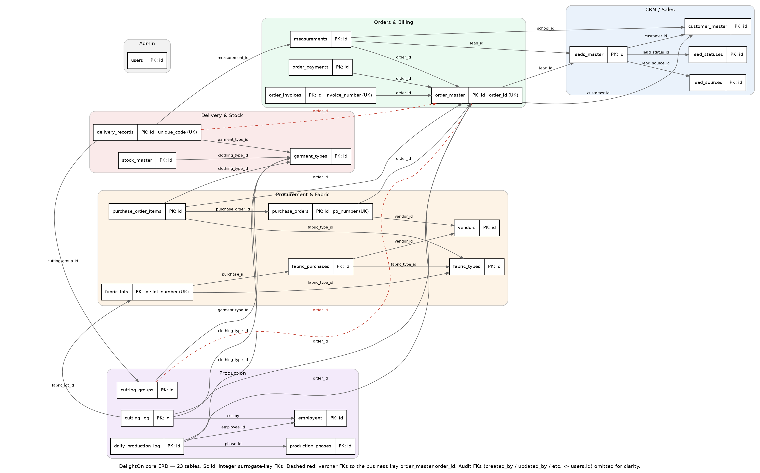
Figure 2 — Core ERD rendered from the verified relationship set (audit FKs omitted).
- Unique business keys: order_master.order_id, order_invoices.invoice_number, purchase_orders.po_number, fabric_lots.lot_number, delivery_records.unique_code.
- Cardinality is one-to-many throughout (each ||—o{ edge): e.g. one order → many measurements (avg 126 students/order), one measurement → 1–2 delivery pieces, one fabric purchase → one lot in this dataset (1:1 realised, 1:N by design).
- measurements is the busiest hub: it carries FKs to the lead, the order and the school, so student-level revenue can be sliced by acquisition source without extra joins.

3. Data Dictionary
The dictionary below lists all 338 columns of the 23 implemented tables, regenerated 1:1 from the mock CSVs (types cross-checked against the PostgreSQL schema; nullability observed from the data; every FK validated). Monetary columns are numeric(12,2) or numeric(10,2) in EUR with an explicit currency column; measurement and requirement payloads are jsonb.
Table | Column | Data type | Null | Key
users | id | integer | NO | PK
 | name | character varying(100) | NO
 | email | character varying(255) | NO
 | role | character varying(50) | NO
 | is_active | boolean | NO
 | created_at | timestamp without time zone | NO
employees | id | integer | NO | PK
 | name | character varying(255) | NO
 | role | character varying(100) | NO
 | phone_number | character varying(20) | NO
 | is_active | boolean | NO
 | created_by | integer | NO | FK -> users.id
 | created_at | timestamp without time zone | NO
 | updated_by | integer | NO | FK -> users.id
 | updated_at | timestamp without time zone | NO
 | deactivated_at | timestamp without time zone | YES
lead_sources | id | integer | NO | PK
 | name | character varying(100) | NO
 | description | text | NO
 | is_active | boolean | NO
 | created_by | integer | NO | FK -> users.id
 | created_at | timestamp without time zone | NO
 | updated_by | integer | NO | FK -> users.id
 | updated_at | timestamp without time zone | NO
lead_statuses | id | integer | NO | PK
 | name | character varying(50) | NO
 | description | text | NO
 | sort_order | integer | NO
 | is_active | boolean | NO
 | process_stage | character varying(50) | NO
 | created_by | integer | NO | FK -> users.id
 | created_at | timestamp without time zone | NO
 | updated_by | integer | NO | FK -> users.id
 | updated_at | timestamp without time zone | NO
customer_master | id | integer | NO | PK
 | name | character varying(255) | NO
 | short_code | character varying(10) | NO
 | institution_type | character varying(100) | NO
 | address | text | NO
 | contact_person | character varying(100) | NO
 | contact_number | character varying(20) | NO
 | email | character varying(255) | NO
 | is_active | boolean | NO
 | password | character varying(255) | NO
 | created_by | integer | NO | FK -> users.id
 | created_at | timestamp without time zone | NO
 | updated_by | integer | NO | FK -> users.id
 | updated_at | timestamp without time zone | NO
leads_master | id | integer | NO | PK
 | school_name | character varying(255) | NO
 | institution_type | character varying(20) | NO
 | requirement | text | NO
 | contact_person | character varying(255) | NO
 | phone_number | character varying(20) | NO
 | email | character varying(255) | NO
 | location | character varying(255) | NO
 | follow_up_date | timestamp without time zone | NO
 | next_action_plan | text | YES
 | remarks_notes | text | YES
 | assigned_to | integer | NO | FK -> users.id
 | created_by | integer | NO | FK -> users.id
 | created_at | timestamp without time zone | NO
 | updated_at | timestamp without time zone | NO
 | is_active | boolean | NO
 | lead_source_id | integer | NO | FK -> lead_sources.id
 | lead_status_id | integer | NO | FK -> lead_statuses.id
 | required_clothing_types | jsonb | NO
 | required_male_clothing_types | jsonb | NO
 | required_female_clothing_types | jsonb | NO
 | year | character varying(10) | NO
 | updated_by | integer | NO | FK -> users.id
 | customer_id | integer | YES | FK -> customer_master.id
 | payment_collection_type | character varying(50) | NO
 | male_payment_amount | "numeric(10 | 2)" | NO
 | female_payment_amount | "numeric(10 | 2)" | NO
 | currency | character(3) | NO
 | is_potential_customer | boolean | NO
 | referrer_name | character varying(255) | YES
 | batch_label | character varying(100) | NO
garment_types | id | integer | NO | PK
 | name | character varying(100) | NO
 | description | text | NO
 | is_active | boolean | NO
 | gender | character varying(10) | NO
 | clothing_category | character varying(50) | NO
 | created_by | integer | NO | FK -> users.id
 | created_at | timestamp without time zone | NO
 | updated_by | integer | NO | FK -> users.id
 | updated_at | timestamp without time zone | NO
fabric_types | id | integer | NO | PK
 | name | character varying(100) | NO
 | composition | text | NO
 | gsm | integer | NO
 | width | "numeric(8 | 2)" | NO
 | price_per_meter | "numeric(10 | 2)" | NO
 | currency | character(3) | NO
 | supplier | character varying(100) | NO
 | color | character varying(50) | NO
 | is_active | boolean | NO
vendors | id | integer | NO | PK
 | name | character varying(100) | NO
 | contact_person | character varying(100) | NO
 | email | character varying(255) | NO
 | phone | character varying(20) | NO
 | address | text | NO
 | vat_number | character varying(20) | NO
 | payment_terms | text | NO
 | is_active | boolean | NO
 | created_at | timestamp without time zone | NO
order_master | id | integer | NO | PK
 | order_id | character varying(50) | NO | UQ (business key)
 | lead_id | integer | NO | FK -> leads_master.id
 | customer_id | integer | NO | FK -> customer_master.id
 | school_name | character varying(255) | NO
 | year | character varying(10) | NO
 | institution_type | character varying(100) | NO
 | status | character varying(50) | NO
 | requirements | jsonb | NO
 | contact_person | character varying(255) | NO
 | phone_number | character varying(20) | NO
 | email | character varying(255) | NO
 | location | character varying(255) | NO
 | expected_delivery_date | timestamp without time zone | NO
 | actual_delivery_date | timestamp without time zone | YES
 | created_by | integer | NO | FK -> users.id
 | created_at | timestamp without time zone | NO
 | updated_by | integer | NO | FK -> users.id
 | updated_at | timestamp without time zone | NO
 | is_active | boolean | NO
 | payment_contact_name | character varying(255) | NO
 | payment_contact_mobile | character varying(20) | NO
 | batch_label | character varying(100) | NO
 | assigned_to | integer | NO | FK -> users.id
measurements | id | integer | NO | PK
 | lead_id | integer | NO | FK -> leads_master.id
 | order_id | integer | NO | FK -> order_master.id
 | school_id | integer | NO | FK -> customer_master.id
 | person_name | character varying(255) | NO
 | student_name | character varying(255) | NO
 | student_class | character varying(50) | NO
 | student_section | character varying(50) | NO
 | roll_number | character varying(50) | NO
 | gender | character varying(10) | NO
 | mobile_number | character varying(20) | YES
 | clothing_types | jsonb | NO
 | measurements | jsonb | NO
 | quantities | jsonb | NO
 | total_payable | "numeric(10 | 2)" | NO
 | payment_received | "numeric(10 | 2)" | NO
 | balance_amount | "numeric(10 | 2)" | NO
 | currency | character(3) | NO
 | measurement_date | timestamp without time zone | NO
 | measurement_status | character varying(50) | NO
 | taken_by | integer | NO | FK -> users.id
 | notes | text | YES
 | created_by | integer | NO | FK -> users.id
 | created_at | timestamp without time zone | NO
 | updated_by | integer | NO | FK -> users.id
 | updated_at | timestamp without time zone | NO
 | is_active | boolean | NO
order_invoices | id | integer | NO | PK
 | invoice_number | character varying(50) | NO | UQ
 | order_id | integer | NO | FK -> order_master.id
 | invoice_date | timestamp without time zone | NO
 | line_items_json | jsonb | NO
 | net_total | "numeric(12 | 2)" | NO
 | vat_rate | "numeric(12 | 2)" | NO
 | vat_amount | "numeric(12 | 2)" | NO
 | grand_total | "numeric(12 | 2)" | NO
 | currency | character(3) | NO
 | advance_paid | "numeric(12 | 2)" | NO
 | balance | "numeric(12 | 2)" | NO
 | is_active | boolean | NO
 | created_by | integer | NO | FK -> users.id
 | created_at | timestamp without time zone | NO
 | bill_to_name | text | NO
 | bill_to_address | text | NO
 | bank_details | text | NO
 | comments | text | NO
 | signatory_name | character varying(200) | NO
 | updated_at | timestamp with time zone | NO
 | updated_by | integer | NO | FK -> users.id
 | is_draft | boolean | NO
order_payments | id | integer | NO | PK
 | order_id | integer | NO | FK -> order_master.id
 | amount | "numeric(10 | 2)" | NO
 | currency | character(3) | NO
 | payment_date | timestamp without time zone | NO
 | payment_mode | character varying(20) | NO
 | transaction_type | character varying(20) | NO
 | receipt_number | character varying(100) | NO
 | notes | text | YES
 | recorded_by | integer | NO | FK -> users.id
 | created_at | timestamp without time zone | NO
purchase_orders | id | integer | NO | PK
 | po_number | character varying(50) | NO | UQ
 | vendor_id | integer | NO | FK -> vendors.id
 | total_amount | "numeric(12 | 2)" | NO
 | currency | character(3) | NO
 | po_date | timestamp without time zone | NO
 | expected_delivery | timestamp without time zone | NO
 | actual_delivery | timestamp without time zone | NO
 | status | character varying(20) | NO
 | notes | text | YES
 | created_by | integer | NO | FK -> users.id
 | created_at | timestamp without time zone | NO
 | order_id | integer | NO | FK -> order_master.id
 | remarks | text | NO
purchase_order_items | id | integer | NO | PK
 | purchase_order_id | integer | NO | FK -> purchase_orders.id
 | fabric_type_id | integer | NO | FK -> fabric_types.id
 | quantity | "numeric(10 | 4)" | NO
 | unit_of_measure | character varying(20) | NO
 | unit_price | "numeric(10 | 2)" | NO
 | net_price | "numeric(12 | 2)" | NO
 | vat_rate | "numeric(12 | 2)" | NO
 | vat_amount | "numeric(12 | 2)" | NO
 | total_price | "numeric(12 | 2)" | NO
 | currency | character(3) | NO
 | specifications | text | NO
 | order_id | integer | NO | FK -> order_master.id
 | clothing_type_id | integer | NO | FK -> garment_types.id
 | material_type | character varying(100) | NO
 | manufacturer | character varying(100) | NO
 | color | character varying(50) | NO
 | created_by | integer | NO | FK -> users.id
 | created_at | timestamp without time zone | NO
 | buffer_stock | "numeric(10 | 4)" | NO
 | per_piece_requirement | "numeric(10 | 4)" | NO
 | piece_count | integer | NO
fabric_purchases | id | integer | NO | PK
 | invoice_number | character varying(100) | NO
 | invoice_date | timestamp without time zone | NO
 | vendor_id | integer | NO | FK -> vendors.id
 | vendor_name | character varying(255) | NO
 | fabric_type_id | integer | NO | FK -> fabric_types.id
 | manufacturer | character varying(255) | NO
 | color | character varying(50) | NO
 | quantity | "numeric(10 | 2)" | NO
 | unit | character varying(20) | NO
 | cost_per_unit | "numeric(10 | 2)" | NO
 | net_cost | "numeric(12 | 2)" | NO
 | vat_rate | "numeric(12 | 2)" | NO
 | vat_amount | "numeric(12 | 2)" | NO
 | total_cost | "numeric(12 | 2)" | NO
 | currency | character(3) | NO
 | notes | text | YES
 | created_by | integer | NO | FK -> users.id
 | created_at | timestamp without time zone | NO
fabric_lots | id | integer | NO | PK
 | lot_number | character varying(50) | NO | UQ
 | purchase_id | integer | NO | FK -> fabric_purchases.id
 | fabric_type_id | integer | NO | FK -> fabric_types.id
 | color | character varying(50) | NO
 | initial_quantity | "numeric(10 | 2)" | NO
 | remaining_quantity | "numeric(10 | 2)" | NO
 | unit | character varying(20) | NO
 | price_per_unit | "numeric(10 | 2)" | NO
 | currency | character(3) | NO
 | created_at | timestamp without time zone | NO
 | updated_at | timestamp without time zone | NO
production_phases | id | integer | NO | PK
 | name | character varying(100) | NO
 | sequence_order | integer | NO
 | is_active | boolean | NO
 | created_at | timestamp without time zone | NO
cutting_groups | id | integer | NO | PK
 | order_id | character varying(50) | NO | FK -> order_master.order_id
 | garment_type_id | integer | NO | FK -> garment_types.id
 | group_number | integer | NO
 | adjusted_measurements | jsonb | NO
 | notes | text | YES
 | created_by | integer | NO | FK -> users.id
 | created_at | timestamp without time zone | NO
 | updated_at | timestamp without time zone | NO
cutting_log | id | integer | NO | PK
 | order_id | integer | NO | FK -> order_master.id
 | clothing_type_id | integer | NO | FK -> garment_types.id
 | fabric_lot_id | integer | NO | FK -> fabric_lots.id
 | fabric_consumed_meters | "numeric(10 | 2)" | NO
 | pieces_produced | integer | NO
 | expected_wastage | "numeric(10 | 2)" | NO
 | actual_wastage | "numeric(10 | 2)" | NO
 | wastage_reason | text | YES
 | cut_by | integer | NO | FK -> employees.id
 | cut_date | timestamp without time zone | NO
 | notes | text | YES
 | created_by | integer | NO | FK -> users.id
 | created_at | timestamp without time zone | NO
daily_production_log | id | integer | NO | PK
 | order_id | integer | NO | FK -> order_master.id
 | phase_id | integer | NO | FK -> production_phases.id
 | clothing_type_id | integer | NO | FK -> garment_types.id
 | production_date | timestamp without time zone | NO
 | employee_id | integer | NO | FK -> employees.id
 | pieces_completed | integer | NO
 | pieces_in_progress | integer | NO
 | pieces_pending | integer | NO
 | notes | text | YES
 | created_by | integer | NO | FK -> users.id
 | created_at | timestamp without time zone | NO
delivery_records | id | integer | NO | PK
 | unique_code | text | NO | UQ
 | order_id | character varying(50) | NO | FK -> order_master.order_id
 | measurement_id | integer | NO | FK -> measurements.id
 | garment_type_id | integer | NO | FK -> garment_types.id
 | cutting_group_id | integer | NO | FK -> cutting_groups.id
 | student_name | text | NO
 | student_class | text | NO
 | student_section | text | NO
 | adjusted_measurements | jsonb | NO
 | original_measurements | jsonb | NO
 | status | character varying(30) | NO
 | dc_number | text | YES
 | piece_index | integer | NO
 | created_by | integer | NO | FK -> users.id
 | created_at | timestamp without time zone | NO
 | updated_at | timestamp without time zone | NO
 | delivered_at | timestamp without time zone | YES
 | delivered_by | integer | YES | FK -> users.id
 | returned_at | timestamp without time zone | YES
 | returned_by | integer | YES | FK -> users.id
 | return_reason | text | YES
stock_master | id | integer | NO | PK
 | clothing_type_id | integer | NO | FK -> garment_types.id
 | item_code | character varying(50) | NO
 | lot_batch | character varying(50) | NO
 | material_type | character varying(255) | NO
 | manufacturer | character varying(255) | NO
 | material_color | character varying(255) | NO
 | available_qty | "numeric(10 | 2)" | NO
 | unit_of_measure | character varying(20) | NO
 | purchase_price | "numeric(10 | 2)" | NO
 | vat_rate | "numeric(12 | 2)" | NO
 | currency | character(3) | NO
 | created_at | timestamp without time zone | NO
 | updated_at | timestamp without time zone | NO
 | remarks | text | NO
Table 1 — Full data dictionary (23 tables · 338 columns · 66 validated FKs).

4. Exploratory Data Analysis (EDA) Highlights
All statistics below are computed directly from the mock CSVs and are reproducible with the queries in the accompanying schema. Together they quantify the operational distress that motivates the SWOT/gap analysis and the CRM + BI intervention.
Metric | AY 2025 | AY 2026 | Reading
Lead → order conversion | 27.1% (19/70) | 15.5% (17/110) | Down 11.6 pts despite 57% more leads
Orders delivered late | 47.4% (9/19) | 85.7% (12/14) | Avg slip 5.5 → 12.6 days
Fabric POs delivered late | 38.9% overall (14/36) | — | Quayside 6/9 and Boyne Valley 4/8 late
Cutting wastage (mean of 194 lays) | 11.2% actual vs 4.6% planned | — | Range 0.5%–34%; 2.4× plan
Fabric idle in lots | 17.5% of 22,417 m | — | €209,214 total fabric spend
Garment return rate | 4.8% (256 of 5,370 pieces) | — | Top: size remakes, hem faults, shade mismatch
Invoiced vs collected | €514,905 invoiced | €445,913 collected | €68,992 (13.4%) receivables outstanding
Table 2 — Headline metrics by academic year.

4.1 The sales funnel is leaking
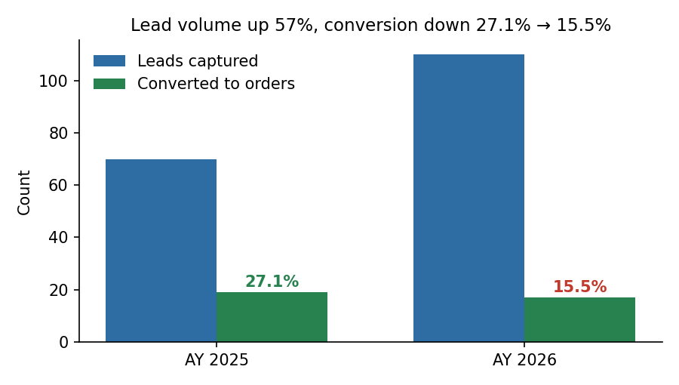
Figure 3 — Leads rose 70 → 110, but conversions fell 19 → 17.
Marketing is generating more demand than ever, yet conversion nearly halved (27.1% → 15.5%). 60 of 180 leads ended Lost and 21 sit Dormant — evidence of follow-up failure rather than demand failure, since follow-up dates and next actions are frequently overdue in leads_master.
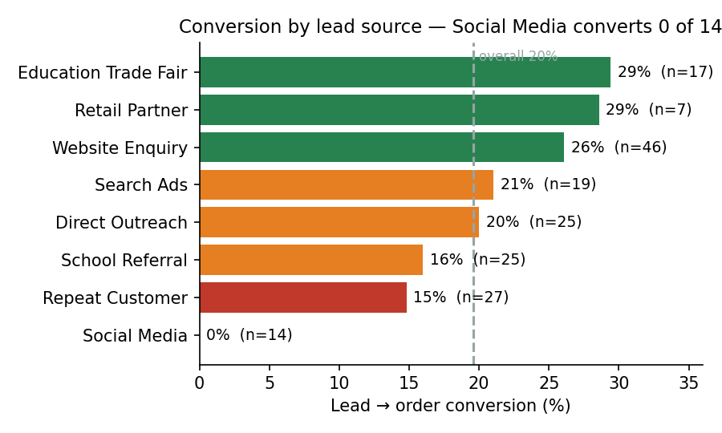
Figure 4 — Conversion by source; volume ≠ quality.
Education trade fairs (29.4%) and the website (26.1%, and the largest source at 46 leads) outperform; Social Media converted 0 of 14 leads and Repeat Customer conversion (14.8%) is alarmingly low for what should be the warmest segment — a retention red flag.

4.2 Delivery punctuality is collapsing
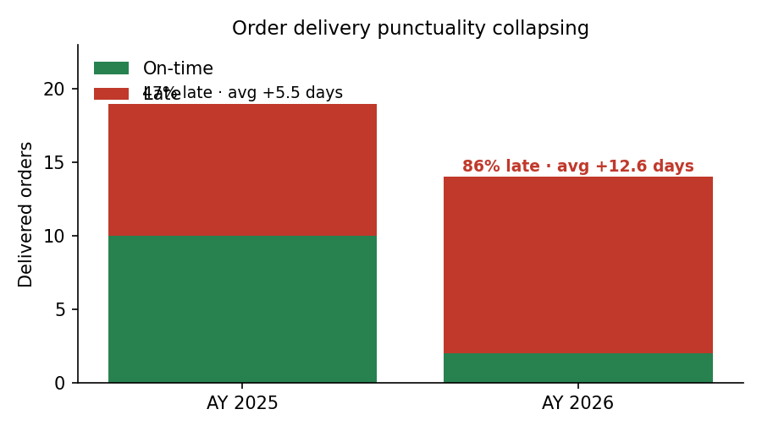
Figure 5 — Late deliveries 47% → 86% of delivered orders; average slip 5.5 → 12.6 days.
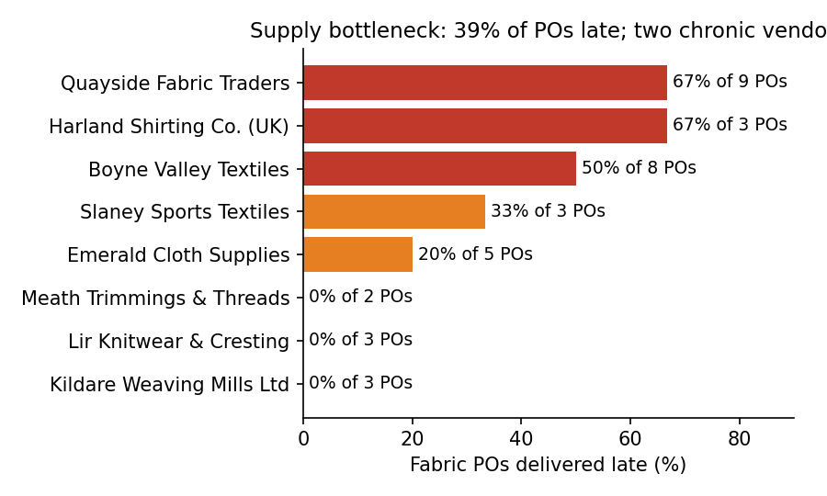
Figure 6 — 14 of 36 fabric POs (39%) arrived late; Quayside Fabric Traders (6/9) and Boyne Valley Textiles (4/8) are chronic.
Late fabric arrivals cascade directly into late school deliveries — orders supplied by the two chronic vendors dominate the AY2026 late list. Uniforms that miss the back-to-school window are the single biggest driver of the returns and reputation damage below.

4.3 The factory burns margin
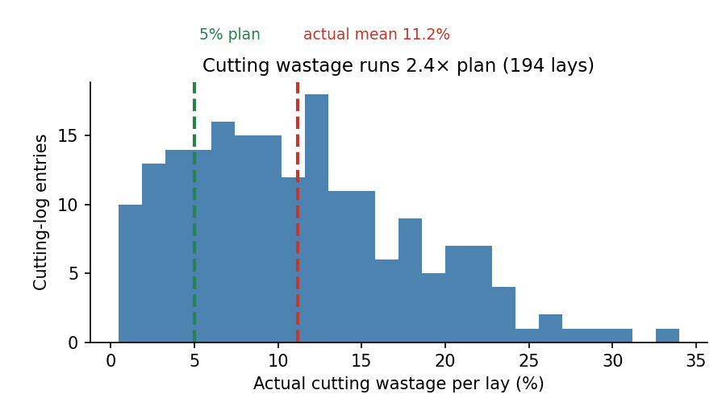
Figure 7 — Actual wastage per lay vs the 5% plan.
Mean wastage of 11.2% vs 4.6% planned, with lays as high as 34%. The recorded reasons are process problems, not fabric problems: operator re-cuts (40 entries), shade variation between lots (38) and tartan pattern misalignment (30) lead the Pareto — all addressable with marker software and lot-shade controls.
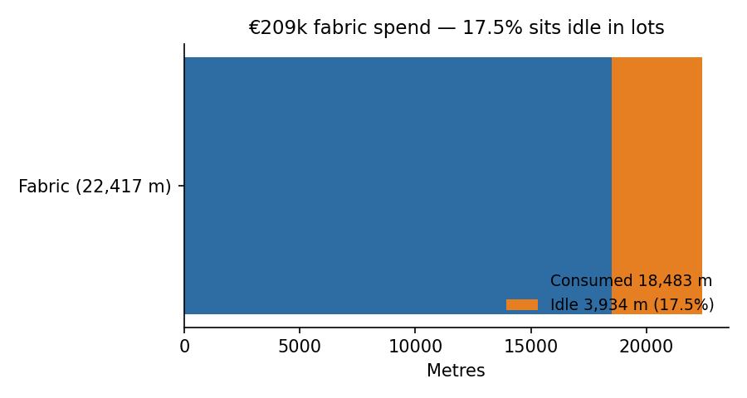
Figure 8 — 17.5% of purchased fabric (≈3,913 m of 22,417 m) sits idle across 149 lots.

4.4 Quality and cash leakage
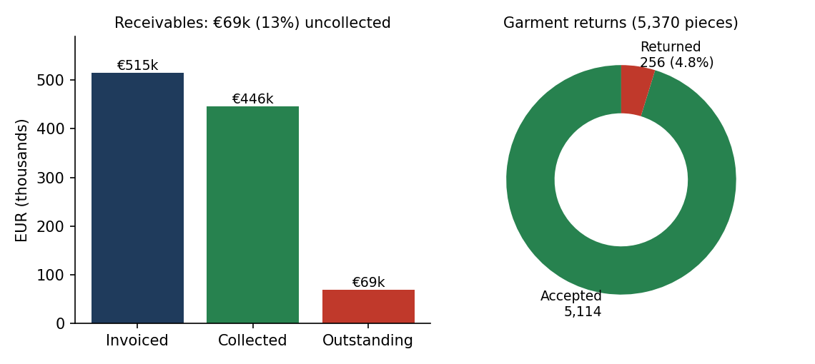
Figure 9 — Receivables and piece-level returns.
4.8% of delivered garments come back — size remakes (57), hem faults (52) and fabric shade mismatch (51) top the reasons, tying quality directly to the cutting-floor findings. Financially, €68,992 of €514,905 invoiced remains outstanding, and at student level €220,818 of €437,940 payable is still uncollected — the receivables-ageing problem the BI layer must make visible. Every invoice satisfies grand_total = net_total + vat_amount, with 27 invoices at 23% VAT (adult sizes) and 9 at 0% (children's clothing).

4.5 Linking the EDA to the SWOT / gap analysis
SWOT / gap item | Evidence in the mock data | BI / CRM response
Weakness — sales funnel leaking | Conversion 27.1% → 15.5%; Social Media converts 0/14; 36 leads Lost in AY2026 | CRM pipeline stages, follow-up SLAs, lead-source ROI dashboard
Weakness — chronic lateness | 86% of AY2026 orders late; late fabric POs correlate with late orders | Supplier scorecard + order-punctuality dashboard; reorder-point alerts
Weakness — factory efficiency | Wastage 2.4× plan; 17.5% of fabric idle (≈€36.6k tied up) | Wastage-by-reason Pareto; lot-utilisation report
Weakness — cash collection | €69k receivables outstanding; €220.8k parent balances unpaid at measurement level | Receivables-ageing dashboard; automated payment reminders via CRM
Strength — data capture discipline | Piece-level delivery_records (5,370 rows), 6-phase production log, lot-level fabric traceability | Foundation is strong enough to power BI without re-platforming
Opportunity — repeat business | 27 repeat-customer leads; 40 school accounts on file | CRM nurture journeys per school year; earlier measurement scheduling
Threat — vendor concentration | 2 of 8 vendors cause 10 of 14 late POs | Dual-sourcing rules; vendor OTIF KPI in dashboard
Table 3 — Evidence-to-intervention mapping used in the SWOT/gap analysis.

5. Data Pre-Processing Steps
The dataset was synthesised, cleaned and validated before loading into the CRM and BI tools. The pipeline (Python 3 / pandas / Faker, fixed seed 4321 for full reproducibility) applied the following steps in order:
- Seed reference entities. Reference data first — users, employees, vendors, fabric_types, garment_types, lead_sources, lead_statuses and production_phases were generated as controlled vocabularies so that every later fact row could key into them.
- Synthetic PII generation. All personal data (school names, contact people, parents' and students' names, phone numbers, emails, Eircodes) was produced with the en_IE Faker locale — no real PII exists anywhere in the dataset, satisfying GDPR-safe handling for coursework.
- Currency normalisation. Every monetary value was normalised to EUR, rounded to 2 decimal places, and each financial table carries an explicit currency = 'EUR' column; no legacy GST fields remain (vendors carry vat_number).
- VAT computation & financial identities. Irish VAT was calculated, not randomised: 0% on children's clothing (Primary School / Gaelscoil orders), 23% on adult-size clothing (Secondary / College) and on B2B fabric purchases. The identities grand_total = net_total + vat_amount and grand_total = advance + payments + balance were enforced and re-verified to a maximum error of 4 × 10⁻¹² across all 36 invoices.
- JSON encoding of measurements. Semi-structured attributes — per-student sizes, garment lists, quantities and order requirements — were serialised as JSON (jsonb) so a single measurements row fully describes a student while remaining queryable.
- Temporal ordering. Chronological causality was enforced: no effect precedes its cause (lead before order, order before measurement, PO before lot, cutting before production, production before delivery, delivery before return).
- Referential-integrity validation. All 66 foreign keys were programmatically validated to resolve — including the two varchar references (cutting_groups.order_id, delivery_records.order_id → order_master.order_id) — and lot consistency (remaining_quantity ≤ initial_quantity) was checked on all 149 fabric lots.
- Distress-signal injection. Known business-distress patterns were injected at controlled rates so dashboards have signal to find: falling conversion, worsening lateness concentrated in two vendors, above-plan wastage, ~5% returns and ageing receivables (Section 4 quantifies each).
- Load-test against the DDL. As a final gate, the rewritten schema.sql (PK, FK, UNIQUE and NOT NULL constraints) was executed in a fresh database and all 23 CSVs were bulk-loaded in dependency order with constraints enforced — 100% of rows loaded, proving the data and structure agree exactly.
- Export & load. CSVs were exported UTF-8 with ISO-8601 timestamps, then imported into the CRM (leads, accounts, contacts, orders) and the BI tool (full star of fact and dimension tables) without further transformation.

