AI in Cyber Security Laboratory Manual
Table of Contents

This lab manual contains the program question, dataset reference, complete Python code, terminal output, and generated image outputs for each weekly lab program.
Dataset Files
- auth.log (datasets/auth.log)
- capture20110810.binetflow (datasets/capture20110810.binetflow)
- dataset_full.csv (datasets/dataset_full.csv)
- KDDTest+.txt (datasets/KDDTest+.txt)
- KDDTrain+.txt (datasets/KDDTrain+.txt)
- spam.csv (datasets/spam.csv)
Program 1
Lab Program Question
Write a program to preprocess and visualize cyber threat datasets to understand attack patterns and data characteristics.
Dataset Link
- KDDTrain+.txt (datasets/KDDTrain+.txt)
Program Code
File: week1/p1.py (week1/p1.py)
# ============================================
# WEEK 1: DATA PREPROCESSING & VISUALIZATION
# (UPGRADED VERSION)
# ============================================
import pandas as pd
import numpy as np
import matplotlib.pyplot as plt
import seaborn as sns
from sklearn.preprocessing import LabelEncoder, MinMaxScaler
from mpl_toolkits.mplot3d import Axes3D
# ============================================
# LOAD DATASET
# ============================================
def load_dataset(filepath):
columns = [
'duration','protocol_type','service','flag','src_bytes','dst_bytes',
'land','wrong_fragment','urgent','hot','num_failed_logins','logged_in',
'num_compromised','root_shell','su_attempted','num_root','num_file_creations',
'num_shells','num_access_files','num_outbound_cmds','is_host_login',
'is_guest_login','count','srv_count','serror_rate','srv_serror_rate',
'rerror_rate','srv_rerror_rate','same_srv_rate','diff_srv_rate',
'srv_diff_host_rate','dst_host_count','dst_host_srv_count',
'dst_host_same_srv_rate','dst_host_diff_srv_rate',
'dst_host_same_src_port_rate','dst_host_srv_diff_host_rate',
'dst_host_serror_rate','dst_host_srv_serror_rate',
'dst_host_rerror_rate','dst_host_srv_rerror_rate','label','difficulty'
]
df = pd.read_csv(filepath, names=columns)
print("Dataset Loaded:", df.shape)
return df
# ============================================
# CLEAN DATA
# ============================================
def clean_data(df):
df = df.drop_duplicates()
df = df.dropna()
# Convert label to binary
df['label'] = df['label'].apply(lambda x: 'Normal' if x == 'normal' else 'Attack')
print("After Cleaning:", df.shape)
return df
# ============================================
# ENCODE + SCALE (FOR FUTURE USE)
# ============================================
def encode_scale(df):
df_encoded = df.copy()
le = LabelEncoder()
for col in ['protocol_type','service','flag']:
df_encoded[col] = le.fit_transform(df_encoded[col])
scaler = MinMaxScaler()
num_cols = df_encoded.select_dtypes(include=np.number).columns
df_encoded[num_cols] = scaler.fit_transform(df_encoded[num_cols])
return df_encoded
# ============================================
# VISUALIZATION (RAW DATA ONLY)
# ============================================
def visualize(df):
print("\nGenerating Visualizations...")
# -------- 1. COUNT PLOT --------
plt.figure(figsize=(6,4))
sns.countplot(x='label', data=df)
plt.title("Normal vs Attack Count")
plt.show()
# -------- 2. SCATTER (LOG SCALE) --------
plt.figure(figsize=(6,4))
plt.scatter(df['src_bytes'], df['dst_bytes'], alpha=0.5)
plt.xscale('log')
plt.yscale('log')
plt.title("Scatter (Log Scale): src_bytes vs dst_bytes")
plt.xlabel("src_bytes")
plt.ylabel("dst_bytes")
plt.show()
# -------- 3. HEATMAP --------
plt.figure(figsize=(12,8))
numeric_df = df.select_dtypes(include=np.number)
sns.heatmap(numeric_df.corr(), cmap='coolwarm')
plt.title("Correlation Heatmap")
plt.show()
# -------- 4. BOXPLOT --------
plt.figure(figsize=(6,4))
sns.boxplot(x='label', y='src_bytes', data=df)
plt.yscale('log')
plt.title("Boxplot (Log Scale): src_bytes vs Label")
plt.show()
# -------- 5. 3D SCATTER --------
sample = df.sample(3000)
fig = plt.figure(figsize=(8,6))
ax = fig.add_subplot(111, projection='3d')
ax.scatter(sample['src_bytes'], sample['dst_bytes'], sample['count'],
alpha=0.5)
ax.set_xlabel("src_bytes")
ax.set_ylabel("dst_bytes")
ax.set_zlabel("count")
plt.title("3D Scatter Plot")
plt.show()
# ============================================
# MAIN
# ============================================
if __name__ == "__main__":
# Load
df = load_dataset("../datasets/KDDTrain+.txt")
# Clean
df = clean_data(df)
# Keep RAW for visualization
df_visual = df.copy()
# Create scaled version (future weeks)
df_scaled = encode_scale(df)
# Visualize RAW data
visualize(df_visual)
print("\n✅ Week 1 Completed (Enhanced Visualization)")

Terminal Output
Terminal output file: week1/result.txt (week1/result.txt)
Program: p1.py
Working directory: D:\Desktop\msc-lab\week1
Exit code: 0
========================================================================
Dataset Loaded: (125973, 43)
After Cleaning: (125973, 43)
Generating Visualizations...
[saved image] result_image_01.png
[saved image] result_image_02.png
[saved image] result_image_03.png
[saved image] result_image_04.png
[saved image] result_image_05.png
✅ Week 1 Completed (Enhanced Visualization)

Output Images
Program 1 Result Image 01
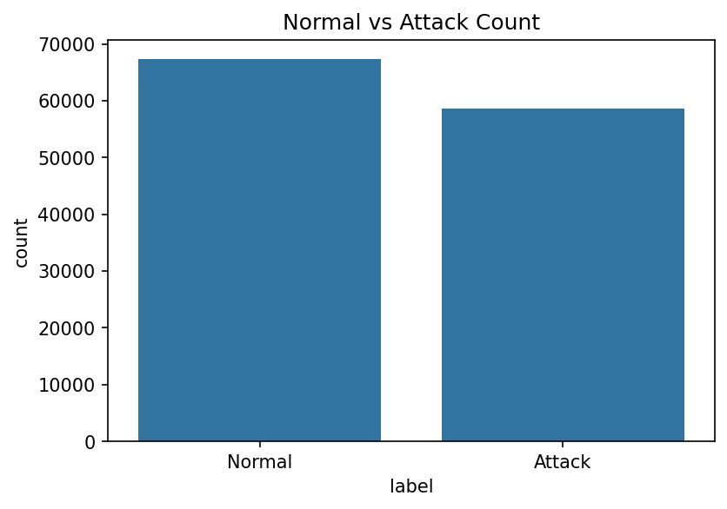
Program 1 Result Image 02
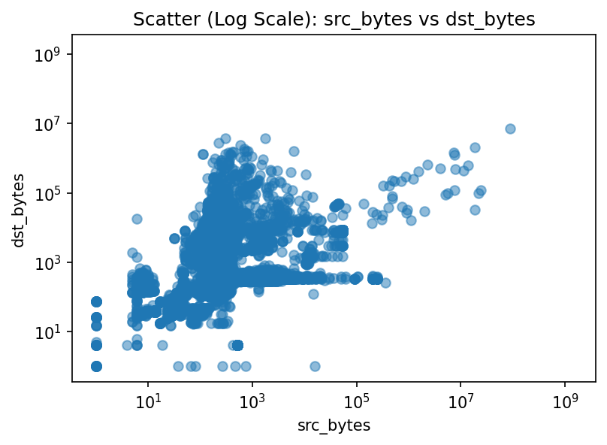
Program 1 Result Image 03
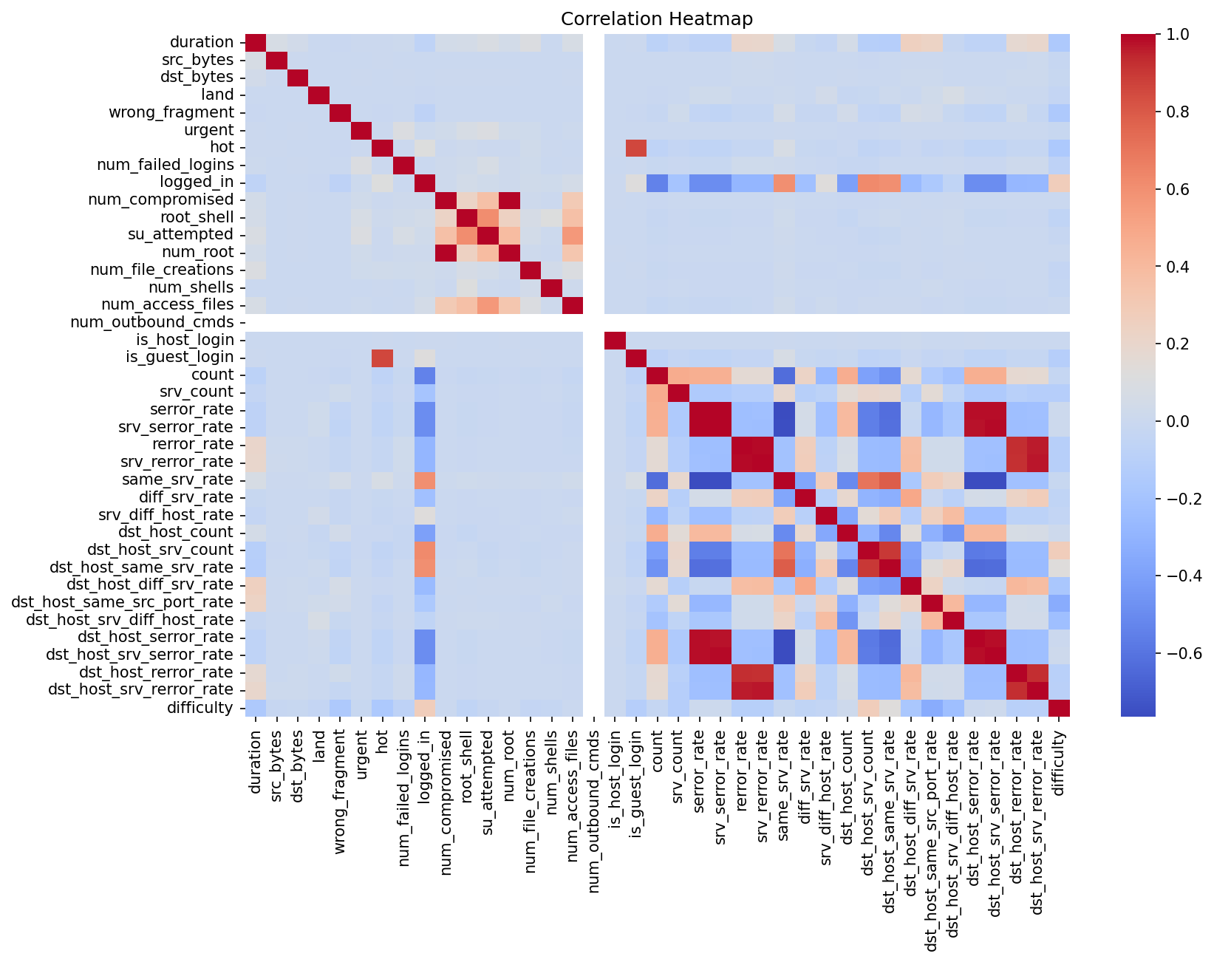
Program 1 Result Image 04
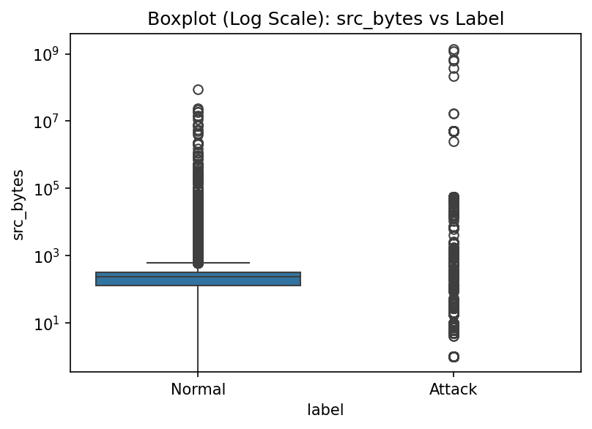
Program 1 Result Image 05
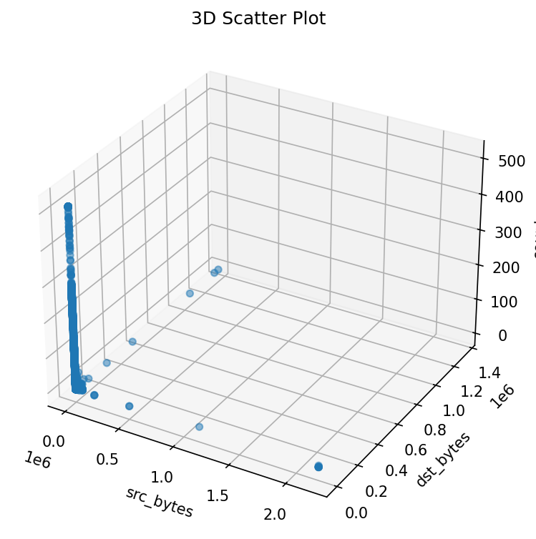

Program 2
Lab Program Question
Write a program to implement supervised classification for spam or phishing detection using algorithms such as Logistic Regression, Decision Trees, and Naive Bayes.
Dataset Link
- dataset_full.csv (datasets/dataset_full.csv)
Program Code
File: week2/p2.py (week2/p2.py)
# ============================================
# WEEK 2: PHISHING DETECTION (FIXED VERSION)
# ============================================
import pandas as pd
import numpy as np
from sklearn.model_selection import train_test_split
from sklearn.preprocessing import StandardScaler
from sklearn.linear_model import LogisticRegression
from sklearn.tree import DecisionTreeClassifier
from sklearn.naive_bayes import GaussianNB
from sklearn.metrics import accuracy_score, confusion_matrix, classification_report
import seaborn as sns
import matplotlib.pyplot as plt
# ============================================
# LOAD DATA
# ============================================
def load_data(filepath):
df = pd.read_csv(filepath)
print("Dataset Loaded:", df.shape)
return df
# ============================================
# PREPROCESS DATA
# ============================================
def preprocess(df):
print("\nColumns:")
print(df.columns)
# Target column (based on your dataset)
target = 'phishing'
# Features and labels
X = df.drop(columns=[target])
y = df[target]
# Convert to numeric (just in case)
X = X.apply(pd.to_numeric, errors='coerce')
# Handle missing values
X = X.fillna(0)
# Scale features
scaler = StandardScaler()
X_scaled = scaler.fit_transform(X)
return X_scaled, y
# ============================================
# TRAIN MODELS
# ============================================
def train_models(X_train, y_train):
models = {
"Logistic Regression": LogisticRegression(max_iter=1000),
"Decision Tree": DecisionTreeClassifier(),
"Naive Bayes": GaussianNB()
}
trained_models = {}
for name, model in models.items():
model.fit(X_train, y_train)
trained_models[name] = model
return trained_models
# ============================================
# EVALUATE MODELS
# ============================================
def evaluate(models, X_test, y_test):
for name, model in models.items():
print(f"\n===== {name} =====")
y_pred = model.predict(X_test)
acc = accuracy_score(y_test, y_pred)
print("Accuracy:", acc)
print("\nClassification Report:")
print(classification_report(y_test, y_pred))
# Confusion Matrix
cm = confusion_matrix(y_test, y_pred)
plt.figure(figsize=(4,3))
sns.heatmap(cm, annot=True, fmt='d', cmap='Blues')
plt.title(f"{name} Confusion Matrix")
plt.xlabel("Predicted")
plt.ylabel("Actual")
plt.show()
# ============================================
# MAIN
# ============================================
if __name__ == "__main__":
# Load dataset
df = load_data("../datasets/dataset_full.csv")
# Preprocess
X, y = preprocess(df)
# Split data
X_train, X_test, y_train, y_test = train_test_split(
X, y, test_size=0.2, random_state=42
)
# Train models
models = train_models(X_train, y_train)
# Evaluate
evaluate(models, X_test, y_test)
print("\n✅ Week 2 Completed Successfully!")

Terminal Output
Terminal output file: week2/result.txt (week2/result.txt)
Program: p2.py
Working directory: D:\Desktop\msc-lab\week2
Exit code: 0
========================================================================
Dataset Loaded: (88647, 112)
Columns:
Index(['qty_dot_url', 'qty_hyphen_url', 'qty_underline_url', 'qty_slash_url',
'qty_questionmark_url', 'qty_equal_url', 'qty_at_url', 'qty_and_url',
'qty_exclamation_url', 'qty_space_url',
...
'qty_ip_resolved', 'qty_nameservers', 'qty_mx_servers', 'ttl_hostname',
'tls_ssl_certificate', 'qty_redirects', 'url_google_index',
'domain_google_index', 'url_shortened', 'phishing'],
dtype='str', length=112)
===== Logistic Regression =====
Accuracy: 0.9328821206993796
Classification Report:
precision recall f1-score support
0 0.95 0.94 0.95 11612
1 0.89 0.91 0.90 6118
accuracy 0.93 17730
macro avg 0.92 0.93 0.93 17730
weighted avg 0.93 0.93 0.93 17730
[saved image] result_image_01.png
===== Decision Tree =====
Accuracy: 0.9545967287084038
Classification Report:
precision recall f1-score support
0 0.97 0.96 0.97 11612
1 0.93 0.94 0.93 6118
accuracy 0.95 17730
macro avg 0.95 0.95 0.95 17730
weighted avg 0.95 0.95 0.95 17730
[saved image] result_image_02.png
===== Naive Bayes =====
Accuracy: 0.7763113367174281
Classification Report:
precision recall f1-score support
0 0.76 0.97 0.85 11612
1 0.89 0.40 0.55 6118
accuracy 0.78 17730
macro avg 0.82 0.69 0.70 17730
weighted avg 0.80 0.78 0.75 17730
[saved image] result_image_03.png
✅ Week 2 Completed Successfully!

Output Images
Program 2 Result Image 01
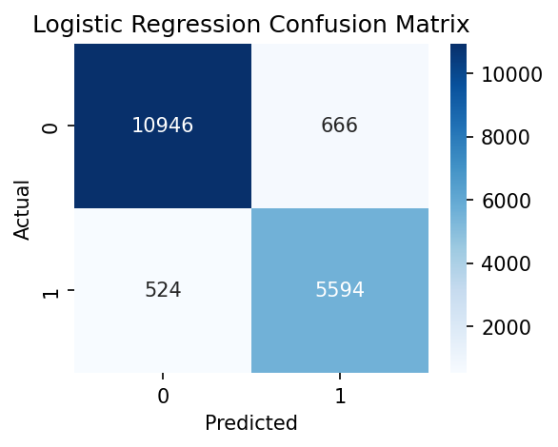
Program 2 Result Image 02
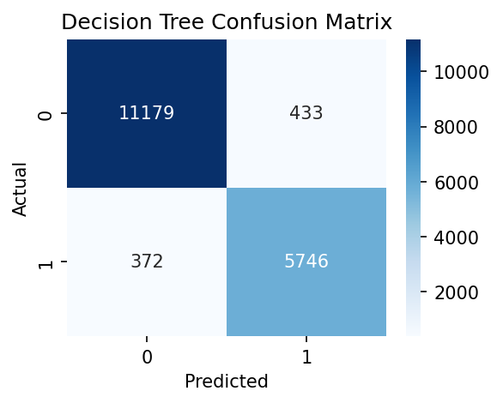
Program 2 Result Image 03
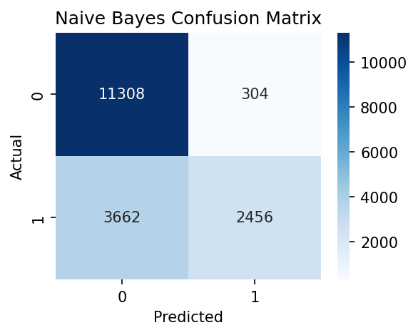

Program 3
Lab Program Question
Write a program to implement an anomaly detection system using unsupervised learning techniques for identifying network intrusions.
Dataset Link
- KDDTrain+.txt (datasets/KDDTrain+.txt)
Program Code
File: week3/p3.py (week3/p3.py)
# ============================================
# WEEK 3: ANOMALY DETECTION (UNSUPERVISED)
# ============================================
import pandas as pd
import numpy as np
from sklearn.ensemble import IsolationForest
from sklearn.preprocessing import LabelEncoder, StandardScaler
import matplotlib.pyplot as plt
# ============================================
# LOAD DATA
# ============================================
def load_dataset(filepath):
columns = [
'duration','protocol_type','service','flag','src_bytes','dst_bytes',
'land','wrong_fragment','urgent','hot','num_failed_logins','logged_in',
'num_compromised','root_shell','su_attempted','num_root','num_file_creations',
'num_shells','num_access_files','num_outbound_cmds','is_host_login',
'is_guest_login','count','srv_count','serror_rate','srv_serror_rate',
'rerror_rate','srv_rerror_rate','same_srv_rate','diff_srv_rate',
'srv_diff_host_rate','dst_host_count','dst_host_srv_count',
'dst_host_same_srv_rate','dst_host_diff_srv_rate',
'dst_host_same_src_port_rate','dst_host_srv_diff_host_rate',
'dst_host_serror_rate','dst_host_srv_serror_rate',
'dst_host_rerror_rate','dst_host_srv_rerror_rate','label','difficulty'
]
df = pd.read_csv(filepath, names=columns)
print("Dataset Loaded:", df.shape)
return df
# ============================================
# PREPROCESS
# ============================================
def preprocess(df):
# Convert label for evaluation only
df['label'] = df['label'].apply(lambda x: 0 if x == 'normal' else 1)
# Encode categorical features
le = LabelEncoder()
for col in ['protocol_type', 'service', 'flag']:
df[col] = le.fit_transform(df[col])
# Drop label for UNSUPERVISED learning
X = df.drop(columns=['label', 'difficulty'])
# Scale features
scaler = StandardScaler()
X_scaled = scaler.fit_transform(X)
return X_scaled, df['label']
# ============================================
# ANOMALY DETECTION
# ============================================
def detect_anomalies(X):
# Isolation Forest model
model = IsolationForest(contamination=0.1, random_state=42)
model.fit(X)
predictions = model.predict(X) # 1 (normal), -1 (anomaly)
return predictions
# ============================================
# EVALUATION
# ============================================
def evaluate(predictions, true_labels):
# Convert predictions:
# -1 → anomaly → 1
# 1 → normal → 0
pred = np.where(predictions == -1, 1, 0)
print("\nDetected Anomalies:", np.sum(pred))
# Compare with true labels
accuracy = np.mean(pred == true_labels)
print("Approx Accuracy:", accuracy)
# ============================================
# VISUALIZATION
# ============================================
def visualize(X, predictions):
# Convert predictions
normal = X[predictions == 1]
anomaly = X[predictions == -1]
plt.figure(figsize=(6,4))
# Plot normal points
plt.scatter(normal[:, 0], normal[:, 1],
color='blue', label='Normal', alpha=0.5)
# Plot anomalies
plt.scatter(anomaly[:, 0], anomaly[:, 1],
color='red', label='Anomaly', alpha=0.5)
plt.title("Anomaly Detection Visualization")
plt.xlabel("Feature 1")
plt.ylabel("Feature 2")
plt.legend()
plt.show()
# ============================================
# MAIN
# ============================================
if __name__ == "__main__":
df = load_dataset("../datasets/KDDTrain+.txt")
X, y = preprocess(df)
predictions = detect_anomalies(X)
evaluate(predictions, y)
visualize(X, predictions)
print("\n✅ Week 3 Completed Successfully!")

Terminal Output
Terminal output file: week3/result.txt (week3/result.txt)
Program: p3.py
Working directory: D:\Desktop\msc-lab\week3
Exit code: 0
========================================================================
Dataset Loaded: (125973, 43)
Detected Anomalies: 12598
Approx Accuracy: 0.5669071943987998
[saved image] result_image_01.png
✅ Week 3 Completed Successfully!

Output Images
Program 3 Result Image 01
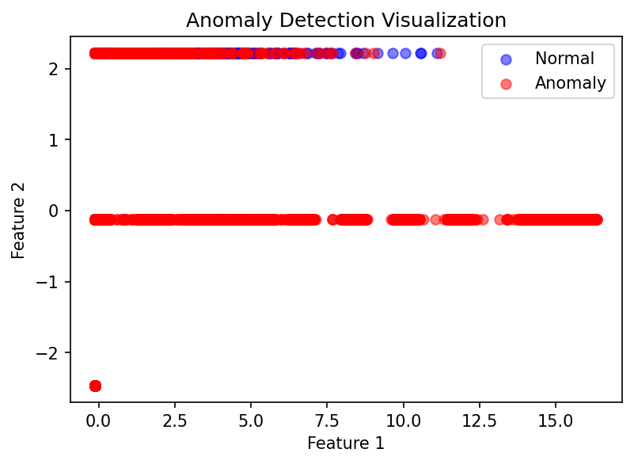

Program 4
Lab Program Question
Write a program to design and evaluate an Intrusion Detection System (IDS) using machine learning algorithms and performance metrics such as Accuracy, Precision, Recall, and F1-Score.
Dataset Link
- KDDTrain+.txt (datasets/KDDTrain+.txt)
Program Code
File: week4/p4.py (week4/p4.py)
# ============================================
# WEEK 4: INTRUSION DETECTION SYSTEM (IDS)
# ============================================
import pandas as pd
import numpy as np
from sklearn.model_selection import train_test_split
from sklearn.preprocessing import LabelEncoder, StandardScaler
from sklearn.tree import DecisionTreeClassifier
from sklearn.metrics import accuracy_score, precision_score, recall_score, f1_score,
confusion_matrix
import seaborn as sns
import matplotlib.pyplot as plt
# ============================================
# LOAD DATA
# ============================================
def load_dataset(filepath):
columns = [
'duration','protocol_type','service','flag','src_bytes','dst_bytes',
'land','wrong_fragment','urgent','hot','num_failed_logins','logged_in',
'num_compromised','root_shell','su_attempted','num_root','num_file_creations',
'num_shells','num_access_files','num_outbound_cmds','is_host_login',
'is_guest_login','count','srv_count','serror_rate','srv_serror_rate',
'rerror_rate','srv_rerror_rate','same_srv_rate','diff_srv_rate',
'srv_diff_host_rate','dst_host_count','dst_host_srv_count',
'dst_host_same_srv_rate','dst_host_diff_srv_rate',
'dst_host_same_src_port_rate','dst_host_srv_diff_host_rate',
'dst_host_serror_rate','dst_host_srv_serror_rate',
'dst_host_rerror_rate','dst_host_srv_rerror_rate','label','difficulty'
]
df = pd.read_csv(filepath, names=columns)
print("Dataset Loaded:", df.shape)
return df
# ============================================
# PREPROCESS
# ============================================
def preprocess(df):
# Convert label
df['label'] = df['label'].apply(lambda x: 0 if x == 'normal' else 1)
# Encode categorical features
le = LabelEncoder()
for col in ['protocol_type', 'service', 'flag']:
df[col] = le.fit_transform(df[col])
# Features & Target
X = df.drop(columns=['label', 'difficulty'])
y = df['label']
# Scale data
scaler = StandardScaler()
X_scaled = scaler.fit_transform(X)
return X_scaled, y
# ============================================
# TRAIN MODEL
# ============================================
def train_model(X_train, y_train):
model = DecisionTreeClassifier()
model.fit(X_train, y_train)
return model
# ============================================
# EVALUATE
# ============================================
def evaluate(model, X_test, y_test):
y_pred = model.predict(X_test)
print("\nAccuracy:", accuracy_score(y_test, y_pred))
print("Precision:", precision_score(y_test, y_pred))
print("Recall:", recall_score(y_test, y_pred))
print("F1 Score:", f1_score(y_test, y_pred))
# Confusion Matrix
cm = confusion_matrix(y_test, y_pred)
plt.figure(figsize=(4,3))
sns.heatmap(cm, annot=True, fmt='d', cmap='Blues')
plt.title("Confusion Matrix")
plt.xlabel("Predicted")
plt.ylabel("Actual")
plt.show()
# ============================================
# MAIN
# ============================================
if __name__ == "__main__":
df = load_dataset("../datasets/KDDTrain+.txt")
X, y = preprocess(df)
X_train, X_test, y_train, y_test = train_test_split(
X, y, test_size=0.2, random_state=42
)
model = train_model(X_train, y_train)
evaluate(model, X_test, y_test)
print("\n✅ Week 4 Completed Successfully!")

Terminal Output
Terminal output file: week4/result.txt (week4/result.txt)
Program: p4.py
Working directory: D:\Desktop\msc-lab\week4
Exit code: 0
========================================================================
Dataset Loaded: (125973, 43)
Accuracy: 0.9980154792617583
Precision: 0.9982150446238844
Recall: 0.9975367366006965
F1 Score: 0.9978757753420001
[saved image] result_image_01.png
✅ Week 4 Completed Successfully!

Output Images
Program 4 Result Image 01
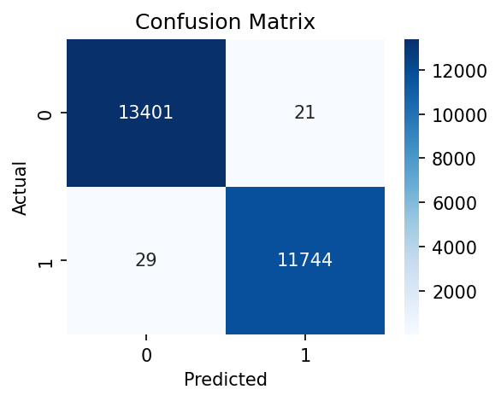

Program 5
Lab Program Question
Write a program to apply clustering algorithms such as K-Means and DBSCAN for detecting abnormal patterns and grouping malicious network traffic.
Dataset Link
- KDDTrain+.txt (datasets/KDDTrain+.txt)
Program Code
File: week5/p5.py (week5/p5.py)
# ============================================
# WEEK 5: CLUSTERING (K-MEANS + DBSCAN)
# ============================================
import pandas as pd
import numpy as np
from sklearn.preprocessing import LabelEncoder, StandardScaler
from sklearn.cluster import KMeans, DBSCAN
import matplotlib.pyplot as plt
# ============================================
# LOAD DATA
# ============================================
def load_dataset(filepath):
columns = [
'duration','protocol_type','service','flag','src_bytes','dst_bytes',
'land','wrong_fragment','urgent','hot','num_failed_logins','logged_in',
'num_compromised','root_shell','su_attempted','num_root','num_file_creations',
'num_shells','num_access_files','num_outbound_cmds','is_host_login',
'is_guest_login','count','srv_count','serror_rate','srv_serror_rate',
'rerror_rate','srv_rerror_rate','same_srv_rate','diff_srv_rate',
'srv_diff_host_rate','dst_host_count','dst_host_srv_count',
'dst_host_same_srv_rate','dst_host_diff_srv_rate',
'dst_host_same_src_port_rate','dst_host_srv_diff_host_rate',
'dst_host_serror_rate','dst_host_srv_serror_rate',
'dst_host_rerror_rate','dst_host_srv_rerror_rate','label','difficulty'
]
df = pd.read_csv(filepath, names=columns)
print("Dataset Loaded:", df.shape)
return df
# ============================================
# PREPROCESS
# ============================================
def preprocess(df):
# Encode categorical features
le = LabelEncoder()
for col in ['protocol_type', 'service', 'flag']:
df[col] = le.fit_transform(df[col])
# Drop label (unsupervised)
X = df.drop(columns=['label', 'difficulty'])
# Scale data
scaler = StandardScaler()
X_scaled = scaler.fit_transform(X)
return X_scaled
# ============================================
# K-MEANS
# ============================================
def apply_kmeans(X):
kmeans = KMeans(n_clusters=2, random_state=42)
labels = kmeans.fit_predict(X)
print("\nK-Means Clustering Done!")
return labels
# ============================================
# DBSCAN
# ============================================
def apply_dbscan(X):
dbscan = DBSCAN(eps=2, min_samples=10)
labels = dbscan.fit_predict(X)
print("\nDBSCAN Clustering Done!")
return labels
# ============================================
# VISUALIZATION
# ============================================
def visualize(X, labels, title):
plt.figure(figsize=(10,6)) # bigger figure
unique_labels = np.unique(labels)
max_clusters = 5
shown_labels = unique_labels[:max_clusters]
for label in shown_labels:
cluster_points = X[labels == label]
# Noise handling
if label == -1:
plt.scatter(cluster_points[:, 0], cluster_points[:, 1],
label='Noise (Anomaly)',
alpha=0.6, s=10)
else:
plt.scatter(cluster_points[:, 0], cluster_points[:, 1],
label=f'Cluster {label}',
alpha=0.6, s=10)
plt.title(title)
plt.xlabel("Feature 1")
plt.ylabel("Feature 2")
# 🔥 Move legend outside
plt.legend(bbox_to_anchor=(1.05, 1), loc='upper left')
# Adjust layout so graph doesn't shrink
plt.tight_layout()
plt.show()
# ============================================
# MAIN
# ============================================
if __name__ == "__main__":
df = load_dataset("../datasets/KDDTrain+.txt")
X = preprocess(df)
X_sample = X[:10000] # or 3000 if needed
# K-Means
kmeans_labels = apply_kmeans(X)
visualize(X, kmeans_labels, "K-Means Clustering")
# DBSCAN
dbscan_labels = apply_dbscan(X_sample)
visualize(X_sample, dbscan_labels, "DBSCAN Clustering")
print("\n✅ Week 5 Completed Successfully!")

Terminal Output
Terminal output file: week5/result.txt (week5/result.txt)
Program: p5.py
Working directory: D:\Desktop\msc-lab\week5
Exit code: 0
========================================================================
Dataset Loaded: (125973, 43)
D:\Desktop\msc-lab\cyber_env\Lib\site-packages\joblib\externals\loky\backend\context.py:
131: UserWarning: Could not find the number of physical cores for the following
reason:
found 0 physical cores < 1
Returning the number of logical cores instead. You can silence this warning by setting
LOKY_MAX_CPU_COUNT to the number of cores you want to use.
warnings.warn(
File "D:\Desktop\msc-lab\cyber_env\Lib\site-packages\joblib\externals\loky\backend\con
text.py", line 255, in _count_physical_cores
raise ValueError(f"found {cpu_count_physical} physical cores < 1")
K-Means Clustering Done!
[saved image] result_image_01.png
DBSCAN Clustering Done!
[saved image] result_image_02.png
✅ Week 5 Completed Successfully!

Output Images
Program 5 Result Image 01
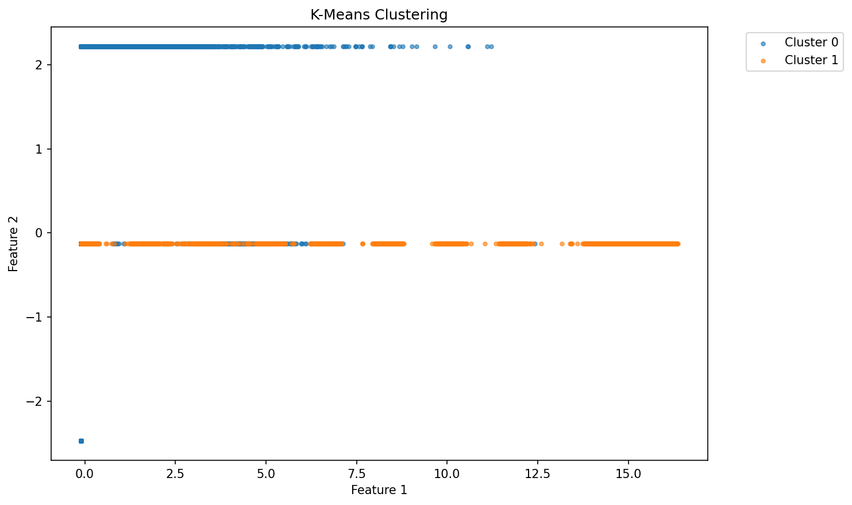
Program 5 Result Image 02
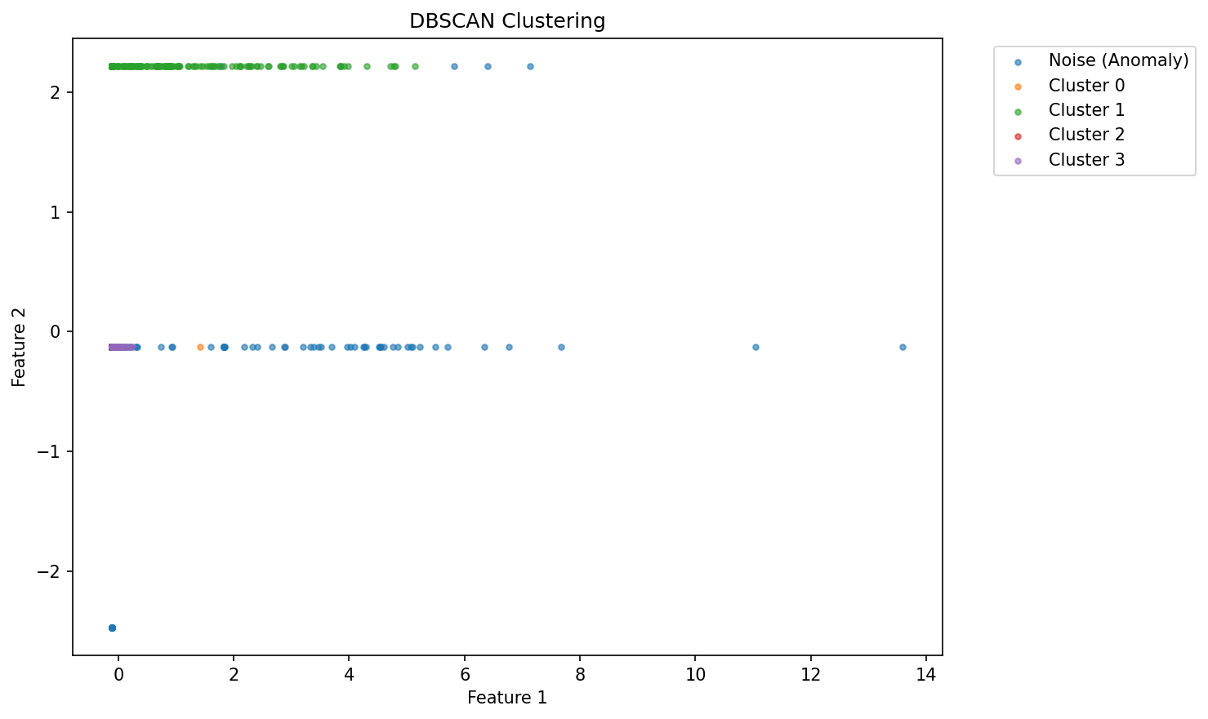

Program 6
Lab Program Question
Write a program to implement malware classification using feature extraction and supervised learning models such as Random Forest and SVM.
Dataset Link
- KDDTrain+.txt (datasets/KDDTrain+.txt)
Program Code
File: week6/p6.py (week6/p6.py)
# ============================================
# WEEK 6: MALWARE CLASSIFICATION
# ============================================
import pandas as pd
import numpy as np
from sklearn.model_selection import train_test_split
from sklearn.preprocessing import LabelEncoder, StandardScaler
from sklearn.ensemble import RandomForestClassifier
from sklearn.svm import SVC
from sklearn.metrics import accuracy_score, confusion_matrix, classification_report
import seaborn as sns
import matplotlib.pyplot as plt
# ============================================
# LOAD DATA
# ============================================
def load_dataset(filepath):
columns = [
'duration','protocol_type','service','flag','src_bytes','dst_bytes',
'land','wrong_fragment','urgent','hot','num_failed_logins','logged_in',
'num_compromised','root_shell','su_attempted','num_root','num_file_creations',
'num_shells','num_access_files','num_outbound_cmds','is_host_login',
'is_guest_login','count','srv_count','serror_rate','srv_serror_rate',
'rerror_rate','srv_rerror_rate','same_srv_rate','diff_srv_rate',
'srv_diff_host_rate','dst_host_count','dst_host_srv_count',
'dst_host_same_srv_rate','dst_host_diff_srv_rate',
'dst_host_same_src_port_rate','dst_host_srv_diff_host_rate',
'dst_host_serror_rate','dst_host_srv_serror_rate',
'dst_host_rerror_rate','dst_host_srv_rerror_rate','label','difficulty'
]
df = pd.read_csv(filepath, names=columns)
print("Dataset Loaded:", df.shape)
return df
# ============================================
# PREPROCESS
# ============================================
def preprocess(df):
# Convert label
df['label'] = df['label'].apply(lambda x: 0 if x == 'normal' else 1)
# Encode categorical
le = LabelEncoder()
for col in ['protocol_type', 'service', 'flag']:
df[col] = le.fit_transform(df[col])
# Split features & target
X = df.drop(columns=['label', 'difficulty'])
y = df['label']
# Scale features (important for SVM)
scaler = StandardScaler()
X_scaled = scaler.fit_transform(X)
return X_scaled, y, X.columns
# ============================================
# TRAIN MODELS
# ============================================
def train_models(X_train, y_train):
models = {
"Random Forest": RandomForestClassifier(n_estimators=100),
"SVM": SVC()
}
trained = {}
for name, model in models.items():
model.fit(X_train, y_train)
trained[name] = model
return trained
# ============================================
# EVALUATE
# ============================================
def evaluate(models, X_test, y_test):
for name, model in models.items():
print(f"\n===== {name} =====")
y_pred = model.predict(X_test)
print("Accuracy:", accuracy_score(y_test, y_pred))
print("\nReport:\n", classification_report(y_test, y_pred))
# Confusion Matrix
cm = confusion_matrix(y_test, y_pred)
plt.figure(figsize=(4,3))
sns.heatmap(cm, annot=True, fmt='d', cmap='Blues')
plt.title(f"{name} Confusion Matrix")
plt.show()
# ============================================
# FEATURE IMPORTANCE (KEY PART)
# ============================================
def feature_importance(model, feature_names):
importances = model.feature_importances_
# Sort top features
indices = np.argsort(importances)[-10:]
plt.figure(figsize=(8,5))
plt.barh(range(len(indices)), importances[indices])
plt.yticks(range(len(indices)), [feature_names[i] for i in indices])
plt.title("Top 10 Important Features")
plt.xlabel("Importance")
plt.show()
# ============================================
# MAIN
# ============================================
if __name__ == "__main__":
df = load_dataset("../datasets/KDDTrain+.txt")
X, y, feature_names = preprocess(df)
X_train, X_test, y_train, y_test = train_test_split(
X, y, test_size=0.2, random_state=42
)
models = train_models(X_train, y_train)
evaluate(models, X_test, y_test)
# Feature importance (only Random Forest)
feature_importance(models["Random Forest"], feature_names)
print("\n✅ Week 6 Completed Successfully!")

Terminal Output
Terminal output file: week6/result.txt (week6/result.txt)
Program: p6.py
Working directory: D:\Desktop\msc-lab\week6
Exit code: 0
========================================================================
Dataset Loaded: (125973, 43)
===== Random Forest =====
Accuracy: 0.9989283588013494
Report:
precision recall f1-score support
0 1.00 1.00 1.00 13422
1 1.00 1.00 1.00 11773
accuracy 1.00 25195
macro avg 1.00 1.00 1.00 25195
weighted avg 1.00 1.00 1.00 25195
[saved image] result_image_01.png
===== SVM =====
Accuracy: 0.9903155387973804
Report:
precision recall f1-score support
0 0.99 0.99 0.99 13422
1 0.99 0.99 0.99 11773
accuracy 0.99 25195
macro avg 0.99 0.99 0.99 25195
weighted avg 0.99 0.99 0.99 25195
[saved image] result_image_02.png
[saved image] result_image_03.png
✅ Week 6 Completed Successfully!

Output Images
Program 6 Result Image 01
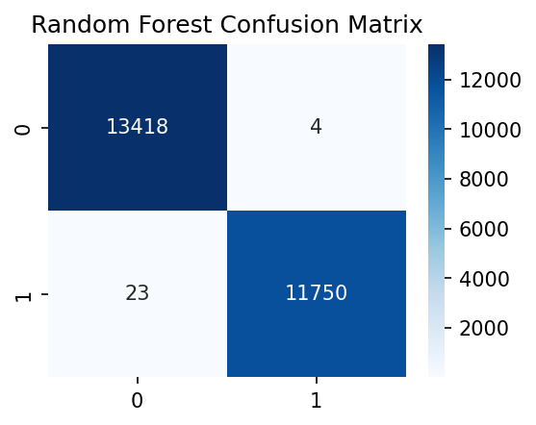
Program 6 Result Image 02
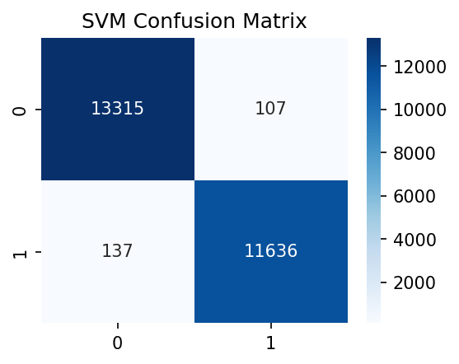
Program 6 Result Image 03
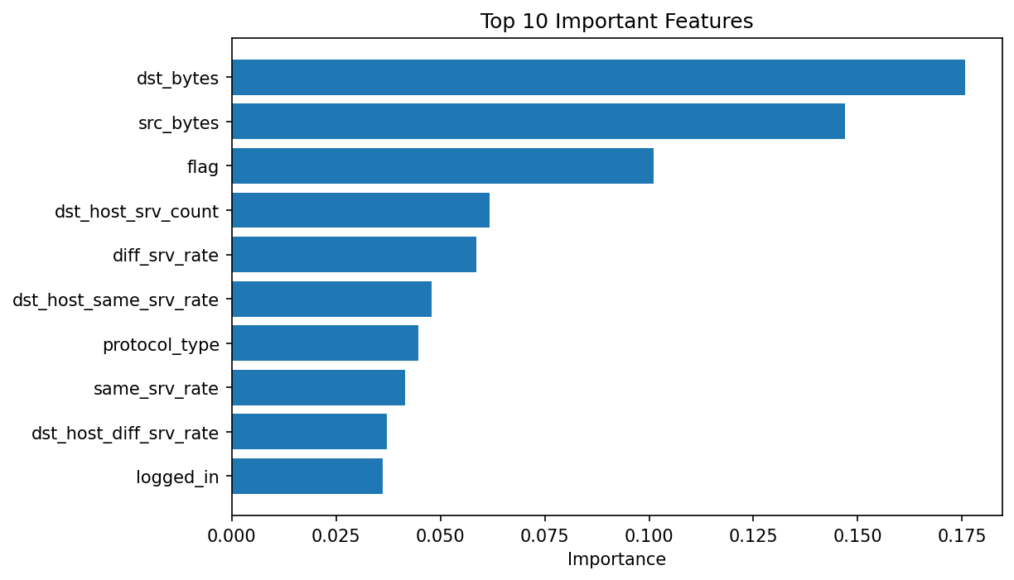

Program 7
Lab Program Question
Write a program to perform malware behavior analysis using unsupervised learning and dimensionality reduction techniques.
Dataset Link
- KDDTrain+.txt (datasets/KDDTrain+.txt)
Program Code
File: week7/p7.py (week7/p7.py)
# ============================================
# WEEK 7: DIMENSIONALITY REDUCTION (PCA)
# ============================================
import pandas as pd
import numpy as np
from sklearn.preprocessing import LabelEncoder, StandardScaler
from sklearn.decomposition import PCA
import matplotlib.pyplot as plt
# ============================================
# LOAD DATA
# ============================================
def load_dataset(filepath):
columns = [
'duration','protocol_type','service','flag','src_bytes','dst_bytes',
'land','wrong_fragment','urgent','hot','num_failed_logins','logged_in',
'num_compromised','root_shell','su_attempted','num_root','num_file_creations',
'num_shells','num_access_files','num_outbound_cmds','is_host_login',
'is_guest_login','count','srv_count','serror_rate','srv_serror_rate',
'rerror_rate','srv_rerror_rate','same_srv_rate','diff_srv_rate',
'srv_diff_host_rate','dst_host_count','dst_host_srv_count',
'dst_host_same_srv_rate','dst_host_diff_srv_rate',
'dst_host_same_src_port_rate','dst_host_srv_diff_host_rate',
'dst_host_serror_rate','dst_host_srv_serror_rate',
'dst_host_rerror_rate','dst_host_srv_rerror_rate','label','difficulty'
]
df = pd.read_csv(filepath, names=columns)
print("Dataset Loaded:", df.shape)
return df
# ============================================
# PREPROCESS
# ============================================
def preprocess(df):
# Convert label for visualization
df['label'] = df['label'].apply(lambda x: 0 if x == 'normal' else 1)
# Encode categorical features
le = LabelEncoder()
for col in ['protocol_type', 'service', 'flag']:
df[col] = le.fit_transform(df[col])
# Features & labels
X = df.drop(columns=['label', 'difficulty'])
y = df['label']
# Scale
scaler = StandardScaler()
X_scaled = scaler.fit_transform(X)
return X_scaled, y
# ============================================
# APPLY PCA
# ============================================
def apply_pca(X):
pca = PCA(n_components=2)
X_pca = pca.fit_transform(X)
print("Explained Variance:", pca.explained_variance_ratio_)
return X_pca
# ============================================
# VISUALIZE
# ============================================
def visualize(X_pca, y):
plt.figure(figsize=(8,6))
# Normal
plt.scatter(X_pca[y == 0, 0],
X_pca[y == 0, 1],
label="Normal",
alpha=0.5)
# Attack
plt.scatter(X_pca[y == 1, 0],
X_pca[y == 1, 1],
label="Attack",
alpha=0.5)
plt.title("PCA: Malware Behavior Visualization")
plt.xlabel("Principal Component 1")
plt.ylabel("Principal Component 2")
plt.legend()
plt.show()
# ============================================
# MAIN
# ============================================
if __name__ == "__main__":
df = load_dataset("../datasets/KDDTrain+.txt")
X, y = preprocess(df)
# Use subset for faster visualization
X = X[:80000]
y = y[:80000]
X_pca = apply_pca(X)
visualize(X_pca, y)
print("\n✅ Week 7 Completed Successfully!")

Terminal Output
Terminal output file: week7/result.txt (week7/result.txt)
Program: p7.py
Working directory: D:\Desktop\msc-lab\week7
Exit code: 0
========================================================================
Dataset Loaded: (125973, 43)
Explained Variance: [0.19517453 0.13038314]
[saved image] result_image_01.png
✅ Week 7 Completed Successfully!

Output Images
Program 7 Result Image 01
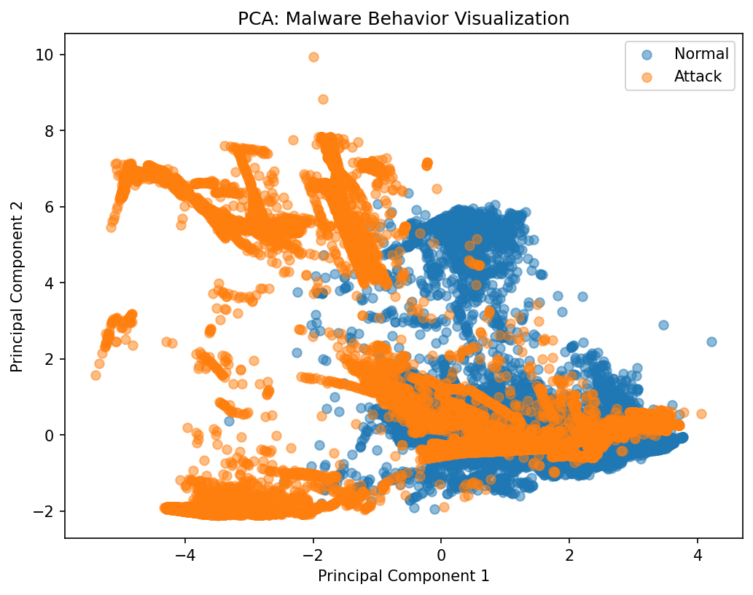

Program 8
Lab Program Question
Write a program to implement phishing URL detection using machine learning with lexical and content-based features.
Dataset Link
- dataset_full.csv (datasets/dataset_full.csv)
Program Code
File: week8/p8.py (week8/p8.py)
# ============================================
# WEEK 8: PHISHING URL DETECTION
# ============================================
import pandas as pd
import numpy as np
from sklearn.model_selection import train_test_split
from sklearn.preprocessing import StandardScaler
from sklearn.linear_model import LogisticRegression
from sklearn.ensemble import RandomForestClassifier
from sklearn.metrics import accuracy_score, confusion_matrix, classification_report
import seaborn as sns
import matplotlib.pyplot as plt
# ============================================
# LOAD DATA
# ============================================
def load_data(filepath):
df = pd.read_csv(filepath)
print("Dataset Loaded:", df.shape)
return df
# ============================================
# PREPROCESS
# ============================================
def preprocess(df):
target = 'phishing'
X = df.drop(columns=[target])
y = df[target]
# Convert to numeric
X = X.apply(pd.to_numeric, errors='coerce')
X = X.fillna(0)
# Scale
scaler = StandardScaler()
X_scaled = scaler.fit_transform(X)
return X_scaled, y, X.columns
# ============================================
# TRAIN MODELS
# ============================================
def train_models(X_train, y_train):
models = {
"Logistic Regression": LogisticRegression(max_iter=1000),
"Random Forest": RandomForestClassifier(n_estimators=100)
}
trained = {}
for name, model in models.items():
model.fit(X_train, y_train)
trained[name] = model
return trained
# ============================================
# EVALUATE
# ============================================
def evaluate(models, X_test, y_test):
for name, model in models.items():
print(f"\n===== {name} =====")
y_pred = model.predict(X_test)
print("Accuracy:", accuracy_score(y_test, y_pred))
print("\nReport:\n", classification_report(y_test, y_pred))
cm = confusion_matrix(y_test, y_pred)
plt.figure(figsize=(4,3))
sns.heatmap(cm, annot=True, fmt='d', cmap='Blues')
plt.title(f"{name} Confusion Matrix")
plt.show()
# ============================================
# FEATURE IMPORTANCE
# ============================================
def feature_importance(model, feature_names):
importances = model.feature_importances_
# Top 10 features
indices = np.argsort(importances)[-10:]
plt.figure(figsize=(8,5))
plt.barh(range(len(indices)), importances[indices])
plt.yticks(range(len(indices)), [feature_names[i] for i in indices])
plt.title("Top 10 Important URL Features")
plt.xlabel("Importance")
plt.show()
# ============================================
# MAIN
# ============================================
if __name__ == "__main__":
df = load_data("../datasets/dataset_full.csv")
X, y, feature_names = preprocess(df)
X_train, X_test, y_train, y_test = train_test_split(
X, y, test_size=0.2, random_state=42
)
models = train_models(X_train, y_train)
evaluate(models, X_test, y_test)
# Feature importance (Random Forest)
feature_importance(models["Random Forest"], feature_names)
print("\n✅ Week 8 Completed Successfully!")

Terminal Output
Terminal output file: week8/result.txt (week8/result.txt)
Program: p8.py
Working directory: D:\Desktop\msc-lab\week8
Exit code: 0
========================================================================
Dataset Loaded: (88647, 112)
===== Logistic Regression =====
Accuracy: 0.9328821206993796
Report:
precision recall f1-score support
0 0.95 0.94 0.95 11612
1 0.89 0.91 0.90 6118
accuracy 0.93 17730
macro avg 0.92 0.93 0.93 17730
weighted avg 0.93 0.93 0.93 17730
[saved image] result_image_01.png
===== Random Forest =====
Accuracy: 0.9697687535250987
Report:
precision recall f1-score support
0 0.98 0.97 0.98 11612
1 0.95 0.96 0.96 6118
accuracy 0.97 17730
macro avg 0.97 0.97 0.97 17730
weighted avg 0.97 0.97 0.97 17730
[saved image] result_image_02.png
[saved image] result_image_03.png
✅ Week 8 Completed Successfully!

Output Images
Program 8 Result Image 01
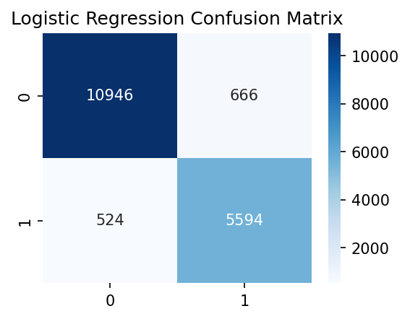
Program 8 Result Image 02
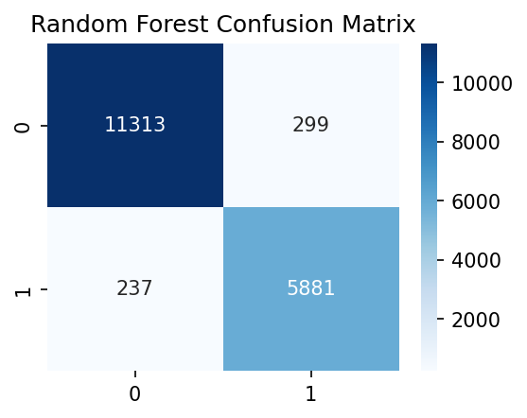
Program 8 Result Image 03
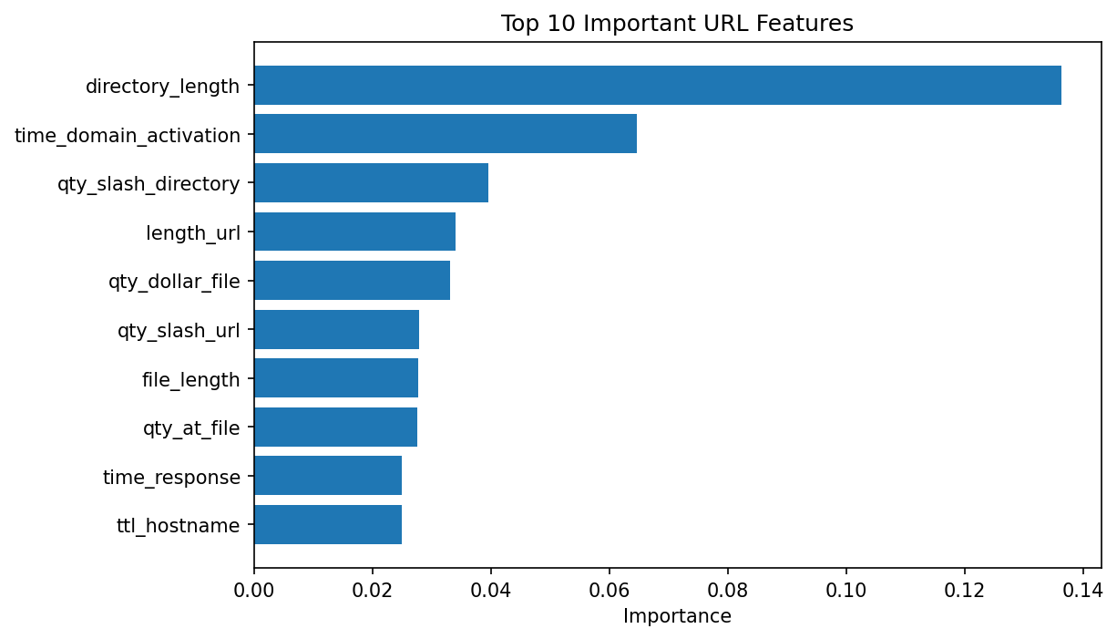

Program 9
Lab Program Question
Write a program to simulate adversarial attacks on machine learning models and demonstrate model robustness evaluation.
Dataset Link
- KDDTrain+.txt (datasets/KDDTrain+.txt)
Program Code
File: week9/p9.py (week9/p9.py)
# ============================================
# WEEK 9: ADVERSARIAL ATTACK SIMULATION
# ============================================
import pandas as pd
import numpy as np
from sklearn.model_selection import train_test_split
from sklearn.preprocessing import LabelEncoder, StandardScaler
from sklearn.tree import DecisionTreeClassifier
from sklearn.metrics import accuracy_score
import matplotlib.pyplot as plt
# ============================================
# LOAD DATA
# ============================================
def load_dataset(filepath):
columns = [
'duration','protocol_type','service','flag','src_bytes','dst_bytes',
'land','wrong_fragment','urgent','hot','num_failed_logins','logged_in',
'num_compromised','root_shell','su_attempted','num_root','num_file_creations',
'num_shells','num_access_files','num_outbound_cmds','is_host_login',
'is_guest_login','count','srv_count','serror_rate','srv_serror_rate',
'rerror_rate','srv_rerror_rate','same_srv_rate','diff_srv_rate',
'srv_diff_host_rate','dst_host_count','dst_host_srv_count',
'dst_host_same_srv_rate','dst_host_diff_srv_rate',
'dst_host_same_src_port_rate','dst_host_srv_diff_host_rate',
'dst_host_serror_rate','dst_host_srv_serror_rate',
'dst_host_rerror_rate','dst_host_srv_rerror_rate','label','difficulty'
]
df = pd.read_csv(filepath, names=columns)
print("Dataset Loaded:", df.shape)
return df
# ============================================
# PREPROCESS
# ============================================
def preprocess(df):
df['label'] = df['label'].apply(lambda x: 0 if x == 'normal' else 1)
le = LabelEncoder()
for col in ['protocol_type', 'service', 'flag']:
df[col] = le.fit_transform(df[col])
X = df.drop(columns=['label', 'difficulty'])
y = df['label']
scaler = StandardScaler()
X_scaled = scaler.fit_transform(X)
return X_scaled, y
# ============================================
# TRAIN MODEL
# ============================================
def train_model(X_train, y_train):
model = DecisionTreeClassifier()
model.fit(X_train, y_train)
return model
# ============================================
# ADVERSARIAL ATTACK (ADD NOISE)
# ============================================
def add_noise(X, epsilon=0.1):
noise = epsilon * np.random.normal(size=X.shape)
X_adv = X + noise
return X_adv
# ============================================
# MAIN
# ============================================
if __name__ == "__main__":
df = load_dataset("../datasets/KDDTrain+.txt")
X, y = preprocess(df)
X_train, X_test, y_train, y_test = train_test_split(
X, y, test_size=0.2, random_state=42
)
# Train model
model = train_model(X_train, y_train)
# Original accuracy
y_pred = model.predict(X_test)
acc_original = accuracy_score(y_test, y_pred)
print("\nOriginal Accuracy:", acc_original)
# Apply adversarial attack
X_test_adv = add_noise(X_test, epsilon=0.2)
# Accuracy after attack
y_pred_adv = model.predict(X_test_adv)
acc_adv = accuracy_score(y_test, y_pred_adv)
print("Accuracy After Attack:", acc_adv)
print("\nAccuracy Drop:", acc_original - acc_adv)
print("\n✅ Week 9 Completed Successfully!")

Terminal Output
Terminal output file: week9/result.txt (week9/result.txt)
Program: p9.py
Working directory: D:\Desktop\msc-lab\week9
Exit code: 0
========================================================================
Dataset Loaded: (125973, 43)
Original Accuracy: 0.9979757888469935
Accuracy After Attack: 0.6881921016074618
Accuracy Drop: 0.30978368723953165
✅ Week 9 Completed Successfully!

Output Images
No image output was generated for this program.

Program 10
Lab Program Question
Write a program to analyze network traffic captures (PCAP files) and extract features for botnet detection using classification or clustering methods.
Dataset Link
- capture20110810.binetflow (datasets/capture20110810.binetflow)
Program Code
File: week10/p10.py (week10/p10.py)
# ============================================
# WEEK 10: PCAP / BINETFLOW ANALYSIS
# ============================================
import pandas as pd
import numpy as np
from sklearn.preprocessing import LabelEncoder, StandardScaler
from sklearn.cluster import KMeans
import matplotlib.pyplot as plt
# ============================================
# LOAD DATA
# ============================================
def load_data(filepath):
df = pd.read_csv(filepath)
print("Dataset Loaded:", df.shape)
print("\nColumns:\n", df.columns)
return df
# ============================================
# PREPROCESS
# ============================================
def preprocess(df):
# Drop non-useful columns if present
drop_cols = ['StartTime', 'SrcAddr', 'DstAddr']
for col in drop_cols:
if col in df.columns:
df = df.drop(columns=[col])
# Handle categorical columns
df = df.apply(LabelEncoder().fit_transform)
# Separate features
X = df.values
# Scale
scaler = StandardScaler()
X_scaled = scaler.fit_transform(X)
return X_scaled
# ============================================
# CLUSTERING (BOTNET DETECTION)
# ============================================
def detect_botnet(X):
kmeans = KMeans(n_clusters=2, random_state=42)
labels = kmeans.fit_predict(X)
print("\nClustering Done!")
return labels
# ============================================
# VISUALIZE
# ============================================
def visualize(X, labels):
plt.figure(figsize=(10,6))
unique_labels = np.unique(labels)
for label in unique_labels:
cluster_points = X[labels == label]
# Assign meaningful names
if label == 0:
name = "Normal Traffic"
else:
name = "Suspicious / Botnet"
plt.scatter(cluster_points[:, 0], cluster_points[:, 1],
label=name,
alpha=0.5,
s=10)
plt.title("Botnet Detection (Clustering)")
plt.xlabel("Feature 1")
plt.ylabel("Feature 2")
# Move legend outside (important)
plt.legend(bbox_to_anchor=(1.05, 1), loc='upper left')
plt.tight_layout()
plt.show()
# ============================================
# MAIN
# ============================================
if __name__ == "__main__":
df = load_data("../datasets/capture20110810.binetflow")
X = preprocess(df)
# Use subset (important)
X = X[:5000]
labels = detect_botnet(X)
visualize(X, labels)
print("\n✅ Week 10 Completed Successfully!")

Terminal Output
Terminal output file: week10/result.txt (week10/result.txt)
Program: p10.py
Working directory: D:\Desktop\msc-lab\week10
Exit code: 0
========================================================================
Dataset Loaded: (254245, 15)
Columns:
Index(['StartTime', 'Dur', 'Proto', 'SrcAddr', 'Sport', 'Dir', 'DstAddr',
'Dport', 'State', 'sTos', 'dTos', 'TotPkts', 'TotBytes', 'SrcBytes',
'Label'],
dtype='str')
Clustering Done!
[saved image] result_image_01.png
✅ Week 10 Completed Successfully!

Output Images
Program 10 Result Image 01
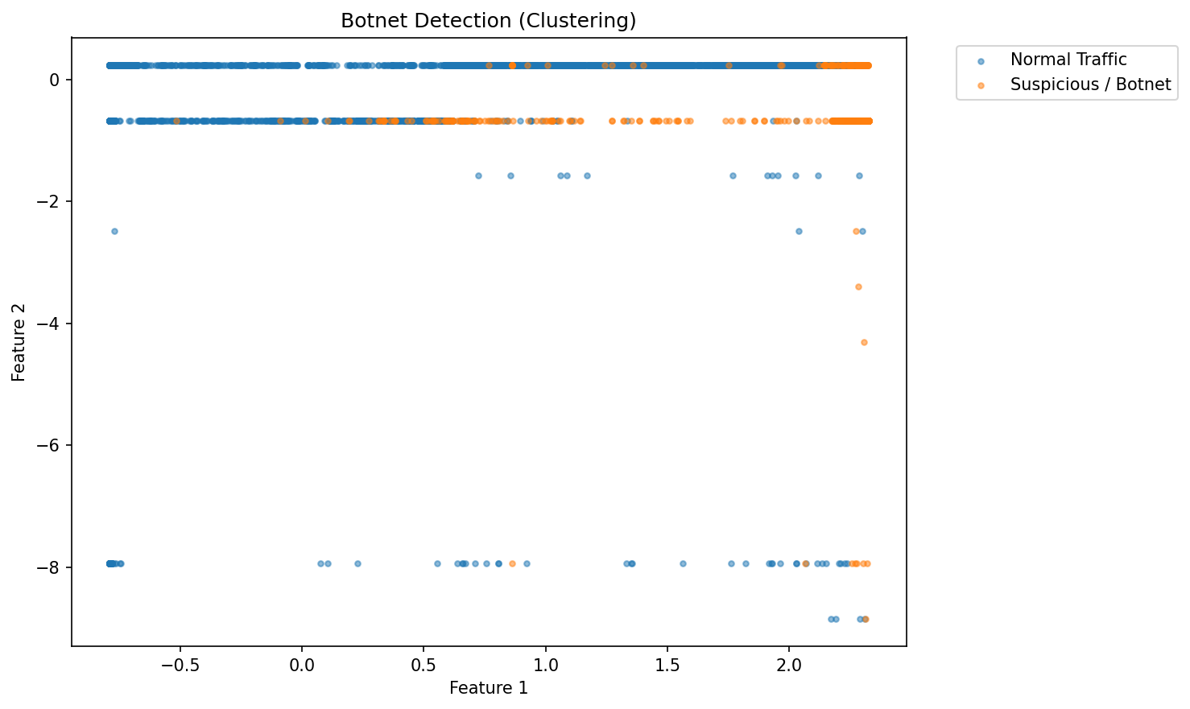

Program 11
Lab Program Question
Write a program to design a predictive model to detect brute-force or penetration attack attempts from log or network data.
Dataset Link
- auth.log (datasets/auth.log)
Program Code
File: week11/p11.py (week11/p11.py)
# ============================================
# WEEK 11: BRUTE FORCE DETECTION (FIXED)
# ============================================
import pandas as pd
import re
import matplotlib.pyplot as plt
# ============================================
# LOAD & PARSE LOG FILE
# ============================================
def load_logs(filepath):
data = []
with open(filepath, 'r') as f:
for line in f:
# Extract IP
ip_match = re.findall(r'\d+\.\d+\.\d+\.\d+', line)
if not ip_match:
continue
ip = ip_match[0]
# Extract timestamp (simple format)
timestamp_match = re.search(r'^\w+\s+\d+\s+\d+:\d+:\d+', line)
timestamp = timestamp_match.group(0) if timestamp_match else None
# Case 1: Multiple failures in one line
multi_fail = re.search(r'(\d+) more authentication failures', line)
if multi_fail:
count = int(multi_fail.group(1))
success = 0
for _ in range(count):
data.append([ip, timestamp, success])
# Case 2: Single failed password
elif "Failed password" in line:
success = 0
data.append([ip, timestamp, success])
# Case 3: Successful login
elif "Accepted" in line:
success = 1
data.append([ip, timestamp, success])
df = pd.DataFrame(data, columns=['ip', 'timestamp', 'success'])
print("Logs Loaded:", df.shape)
return df
# ============================================
# DETECT BRUTE FORCE
# ============================================
def detect_bruteforce(df):
# Count failed attempts per IP
failed = df[df['success'] == 0]
attack_counts = failed.groupby('ip').size()
# Threshold
threshold = 5
attackers = attack_counts[attack_counts > threshold]
print("\n⚠️ Suspicious IPs (Brute Force):")
print(attackers)
return attackers
# ============================================
# VISUALIZATION
# ============================================
def visualize(attackers, top_n=10):
if len(attackers) == 0:
print("No brute force attacks detected.")
return
# Take top N attackers
attackers = attackers.sort_values(ascending=False).head(top_n)
plt.figure(figsize=(10,5))
attackers.plot(kind='bar')
plt.title(f"Top {top_n} Brute Force Attackers")
plt.xlabel("IP Address")
plt.ylabel("Failed Attempts")
plt.xticks(rotation=45, fontsize=8) # cleaner labels
plt.tight_layout()
plt.show()
# ============================================
# MAIN
# ============================================
if __name__ == "__main__":
df = load_logs("../datasets/auth.log")
attackers = detect_bruteforce(df)
visualize(attackers)
print("\n✅ Week 11 Completed Successfully!")

Terminal Output
Terminal output file: week11/result.txt (week11/result.txt)
Program: p11.py
Working directory: D:\Desktop\msc-lab\week11
Exit code: 0
========================================================================
Logs Loaded: (1624, 3)
⚠️ Suspicious IPs (Brute Force):
ip
1.189.205.173 7
1.30.211.144 11
103.230.120.26 11
105.101.221.33 11
106.57.58.19 7
..
85.245.107.41 11
91.243.236.123 7
93.120.176.237 11
94.154.25.149 7
95.190.198.34 7
Length: 102, dtype: int64
[saved image] result_image_01.png
✅ Week 11 Completed Successfully!

Output Images
Program 11 Result Image 01
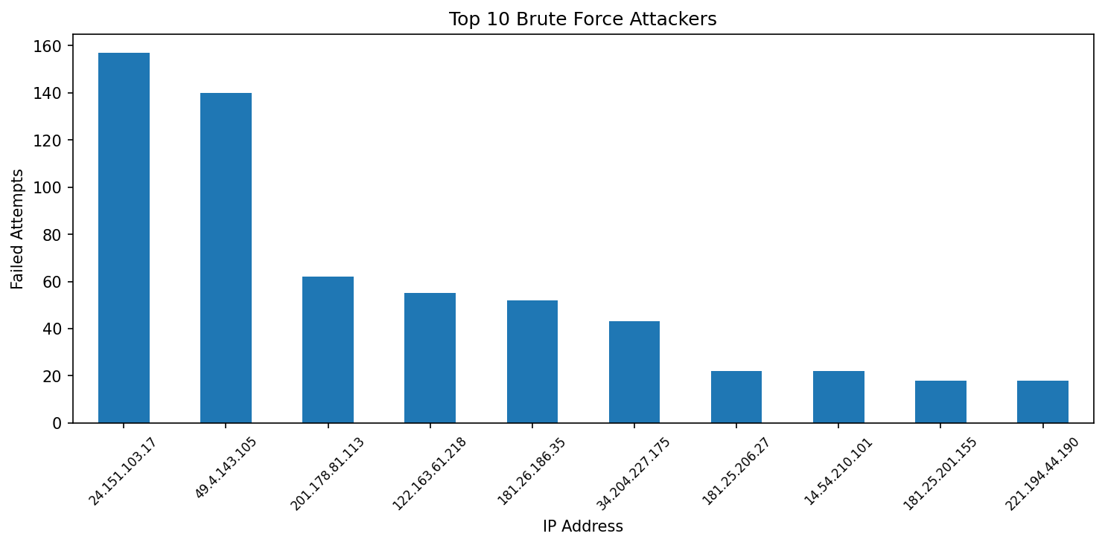

Program 12
Lab Program Question
Write a program to build and test a hybrid intrusion detection system combining supervised and unsupervised approaches for adaptive security.
Dataset Link
- KDDTrain+.txt (datasets/KDDTrain+.txt)
Program Code
File: week12/p12.py (week12/p12.py)
# ============================================
# WEEK 12: HYBRID IDS (SUPERVISED + UNSUPERVISED)
# ============================================
import pandas as pd
import numpy as np
from sklearn.model_selection import train_test_split
from sklearn.preprocessing import LabelEncoder, StandardScaler
from sklearn.tree import DecisionTreeClassifier
from sklearn.ensemble import IsolationForest
from sklearn.metrics import accuracy_score
# ============================================
# LOAD DATA
# ============================================
def load_dataset(filepath):
columns = [
'duration','protocol_type','service','flag','src_bytes','dst_bytes',
'land','wrong_fragment','urgent','hot','num_failed_logins','logged_in',
'num_compromised','root_shell','su_attempted','num_root','num_file_creations',
'num_shells','num_access_files','num_outbound_cmds','is_host_login',
'is_guest_login','count','srv_count','serror_rate','srv_serror_rate',
'rerror_rate','srv_rerror_rate','same_srv_rate','diff_srv_rate',
'srv_diff_host_rate','dst_host_count','dst_host_srv_count',
'dst_host_same_srv_rate','dst_host_diff_srv_rate',
'dst_host_same_src_port_rate','dst_host_srv_diff_host_rate',
'dst_host_serror_rate','dst_host_srv_serror_rate',
'dst_host_rerror_rate','dst_host_srv_rerror_rate','label','difficulty'
]
df = pd.read_csv(filepath, names=columns)
print("Dataset Loaded:", df.shape)
return df
# ============================================
# PREPROCESS
# ============================================
def preprocess(df):
# Convert label
df['label'] = df['label'].apply(lambda x: 0 if x == 'normal' else 1)
# Encode categorical
le = LabelEncoder()
for col in ['protocol_type', 'service', 'flag']:
df[col] = le.fit_transform(df[col])
X = df.drop(columns=['label', 'difficulty'])
y = df['label']
# Scale
scaler = StandardScaler()
X_scaled = scaler.fit_transform(X)
return X_scaled, y
# ============================================
# SUPERVISED MODEL
# ============================================
def train_supervised(X_train, y_train):
model = DecisionTreeClassifier()
model.fit(X_train, y_train)
return model
# ============================================
# UNSUPERVISED MODEL
# ============================================
def train_unsupervised(X_train):
model = IsolationForest(contamination=0.1, random_state=42)
model.fit(X_train)
return model
# ============================================
# HYBRID DETECTION
# ============================================
def hybrid_detection(supervised_model, unsupervised_model, X_test):
# Supervised prediction
y_super = supervised_model.predict(X_test)
# Unsupervised prediction (-1 anomaly, 1 normal)
y_unsuper = unsupervised_model.predict(X_test)
# Convert to 0/1
y_unsuper = np.where(y_unsuper == -1, 1, 0)
# Hybrid: if either detects attack → attack
y_final = np.where((y_super == 1) | (y_unsuper == 1), 1, 0)
return y_super, y_unsuper, y_final
# ============================================
# EVALUATION
# ============================================
def evaluate(y_test, y_super, y_unsuper, y_final):
print("\nSupervised Accuracy:", accuracy_score(y_test, y_super))
print("Unsupervised Approx Accuracy:", accuracy_score(y_test, y_unsuper))
print("Hybrid Accuracy:", accuracy_score(y_test, y_final))
# ============================================
# MAIN
# ============================================
if __name__ == "__main__":
df = load_dataset("../datasets/KDDTrain+.txt")
X, y = preprocess(df)
X_train, X_test, y_train, y_test = train_test_split(
X, y, test_size=0.2, random_state=42
)
# Train models
supervised_model = train_supervised(X_train, y_train)
unsupervised_model = train_unsupervised(X_train)
# Hybrid prediction
y_super, y_unsuper, y_final = hybrid_detection(
supervised_model, unsupervised_model, X_test
)
# Evaluate
evaluate(y_test, y_super, y_unsuper, y_final)
print("\n✅ Week 12 Completed Successfully!")

Terminal Output
Terminal output file: week12/result.txt (week12/result.txt)
Program: p12.py
Working directory: D:\Desktop\msc-lab\week12
Exit code: 0
========================================================================
Dataset Loaded: (125973, 43)
Supervised Accuracy: 0.9978567176026989
Unsupervised Approx Accuracy: 0.565985314546537
Hybrid Accuracy: 0.9645961500297678
✅ Week 12 Completed Successfully!

Output Images
No image output was generated for this program.

Program 13
Lab Program Question
Write a program to implement feature engineering and model explainability techniques such as SHAP or LIME for AI-driven cyber threat detection systems.
Dataset Link
- KDDTrain+.txt (datasets/KDDTrain+.txt)
Program Code
File: week13/p13.py (week13/p13.py)
# ============================================
# WEEK 13: EXPLAINABLE AI (SHAP)
# ============================================
import pandas as pd
import numpy as np
from sklearn.model_selection import train_test_split
from sklearn.preprocessing import LabelEncoder, StandardScaler
from sklearn.ensemble import RandomForestClassifier
import shap
import matplotlib.pyplot as plt
# ============================================
# LOAD DATA
# ============================================
def load_dataset(filepath):
columns = [
'duration','protocol_type','service','flag','src_bytes','dst_bytes',
'land','wrong_fragment','urgent','hot','num_failed_logins','logged_in',
'num_compromised','root_shell','su_attempted','num_root','num_file_creations',
'num_shells','num_access_files','num_outbound_cmds','is_host_login',
'is_guest_login','count','srv_count','serror_rate','srv_serror_rate',
'rerror_rate','srv_rerror_rate','same_srv_rate','diff_srv_rate',
'srv_diff_host_rate','dst_host_count','dst_host_srv_count',
'dst_host_same_srv_rate','dst_host_diff_srv_rate',
'dst_host_same_src_port_rate','dst_host_srv_diff_host_rate',
'dst_host_serror_rate','dst_host_srv_serror_rate',
'dst_host_rerror_rate','dst_host_srv_rerror_rate','label','difficulty'
]
df = pd.read_csv(filepath, names=columns)
print("Dataset Loaded:", df.shape)
return df
# ============================================
# PREPROCESS
# ============================================
def preprocess(df):
df['label'] = df['label'].apply(lambda x: 0 if x == 'normal' else 1)
le = LabelEncoder()
for col in ['protocol_type', 'service', 'flag']:
df[col] = le.fit_transform(df[col])
X = df.drop(columns=['label', 'difficulty'])
y = df['label']
scaler = StandardScaler()
X_scaled = scaler.fit_transform(X)
return X_scaled, y, X.columns
# ============================================
# TRAIN MODEL
# ============================================
def train_model(X_train, y_train):
model = RandomForestClassifier(n_estimators=100)
model.fit(X_train, y_train)
return model
# ============================================
# SHAP EXPLANATION
# ============================================
def explain(model, X_sample, feature_names):
explainer = shap.TreeExplainer(model)
shap_values = explainer.shap_values(X_sample)
# Handle both formats
if isinstance(shap_values, list):
shap_values_to_use = shap_values[1]
else:
shap_values_to_use = shap_values
# 🔥 1. Summary Plot (MOST IMPORTANT)
shap.summary_plot(shap_values_to_use, X_sample, feature_names=feature_names)
# 🔥 2. Feature Importance Bar Plot (VERY SAFE)
shap.summary_plot(shap_values_to_use, X_sample,
feature_names=feature_names,
plot_type="bar")
# ============================================
# MAIN
# ============================================
if __name__ == "__main__":
df = load_dataset("../datasets/KDDTrain+.txt")
X, y, feature_names = preprocess(df)
# Use subset (important for SHAP speed)
X = X[:2000]
y = y[:2000]
X_train, X_test, y_train, y_test = train_test_split(
X, y, test_size=0.2, random_state=42
)
model = train_model(X_train, y_train)
X_test = np.array(X_test)
# Explain predictions
explain(model, X_test[:100], feature_names)
print("\n✅ Week 13 Completed Successfully!")

Terminal Output
Terminal output file: week13/result.txt (week13/result.txt)
Program: p13.py
Working directory: D:\Desktop\msc-lab\week13
Exit code: 0
========================================================================
Dataset Loaded: (125973, 43)
[saved image] result_image_01.png
[saved image] result_image_02.png
✅ Week 13 Completed Successfully!

Output Images
Program 13 Result Image 01
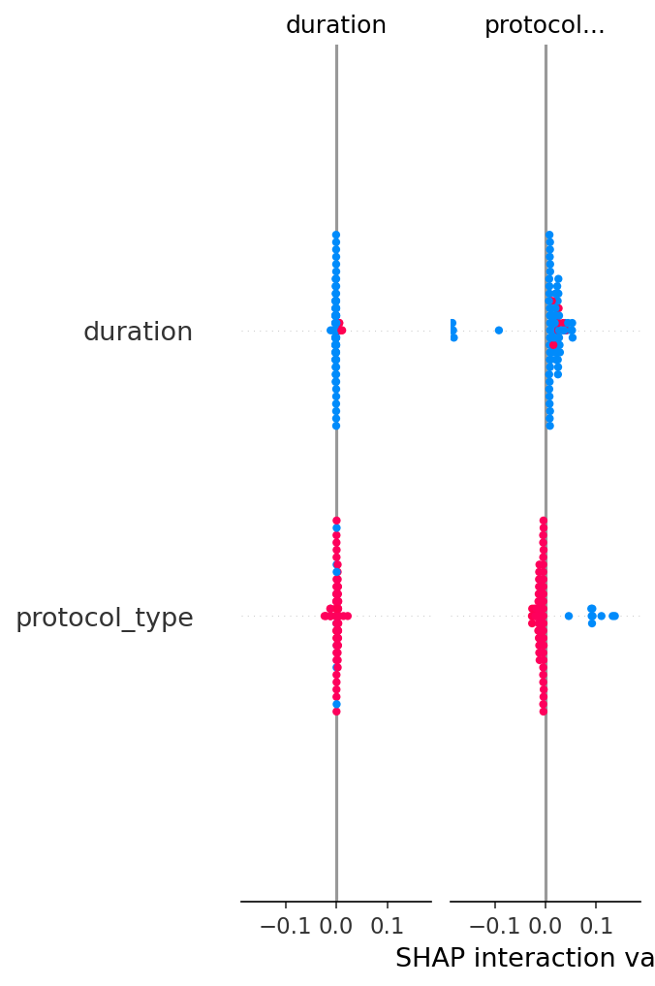
Program 13 Result Image 02
