**Cooperative intrusion detection framework using the blockchain**

**Result:**

|  |  |  |  |
| --- | --- | --- | --- |
| **Parameter** | **Base Paper Result**  **Convolutional Neural Network (CNN)** | **Reference Paper Result** | **Proposed Result** |
| Accuracy | 95 |  | 99 |
| Precision | - | 92.8 | 99 |
| Recall | - | 89 | 99 |
| F1score | - | 91.6 | 99 |

**Plot for Training and Validation Accuracy:**

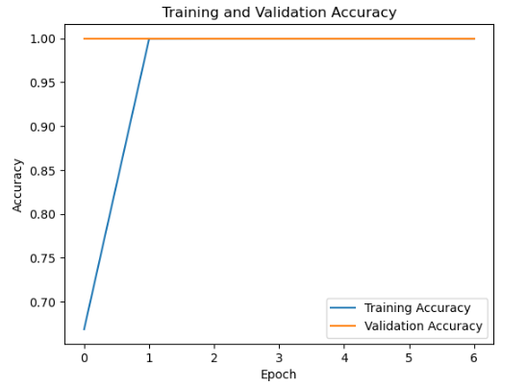

**Plot for Training and Validation Loss:**

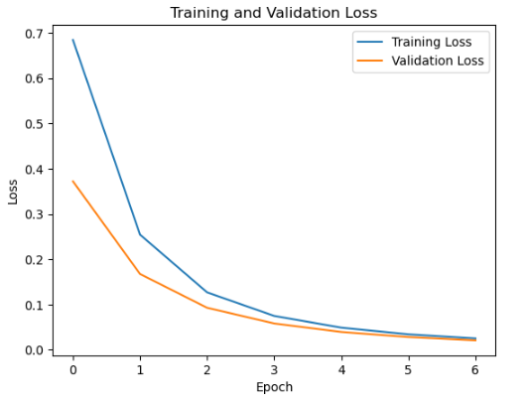

**Plot for AUC ROC Curve:**

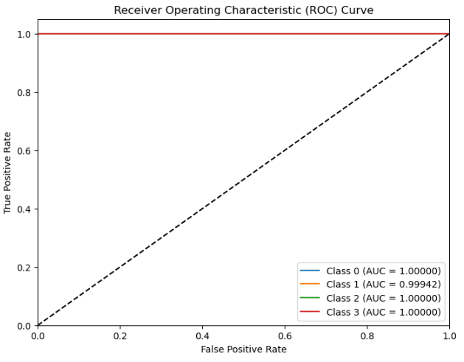

**Plot for Precision-Recall Curve:**

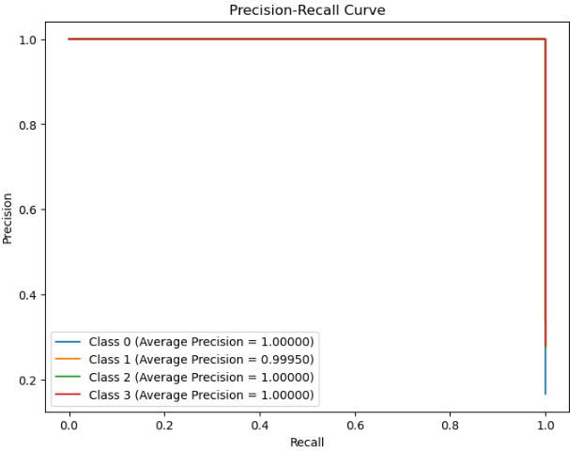

**Plot for Training and Testing Errors (MSE and RMSE)**

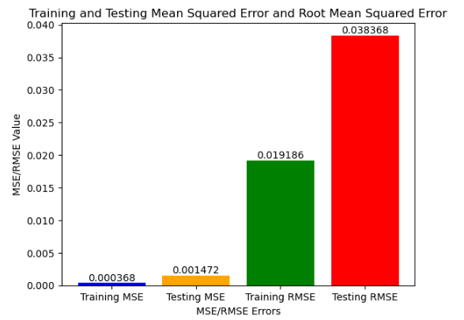

**Confusion Matrix**

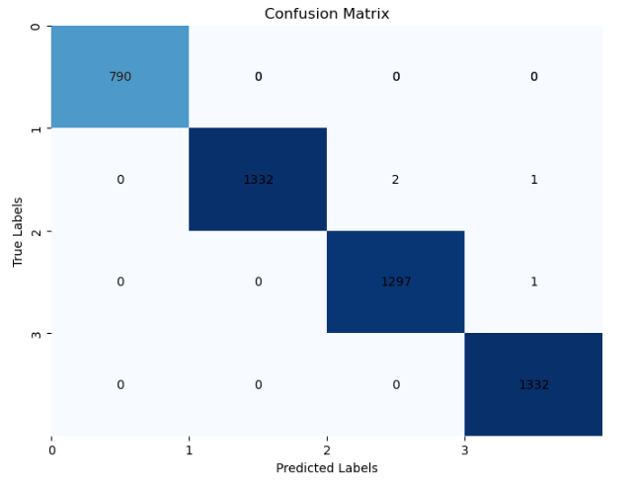

**Attack detection Message Alert:**

