Enterprise AI Platform - User Guide & Overview

What is Enterprise AI Platform?
Enterprise AI Platform is a centralized framework that helps developers use AI tools such as Claude Code and GitHub Copilot in a standardized, governed, and cost-effective way. Instead of every developer creating their own prompts and workflows, the platform provides pre-built commands, standards, templates, and approval processes.

High-Level Architecture
+-----------------------+
| Developer / Engineer |
+-----------+-----------+
|
v
+-----------------------+
| Enterprise AI Platform|
+-----------+-----------+
|
+---------------------+--------------------+
| | | | |
v v v v v
Commands Standards Templates Docs Governance
| |
+------------------+-------------------+
|
v
Claude Code / GitHub Copilot
|
v
Target Repository

How It Reduces Cost
• Loads only required standards (lazy loading)
• Avoids scanning entire repositories
• Reuses shared prompts and workflows
• Reduces token consumption
• Minimizes repeated analysis work
• Improves developer productivity

Key Features
• Bug Fix Workflow
• New Development Workflow
• Migration Workflow
• UI Enhancement Workflow
• Data Correction Workflow
• Approval Gates
• Coding Standards Enforcement
• Claude Code Integration
• GitHub Copilot Integration

How Anybody Can Use It
Step 1: Clone the platform repository.
Step 2: Install Claude Code or GitHub Copilot.
Step 3: Add platform configuration to your project.
Step 4: Choose a command such as /bug-fix or /new-development.
Step 5: Review AI analysis.
Step 6: Approve implementation.
Step 7: Apply generated code.

Developer Workflow Diagram
Developer Request
|
v
AI Analysis
|
v
Impact Assessment
|
v
Approval Required
|
+---+---+
| |
Yes No
| |
v v
Generate Stop
Changes
|
v
Validation
|
v
Final Output

Folder Explanation
shared/ - Core execution contracts and governance.
commands/ - Reusable AI workflows.
standards/ - Coding and architecture standards.
templates/ - Reusable project templates.
adapters/ - Claude Code and Copilot integrations.
docs/ - Documentation and guides.
install/ - Installation scripts.
tools/ - Utility and maintenance tools.
ci/ - Validation and compliance automation.

Business Benefits
• Faster software delivery
• Lower AI costs
• Better code quality
• Easier onboarding
• Standardized development practices
• Improved governance and auditability

Sample Outputs

After prompt and planning

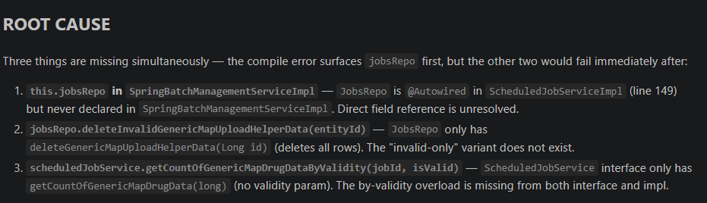

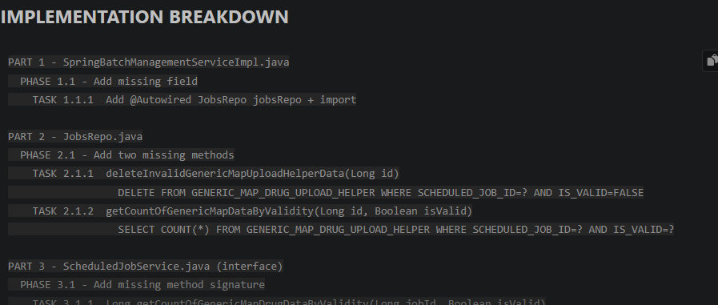
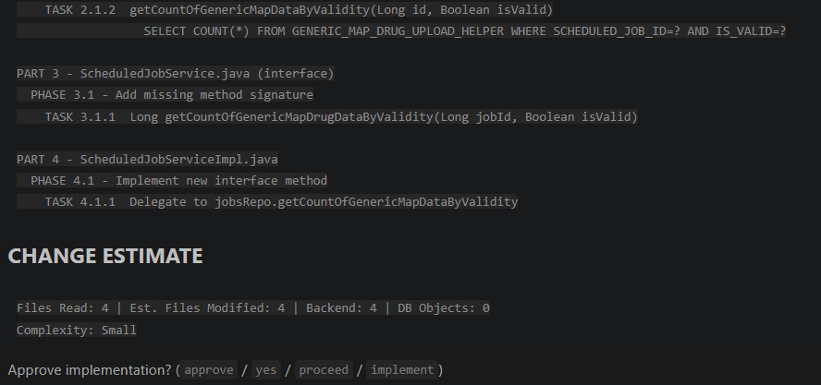

After completion



