UNIT-I
Paradigm
The word ‘Paradigm’ originally meant example or model.
In computer science,a paradigm explains how the elements that go into making a program are organized and how they interact with one another.

Need for OOP Paradigm

- OOP is an approach to program organization and development, which attempts to eliminate some of the drawbacks of conventional programming methods by incorporating the best of structured programming features with several new concepts.
- OOP allows us to decompose a problem into number of entities called objects and then build data and methods (functions) around these entities.
- The data of an object can be accessed only by the methods associated with the object.

A Way of Viewing the World
To illustrate the major ideas in OOP, let us consider a small example which describes a real world problem and handling it. Suppose U wish to send a gift to my your friend who is living very far off from your place. Suppose U r at ‘place A ‘ and your friend at ‘place B’.To carry out this process U will request the shopkeeper living at your place about sending the gift to your friend at ‘place B’ and U can be assured that the gift is sent to your friend.

U Shopkeeper(place A) shopkeeper(place B) Ur Friend

(Place A) (Place B)
Delivery Boy(place B)

Figure: Indicating community of agents

Agents and Communities
An OOP is structured as a community of interacting agents called objects.Each object has a role to play.Each object provides a service,or performs an action,that is used by other members of the community.

In the above figure the agents are the shopkeeper(A),shopkeeper(place B) and the delivery boy(place B).
Here U are not responsible in carrying the gift to your friend, the shopkeeper is initiating the process and U are no way concerned in delivering the gift and also how the gift is being sent is also immaterial.All the details are hidden.This is known as ‘Information hiding.’

- OOP uses an approach of treating a real world agent as an object.
- Object-oriented programming organizes a program around its data (that is, objects) and a set of well-defined interfaces to that data.
- An object-oriented program can be characterized as data controlling access to code by switching the controlling entity to data.

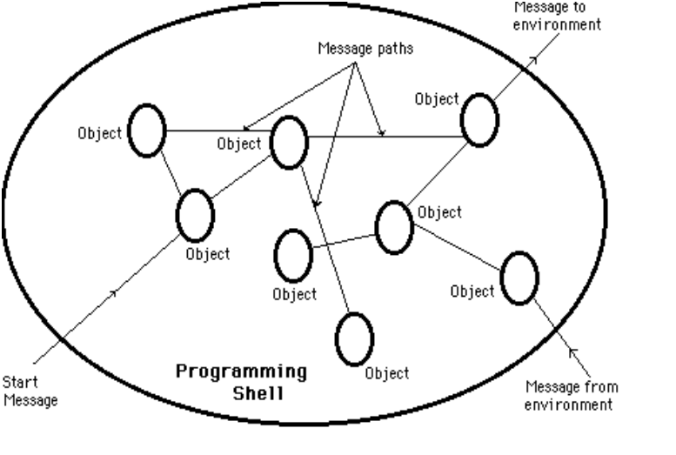

Some of the Object-Oriented Paradigm are:
- Emphasis is on data rather than procedure.
- Programs are divided into objects.
- Data Structures are designed such that they Characterize the objects.
- Methods that operate on the data of an object are tied together in the data structure.
- Data is hidden and can not be accessed by external functions.
- Objects may communicate with each other through methods.

Responsibilities

- Primary motivation is the need for a platform-independent (that is, architecture- neutral) language that could be used to create software to be embedded in various consumer electronic devices, such as microwave ovens and remote controls.
- Objects with clear responsibilities
- Each class should have a clear responsibility.
- The entire collection of responsibilities associated with an object is often termed the protocol.
- A traditional program often operates by acting on data structures,for example changing field in an array or record.In contrast object-oriented program requests data structures(objects) to perform a service.

Example: Shopkeeper(India) is free to pursue any technique that achieves the desired objective and is not hampered by interference of sender(‘U’)

Messages
- We all like to use programs that let us know what's going on. Programs that keep us informed often do so by displaying status and error messages.
- These messages need to be translated so they can be understood by end users around the world.
- Action is initiated in OOP by the transmission of a message to an agent(object) responsible for the action.The message encodes the request for an action and is accompanied by any additional information(arguments) needed to carry out the request.The receiver is the object to whom the message is sent.If the receiver accepts the message,it accepts the responsibility to carry out the indicated action.In response to a message,the receiver will perform some method to satisfy the request.

Methods
- A method is a group of instructions that is given a name and can be called up at any point in a program simply by quoting that name.
- For Example:
Drawing a Triangle require draw of three straight lines.
- We can define a method to call this instruction three times and draw the triangle(i.e. create a method drawLine( ) to draw lines and this method is called repeatedly to achieve the needed task)
- The idea of methods appears in all programming languages, although sometimes it goes under the name functions and sometimes under the name procedures.
- In C++, there is a class which can contain methods. However, everything in Java is enclosed within a class .

Classes

- Class is blue print or an idea of an Object
- From One class any number of Instances can be created
- It is an encapsulation of attributes and methods

Syntax of CLASS
class <ClassName>
{
attributes/variables;
Constructors();
methods();
}

Instance

- Instance is an Object of a class which is an entity with its own attribute values and methods.

- Creating an Instance

ClassName refVariable;
refVariable = new Constructor();
or
ClassName refVariable = new Constructor();

Java Class Hierarchy
- In Java, class “Object” is the base class to all other classes
  - If we do not explicitly say extends in a new class definition, it implicitly extends Object
  - The tree of classes that extend from Object and all of its subclasses is called the class hierarchy
  - All classes eventually lead back up to Object
  - This will enable consistent access of objects of different classes.

Inheritance
- Methods allows to reuse a sequence of statements
- Inheritance allows to reuse classes by deriving a new class from an existing one
- The existing class is called the parent class, or superclass, or base class
- The derived class is called the child class or subclass.
- The child class inherits characteristics of the parent class(i.e the child class inherits the methods and data defined for the parent class

Method Binding
- Objects are used to call methods.
- It is legal for a class to have two or more methods with the same name.
- Java has to be able to uniquely associate the invocation of a method with its definition relying on the number and types of arguments.
- Therefore the same-named methods must be distinguished:
1) by the number of arguments, or
2) by the types of arguments
- Overloading and inheritance are two ways to implement polymorphism.

Method Overriding.

- There may be some occasions when we want an object to respond to the same method but have different behaviour when that method is called.
- That means, we should override the method defined in the superclass. This is possible by defining a method in a sub class that has the same name, same arguments and same return type as a method in the superclass.
- Then when that method is called, the method defined in the sub class is invoked and executed instead of the one in the superclass. This is known as overriding.

Exceptions in Java

- Exception is an abnormal condition that arises in the code sequence.
- Exceptions occur during compile time or run time.
- “throwable” is the super class in exception hierarchy.
- Compile time errors occurs due to incorrect syntax.
- Run-time errors happen when
  - User enters incorrect input
  - Resource is not available (ex. file)
  - Logic error (bug) that was not fixed

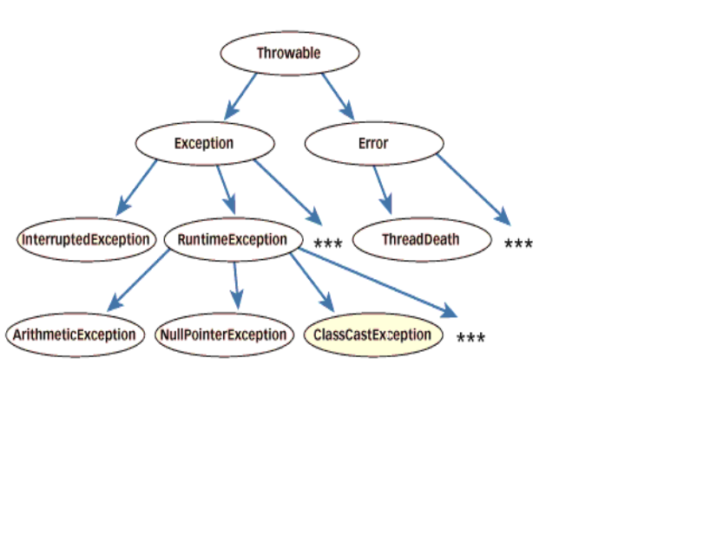
Summary of OOPS

The following are the basic oops concepts.They are as follows:
- Objects.
- Classes.
- Data Abstraction.
- Data Encapsulation.
- Inheritance.
- Polymorphism.
- Dynamic Binding.
- Message Passing.

Abstraction in Object-Oriented Programming

- Procedural Abstraction---Procedural Abstractions organize instructions

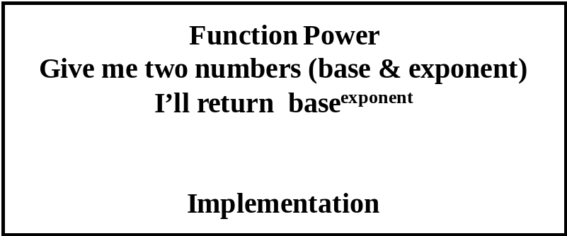

- Data Abstraction--- Data Abstractions organize data.

StudentType

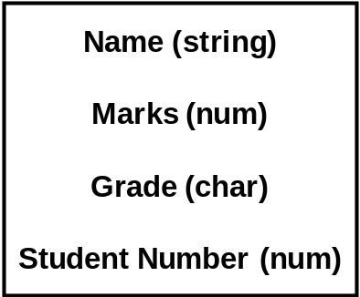

3. Behavioral Abstraction--- Behavioral Abstractions combine procedural and data abstractions.

