UNIT-V

Exception handling

Concepts of Exception Handling

- Exception is an abnormal condition that arises when executing a program.
- An Exception is a condition that is caused by a run-time error in the program.
- In the languages that do not support exception handling, errors must be checked and handled manually, usually through the use of error codes.
- In contrast, Java:
1) provides syntactic mechanisms to signal, detect and handle errors

2) ensures a clean separation between the code executed in the
absence of errors and the code to handle various kinds of errors

3) brings run-time error management into object-oriented programming

Exception Handling

- An exception is an object that describes an exceptional condition (error) that has occurred when executing a program.
- Exception handling involves the following:
1) when an error occurs, an object (exception) representing this error is created and thrown in the method that caused it

2) that method may choose to handle the exception itself or pass it on

3) either way, at some point, the exception is caught and processed

Exception Sources

Exceptions can be:

1) Generated by the Java run-time system--- Fundamental errors that violate the rules of the Java language or the constraints of the Java execution environment.
2) Manually generated by programmer’s code--- Such exceptions are typically used to report some error conditions to the caller of a method

Exception Hierarchy

- All exceptions are sub-classes of the build-in class Throwable.
- Throwable contains two immediate sub-classes:

1) Exception – exceptional conditions that programs should catch

The class includes:
a) RuntimeException – defined automatically for user programs to include: division by zero, invalid array indexing, etc.
b) user-defined exception classes
2) Error – exceptions used by Java to indicate errors with the runtime environment; user programs are not supposed to catch them

Uncaught Exceptions

This small program intentionally causes a divide-by-zero error:
class Exc0
{
public static void main(String args[])
{
int d=0;
int a=32/d;
}
}
When the java run-time system detects the attempt to divide by zero, it constructs a new exception object and then throws this exception. This causes the program to stop, because once an exception has been created, it must be handled by a catch-handler. But this program does have any exception handlers created, so a default handler takes care of handling this situation.

Here, the default handler displays a string describing the exception, prints a stack trace from the point at which the exception has occurred, and then terminates the program.

java.lang.ArithmeticException:/ by zero
a Exc0.main(Exc0.java:4)

The purpose of exception handling mechanism is to provide a means to detect and report an “Exceptional circumstance” so that appropriate action can be taken. The mechanism suggests incorporation of a separate error handling code that performs the following tasks:

- Find the problem(Hit the exception)
- Inform that an error has occurred(Throw the exception)
- Receive the error information(Catch the exception)
- Take corrective exception(Handle the exception)

The error handling code basically consists of two segments, one to detect errors and to throw exceptions and the other to catch exceptions and to take appropriate actions.

Exception Constructs(Keywords)

Five constructs are used in exception handling:

1) try – a block surrounding program statements to monitor for exceptions
2) catch – together with try, catches specific kinds of exceptions and handles them in some way
3) finally – specifies any code that absolutely must be executed whether or not an exception occurs
4) throw – used to throw a specific exception from the program
5) throws – specifies which exceptions a given method can throw

Exception-Handling Block

General form:

try { … }
catch(Exception1 ex1) { … }
catch(Exception2 ex2) { … }
…
finally { … }

where:
1) try { … } is the block of code to monitor for exceptions
2) catch(Exception ex) { … } is exception handler for the
exception Exception
3) finally { … } is the block of code to execute before the try
block ends

The above written code which causes an Exception in the program at runtime solves the problem by handling the exception within the program by using the exception handling mechanism.

Program:

class Exc0
{
public static void main(String args[])
{
int d=0,a;

try
{

a=32/d;
System.out.println(“This will not be printed”);
}
catch(ArithmeticException e )
{
System.out.println(“Division by zero”);
}
System.out.println(“After catch statement”);
}
}
The program generates the following output:

Division by zero
After catch statement

Displaying a description of an Exception

Throwable class overrides the toString( ) method ( defined by Object class )so that it returns a string containing a description of the exception. The description can be displayed by simply passing an exception as an argument.

The above piece of code(println statement) in the catch block can be rewritten like this:

catch(ArithmeticException e )
{
System.out.println(“Exception:”+e);
}

Following message is displayed:

Exception: java.lang.ArithemeticException: / by zero

Benefits of exception handling

- Separating Error-Handling code from “regular” business logic code
- Propagating errors up the call stack
- Grouping and differentiating error types

Termination vs. resumption

- There are two basic models in exception-handling theory.
- In termination the error is so critical there’s no way to get back to where the exception occurred. Whoever threw the exception decided that there was no way to get back to the situation.
- The alternative is called resumption. It means that the exception handler is expected to do something to rectify the situation, and then the method is retried, presuming success the second time. If you want resumption, it means you still hope to continue execution after the exception is handled.
- In resumption a method, place your try block inside a while loop that keeps reentering the try block until the result is satisfactory.
- Operating systems that supported resumptive exception handling eventually ended up using termination-like code and skipping resumption.

Hierarchy of Exception Classes

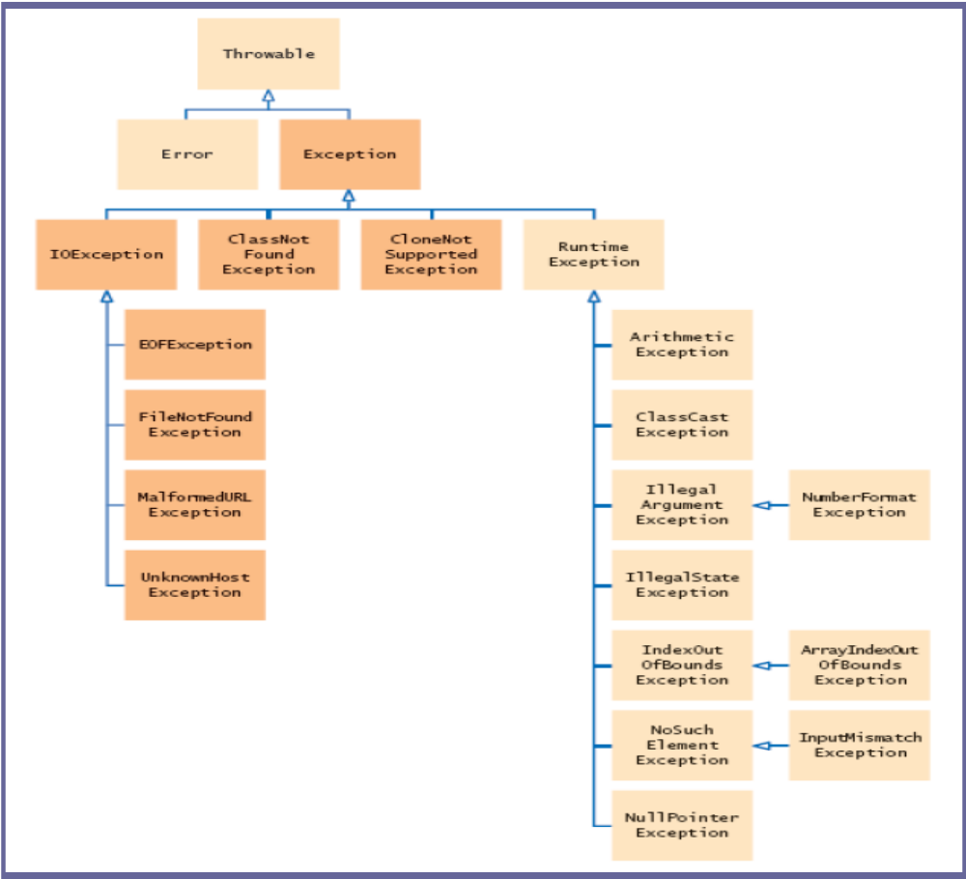

“throw” Declaration

- So far, we were only catching the exceptions thrown by the Java system.
- In fact, a user program may throw an exception explicitly:
    - throw ThrowableInstance;
- ThrowableInstance must be an object of type Throwable or its subclass.
Once an exception is thrown by:

throw ThrowableInstance;

1) the flow of control stops immediately
2) the nearest enclosing try statement is inspected if it has a catch statement that matches the type of exception:
- if one exists, control is transferred to that statement
- otherwise, the next enclosing try statement is examined
- if no enclosing try statement has a corresponding catch clause, the default exception handler halts the program and prints the stack

Refer class Notes for example

Creating Exceptions

Two ways to obtain a Throwable instance:

1) creating one with the new operator---
All Java built-in exceptions have at least two Constructors:
    - One without parameters and
    - another with one String parameter:
Example: throw new NullPointerException("demo");
2) using a parameter of the catch clause
try { … }
catch(Throwable e)
{ … e … }

“throws” Declaration

- If a method is capable of causing an exception that it does not handle, it must specify this behavior by the throws clause in its declaration:
type name(parameter-list) throws exception-list
{
…
}
- where exception-list is a comma-separated list of all types of exceptions that a method might throw.
- All exceptions must be listed except Error and RuntimeException or any of their subclasses, otherwise a compile-time error occurs.

Refer class Notes for example

“finally” Declaration

- When an exception is thrown:
1) the execution of a method is changed
2) the method may even return prematurely.
- This may be a problem in many situations.
- For instance, if a method opens a file on entry and closes on exit; exception handling should not bypass the proper closure of the file.
- The finally block is used to address this problem.

- The try/catch statement requires at least one catch or finally clause, although both are optional:
try { … }
catch(Exception1 ex1) { … } …
finally { … }

- Executed after try/catch whether or not the exception is thrown.
- Any time a method is to return to a caller from inside the try/catch block via:
1) uncaught exception or
2) explicit return
the finally clause is executed just before the method returns.

Refer class Notes for example

Java Built-In Exceptions

- The default java.lang package provides several exception classes, all sub-classing the
RuntimeException class.
- Two sets of build-in exception classes:

1) unchecked exceptions – the compiler does not check if a method handles or throws there exceptions

2) checked exceptions – must be included in the method’s throws clause if the method generates but does not handle them

Unchecked Built-In Exceptions

Methods that generate but do not handle those exceptions need not declare them in the throws clause:--

- ArithmeticException
- ArrayIndexOutOfBoundsException
- ArrayStoreException
- ClassCastException
- IllegalStateException
- IllegalMonitorStateException
- IllegalArgumentException
- StringIndexOutOfBounds
- UnsupportedOperationException
- SecurityException
- NumberFormatException
- NullPointerException
- NegativeArraySizeException
- IndexOutOfBoundsException
- IllegalThreadStateException

Checked Built-In Exceptions

Methods that generate but do not handle those exceptions must declare them in the throws clause:--

- NoSuchMethodException NoSuchFieldException
- InterruptedException
- InstantiationException
- IllegalAccessException
- CloneNotSupportedException
- ClassNotFoundException

Creating Own Exception subclasses

- Build-in exception classes handle some generic errors.
- For application-specific errors define your own exception classes. How? Define a subclass of Exception:
    - class MyException extends Exception { … }
- MyException need not implement anything – its mere existence in the type system allows to use its objects as exceptions.

Refer class Notes for example

Chained Exceptions

The chained exception feature allows you to associate another exception with an exception. The second exception describes the cause of the first exception.

Example:

If a method throws an ArithmeticException because of an attempt to divide by zero. However, the actual cause of the problem was that an I/O occur occurred,which caused the divisor to be set to improperly. Although the method must certainly throw an ArithmeticException,since that is the error that occurred,you might also want to let the calling code know that the underlying cause was an I/O error.Chained Exceptions let you handle this,and any other situation in which layers of exceptions exist.

To allow chained exceptions,two constructors and two methods were added to Throwable class

Constructors are:

Throwable( Throwable causeExc)
Throwable( String msg, Throwable causeExc)

In the first form ,causeExc is the exception that causes the current exception;causeExc is the underlying reason that an exception occurred.
The second form allows you to specify a description at the same time that you specify a cause exception.

Methods are:

Throwable getCause( )
Throwable initCause(Throwable causeExc)

The getCause( ) method returns the exception that underlies the current exception.
If there is no underlying exception, null is returned.

The initCause( ) method associates causeExc with the invoking exception and returns a reference to the exception.
Thus a cause can be set only after creating an exception. However, the cause exception can be set only once.Thus, you can call initCause( ) only once for each exception object.

Chained Exceptions can be carried to any depth. Thus the cause exception can, itself, have a cause.Long chains of exceptions may indicate poor design.

//Refer class notes for Example program.

Multiple Catch clauses

In some cases, more than one exception could be raised by a single piece of code. To handle this type of situation, you can specify two or more catch clauses, each catching a different type of exception.When an exception is thrown, each catch statement is inspected in order, and the first one whose type matches that of the exception is executed.
After one catch statement is executed, the others are bypassed, and execution continues after the try/catch block.

If a superclass Exception and a subclass exceptions are used in a catch block,then first the subclass catch handler should be placed first and latter comes the superclass catch handler. This is because, if the order is reversed(placing the superclass first and then the subclass), the subclass catch handler is never reached.

Nested try Statements

The try statements can be nested. That is, a try statement can be inside the block of another try. Each time a try is entered, the context of that exception is pushed on the stack. If an inner try statement does not hava a catch handler for a particular exception, the stack is unwound( emptied) and the next try statement’s catch handlers are inspected for a match. This continues until one of the catch statements succeeds or until all of the nested try statements are exhausted(completed). If there is no suitable catch handler, then
The Java runtime system will handle the exception.

// Refer Multiple catch statements and also Nested try blocks in class notes

