CASE 1: Roots are real and equal

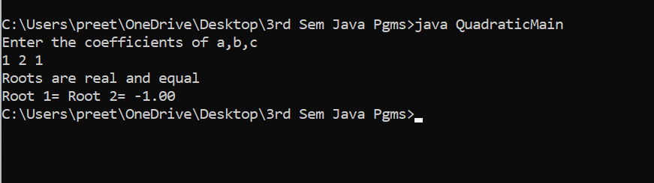

CASE 2: Roots are real and distinct

