**Exercise 1: Control Structures**

**Data :**

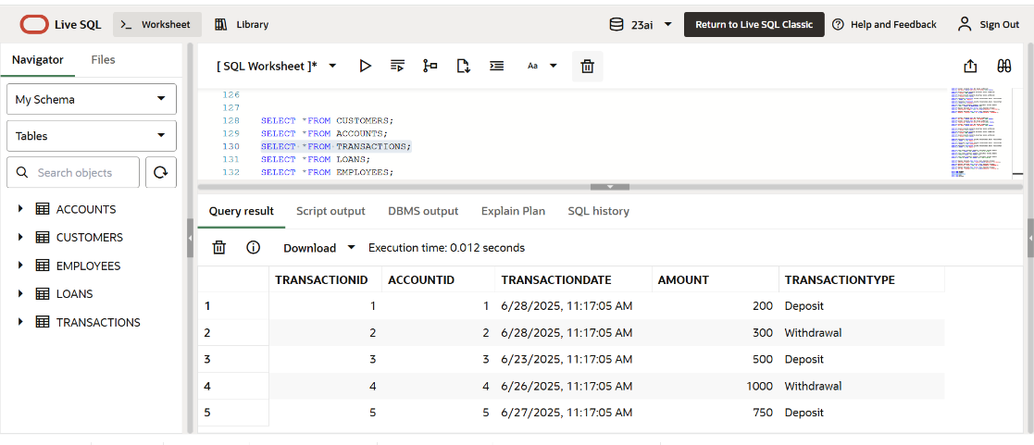

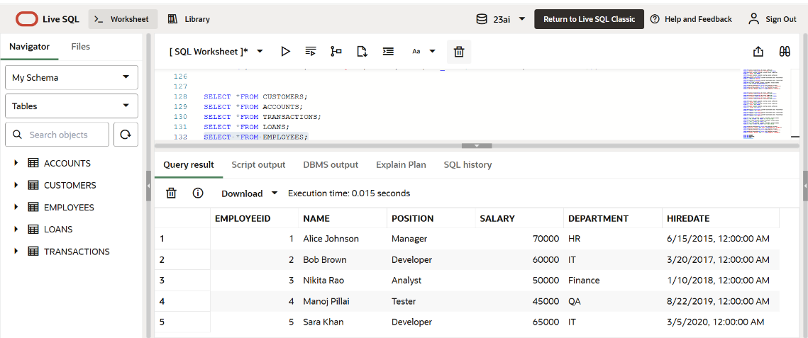

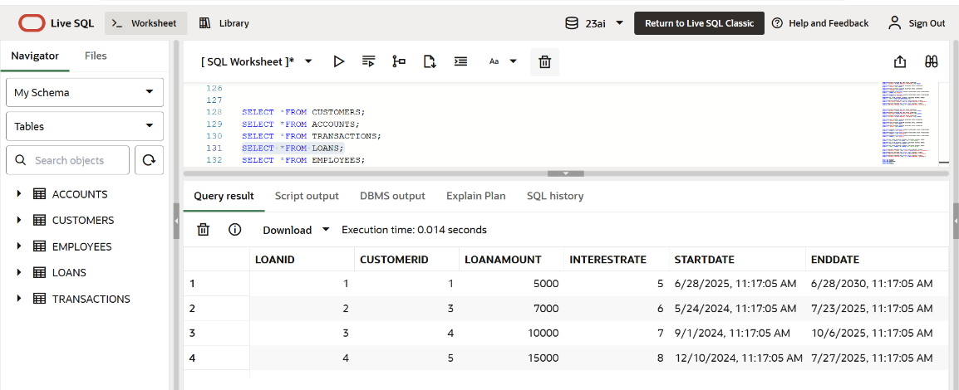

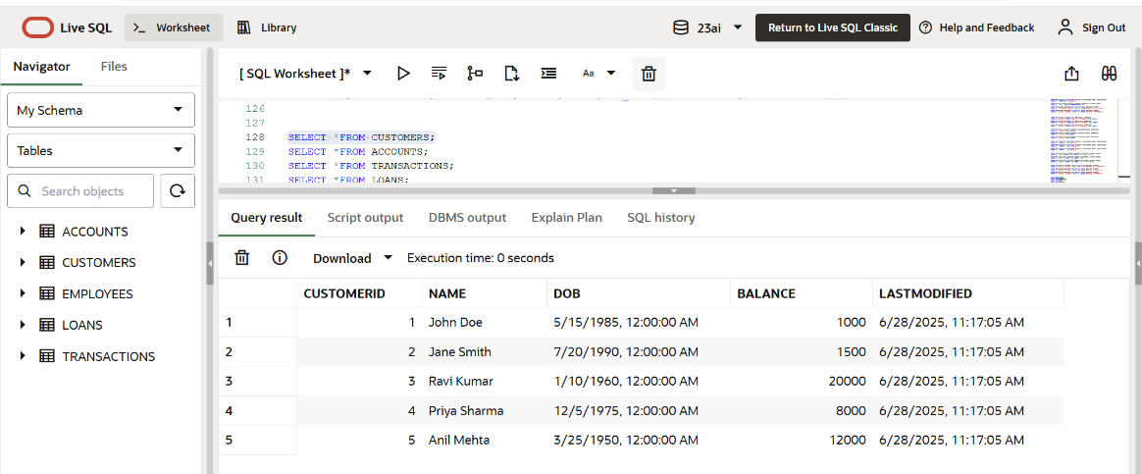

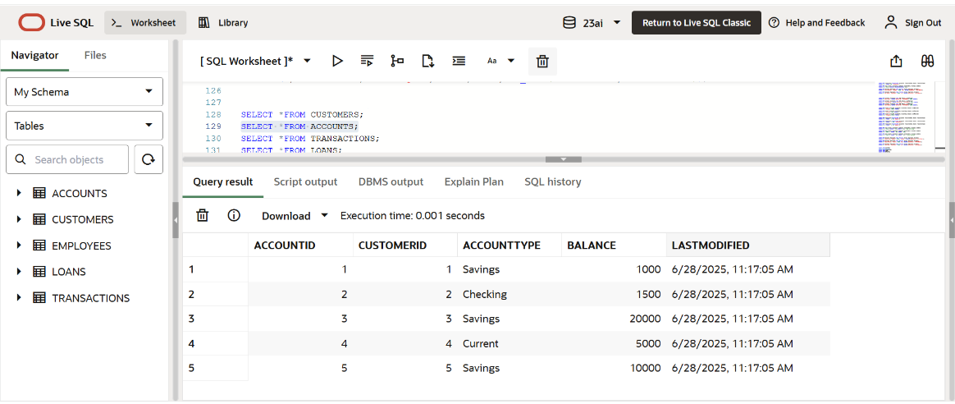

**Scenario 1:** The bank wants to apply a discount to loan interest rates for customers above 60 years old.

* + **Question:** Write a PL/SQL block that loops through all customers, checks their age, and if they are above 60, apply a 1% discount to their current loan interest rates.

**Code :**

BEGIN

  FOR loan_rec IN (SELECT * FROM Loans l JOIN Customers c ON l.CustomerID =c.CustomerID) LOOP

    IF MONTHS_BETWEEN(SYSDATE, loan_rec.DOB)/12 > 60 THEN

      UPDATE Loans

      SET InterestRate = InterestRate - 1

      WHERE LoanID = loan_rec.LoanID;

    END IF;

  END LOOP;

END;

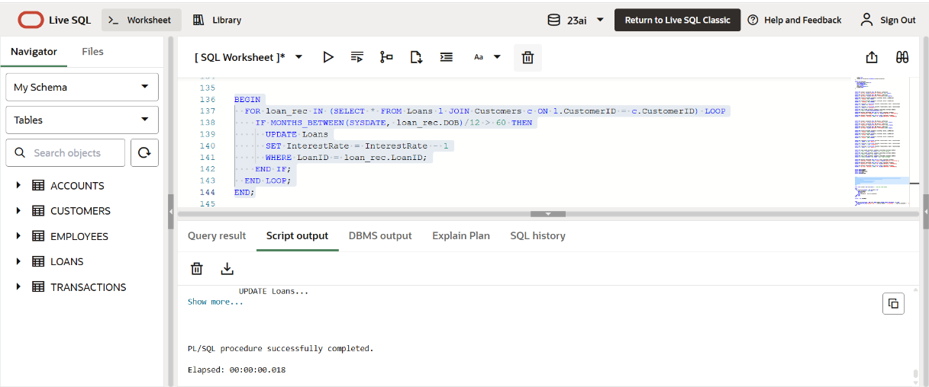

**Scenario 2:** A customer can be promoted to VIP status based on their balance.

* + **Question:** Write a PL/SQL block that iterates through all customers and sets a flag IsVIP to TRUE for those with a balance over $10,000.

**Code :**

ALTER TABLE Customers ADD IsVIP CHAR(1); -- One-time schema update

BEGIN

  FOR cust_rec IN (SELECT * FROM Customers) LOOP

    IF cust_rec.Balance > 10000 THEN

      UPDATE Customers

      SET IsVIP = 'T'

      WHERE CustomerID = cust_rec.CustomerID;

    END IF;

  END LOOP;

END;

select * from CUSTOMERS;

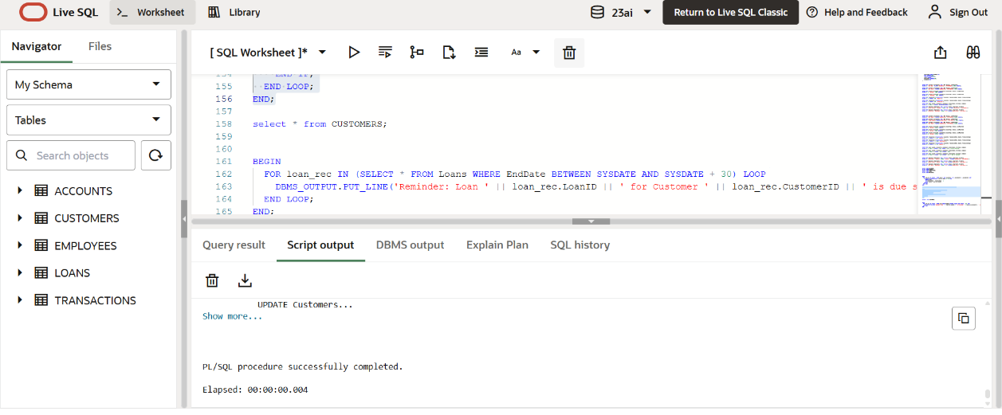

­­­­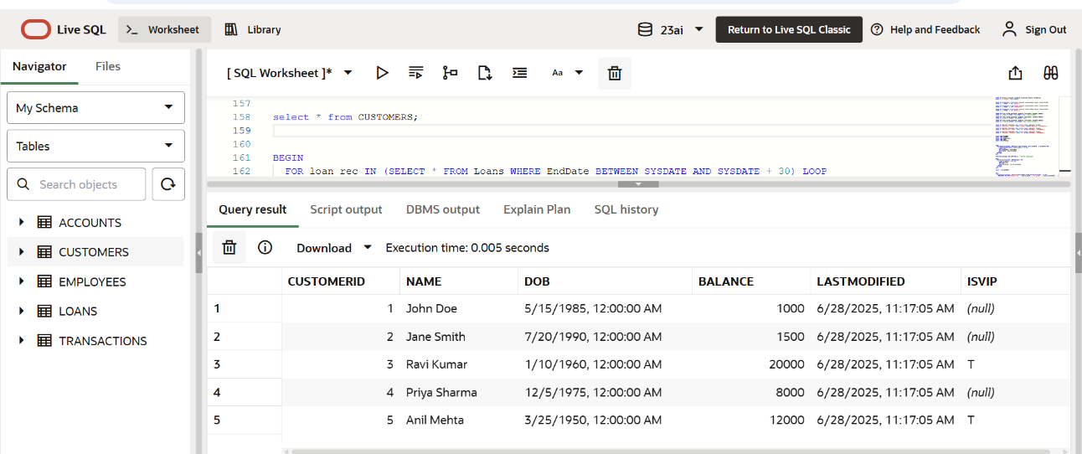

**Scenario 3:** The bank wants to send reminders to customers whose loans are due within the next 30 days.

* + **Question:** Write a PL/SQL block that fetches all loans due in the next 30 days and prints a reminder message for each customer.

**Code :**

BEGIN

  FOR loan_rec IN (SELECT * FROM Loans WHERE EndDate BETWEEN SYSDATE AND SYSDATE + 30) LOOP

    DBMS_OUTPUT.PUT_LINE('Reminder: Loan ' || loan_rec.LoanID || ' for Customer ' || loan_rec.CustomerID || ' is due soon.');

  END LOOP;

END;

