**Exercise 4: Functions**

**Scenario 1:** Calculate the age of customers for eligibility checks.

* + **Question:** Write a function CalculateAge that takes a customer's date of birth as input and returns their age in years.

CREATE OR REPLACE FUNCTION CalculateAge(p_DOB DATE) RETURN NUMBER IS

BEGIN

  RETURN TRUNC(MONTHS_BETWEEN(SYSDATE, p_DOB) / 12);

END;

DECLARE

  v_age NUMBER;

BEGIN

  v_age := CalculateAge(TO_DATE('1980-06-15', 'YYYY-MM-DD'));

  DBMS_OUTPUT.PUT_LINE('Age is: ' || v_age);

END;

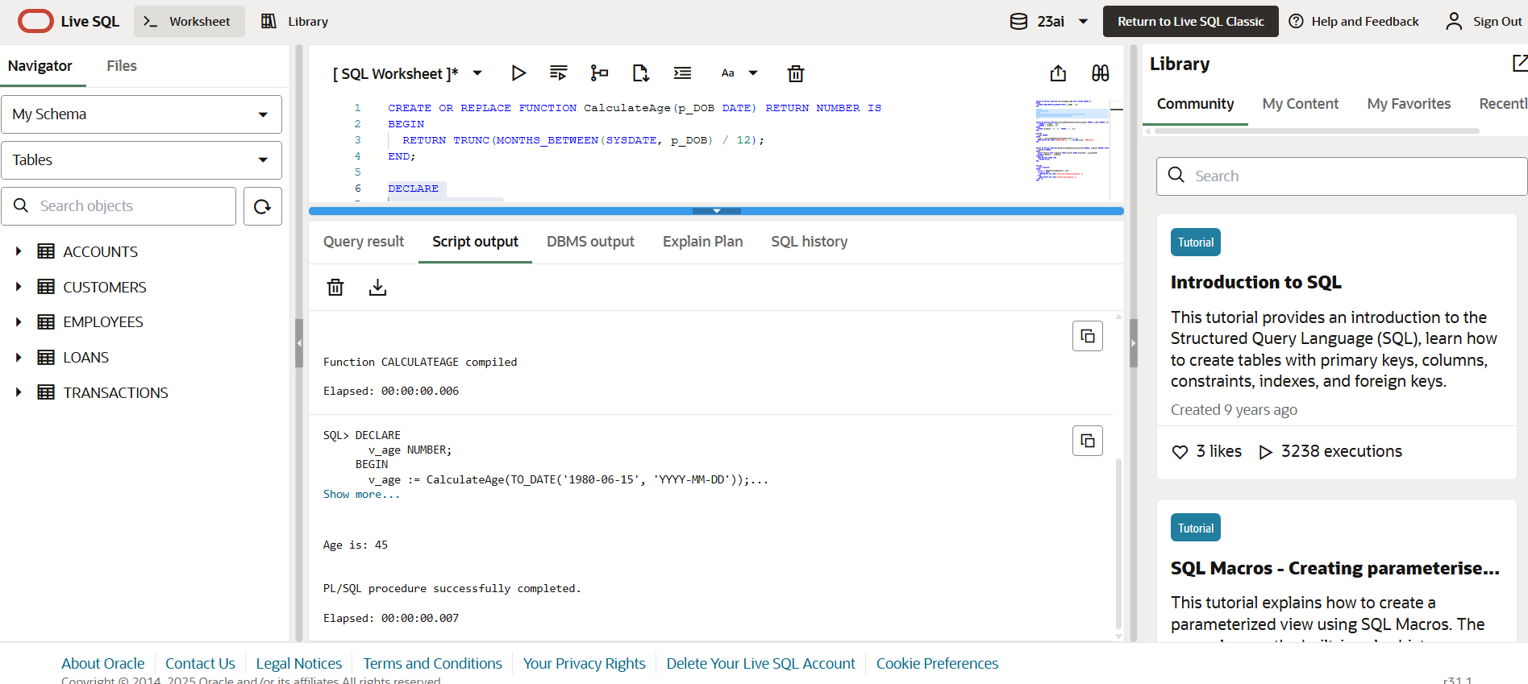

**Scenario 2:** The bank needs to compute the monthly installment for a loan.

* + **Question:** Write a function **CalculateMonthlyInstallment** that takes the loan amount, interest rate, and loan duration in years as input and returns the monthly installment amount.

CREATE OR REPLACE FUNCTION CalculateMonthlyInstallment(p_Amount NUMBER, p_Rate NUMBER, p_Years NUMBER) RETURN NUMBER IS

  r NUMBER := p_Rate / 1200;

  n NUMBER := p_Years * 12;

BEGIN

  RETURN (p_Amount * r) / (1 - POWER(1 + r, -n));

END;

DECLARE

  v_emi NUMBER;

BEGIN

  v_emi := CalculateMonthlyInstallment(10000, 8, 5);

  DBMS_OUTPUT.PUT_LINE('Monthly EMI is: ' || TO_CHAR(v_emi, '9999.99'));

END;

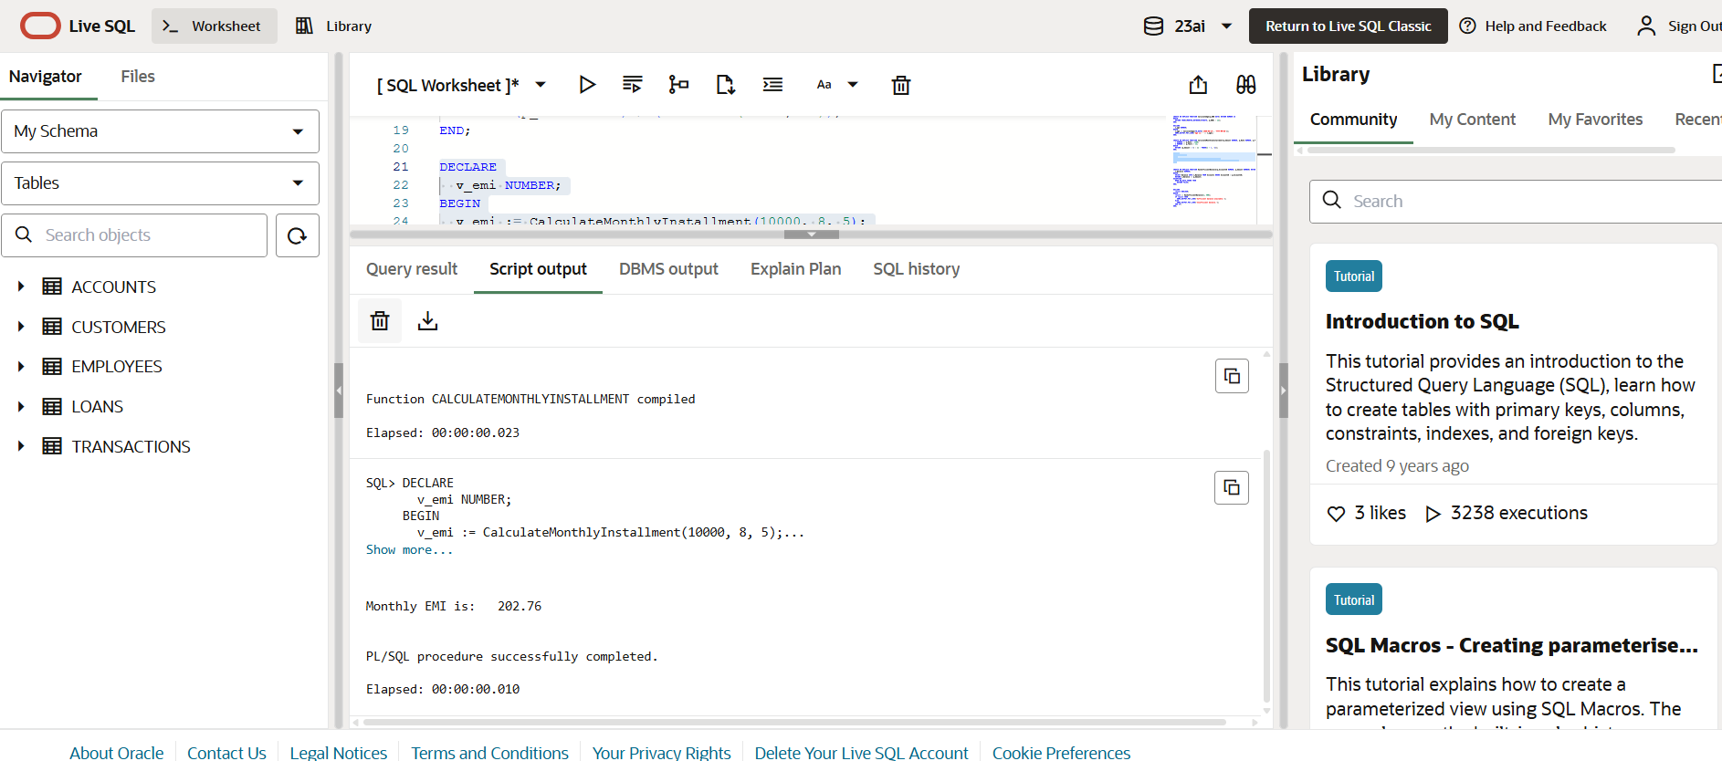

**Scenario 3:** Check if a customer has sufficient balance before making a transaction.

* + **Question:** Write a function **HasSufficientBalance** that takes an account ID and an amount as input and returns a boolean indicating whether the account has at least the specified amount.

CREATE OR REPLACE FUNCTION HasSufficientBalance(p_AccountID NUMBER, p_Amount NUMBER) RETURN BOOLEAN IS

  v_Balance NUMBER;

BEGIN

  SELECT Balance INTO v_Balance FROM Accounts WHERE AccountID = p_AccountID;

  RETURN v_Balance >= p_Amount;

EXCEPTION

  WHEN NO_DATA_FOUND THEN

    RETURN FALSE;

END;

DECLARE

  result BOOLEAN;

BEGIN

  result := HasSufficientBalance(1, 500);

  IF result THEN

    DBMS_OUTPUT.PUT_LINE('Sufficient balance available.');

  ELSE

    DBMS_OUTPUT.PUT_LINE('Insufficient balance.');

  END IF;

END;

