Exercise 6: Cursors

**Scenario 1:** Generate monthly statements for all customers.

* + **Question:** Write a PL/SQL block using an explicit cursor **GenerateMonthlyStatements** that retrieves all transactions for the current month and prints a statement for each customer.

DECLARE

  CURSOR txn_cursor IS

    SELECT AccountID, Amount, TransactionDate, TransactionType

    FROM Transactions

    WHERE TRUNC(TransactionDate, 'MM') = TRUNC(SYSDATE, 'MM');

  v_AccountID        NUMBER;

  v_Amount           NUMBER;

  v_TransactionDate  DATE;

  v_TransactionType  VARCHAR2(10);

BEGIN

  DBMS_OUTPUT.PUT_LINE('--- Generating Monthly Statements ---');

  OPEN txn_cursor;

  LOOP

    FETCH txn_cursor INTO v_AccountID, v_Amount, v_TransactionDate, v_TransactionType;

    EXIT WHEN txn_cursor%NOTFOUND;

    DBMS_OUTPUT.PUT_LINE('AccountID: ' || v_AccountID ||

                         ', Amount: ' || v_Amount ||

                         ', Date: ' || TO_CHAR(v_TransactionDate, 'DD-MON-YYYY') ||

                         ', Type: ' || v_TransactionType);

  END LOOP;

  CLOSE txn_cursor;

  DBMS_OUTPUT.PUT_LINE('--- Monthly Statement Generation Completed ---');

END;

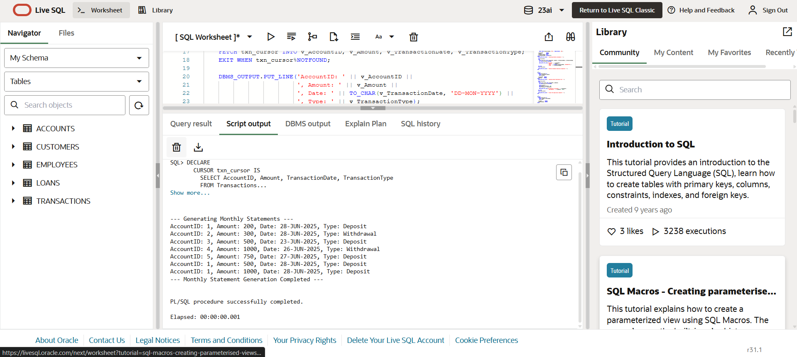

**Scenario 2:** Apply annual fee to all accounts.

* + **Question:** Write a PL/SQL block using an explicit cursor **ApplyAnnualFee** that deducts an annual maintenance fee from the balance of all accounts.

DECLARE

  CURSOR acct_cursor IS

    SELECT AccountID, Balance

    FROM Accounts;

  v_AccountID   NUMBER;

  v_Balance     NUMBER;

BEGIN

  DBMS_OUTPUT.PUT_LINE('--- Applying Annual Maintenance Fee ---');

  OPEN acct_cursor;

  LOOP

    FETCH acct_cursor INTO v_AccountID, v_Balance;

    EXIT WHEN acct_cursor%NOTFOUND;

    UPDATE Accounts

    SET Balance = v_Balance - 100

    WHERE AccountID = v_AccountID;

    DBMS_OUTPUT.PUT_LINE('Fee applied to AccountID: ' || v_AccountID ||

                         ', New Balance: ' || (v_Balance - 100));

  END LOOP;

  CLOSE acct_cursor;

  DBMS_OUTPUT.PUT_LINE('--- Annual Fee Application Complete ---');

END;

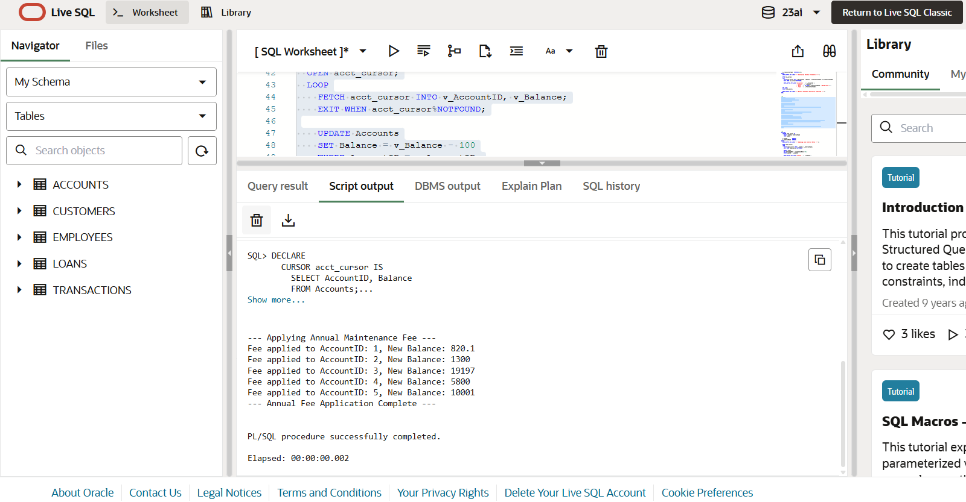

**Scenario 3:** Update the interest rate for all loans based on a new policy.

* + **Question:** Write a PL/SQL block using an explicit cursor **UpdateLoanInterestRates** that fetches all loans and updates their interest rates based on the new policy.

DECLARE

  CURSOR loan_cursor IS

    SELECT LoanID, InterestRate

    FROM Loans;

v_LoanID        NUMBER;

  v_InterestRate  NUMBER;

BEGIN

  DBMS_OUTPUT.PUT_LINE('--- Updating Loan Interest Rates ---');

  OPEN loan_cursor;

  LOOP

    FETCH loan_cursor INTO v_LoanID, v_InterestRate;

    EXIT WHEN loan_cursor%NOTFOUND;

    UPDATE Loans

    SET InterestRate = v_InterestRate + 0.5

    WHERE LoanID = v_LoanID;

    DBMS_OUTPUT.PUT_LINE('LoanID: ' || v_LoanID ||

                         ', Updated Interest Rate: ' || (v_InterestRate + 0.5));

  END LOOP;

  CLOSE loan_cursor;

  DBMS_OUTPUT.PUT_LINE('--- Interest Rate Update Completed ---');

END;

