Exercise 7: Packages

**Scenario 1:** Group all customer-related procedures and functions into a package.

* + **Question:** Create a package **CustomerManagement** with procedures for adding a new customer, updating customer details, and a function to get customer balance.

CREATE OR REPLACE PACKAGE CustomerManagement AS

  PROCEDURE AddCustomer(p_ID NUMBER, p_Name VARCHAR2, p_DOB DATE, p_Balance NUMBER);

  PROCEDURE UpdateCustomer(p_ID NUMBER, p_Name VARCHAR2, p_Balance NUMBER);

  FUNCTION GetCustomerBalance(p_ID NUMBER) RETURN NUMBER;

END CustomerManagement;

/

CREATE OR REPLACE PACKAGE BODY CustomerManagement AS

  PROCEDURE AddCustomer(p_ID NUMBER, p_Name VARCHAR2, p_DOB DATE, p_Balance NUMBER) IS

  BEGIN

    INSERT INTO Customers (CustomerID, Name, DOB, Balance, LastModified)

    VALUES (p_ID, p_Name, p_DOB, p_Balance, SYSDATE);

  END;

  PROCEDURE UpdateCustomer(p_ID NUMBER, p_Name VARCHAR2, p_Balance NUMBER) IS

  BEGIN

    UPDATE Customers

    SET Name = p_Name, Balance = p_Balance, LastModified = SYSDATE

    WHERE CustomerID = p_ID;

  END;

  FUNCTION GetCustomerBalance(p_ID NUMBER) RETURN NUMBER IS

    v_balance NUMBER;

  BEGIN

    SELECT Balance INTO v_balance FROM Customers WHERE CustomerID = p_ID;

    RETURN v_balance;

  END;

END CustomerManagement;

/

BEGIN

  CustomerManagement.AddCustomer(10, 'Rahul Dev', TO_DATE('1993-08-12', 'YYYY-MM-DD'), 8000);

  CustomerManagement.UpdateCustomer(10, 'Rahul Dev Updated', 8500);

  DBMS_OUTPUT.PUT_LINE('Balance: ' || CustomerManagement.GetCustomerBalance(10));

END;

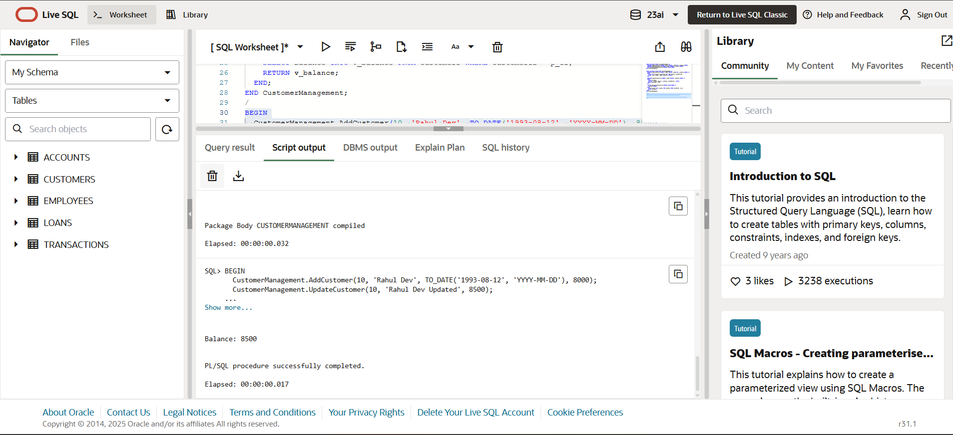

**Scenario 2:** Create a package to manage employee data.

* + **Question:** Write a package **EmployeeManagement** with procedures to hire new employees, update employee details, and a function to calculate annual salary.

CREATE OR REPLACE PACKAGE EmployeeManagement AS

  PROCEDURE HireEmployee(p_ID NUMBER, p_Name VARCHAR2, p_Position VARCHAR2, p_Salary NUMBER, p_Dept VARCHAR2, p_HireDate DATE);

  PROCEDURE UpdateEmployee(p_ID NUMBER, p_Salary NUMBER);

  FUNCTION GetAnnualSalary(p_ID NUMBER) RETURN NUMBER;

END EmployeeManagement;

/

CREATE OR REPLACE PACKAGE BODY EmployeeManagement AS

  PROCEDURE HireEmployee(p_ID NUMBER, p_Name VARCHAR2, p_Position VARCHAR2, p_Salary NUMBER, p_Dept VARCHAR2, p_HireDate DATE) IS

  BEGIN

    INSERT INTO Employees (EmployeeID, Name, Position, Salary, Department, HireDate)

    VALUES (p_ID, p_Name, p_Position, p_Salary, p_Dept, p_HireDate);

  END;

  PROCEDURE UpdateEmployee(p_ID NUMBER, p_Salary NUMBER) IS

  BEGIN

    UPDATE Employees SET Salary = p_Salary WHERE EmployeeID = p_ID;

  END;

  FUNCTION GetAnnualSalary(p_ID NUMBER) RETURN NUMBER IS

    v_salary NUMBER;

  BEGIN

    SELECT Salary INTO v_salary FROM Employees WHERE EmployeeID = p_ID;

    RETURN v_salary * 12;

  END;

END EmployeeManagement;

/

BEGIN

  EmployeeManagement.HireEmployee(10, 'Nisha Reddy', 'Analyst', 40000, 'Finance', TO_DATE('2022-04-10', 'YYYY-MM-DD'));

  EmployeeManagement.UpdateEmployee(10, 45000);

  DBMS_OUTPUT.PUT_LINE('Annual Salary: ' || EmployeeManagement.GetAnnualSalary(10));

END;

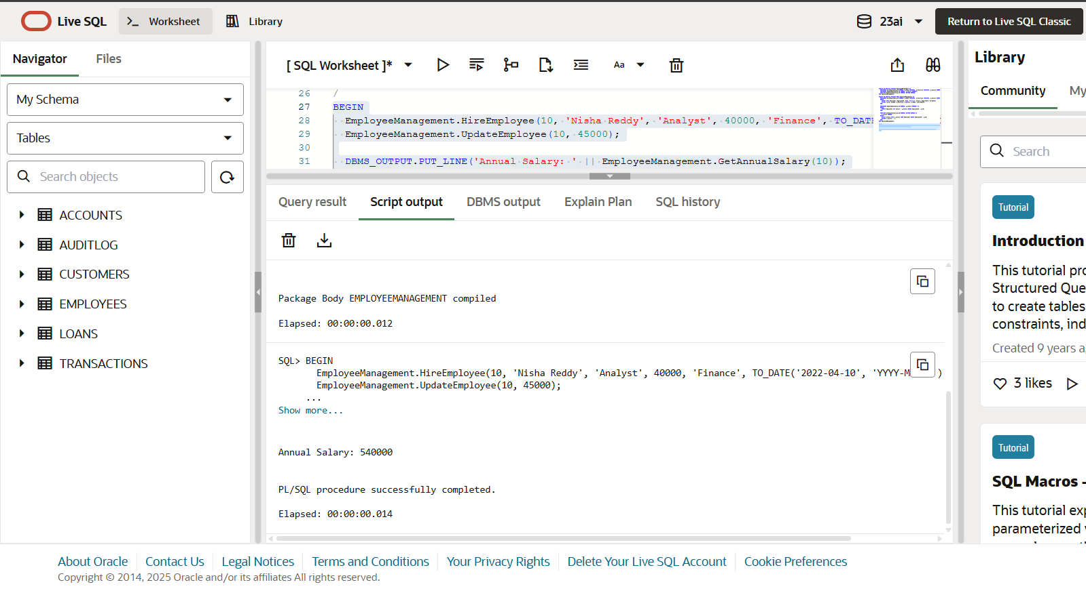

**Scenario 3:** Group all account-related operations into a package.

* + **Question:** Create a package **AccountOperations** with procedures for opening a new account, closing an account, and a function to get the total balance of a customer across all accounts.

CREATE OR REPLACE PACKAGE AccountOperations AS

  PROCEDURE OpenAccount(p_AccountID NUMBER, p_CustID NUMBER, p_Type VARCHAR2, p_Balance NUMBER);

  PROCEDURE CloseAccount(p_AccountID NUMBER);

  FUNCTION TotalCustomerBalance(p_CustID NUMBER) RETURN NUMBER;

END AccountOperations;

/

CREATE OR REPLACE PACKAGE BODY AccountOperations AS

  PROCEDURE OpenAccount(p_AccountID NUMBER, p_CustID NUMBER, p_Type VARCHAR2, p_Balance NUMBER) IS

  BEGIN

    INSERT INTO Accounts (AccountID, CustomerID, AccountType, Balance, LastModified)

    VALUES (p_AccountID, p_CustID, p_Type, p_Balance, SYSDATE);

  END;

  PROCEDURE CloseAccount(p_AccountID NUMBER) IS

  BEGIN

    DELETE FROM Accounts WHERE AccountID = p_AccountID;

  END;

  FUNCTION TotalCustomerBalance(p_CustID NUMBER) RETURN NUMBER IS

    v_total NUMBER;

  BEGIN

    SELECT SUM(Balance) INTO v_total FROM Accounts WHERE CustomerID = p_CustID;

    RETURN NVL(v_total, 0);

  END;

END AccountOperations;

/

BEGIN

  AccountOperations.OpenAccount(20, 10, 'Savings', 5000);

  AccountOperations.OpenAccount(21, 10, 'Current', 3000);

  DBMS_OUTPUT.PUT_LINE('Total Balance: ' || AccountOperations.TotalCustomerBalance(10));

  AccountOperations.CloseAccount(21);

END;

