Credit card fraud detection

# Program:

Program for Data visualization :

Import numpy as np

Import pandas as pd

Import seaborn as sns

Import matplotlib.pyplot as plt

From sklearn.model_selection import train_test_split

From imblearn.over_sampling import SMOTE

From sklearn.preprocessing import StandardScaler

From sklearn.ensemble import RandomForestClassifier

From sklearn.metrics import confusion_matrix, classification_report

Df=pd.read_csv(‘/content/drive/MyDrive/creditcard.csv’)

Df

Df.info()

Df.describe()

Df[‘Class’].unique()

Df[‘Class’].value_counts()

Corr = df.corr()

Fig = plt.figure(figsize = (12, 9))

Sns.heatmap(corr, vmax = .8, square = True)

Plt.show()

**Output:**

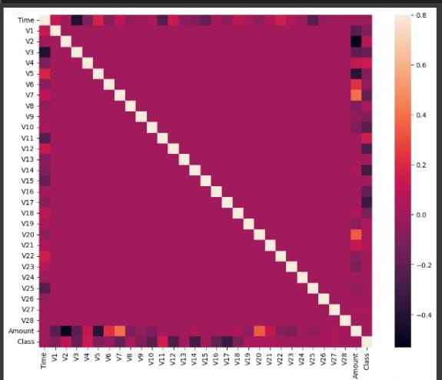

**Program 1:**

Df[‘Amount’] = StandardScaler().fit_transform(np.array(df[‘Amount’]).reshape(-1,1))

Df

Df[‘Amount’] = StandardScaler().fit_transform(np.array(df[‘Amount’]).reshape(-1, 1))

D

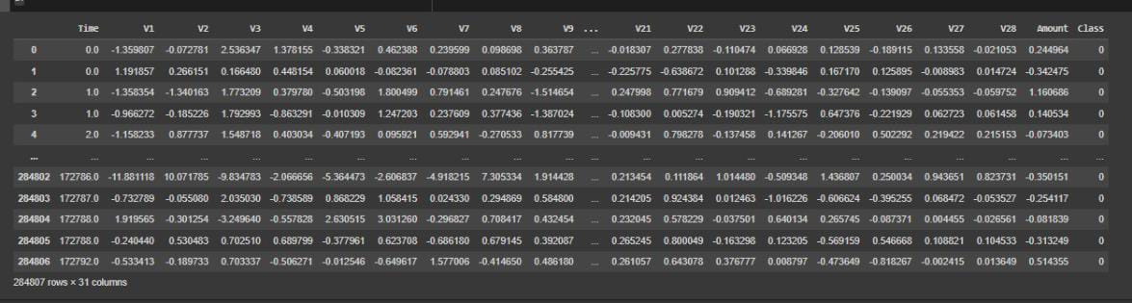**Output 1:**

**PROGRAM 2:**

X=df.drop([‘Class’], axis=1)

Y=df[“Class”]

X_train, X_test, y_train, y_test = train_test_split(X, y, test_size = 0.3, random_state = 0)

Sm = SMOTE() #solving class imbalance problem

X_train_res, y_train_res = sm.fit_resample(X_train, y_train.ravel())

Rfc=RandomForestClassifier()

Rfc.fit(X_train_res,y_train_res)

Y_pred = rfc.predict(X_test)

Print(classification_report(y_test, y_pred))

**OUTPUT 2:**

Precision Recall f1-score Support

0 1.00 1.00 1.00 85296

1 0.91 0.83 0.87 147

Accuracy

Macro avg 0.96 0.91 0.93 85443

Weighted avg 1.00 1.00 1.00 85443

**PROGRAM 3:**

LABELS = [‘Normal’, ‘Fraud’]

Conf_matrix = confusion_matrix(y_test, y_pred)

Plt.figure(figsize=(12, 12))

Sns.heatmap(conf_matrix, xticklabels=LABELS, yticklabels=LABELS, annot=True, fmt=”d”);

Plt.title(“Confusion matrix”)

Plt.ylabel(‘True class’)

Plt.xlabel(‘Predicted class’)

Plt.show()

**Output 3:**

