CONTENTS
Chapter 1 : Introduction
Introduction to Neural Engineering in biology ……………………………………………………2
Human Nervous System, Central Nervous System, Spinal Cord …………………………….2-4

Sensory Motor Pathways, Neural Interfaces and Prosthetics ………………………………...4-5

Chapter 2 Literature Survey

A Siamese Convolutional Neural Network for Identifying Mild Traumatic Brain Injury and Predicting Recovers …………………………………………………………………………………6
Computer Vision Based on a Modular Neural Network for Automatic Assessment of Physical Therapy Rehabilitation Activities ……………………………………………………………………7
Chapter 2 : IEEE Papers

- A Siamese Convolutional Neural Network for Identifying Mild Traumatic Brain Injury and Predicting Recovers
Introduction ………………………………………………………………………………………....7

Method ………………………………………………………………………………………….....7-9

Results …………………………………………………………………………………………….9-11

Conclusion ……………………………………………………………………………………….....11

- Computer Vision Based on a Modular Neural Network for Automatic Assessment of Physical Therapy Rehabilitation Activities
Introduction ……………………………………………………………………………………......12

Fundamentals of the Proposed Methodology ……………………………………………….13-14

The Proposed Methodology…………………………………………………….15-17

Results and Strategies …………………………………………………………………………18-20

Conclusion …………………………………………………………………………………………20
Chapter 1 : Introduction
Introduction to neural engineering in biology
Neural engineering, also known as neuroengineering, is a multidisciplinary field that integrates principles from neuroscience, engineering, biology, and computer science to develop technologies for understanding, repairing, enhancing, and interfacing with neural systems. In the context of biology, neural engineering focuses on exploring the nervous system's functions and creating innovative solutions to address neurological disorders, improve brain-machine interfaces, and advance our knowledge of brain function.
The human nervous system
The human nervous system is a complex network of cells and fibers that coordinates the activities of the body by transmitting signals between different parts. It is divided into two main parts: the central nervous system (CNS) and the peripheral nervous system (PNS).
Central nervous system
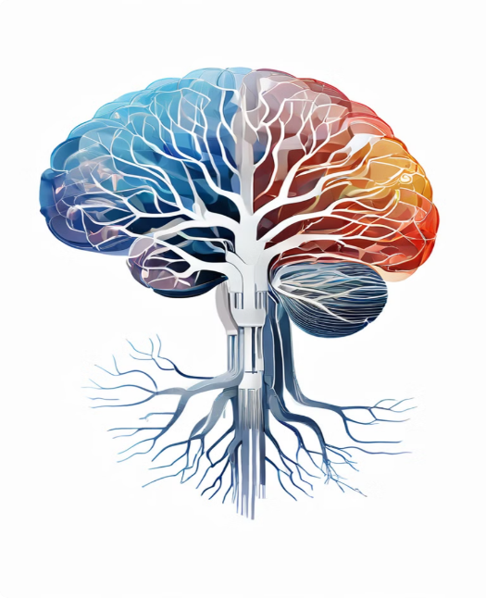
The central nervous system (CNS) is the primary control center of the body, responsible for processing information and coordinating activities. It consists of two main components: the brain and the spinal cord.
Brain:
The brain is the most complex organ in the body, responsible for interpreting sensory information, generating thoughts, and controlling behaviors and bodily functions. It is divided into several major parts
Cerebrum:
Structure: The largest part of the brain, divided into two hemispheres (left and right), each controlling the opposite side of the body.
Lobes: Each hemisphere is further divided into four lobesFIG. Overview of Central nervous system
Frontal Lobe: Involved in reasoning, planning, movement, emotions, and problem-solving.
Parietal Lobe: Processes sensory information such as touch, temperature, and pain.
Temporal Lobe: Responsible for processing auditory information and memory.
Occipital Lobe: Involved in visual processing.
Cerebellum:
Location: Located under the cerebrum at the back of the brain.
Function: Coordinates voluntary movements, balance, and posture. It ensures smooth and precise execution of motor activities.
Brainstem:
Components: Includes the midbrain, pons, and medulla oblongata.
Function: Connects the brain to the spinal cord and controls basic life functions such as heart rate, breathing, and blood pressure.
Midbrain: Involved in vision, hearing, eye movement, and body movement.
Pons: Relays messages between the cerebrum and the cerebellum and is involved in sleep and respiratory functions.
Medulla Oblongata: Regulates vital functions such as heart rate, blood pressure, and breathing.

Spinal Cord
The spinal cord is a long, cylindrical structure that extends from the brainstem down through the vertebral column.
Structure:
Comprised of white matter (myelinated axons) on the outside and gray matter (neuronal cell bodies and unmyelinated axons) on the inside.
Divided into segments corresponding to the vertebrae: cervical, thoracic, lumbar, sacral, and coccygeal regions.

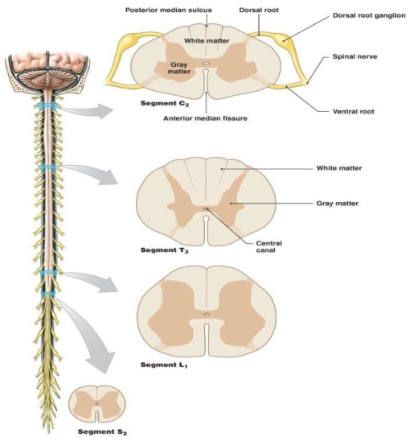
Function:
Transmission of Signals: Serves as the main pathway for transmitting information between the brain and the rest of the body. Sensory information from the body is sent to the brain, and motor commands from the brain are sent to the body.
Reflexes: Coordinates reflex actions, which are automatic responses to stimuli that do not require input from the brain. Reflexes are processed directly within the spinal cord.FIG. Spinal cord Structure
Sensory and motor pathways
Sensory Pathways
Sensory pathways, or afferent pathways, transmit sensory information from the body's receptors to the central nervous system (CNS).
Receptors:
Detect stimuli (e.g., touch, temperature, pain) in the skin, muscles, and organs.
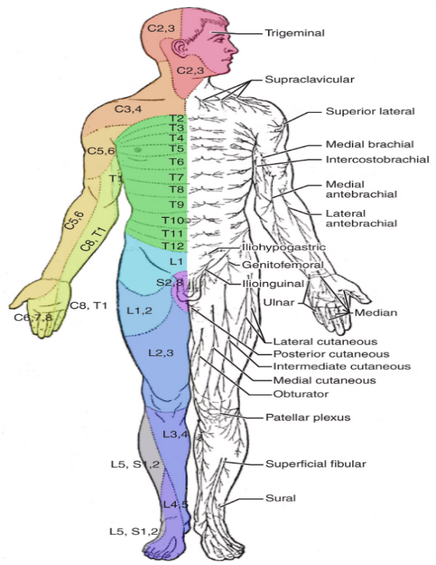
First-Order Neurons: Carry signals from receptors to the spinal cord or brainstem.
Second-Order Neurons: Relay information from the spinal cord or brainstem to the thalamus, often crossing to the opposite side.
Third-Order Neurons: Transmit sensory information from the thalamus to the sensory cortex in the brain.
Motor Pathways
Motor pathways, or efferent pathways, transmit motor commands from the CNS to muscles and glands.
Upper Motor Neurons (UMNs): Originate in the motor cortex and send signals through the brainstem and spinal cord, often crossing to the opposite side.FIG. Sensory and Motor Pathways
Neural interfaces and prosthetics
Neural Interfaces
Neural interfaces, also known as brain-computer interfaces (BCIs), enable direct communication between the brain and external devices. They can be invasive (imp0lanted electrodes) or non-invasive (external electrodes like EEG). Applications include restoring motor functions for paralysis patients, sensory restoration (e.g., cochlear implants for hearing), and facilitating communication for those with severe impairments.
Neural Prosthetics
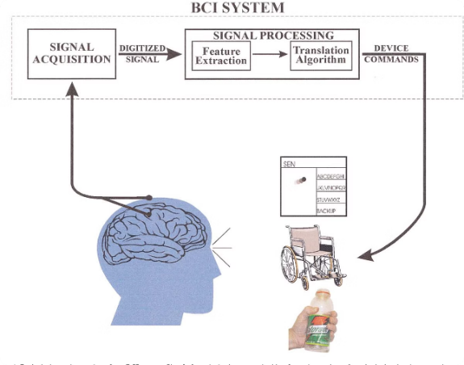
Neural prosthetics are devices that replace or enhance the function of damaged neural structures. Examples include:
Cochlear Implants: Restore hearing by converting sound into electrical signals that stimulate the auditory nerve.
Retinal Implants: Provide visual input for certain types of blindness.
Motor Prosthetics: Prosthetic limbs controlled by neural signals, allowing users to perform complex movements.FIG. BCI System
Key Technologies
Electrodes: Detect neural signals.
Signal Processing Algorithms: Translate neural signals into commands.
Feedback Systems: Provide sensory feedback to improve control and functionality.
These technologies aim to restore lost functions, enhance existing capabilities, and improve the quality of life for individuals with neurological conditions.
`

Chapter 2 Literature Survey
IEEE PAPER DISCRIPTION
PAPER 1 :A Siamese Convolutional Neural Network for Identifying Mild Traumatic Brain Injury and Predicting Recovery
[Author :The authors are with the Integrated Systems and NeuroImaging Laboratory, Department of Electrical and Computer Engineering, Rutgers University, Piscataway, NJ 08854 USA]
Abstract - Timely diagnosis of mild traumatic brain injury (mTBI) remains challenging due to the rapid recovery of acute symptoms and the absence of evidence of injury in static neuroimaging scans. Furthermore, while longitudinal tracking of mTBI is essential in understanding how the diseases progresses/regresses over timefor enhancing personalized patient care, a standardized approach for this purpose is not yet available. Recent functional neuroimaging studies have provided evidence of brain function alterations following mTBI, suggesting mTBI-detection models can be built based on these changes.
Most of these models, however, rely on manual feature engineering, but the optimal set of features for detecting mTBI may be unknown. Data-driven approaches, on the other hand, may uncover hidden relationships in an automated manner, making them suitable for the problem of mTBI detection. This paper presents a data-driven framework based on Siamese Convolutional Neural Network (SCNN) to detect mTBI and to monitor the recovery state from mTBI over time.
The proposed framework is tested on the cortical images of Thy1-GCaMP6s mice, obtained via widefield calcium imaging, acquired in a longitudinal study. Results show that the proposed model achieves a classification accuracy of 96.5%. To track the state of the injured brain over time, a reference distance map is constructed, which together with the SCNN model, are employed to assess the recovery state in subsequent sessions after injury, revealing that the recovery progress varies among subjects. The promising results of this work suggest that a similar approach could be potentially applicable for monitoring recovery from mTBI, in humans.

PAPER 2: Computer Vision Based on a Modular Neural Network for Automatic Assessment of Physical Therapy Rehabilitation Activities
[Author :Authors: João A. Francisco Jr. is with the Electrical Engineering Department, Centro University FEI, São Bernardo do Campo, São Paulo09850-901, Brazil]
Abstract--Physical rehabilitation techniques during the treatment of clinical pathology are one of the most challenging areas for the medical structure, patients, and families. In large and continental countries, remote monitoring of this treatment is essential. However, equipment and medical follow-up during exercises still have high costs. With the improvement of computer vision and machine learning techniques, some computational, less expensive alternatives have been proposed in the literature.
However, monitoring patients during physical rehabilitation exercises with the help of artificial intelligence by a health professional, especially from the capture of visual signals, is still a challenge and poorly explored in the scientific-technological literature. This work aims to propose a new methodology based on computer vision and machine learning for remote tracking of the body joints of patients during physiotherapy rehabilitation exercises.
As a new contribution, this work presents a modular neural network architecture composed of two modules: one for detecting physical exercises and another for measuring how much is correct. Another contribution is a strategy for expanding databases, considering that generic databases for this type of exercise are rare on the internet. The results showed that both modules obtained more than 90% of accuracy in recognition and their respective validation.

Chapter 3 : IEEE Papers
PAPER 1: Computer Vision Based on a Modular Neural Network for Automatic Assessment of Physical Therapy Rehabilitation Activities
Abstract
Physical rehabilitation techniques during the treatment of clinical pathology are one of the most challenging areas for the medical structure, patients, and families.In large and continental countries, remote monitoring of this treatment is essential. However, equipment and medical follow-up during exercises still have high costs. With the improvement of computer vision and machine learning techniques, some computational, less expensive alternatives have been proposed in the literature. However, monitoring patients during physical rehabilitation exercises with the help of artificial intelligence by a health professional, especially from the capture of visual signals, is still a challenge and poorly explored in the scientific-technological literature. This work aims to propose a new methodology based on computer vision and machine learning for remote tracking of the body joints of patients during physiotherapy rehabilitation exercises. As a new contribution, this work presents a modular neural network architecture compose of two modules: one for detecting physical exercises and another for measuring how much is correct. Another contribution is a strategy for expanding databases, considering that generic databases for this type of exercise are rare On the internet. The results showed that both modules obtained more than 90% of accuracy in recognition and their respective validation.
Index Terms—Modular neural network, OpenPose, physical therapy
Introduction
The development of machine learning combined with Artificial Intelligence is mainly due to the vast application areas, with engineering, biology, and healthcare as greatexamples Despite undeniable advances, a critical issue for the importance of Artificial Intelligence is the use of low-cost technologies for the operation of predictive models, such as standard cameras and IMU (Inertial measurement unit) Manuscript received 5 May 2022; revised 2 November 2022; accepted 27 November 2022. Date of publication 2 December 2022; date of current version 5 May 2023. (Corresponding author: Paulo Sérgio Rodrigues.) João A Francisco Jr. is with the Electrical Engineering Department, Centro Universitário FEI, São Bernardo do Campo, São Paulo09850-901, Brazil (e-mail: joao_junior174@outlook.com).
Paulo Sérgio Rodrigues is with the Computer Science Department, Centro Universitário FEI, São Bernardo do Campo, São Paulo 09850-901, Brazil (e-mail: psergio@fei.edu.br). Digital Object Identifier 10.1109/TNSRE.2022.3226459 sensors for methodologies that use digital signals as input on the network. The health area is one of the fields that most benefits from
the use of artificial intelligence, such as cancer treatment withConvolutional Neural Networks the treatment of chronic diseases such as diabetes [6]; the prevention of falls the rehabilitation of patients who had a stroke [14], to name a few examples. The results of such studies are promising, and the accuracy of the models can be comparable to treatments performed by health professionals. Nowadays, there is a hybrid treatment of patients in which the professional uses methodologies that employ machine learning to assist in the procedure
and follow-up of the patient In recent times, with the advancement of artificial intelligence, cheaper sensors and promising results in the literature have accomplished a new field of study for treating people who had a stroke, especially in recognizing rehabilitative exercises. Using cameras in an indoor environment or sensors attached to the patient’s body, It is now possible to monitor rehabilitative movements more precisely. Under these technologies, healthcare professionals can efficiently monitor their patients with increasing quantitative and qualitative analysis. This technology allows patients to perform their treatment entirely remotely .However, there are still many challenges in rehabilitation using Artificial Intelligence (AI). Many methodologies do not consider the severity of the patient’s pathology. In contrast, the assessment by the AI models does not distinguish between a patient with a severe or mild stroke, which makes the quantitative and qualitative evaluation relatively poor. The lack of disease specificity can be important information to the health professional during the patient’s treatment. There are also challenges when the healthcare professional wants to evaluate each step of the rehabilitative activity. One challenge occurs when the AI model shows the moment when the exercise is performed incorrectly and what could be done to improve the rehabilitation movement. The work proposed here presents two main contributions. The first is a modular neural network for recognizing and assessing the assertiveness of physical therapy activities.The other is data augmentation of the databases used in the first contribution.

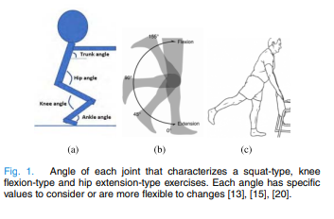
Fig 1:Angel of each joint that charecterized a squat-type ,knee flexion type hip extension type exersises.

As a future impact, these two contributions allow the construction of intelligent computational systems to aid distance physical therapy and further studies of therapies related to previous pathologies whose treatment indicated the aforementioned physical therapy exercises.

Fundamentals of the Proposed Methodology
The general idea of the proposed methodology is to use popular videos available on the internet of people performing three types of AROM-type (Active Range of Motion) rehabilitative physical exercises: squat, hip extension, and knee flexion. After capturing the exercises, the body joint’s identification and validation are carried out.
Then, to identify the body joints of the person performing the exercises, an AI-based library called Openpose is used. The Openpose is a well-known library developed which uses neural network concepts to identify 25 human body joints. It is commonly used in the literature for gesture recognition. Four angles, studied as sufficient to describe the exercises, were extracted: from the armpits, hip, knee, and lower limbs.
These angles were stored in two action banks. Finally, to validate the exercises, two modules with a back-propagation network were built, the Detection Module and the Measure Module. Therefore, this section explains the concepts used to develop the methodology further presented in Section III. The concepts presented here are: AROMtype exercises; Openpose; Action Banks; and Modular Neural Networks.

AROM-Type Exercises
The AROM (Active Range Motion) is a category of therapeutic exercises where the health professional measures the distance in which a joint of the human body can be moved from two points. These exercises help keep the joints flexible, reduce pain and improve balance and strength. Before starting treatment, the physical therapist usually measures the patient’s range of motion. Three types of exercises were selected for this article: squat, knee flexion, and hip extension. Each of these exercises has specific angles to consider.
- Squat Exercise: This exercise is accomplished by bending the knees to a specific angle and slightly bending the hips. The degree of knee flexion angle will determine the type of squat exercise, which is generally classified as mini-squat (140◦ − 150◦), semi-squat (120◦ − 140◦), half squat (80◦ − 110◦) and deep squat (<80◦). Such exercise is mainly performed to strengthen the lower parts of the body, including the thighs, hips, and buttocks.
- Knee Flexion Exercises: These exercises have no predefined angles, which depend on the patient’s dynamic and the severity of the pathology.
- Hip Extension: These exercises also have no predefined angle, depending on the patient’s ability to perform the exercise correctly. The angle between the lower limbs must be close to 60◦ to perform correctly.

B. Openpose
Openpose is an application proposed by [5] to recognize joints in the human body using AI. It is a real-time approach to detecting the body joints of multiple people in an image or video. The Openpose method uses a non-parametric representation, referred to as PAFs (Part Affinity Fields), to learn to associate human body joints with individuals in the image.
The network architecture includes several 7 × 7 convolutional layers preserving the receptive field. The output of each layer kernels is concatenated, following a similar approach to DenseNet. The method has six steps: input image, trust maps; affinity maps; bipartite combination; and merging of the results. The algorithm detects 25 points of articulations that coordinate,specify the pixel and the probability of that pixel corresponding to that articulation.

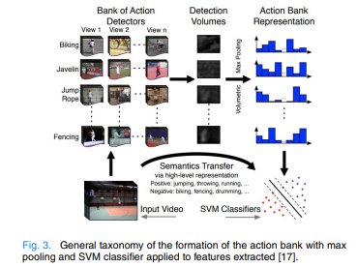
Fig 2: General taxonomy of the formation of the action bank with max pooling and SVM classifier applied to features extracted.

C. Action Bank
The objective was to propose a new representation of human action in the video. The action bank exploits a large set of action detectors that behave like the foundations of a high-dimensional action space that, combined with a simple linear classifier, can form the basis of a semantically rich representation for activity recognition. illustrates the input images to form the Action Bank. The action bank representation is a concatenation of max pooling features in the network used in the volumetric detection of input images. Each of these networks is called Detector. The SVM (Support Vector Machine) classifier detects action according to the feature vector.
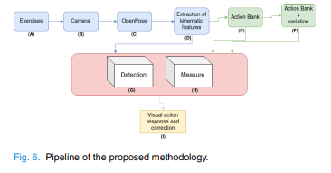
Fig 3: Pipeline of the proposed methodology.

The Proposed Methodology
This section aims to show the proposed methodology and the description of each module. Each step is described in a specific subsection, and each subsection presents the purpose, input, and output for a given step.
A. General Explanation of Methodology
The methodology starts in step (A) when a patient performs a set of exercises for lower limbs, and a standard camera in step (B) captures their movements. In step (C), the Openpose identifies the body’s joints in each frame.In step (D), kinematic data are captured, like the joint’s angles built in the previous step. In steps (D), (E), and (F), these kinematics data are stored in the action bank used for testing and training. In step (F), new movement variations were added to expand the actions of the previous step. This expansion allows the measure module to detect exercises performed incorrectly.
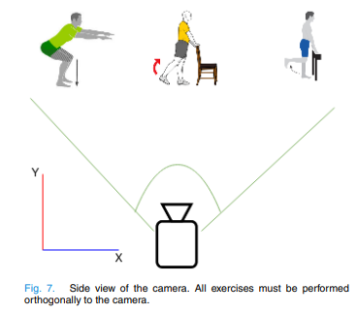
1) Step A: Exercises: In this step, the user performs exercises in an environment monitored by a standard camera. Patients with stroke may have poor mobility of the lower or upper limbs, depending on the severity. The first exercise is squat, as shown in Fig . Knee angles were adopted as approximately 40◦, as discussed in Section II-A with arms straight and extended forward and hips flexed over the knees. The second movement flexes the knee. The knee angle was adopted to be approximate 100◦ to 120◦. For the correct execution of this exercise, the lower limbs must perform the movements alternating with each other. The last movement is hip extension. This exercise can be performed with or without support. The angle between thelower limbs can range from 50◦ to 100◦.
2) Step B: Camera: Since the database used to train the networks presented here is built with popular databases found on the internet, the camera chosen for this step can be a simple standard camera. In this work, the user must perform the movements in the orthogonal perspective of the camera.
3) Step C: OpenPose: This step aims to collect the frames captured from input camera and estimate the user’s joints performing the exercise. Then, the OpenPose is used here. The program’s output represents the body articulation of the person performing the activity in the captured frames. Furthermore, a matrix of the size of the frame is generated, where each position (i, j) corresponds to the probability of the point (i, j) in the frame belonging to a possible articulation. After filtering the pixels with the highest probabilistic value, a vector of 25 positions is obtained. Each (i, j) position stands for a 2D point containing the coordinates i and j of that pixel in the input image of the OpenPose
4) Step D: Extraction of Kinematic Features: From the kinematic data, the angles between the joints are calculated. Let D3 be the Euclidean distance between points (x1, y1) and (x3, y3), D2 the distance between (x1, y1) and (x2, y2) and D1 a distance between (x3, y3) and (x2, y2). Then, the angle A iscalculated using the Law of Cosines by Equation (1). D2 3 = D22 + D21 − 2.D2.D1.cos A
5) Step E: Action Bank: The action bank aims to store the vectors of angles obtained with the 25 points extracted from OpenPose. Each column of Fig. shows the type of exercise a user performs. Each line stands for the moment at which the first frame was captured. After reaching an exercise state, the second frame is captured, until the last frame N, representing the end of the physical activity. Each matrix position in Fig shows an angle of the user’s joints in a specific exercise. The present work uses publicly available databases of people undergoing physical therapy exercises. The number of frames varies according to the video’s size. After identifying the joints of a human body, only the angles are stored and used to train the detection and measure networks. Here, only four angles are considered and stored in each action bank position: armpit angle; knee; hip; and the angle between lower limbs.
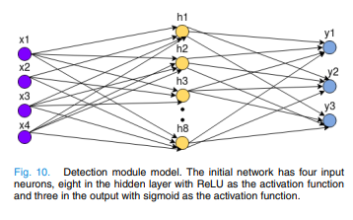
6) Step F: Action Bank + Variation: This step stands for storing a copy of the action bank. This action bank aims to train the measure module, which is responsible for showing the region in which the exercise is being performed incorrectly.
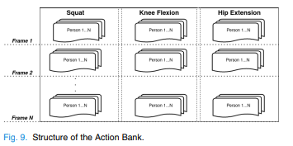
7) Step G: Detection Module: This step aims to receive the angles of the exercises performed by a user and associate them with the corresponding class in the action bank. The module Input corresponds to the four angles that describe the proposed exercises. Initially, only one hidden layer contains eight neurons (h1, h2, h3,..., h8). ReLU is the activation function of each hidden layer. As an output, there are three neurons, each representing a class of exercise. The activation function of the last layer was sigmoid. More hidden layers were added to verify which model was more accurate during training, testing, and generating the results. However, it is not enough to recognize all types of exercises based only on the action bank without variations. Here in Step G, random noises were added to the angles to expand the database.
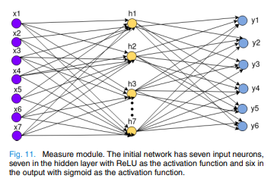
8) Step H: Measure Module: This step has the objective of assessing whether the exercise performed by the person is being performed correctly. If it is incorrect, it will show which member is in error.The output of this module is a six-dimensional vector. The first dimension of the output vector only indicates whether the exercise is right or wrong. The next five dimensions only indicate which type of error occurred in case the first dimension indicates that there was an error in the exercise performed by the user.
9) Step I: Visual Action Response and Correction: This step displays the results of the network output of the measure and detection modules. The results are presented in an image, superimposing in the captured video, the type of exercise, and the status. If it is being performed wrongly, a correction recommendation will appear.

Results and Strategies
A.Experimental Strategy
The experimental strategy of this work is divided into five main steps: action bank database building, detection module training; measure module training; metrics; and hardware used. All are described in more detail in the following sections.
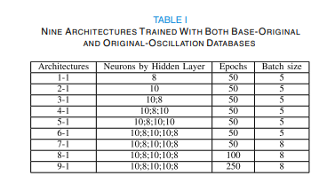
- Action Bank Database Building: Section III presents the three classes of exercises: squat, knee flexion, and hip extension. On the other hand, this work used public videos of physical exercises to build the stock bank. Each database class has twelve videos containing between 100 and 500 frames, thus producing 36 videos with 3600 to 6000 frames. This first database is denoted here in our work as Base-Original. The detection module recognizes the exercise even if it is incorrect. However, as all test examples are of people performing the exercises correctly, there is expected to be an error in the classification. Also, a simple data-augmentation technique was created where small random oscillations were added to the Base-Original in the following body’s articulation: armpit, hip, and lower limbs (legs). The added random oscillations extrapolate these limits, creating new artificial videos and a second database denoted as Original-Oscillation.
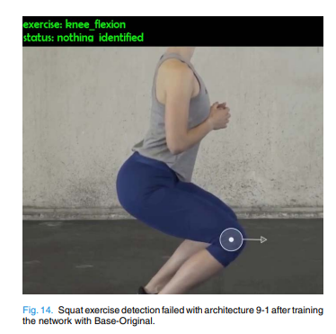
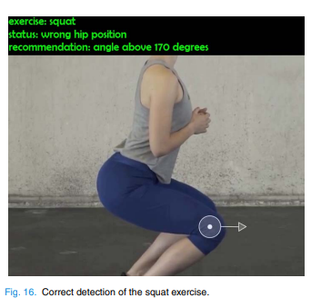
- Detection Module Training: To perform tests, 10% of the data from both databases were considered (Base-Original and Original-Oscillation) for testing and 90% for training. It is expected that the accuracy of the architecture trained with the Original-Oscillation database will be higher when compared to the accuracy of the architecture obtained with the Base-Original database, making it possible to recognize the exercises being performed incorrectly.
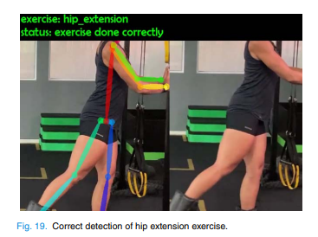
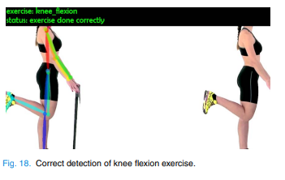
- Metrics Used to Validate the Results of the Detection and Measure Modules: Two metrics were used to validate the accuracy of the detection and measure modules: confusion matrix and area under the ROC curve. The best architecture with Original-Oscillation database was used for training, and the best architecture with the Oscillation-Errors database was used for the measure module. Six confusion matrices were generated for each class of the Network-Detection and six others for each Network-Measure class
- Hardware Used to Perform the Experiments: The Python language was used to develop the entire methodology. The library Keras, Numpy, Scikit-Learn, and Tensorflow were used to build the two modules.

B. Results
1) Detection Module: The first test was accomplished with the Base-Original and the Original-Oscillation databases. Thus, nine architectures were developed, with 90% of data used for training and 10% for testing in each database. The nine types of architectures are summarized in Table I. The first column represents the types of built architecture. There are nine architectures, so they were numbered 1-1 through 9-1
2) When comparing the accuracy of architecture 9-1 for Base-Original and Original-Oscillation in Table II, we can note that the results for Base-Original are superior. However, even with a decrease in accuracy, the results of architecture 9-1 after training its network model with the Original-Oscillation database are more acceptable, as the network identified the type of exercise even with small oscillations.In the upper left corner, the classification of the exercise as knee flexion is incorrect when it should be a squat. The reason is that all the
training examples are of people performing the exercise correctly. Thus, if there is an example of someone doing the exercise incorrectly but still within the exercise class, the classification may present not coherent results.
4). Confusion Matrix and ROC Curve: Based on the confusion matrix and the ROC curve, the following considerations were accomplished: the used threshold, 0.1, is in the range of [0, 0.5]; in the networks of the detection and measure modules, the cut-off threshold was 0.5; the area under the curve was calculated; since all graphs showed the same pattern, the formula side multiplied by height, in this case, specificity multiplied by sensitivity, was used; For the detection module, the architecture 9-1 was used with its network trained with the Original-Oscillation database; and for the measure module, architecture 9-2 was used with its network trained with the Oscillation-Errors database.

Conclusion
This work contributes to the scientific literature on recognizing and evaluating rehabilitative physical exercises, capturing videos of people performing physical activities with a standard RGB camera. A nine-step methodology is proposed to capture videos of a person performing rehabilitative activities such as a squat, hip extension, and knee flexion.
Two neural networks, called detection and measure modules, were developed. Both modules are responsible for recognizing and validating the type of exercise. The final step is responsible for presenting the results in the text on the video. Based on the results, we can note that the accuracies for architectures 9-1 and 9-2, trained respectively with Original-Oscillation and Oscillation-Errors, were approximately 90%. It is possible to notice that the area under the curve of all classes comes close to the ground truth.
With the areas under the curve being close to the ground truth, it is evident that the architecture 9-1 and 9-2 networks are classifiers with satisfactory accuracy. The proposed methodology can help in two lines of research. First, it can deal with extracting information from physical therapy exercises. Then, it is possible to further statistical analysis, allowing the construction of artificial agents that can assist health professionals in reaching conclusions regarding diagnoses and treatments. The second line can be the construction of artificial agents that accompany the patients and help them in real-time to execute the exercises correctly
Chapter 3 : IEEE Papers
PAPER 2: Real-Time Detection of Acute Cognitive Stress Using a Convolutional Neural Network From Electrocardiographic Signal
ABSTRACT
As stress is related to many mental and physical health problems, monitoring stress and itsmanagement is getting increasingly important in modern societies. Because of the advantage of convolutional neural network (CNN) in automatic feature learning, this study is proposed to use CNN to achieve accurate and fast detection of acute cognitive stress from heart rate variability (HRV). The traditional mental arithmetic calculation was adopted as the stressor for a total of twenty participants, during which one-lead electrocardiogram (ECG) was acquired. Six conventional HRV methods for inferring cognitive stress were extracted from the ECG signals, and their performance in identifying acute cognitive stress was compared with the proposed CNN-based method. The experimental results showed that with a super-short (10 s) time window, the detection error rate of CNN was 17.3%, which is significantly better than the performance of all six conventional HRV methods (> 7.2%, p < 0.01). Further analysis showed that the improvement achieved by the proposed CNN methods mainly came from the decrease in false stress sample detection. This study demonstrated the possibility of super-short windows and the advantage of CNN on acute cognitive stress detection. Its outcome would benefit practical applications of real-time stress detection via HRV.
INTRODUCTION
Stress is normally presented when the mental and physiological resources available could not meet the corresponding demands of an individual , such as a person is questioned over the area he/she is not familiar with, or a student still has several problems unsolved with a few minutes left in a final exam. In modern societies, stress is prevalent among ordinary people and its consequences can severely affect their daily living, as well as their health. According to the statistics from American Physiological Association and American Institute of Stress, in 2014, there were 77% of US people regularly experiencing physical symptoms, and 73% of US people regularly experiencing psychological symptoms, both of which The associate editor coordinating the review of this manuscript and approving it for publication was Qingxue Zhang. were caused by stress . Further, 33% of people felt that they lived with extreme stress, and 48% of people confirmed that stress had a negative impact on both their personal and professional life. The scenario in the EU was similar, more than 22% of employees thought that their health was at risk because of their intense work . The subsequent cost for stress caused health care and missed work was countless. In the US, it reached up to 300 billion dollars per year . In the UK, 13 million working days were lost every year with a cost of 12 billion pounds . Consequently, to get rid of stress and keep a healthy lifestyle, stress detection and management was necessary and essential for ordinary people. The physiological response to stress would be initially reflected on the activities of the autonomic nervous system (ANS) . ANS consists of two branches, the sympathetic and parasympathetic. The parasympathetic branch would be suppressed, while the sympathetic branch would be hyper-activated. This information would be transmitted to the cardiac activity, which could be measured by electrocardiogram (ECG) signals. As such, ECG signal is usually adopted as a source signal for stress measurement.Heart rate variability (HRV) is the variation between the interval of two consecutive R peaks (heartbeats) of ECG signals . As only R peaks are required for calculation, HRV is robust to noise and disturbances because R peaks have the highest amplitude in ECG. As such, HRV is commonly used as an investigation tool for stress detection. To obtain HRV measurement, normally three ECG electrodes are needed, attached on the right leg (RL), right arm (RA) and left leg (LL), to collect the standard Lead II ECG signal. Once all the R peaks are detected, HRV features can be extracted for stress detection . Normally a selected time window is chosen, and the features are calculated within the window. In the HRV based stress detection literatures, the window length was usually adopted in minutes . As such,inferences of cognitive stress could only be made with at least a minute delay, not possible for real-time stress detection. For feature extraction, many methods were proposed based on the physiological symptoms of stress, which induced the increase of heart rate beats , balance change between the sympathetic and parasympathetic branch of ANS ,chaotics of heart rate rhythm , etc. The common features of stress detection included heart rate (HR), the power ratio of the low-frequency band (0.04 - 0.15 Hz) to the highfrequency band (0.15 – 0.4 Hz), etc. However, there werestudies found that the performance of a single feature was not consistent due to large inter-participant variabilities, and the combination of several features provided better performance in stress detection . This indicated that the response of people to stress might vary and had multiple manifestationsin HRV. The extracted features were then sent to the classifier for detection

II. METHOD
A. EXPERIMENTAL PROTOCOL AND DATAPREPROCESSING
Twenty healthy subjects, eight females and twelve males,aging from 18 to 35, participated in this study. The inclusioncriteria were:
1) no history of neurological and heart disease;
2) no allergy to adhesive or rubbing alcohol;
3) receivingsecondary school education or higher, capable of performingtwo-digit arithmetic calculation mentally. Written informed consent was obtained before the experiment. The experimental protocol was in accordance with the Declaration of Helsinki and approved by the Research Ethics Committee of the University of Waterloo (#22188). Mental calculation method was adopted in this study to induce the acute cognitive stress for the participants. Before the experiment, three ECG electrodes were separately attached on the LA, RA, and RL of each participant (Fig. 1), for the collection of standard lead II ECG signal. The raw data was acquired by a custom-made biomedical signal collection device with a sampling frequency at 500 Hz. The chip of analog to digital converter (ADC) is ADS1298IPAG (Texas Instruments Inc., USA), which are mainly applied in medical instrumentation, such as EEG, EMG and ECG measurement. Its common mode rejection ration (CMRR) is −115 dB. During the experiment, the participants were seated in a height adjustable chair with a headset, around 1 m away from the monitor. There were five sessions for each participant. The
first, third and fifth session was the rest session, in which the participant was asked to sit still and relax. Meanwhile, the headset would play comfortable music to help the participants loosen up as much as possible. The duration of the three sessions was 120 s, 60 s and 120 s, respectively. The middl erest session was added to avoid mental fatigue from mental tasks. he second and fourth session was the mental task session. The participants were asked to mentally perform a series of mathematical calculations, which were displayed in the front monitor. In the second session (the first mental task session), the question consisted of two operations, the multiplication of a one-digit and two-digit number, and the addition/subtraction of the product and a one-digit number. There were 10 questions. For each question, the participant had 10 s to input the answer. In the fourth session (the second mental task session), the question difficulty was increased. The addition/subtraction operation was conducted between the product of a one-digit and two-digit number and a two digit number, instead of a one-digit number in the second session. There were 30 questions, and the time limit for each question was increased to 20 s. As there was no electrode attached on the left hand, to avoid the interference from muscle contractions, it was the only hand allowed to press the keys for submitting the answers. There were several settings added to increase the mental stimulation level and engage the participants in the calculations. During the question and answer period, the headset would play road noise, such as the footsteps from the pedestrians, engine sound from the vehicles, to interference with the participants. Meanwhile, a stopwatch was positioned below the mathematical question, displaying the remaining time, along with the beeping sound. The pitch of the beeping sound would increase as the time went by. In addition, two or three people would stand behind the participant, of which he/she was aware. Once the answer was submitted, or time run out, the feedback, ‘correct’ or ‘incorrect’, would be given immediately. For the correct answers, the sound of doorbell would play, while for the incorrect answers, a loud beep would play. The image of the result would be kept for 5 s. All the participants reported that the stress level of these two sessions evaluated by their subjective experience was higher than that of the rest sessions. This study mainly focused on the binary classification between stress and rest status. The second rest session and the first 30 s of the last session were abandoned to avoid the effect of residual stress. As such, the data of rest status consisted of the first session and the last 90 s of the last session. To make the data volume even between two classes, the data of stress status consisted of half of the fourth session, which was around 210 s. Before classification, the ECG signals were first band-pass filtered between 1 and 50 Hz to remove the noise from the respiration and muscle contractions. Then the signal was windowed within 10 s for feature extraction. The step size between two consecutive windows was 0.1 s (the overlap was 9.9 s).
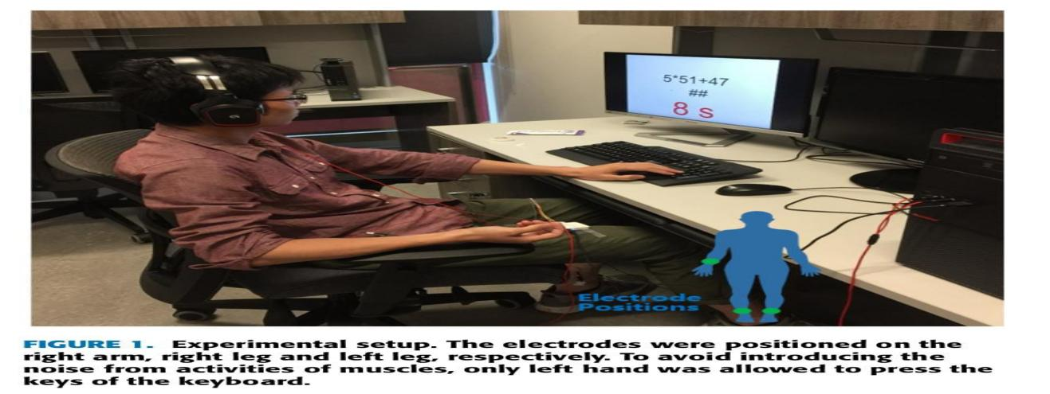
Fig1.1 Experimental setup
B. CNN CLASSIFICATION
To increase the robustness of the system against noise, the spectrum derived from the positions of R peaks was used for the input of CNN. For ECG signal within each window, the R peaks were first extracted with the classic QRS detection algorithm [24], and visual inspection was performed to correct the false acceptance and false rejection of R peaks. Next, the abnormal RR interval was removed based on the criteria in [10]. The remaining interval was termed as normal-to-normal (NN) interval, which was used to construct the zero-one sequence, where the positions of R peaks were set to one, and the others were set to zero. Then the Lomb Periodogram was employed to obtain the spectrum for its simplicity and common in spectral density estimation of HRV data [9], [10], [25] and no tuning parameters compared to parametric methods. The band from 0.04 to 20 Hz was adopted as the input of CNN. The procedures are illustratedin Fig. 2. A simple CNN structure with ten layers was used in this study. The first layer was an image input layer. Its size was 799×1×1, which was equal to the size of the input frequency band. The second layer was a convolutional layer, which consisted of six filters of 4×1×1 with the stride 1-by-1. It was followed by a batch normalization layer, a ReLU layer, and a dropout layer with a probability of 0.5. The next three layers were two fully connected layers and a batch normalization layer between them. The number of units for the two fully connected layers was ten and two, respectively. The last two layers were a softmax layer and a classification output layer, which both had two units. For the training options of CNN, the stochastic gradient descent with momentum (SGDM) optimizer was used. The maximum number of epochs was set to 30. The learning rate started at 0.001 and was reduced by a factor of 0.1 every 10 epochs. To assess the model performance accurately, a four-fold cross-validation scheme, which was a common method to test the ability of model prediction in machine learning [15], [26], [27], was adopted in this study. The dataset was divided into four partitions, three of which were used for training and the remaining one was for testing, i.e. the samples used for training and testing of each class were 1278 and 426, respectively. This process was repeated four times, so each partition was used the testing set once. The average accuracies of the four folds was used to quantify algorithm performance.

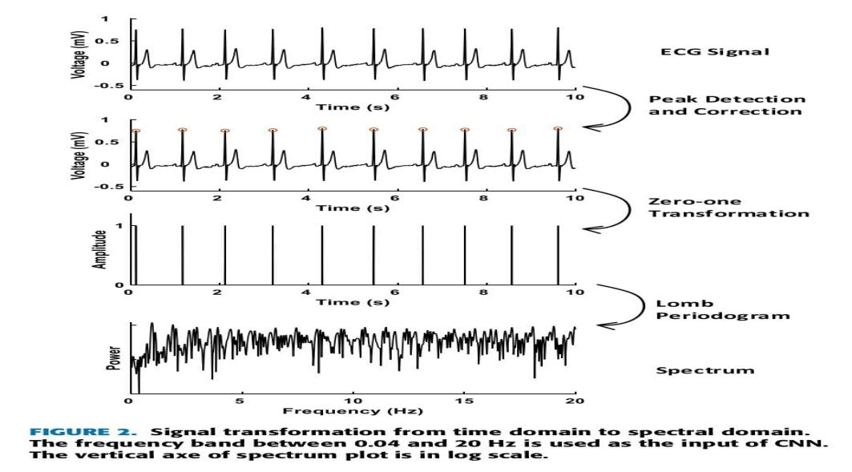
Fig 1.2 : Signal transformation from time domain to special domain.

C. CONVENTIONAL CLASSIFICATION
In this study, four types of features based on HRV, plus HR, were investigated. One HRV feature was the standard deviation of NN intervals, termed as SDNN. Two HRV features were derived from the Poincare plot [28], where the interval of two R peaks was plotted against its following. Poincare plot measured the change of NN interval, which was one of the symptoms caused by stress. To quantify the geometry of the Poincare plot, an ellipse was used to fit the plot shape. Two descriptors, termed as SD1 and SD2, were extracted, representing the minor and major semi-axis of the fitted ellipse, respectively. The two HRV features were SD2 and pQ, which was the ratio of SD1 to SD2. Another HRV features were derived from the frequency domain. The spectrum was calculated from the zeros-and-ones sequence, the same in CNN classification. Two frequency bands were identified for their relation to cognitive stress: 1) low-frequency band from 0.04 to 0.15 Hz, and 2) high-frequency band from 0.15 to 0.4 Hz. The ratio of the power of the two bands (LH) [10]was reported to reflect the balance change between the sympathetic and parasympathetic branch of ANS.As the validity of HRV features with super-short (10 s) windows is still controversial for different statistical methods and stress protocols in literatures [29], [30], SD2, SDNN and pQ were chosen for their good performance with ultrashort windows (usually in minutes) [10]. The selection of, HR and LH was for their prevalence in HRV based stress detection [8], [10], [21]. In addition, the combination of these five features (Comb) were also investigated in this study. The extracted features were then fed into a classifier to discriminate stress status from rest status. Two common classifiers, LDA and SVM, were separately tested with each feature set. For the setting of SVM, the dot product (linear kernel) was adopted to map the data into kernel space. To help converge in SVM, 0.5% of the variables were allowed to violate the Karush-Kuhn-Tucker (KKT) conditions. Same as the CNN classification, a four-fold cross-validation scheme was adopted. In each run, 75% of the data was used for training and the remaining 25% of the data for testing in four runs. All the data processing was performed on the platform of Matlab R2018b (The Mathworks, Inc., Natick, MA).

D. PERFORMANCE EVALUATION AND STATISTICAL ANALYSIS
For performance evaluation, three metrics were used in this study: error rate (ER), false acceptance rate (FAR), and false rejection rate (FRR). ER quantified the overall performance, which was the ratio between the incorrectly classified samples and the total number of samples. FAR quantified the performance of rest status classification, which was the ratio between the incorrectly classified rest class samples and the total number of the rest class samples. FRR quantified the performance of stress status classification, which was the ratio between the incorrectly classified stress class samples and the total number of the stress class samples. It could be induced that ER, FAR, and FRR was equal to the difference between one and accuracy, sensitivity and specificity [21], respectively. To compare the performance of detecting stress using various methods, one-way analysis of variance (ANOVA) was used in this study. Each of the three metrics, ER, FRR and FAR was the response variable, respectively. The main factor was the Methods, including the six feature sets (HR, LH, pQ, SD2, SDNN, Comb) with LDA and SVM, respectively, and CNN. In addition, to illustrate the performance improvement from CNN, the activation difference between rest and stress samples of the first five layers, image input, convolution, batch normalization, ReLU, and dropout, was calculated. A student t-test was implemented on the difference of each unit. Further, to investigate the effect of frequency bands on stress detection, a one-way ANOVA was employed on the ER values of CNN with the inputs of different frequency bands. The main factor was the higher limit of the frequency band used: 0.4, 1, 2, 6, 10, 20, 30, 40, 50, 60, 70, 80, 90, 100 Hz.

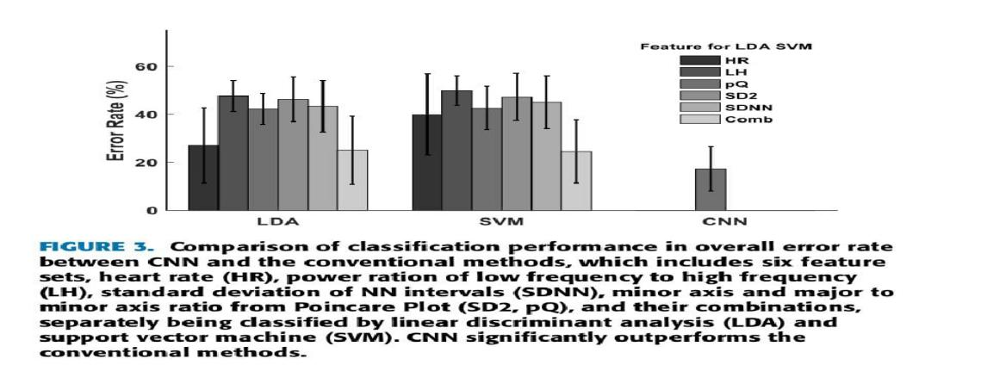
Fig 1.3 Comparison of classification performance in overall error rate between CNN and the conventional methods
.
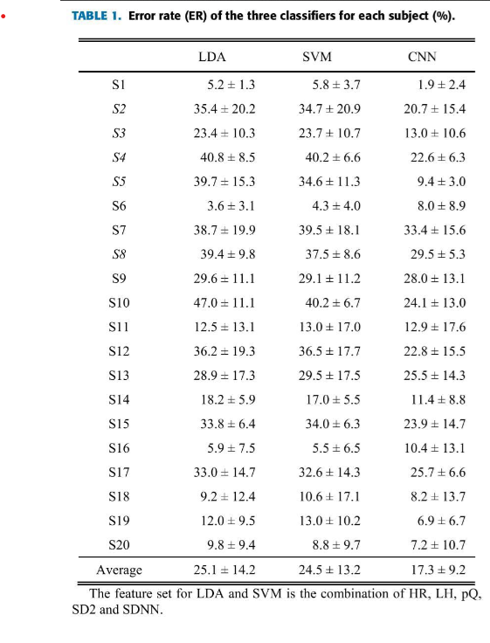
The lower bound of the frequency band remained at 0.04Hz. If the significant difference was indicated, a post hoc analysis with Bonferroni correction was conducted. The significance level of all the tests was set to 0.05.
III. RESULTS
A. PERFORMANCE COMPARISON
In general, CNN outperformed all the conventional methods (Fig. 3), among which the combination of all the acceptance rate (FAR), and (b) and false rejection rate (FRR) between CNNand the conventional methods. The conventional methods (HR, LH, SDNN, pQ, SD2 and Comb) and two classifiers (LDA and SVM). CNN 0.1%, almost invisible in (a)). For FRR, there was no significant difference features (Comb) achieved the best performance. Specifically, CNN achieved the lowest ER at 17.3%, which was 7.2% and 32.6% lower than the best and worst performance of the conventional methods, Comb with SVM and LH with SVM, respectively. For each subject, the ER value with three methods, CNN and two best conventional methods, Comb with SVM and LDA, respectively, was listed in Table 1. CNN reduced ER for most subjects. The reduction even reached 25.2% for S5, making the ER value below 10% for this participant. When dividing the ER into FAR and FRR, it indicated that the ER reduction in CNN was mainly due to the drastic reduction of FAR (Fig. 4). The FAR value of CNN was below 0.1%, close to zero. while the lowest of the conventional methods was 6.2% (HR with SVM), and the FAR value of Comb with SVM, which had the best ER among the conventional methods, was 23.7%. The FRR of CNN was 32.1%, and the range of the conventional methods were between 24.9% (Comb with SVM) and 69.2% (HR with SVM). For the results of statistical analysis, the performance of CNN was significantly better than the performance of the conventional methods in ER (p < 0.01) and FAR (p < 0.001). In terms of FRR, there was no significant difference between the values of CNN and the best conventional method, Comb with SVM.

B. ACTIVATION DIFFERENCE BETWEEN REST AND STRESS
To investigate the information CNN extracted for stress detection, the activation difference of each layer, i.e. the output difference of each layer with respective to rest and stress classes, was displayed in Fig. 5. The values were normalized within each layer and averaged across all the subjects. For the last four layers, cubic interpolation was adopted to resize the length of each feature map to fit the dimension of the first layer, image input. The biggest activation difference mainly located around 1.5 Hz, which was expected for it was corresponding to the frequency of R peaks, the main power of ECG signals. However, the differences were also observed in high frequency band. In the results of statistical analysis, it indicated that the significant difference between rest and stress was not only limited to the frequency band < 2 Hz, of which the information was usually used for feature extraction in conventional methods, such as HR and LH, but also existed in the range > 2 Hz, which might contribute to the improvement from CNN.
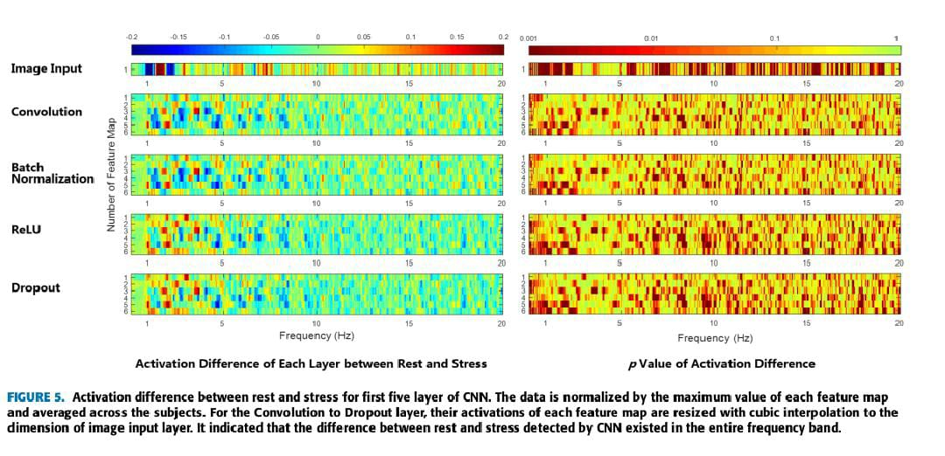
Fig 1.5 Activation difference between rest and stress for first five layer of CNN.

C. EFFECTS OF THE FREQUENCY BAND
The results of section B indicated that the information extracted from higher frequency content beyond 2 Hz might be the reason for the low ER value of CNN on acute stress detection. To further investigate this point, the CNN was tested with the inputs of different frequency bands. The starting frequency points of these bands were the same, which was 0.04 Hz, while the ending frequency point was different, ranging from 0.4 to 100 Hz. As displayed in Fig. 6, the ER value decreased with the increase of the higher end of the frequency band from 0.4 to 6 Hz and plateaued from there on. The statistical analysis showed that there was a significant difference among the ER values of 0.4, 1 and 2 Hz, but the difference between the ER values of 2 Hz and 6 Hz, as well as the other bands, was not significant.
IV. DISCUSSION
This study demonstrated that CNN can significantly improve the real-time detection of acute cognitive stress compared to the conventional HRV based methods (p < 0.01). To investigate the information CNN exploited for stress estimation, the activation differences between the stress state and the rest state of the first five layers were presented (Fig. 5), and the classification performance with the input of different frequency bands was calculated (Fig. 6). The activation difference map showed that there was significant difference between stress and rest in the output corresponding to the frequency band above 2 Hz (p < 0.05). The performance comparison showed that there were differences when the upper bound of the frequency band was higher than 2 Hz and above. However, the differences were not significant (p > 0.05). This indicated that the information in frequencies higher than 2 Hz might play a role in stress estimation of the CNN used in this study, but it was not critical. The main information CNN captured was still mainly from the frequency band below 2 Hz. Though frequency band above 2 Hz was not emphasized in traditional methods, based on the results of this study, its importance in stress estimation still needed to be further explored. In order to help the participants relax themselves in the rest session, listening to music was adopted for the strong effect on increasing relaxation [31], [32]. The quick relaxation before and after the experiment would reduce the bias of the data in rest sessions, and hence increased the reliability of the results in this study. The employment of CNN also provided a new way to learn the characteristics of stress. For the conventional methods, the features used mainly depended on the well-established physiological theory of the effect of stress, such as the balance between sympathetic and parasympathetic nervous systems. Because CNN has the automatic feature learning ability, it enabled the researchers to explore the characteristics of stress from the information CNN captured, which may conversely help the researchers, such as biologists and physiologists to acquire more insights the physiological effect of stress. In addition, the CNN structure used in this study was simple, only containing one convolutional layer,for consideration of computation load and the training time. However, as the structure would also affect the classification performance, complex structures could be explored in future to improve its detection performance further. Through breaking down the ER into FAR and FRR, it showed that the main improvement from CNN lied on the reduction of FAR, while FRR of CNN was still comparable to the conventional methods. This means that many stress data were incorrectly classified into rest class. The imbalance between FRR and FAR could be remedied by adjusting the probability threshold.
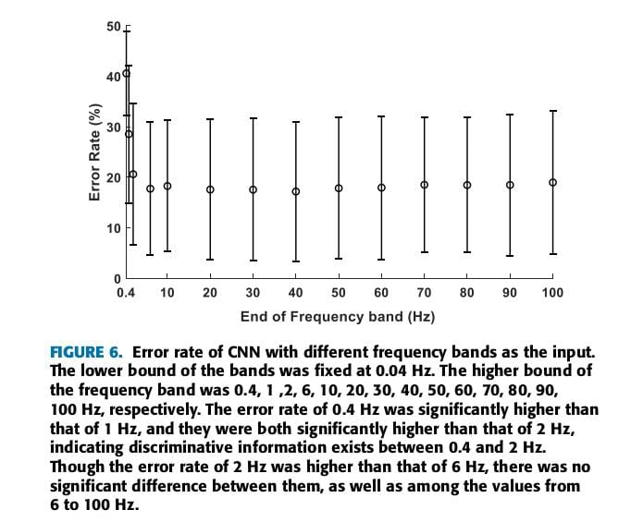
Fig 1.6 Error rate of CNN with different frequency bands as the input.

The softmax layer of CNN provided the probability of the sample assigned to each class. By default, the threshold of the probability was set to 0.5. Through optimizing the probability threshold in the training phase, the classification performance of stress data, consequently the overall stress detection performance, could further be improved. The spectrum derived from the positions of R peaks was used for the input of CNN. As the high amplitude of R peaks, its position detection would be hard to be disrupted by noise from the muscles. On the other hand, the R peaks could also be captured in some non-standard ECG settings, such as arm and ear ECG [27]. These two points made the method robust and applicable in non-ideal conditions. On the other hand, in addition to ECG, there were two other signal modalities, photoplethysmography (PPG) and photoplethysmographic imagining (PPGI), which could also be used for HRV measurement, both of which were noninvasive. PPG was light-based, and the sensor was usually mounted on the mounted on the finger, ear or toe [33]. PPGI was a non-contact measure, collecting signals with a light source and a light detector [34]. The broad spectrum of HRV measurement expanded its application on stress detection. The sensors could be integrated with intelligent mobile devices, such as the smartphone, to make stress estimation available with little limitation of time and place.

CONCLUSION

This study compared the performance of CNN with six conventional HRV-based methods in acute cognitive stress detection, using only 10s of ECG data. Stress was induced by mental calculation for twenty participants. Different from previous studies with minutes long windows, super-short temporal windows were used for it was highly desirable in many practical applications, where the real-time stress monitoring was an important feature. The results showed that the performance of CNN was significantly better than the conventional methods (p < 0.01), and the improvement was at least 7.2%. The activation map of each layer showed the discriminative information regarding stress versus rest existed in the frequency range higher than the conventional 0.4 Hz, and highly concentrated between 0.4 and 2 Hz. The outcome of this study demonstrated that it was possible to perform real-time detection of acute cognitive stress from HRV, and CNN had potential in practical applications of HRV based stress detection.

OVERALL CONCLUSION ABOUT THIS TWO IEE PAPERS

The two IEEE papers collectively highlight the transformative potential of artificial intelligence—particularly deep learning—in advancing modern healthcare systems through automation, precision, and real-time analysis. Though they address different clinical challenges—cognitive stress detection and physical therapy assessment—both studies emphasize how AI technologies can reduce reliance on manual evaluation, improve patient outcomes, and support remote healthcare solutions. The first paper, "Real-Time Detection of Acute Cognitive Stress Using a Convolutional Neural Network From Electrocardiographic Signal," presents a robust method for identifying acute cognitive stress using ECG signals processed through a Convolutional Neural Network (CNN). This approach enables timely, non-invasive, and automated stress monitoring. Such a system has significant implications for occupational health and safety, particularly in high-stress professions such as aviation, medicine, and military operations. Its ability to function in real-time also makes it ideal for integration into wearable health-monitoring devices, offering a continuous and adaptive way to track an individual's mental well-being. The second paper, "Computer Vision Based on a Modular Neural Network for Automatic Assessment of Physical Therapy Rehabilitation Activities," focuses on physical rehabilitation and utilizes video-based computer vision combined with a modular neural network. This system automatically evaluates the correctness and effectiveness of physical therapy movements, providing objective and consistent feedback. The modular architecture allows for specialization in different aspects of movement, making it scalable and adaptable to various rehabilitation protocols. Its application in home-based or remote care settings can significantly enhance the accessibility and continuity of physical therapy, particularly for patients with limited access to in-person clinical resources. In conclusion, both papers illustrate how domain-specific deep learning models can be tailored to solve complex problems in healthcare. They reinforce the broader trend of integrating AI into personalized medicine, where real-time monitoring and assessment tools can support early intervention, enhance compliance, and reduce the burden on healthcare professionals. While the technologies differ in terms of input data and application domain, their shared goal—to make healthcare smarter, more efficient, and more patient-centric—underscores the growing impact of AI across the healthcare landscape.

