Question 1:

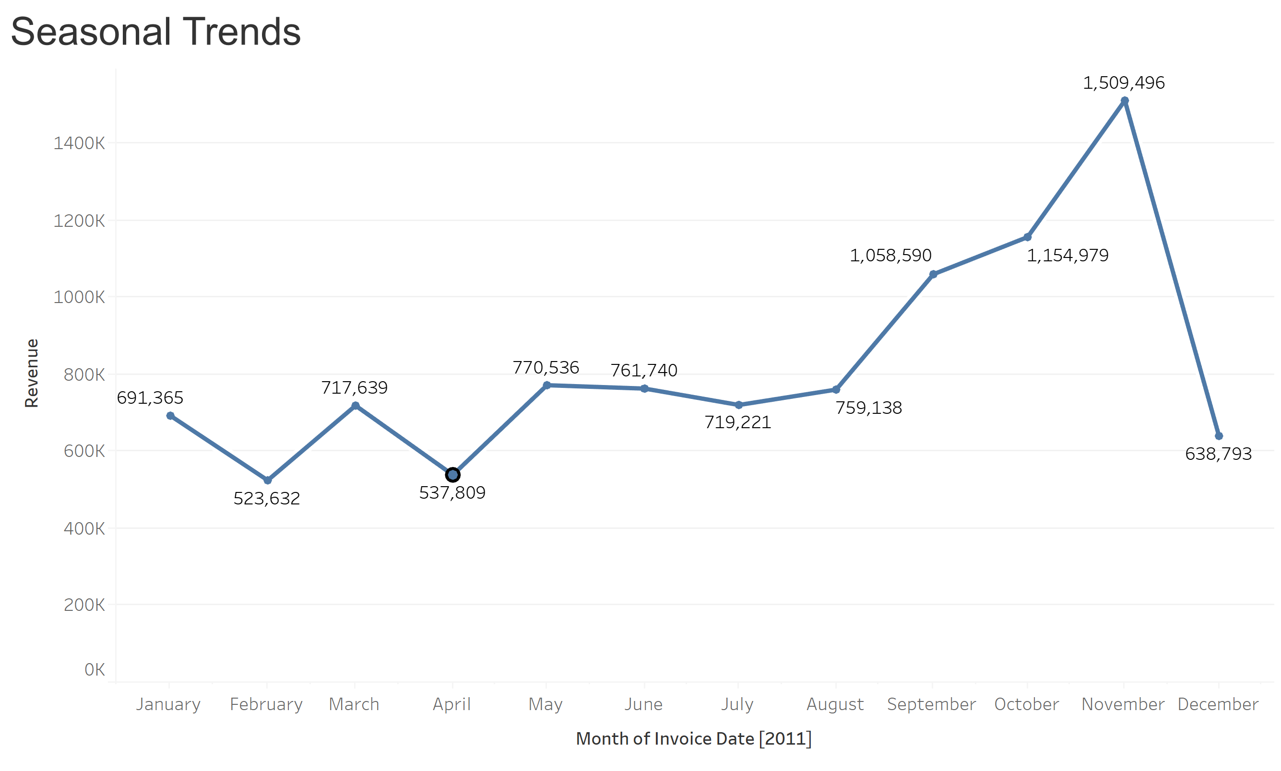

Question 2:

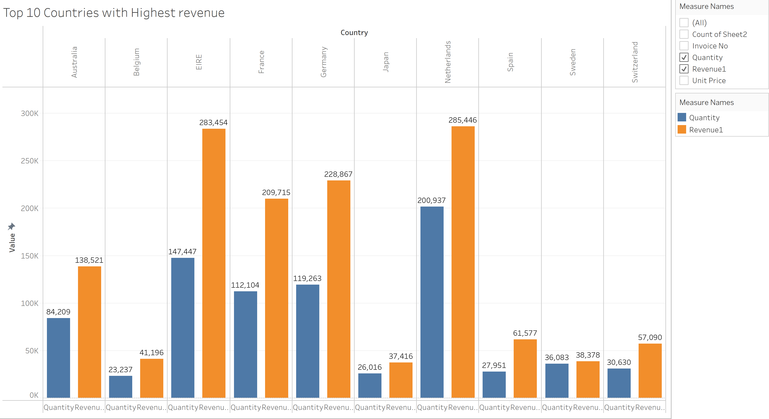

Question 3:

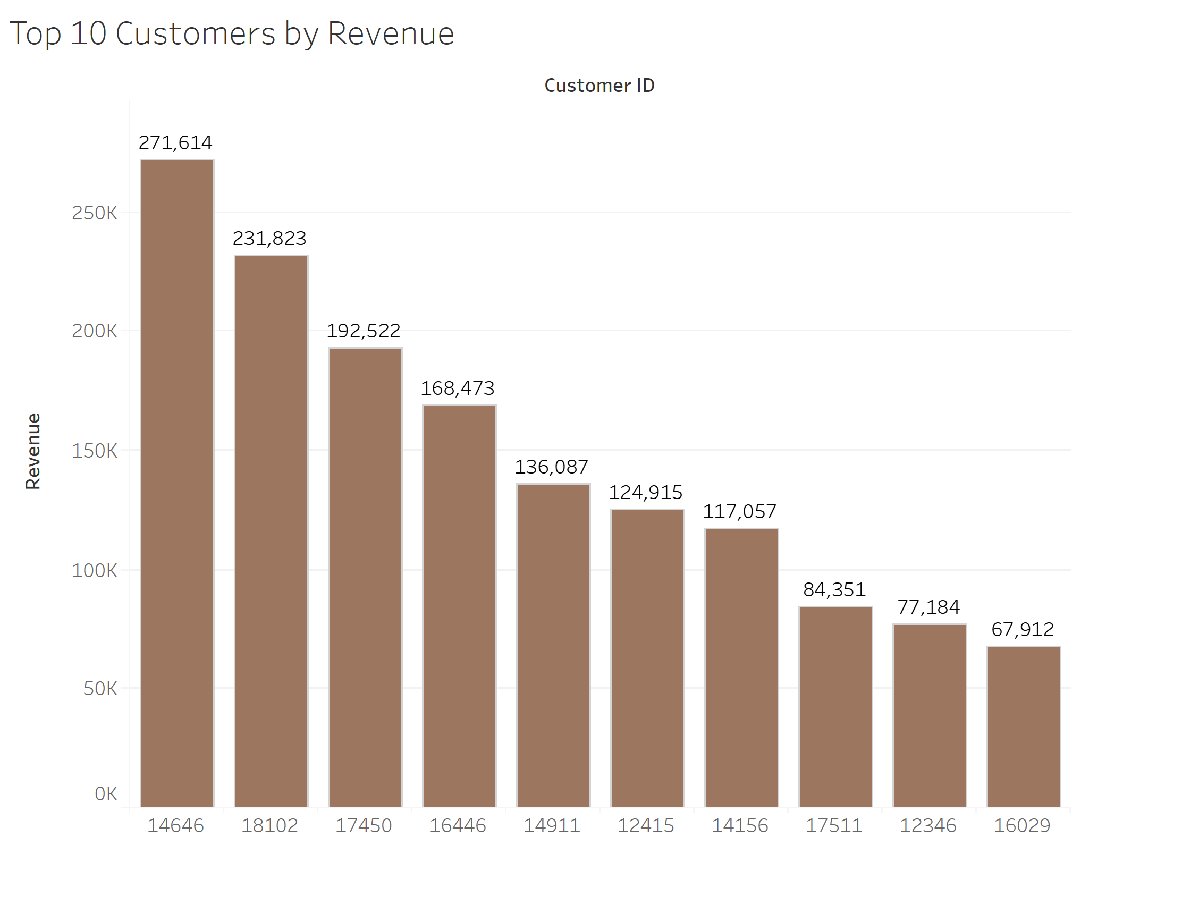

Question 4:

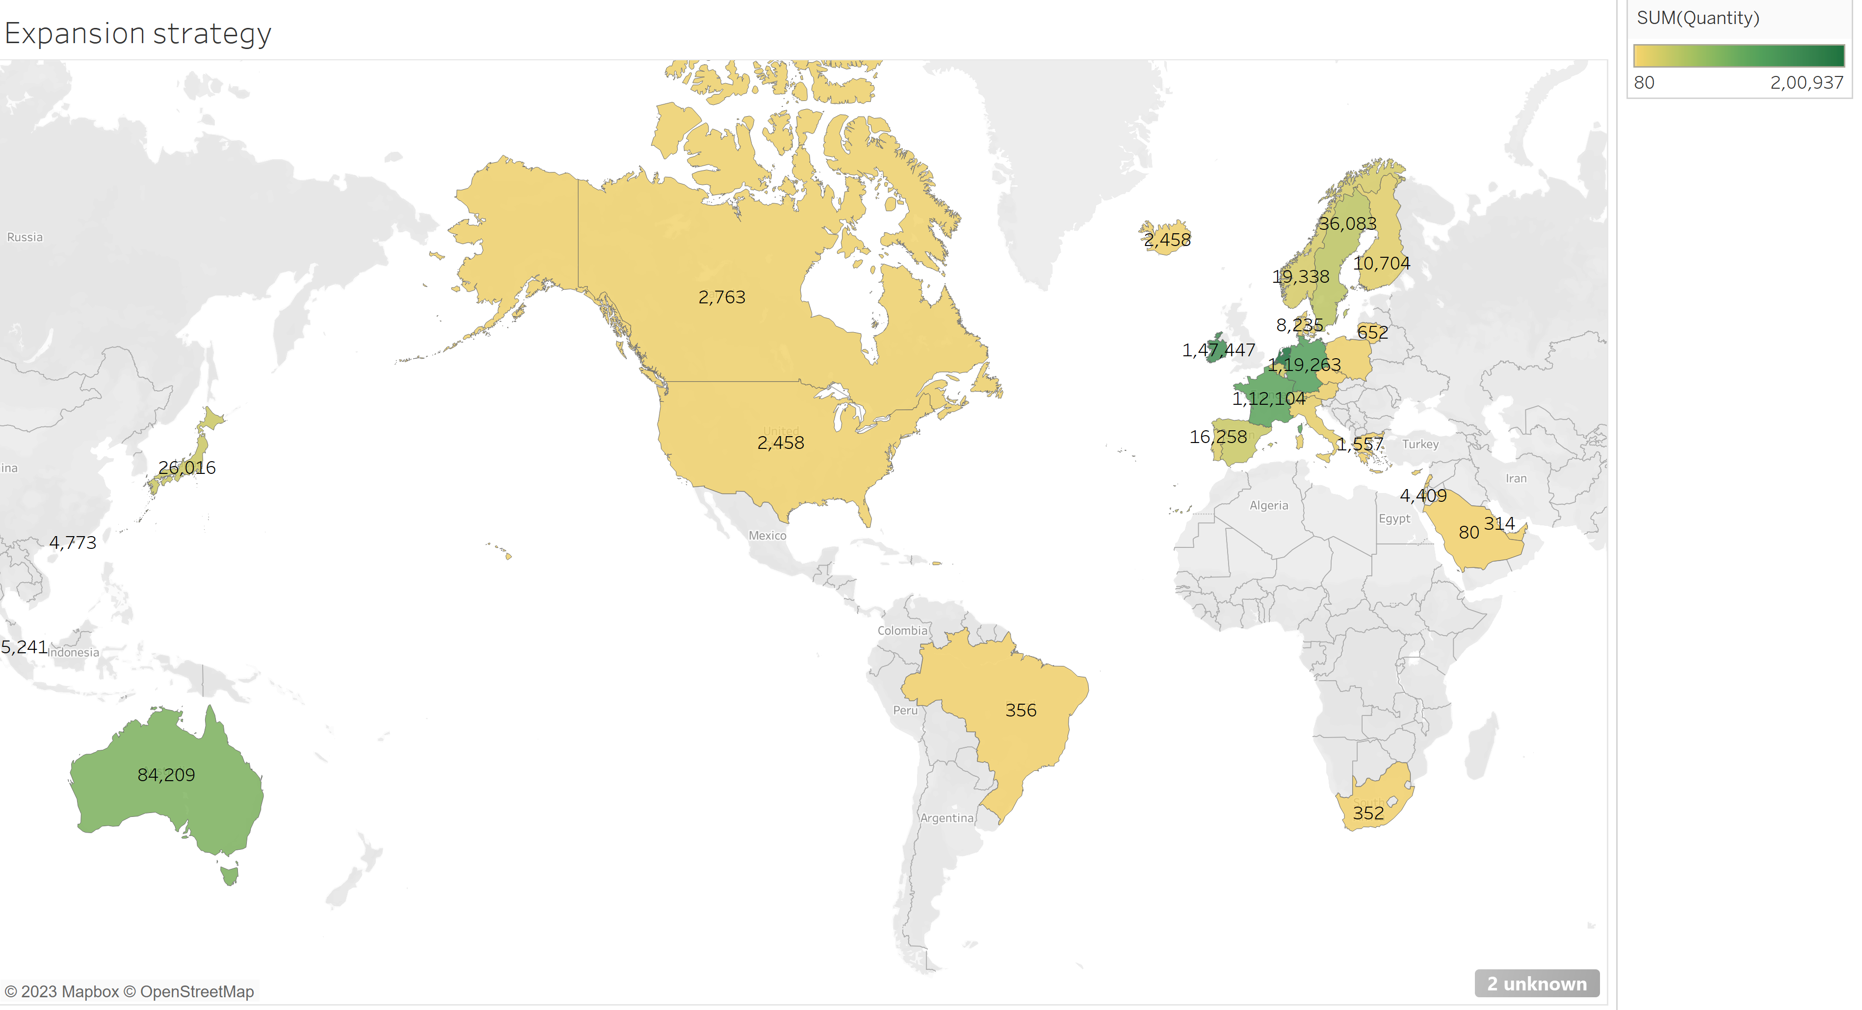

Question1:

The CEO of the retail store is interested to view the time series of the revenue data for the year 2011 only. He would like to view granular data by looking into revenue for each month. The CEO is interested in viewing the seasonal trends and wants to dig deeper into why these trends occur. This analysis will be helpful for the CEO to forecast for the next year.

Question2:

The CMO is interested in viewing the top 10 countries which are generating the highest revenue. Additionally, the CMO is also interested in viewing the quantity sold along with the revenue generated. The CMO does not want to have the United Kingdom in this visual.

Question3:

The CMO of the online retail store wants to view the information on the top 10 customers by revenue. He is interested in a visual that shows the greatest revenue generating customer at the start and gradually declines to the lower revenue generating customers. The CMO wants to target the higher revenue generating customers and ensure that they remain satisfied with their products.

Question4:

The CEO is looking to gain insights on the demand for their products. He wants to look at all countries and see which regions have the greatest demand for their products. Once the CEO gets an idea of the regions that have high demand, he will initiate an expansion strategy which will allow the company to target these areas and generate more business from these regions. He wants to view the entire data on a single view without the need to scroll or hover over the data points to identify the demand. There is no need to show data for the United Kingdom as the CEO is more interested in viewing the countries that have expansion opportunities.

Having a deep dive into the provided dataset gave humoungous insights which has the potential to help boost the performance and the operations of the business.

First and foremost insight from the dataset was about the recurrence in the buying pattern from the consumers part and the time corresponding of placing the order also gave insights on the different product category.

Customers have been Loyal and contributing to the revenue the most are focused on purchasing toys or objects that are considered as play material for kids. Furthermore we could observe that there is wood material and decorative related demand that are in 100s in terms of quantity.

They are from Netherlands, United kingdom.

In terms of expansion strategy, nearly 4 hundred thousand records are observed from Australia. So already we can see that out of the top 10 customers in terms of revenue contribution we already have custID 12415 with revenue generating around 124915$.

The second most top revenue generating country and best suited for expansion would be UAE. Marketing strategies can be altered in accordance to the country’s policies and the consumer habits are observed to be promising for our business model.

Netherlands, France, Germany,