Exercises 1:

Complete the table below by converting the numbers into the other two common bases. You may leave the “Decimal” column unsimplified.

|  |  |  |
| --- | --- | --- |
| **Binary** | **Decimal** | **Hexadecimal** |
| 0b10010011 | 147 | 93 |
| 10110 | 22 | 0*16 |
| 111111 | 63 | 3F |
| 0b100100 | 36 | 24 |
| 110000110000 | 3120 | 0*C30 |
| 0 | 0 | 0 |
| 10111010110 | 2989 | 0*BAD |
| 110110101 | 437 | 1B5 |

Exercises 2:

1. Open the online Linux simulator: <https://bellard.org/jslinux/vm.html?url=https://bellard.org/jslinux/buildroot-x86.cfg>
2. Compile and execute the “hello.c” program as demonstrated below.

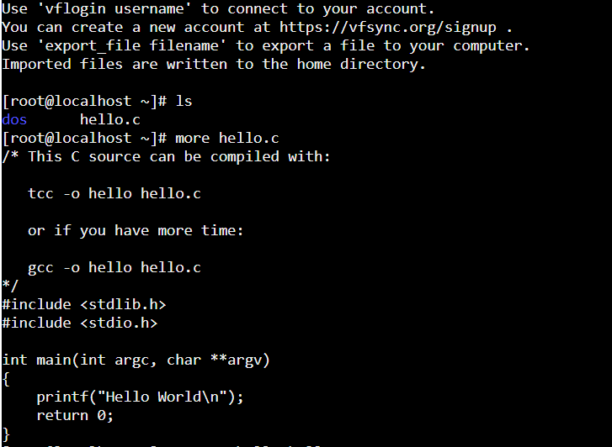

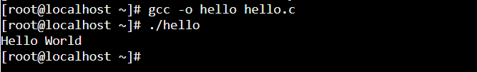

Exercises 3:

Demonstrate that you have an IDE setup on your PC for C/C++ code development (Example of which include MS Visual Studio, or Mac XCode). Please capture your screen shot below. Note: In case you don’t have any of the IDE setup, HOP01 (seen in BB’s “Assignments” Tab, has job aids).

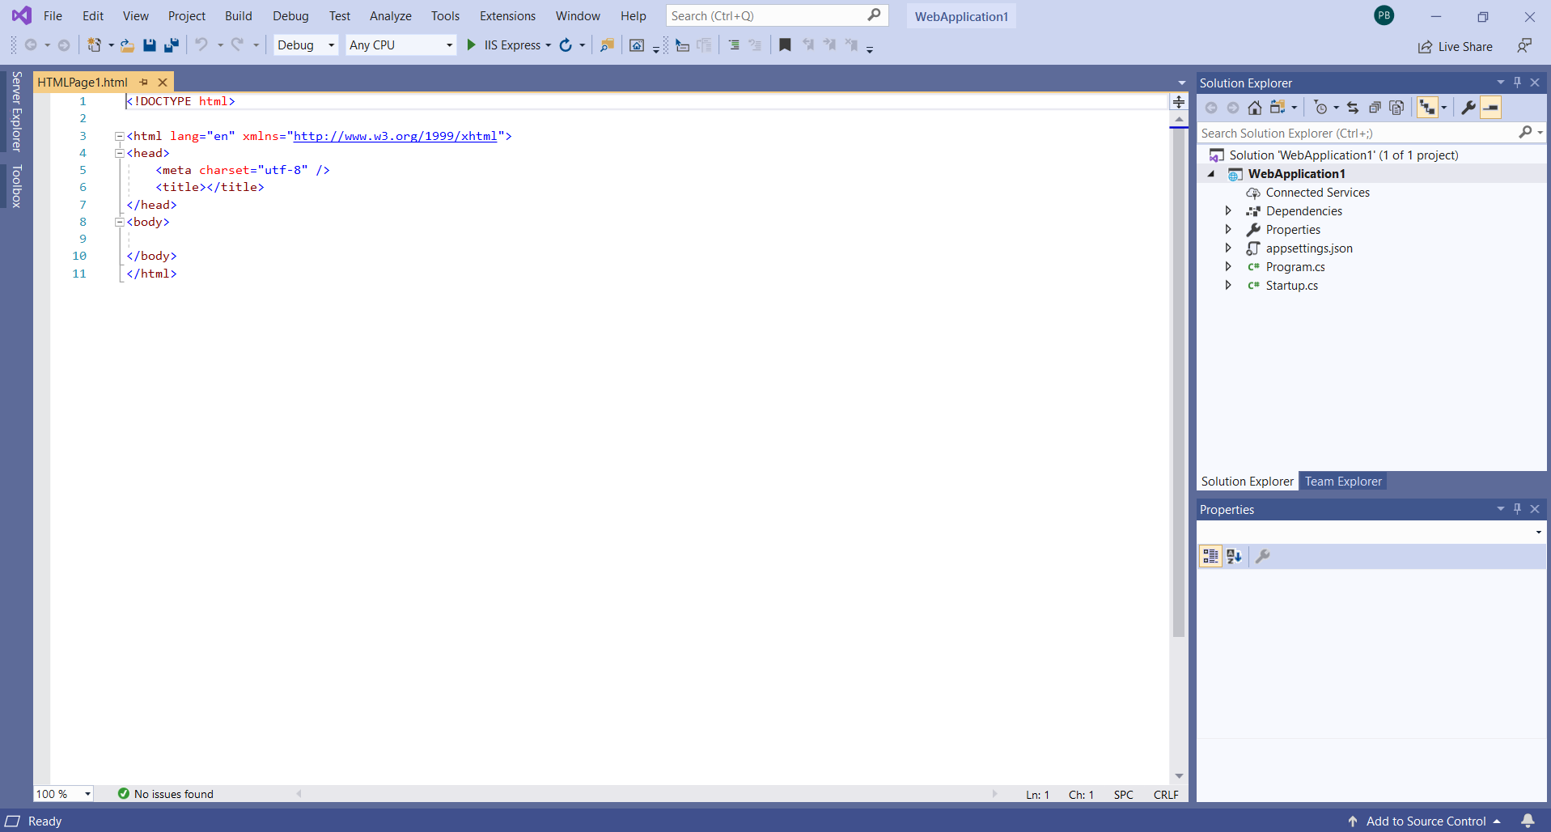

Exercises 4:

Your reflections after viewing this presentation on the history of information/computer age:

<https://www.ted.com/talks/george_dyson_at_the_birth_of_the_computer>

[Historian George Dyson tells stories from the birth of the modern computer -- from its 17th-century origins to the hilarious notebooks of some early computer engineers.]

Examples of thoughts:

* Does “computer” define the information age? (Why it takes the “Atomic Bomb” to make computer happen? Could it happen earlier, the industrial age…?

The **Information age** also commonly known as the **Computer Age** or Digital **Age**. “Computer science is a field which hasn't yet encountered consequences,” .Physics made the atomic bomb, chemistry created chemical weapons, but the cutting-edge sciences of today fields like machine learning, data science, and computational linguistics have yet to face their A-bomb moment.

* What is **information/knowledge**? (How would you define it? How can it be measured, and be quantified?)

**Information** is stimuli that has meaning in some context for its receiver. When information is entered into and stored in a computer, it is generally referred to as data. After processing (such as formatting and printing), output data can again be perceived as information. Important quantities of information are entropy, a **measure** of **information** in a single random variable, and mutual **information**.

* What is the gap between **computer and human**? (The interface, the constraints, the possibilities).

Computers are evolving. We have voice-controlled assistants on our phones, telepresence robots for when we can't make it to a meeting in person, and self-driving cars that are headed to a road near you. These machines aren't just taking over human tasks. Computerized systems are also taking on more human characteristics.

* What is beyond the “**Information Age**”?

The **information age** will eventually be superseded by another age, and it

behooves those with senior executive responsibility to develop a point of view on what that age might look like.

Exercises 5:

Assume a color display using 8 bits for each of the primary colors (red, green, blue) per pixel and a frame size of 1280 × 1024.

1. What is the minimum size in bytes of the frame buffer to store a frame?

8 bits = 1 byte , we have 3 color of the pixel.

3*1=3 Bytes,

There are 3 colors and each color uses 1 byte,

1280*1024=1,310,720 pixels

The memory size of the frame is

3*1,310,720=3,932,160 Bytes

The minimum size of the frame buffer is

**3,932,160 Bytes**.

**b.** How long would it take, at a minimum, for the frame to be sent over a 100 Mbit/s network?

1 Mbit/s =10^(6) bit/s = 10^(2)*1^(6) bit/s =10^(8) bit/s

The memory size of the frame in bits is

3,932,160*8=31,457,280 bit

Finally,

speed=size/time

so,

Time=size/speed

31,457,280 bits/10^(8) bit/s =**0.3145728 s.**