**Analysis of Online Food Delivery Process by**

**Zomato using Data Science**

**Name:** Kolipaka Preethi

**Track:** Python- Data Science

**ABSTRACT:**

People all around the world are preferring online platforms to complete all of their vital work and avoiding going to the marketplaces or to the job owing to the spread of airborne disease, which has brought the entire world to a standstill. The current world is deteriorating due to the spread of the corona virus, and the entire country is going through a difficult time due to the lockdown, which has put a stop to any country's desire of multilateral growth.

Swiggy, Zomato, Uber Eats, and other food-related online giants include Swiggy, Zomato, and Uber Eats, among others. The goal of studying the Zomato dataset is to have a clear understanding of the elements that influence each restaurant's overall rating, as well as to identify distinct types of restaurants in different locations. This report uses data science to demonstrate data analysis on the Zomato dataset assisting website in order to aid in better ideas for future marketing strategy. This study addresses the demands of consumers looking for the best cuisine in the country and which regions of the country have the most restaurants serving such cuisine.

**INTRODUCTION:**

Zomato is one of the most important online foods ordering business in today's generation. It is a kind of an online guide book for users of Zomato. This site mainly focuses on the restaurants of Bangalore and helps the user categorized the different places and choose the best among them in means of menus, dishes, localities, and several other mediums. In order to understand the data set, there is a necessity of procedure by means of machine learning concepts which would help in analysing the data set in all different aspects. We could develop marketing strategy by noticing the client comfort through the result of deep analysis performed by data science.

**DATA COLLECTION:**

Data science is the study of the systematic removal of indistinct and useful patterns and knowledge from data, towards research advancement, organizational decision-making which enables a computer-controlled society. Accordingly, scholars advocate for data-intensive science, discovery science or data-driven science, in which: It is suited to make sense of massive interconnected datasets, overcoming problems of small samples, and scarce data. Interdisciplinary research is promoted. Complete models and theories about complex systems, rather than elements of it, are possible.

The data collected for this research is from the secondary data sources (Kaggle). Since the complexity and quantity of the data leads, need to perform data pre-processing in order to get an accurate result. The first step in data analysis is to prevent missing data, then the co-relation method is performed to foremost the data visualization process.

**APPROACH:**

* The various python libraries such as Numpy, pandas, Matplotlib are used for the purpose of mathematical calculations, extraction of data and visualization respectively.
* The extracted dataset was found to have null values which are then effectively handled to achieve accurate analysis rather than removing them from the dataset.
* The datasets to be used for analysis was found to be highly skewed. Although skewness will not have much effect on descriptive analysis, it is handled for the purpose of predictive analysis to accomplish better decisions from the model. The log transformation was used to handle skewness in the datasets.

**ANALYSIS AND VISUALIZATION:**

1. **Most Popular Top 20 Restaurants in Bangalore**

PURPOSE

* In Order to Know the top famous restaurants to choose by the chains they have in in Bangalore.

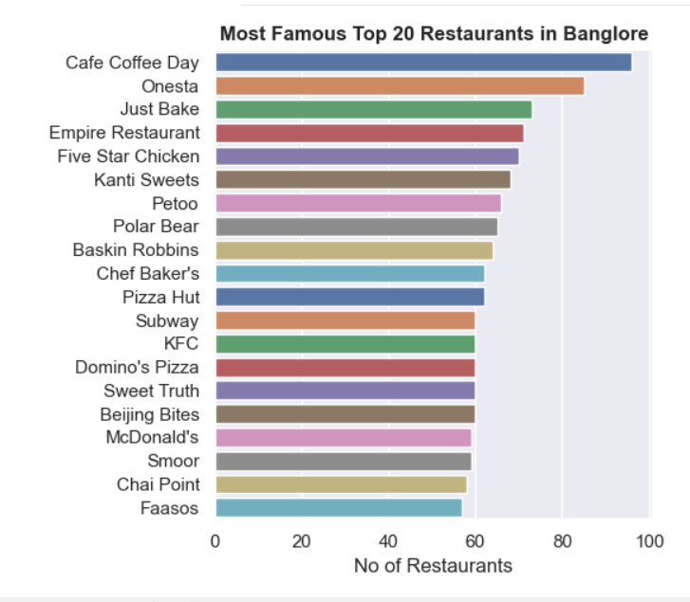

INFERENCE:

* By the above graph here we can see that “Cafe Coffee Day “has the most popular restaurant chains and Onesta has almost 90 popular chains in Bangalore. They have almost 100 restaurants in Bangalore.

1. **Restaurants Accepting Online Orders**

PURPOSE

* To Know the Restaurants Which are accepting Online Orders and their Count for Online vs Offline orders.

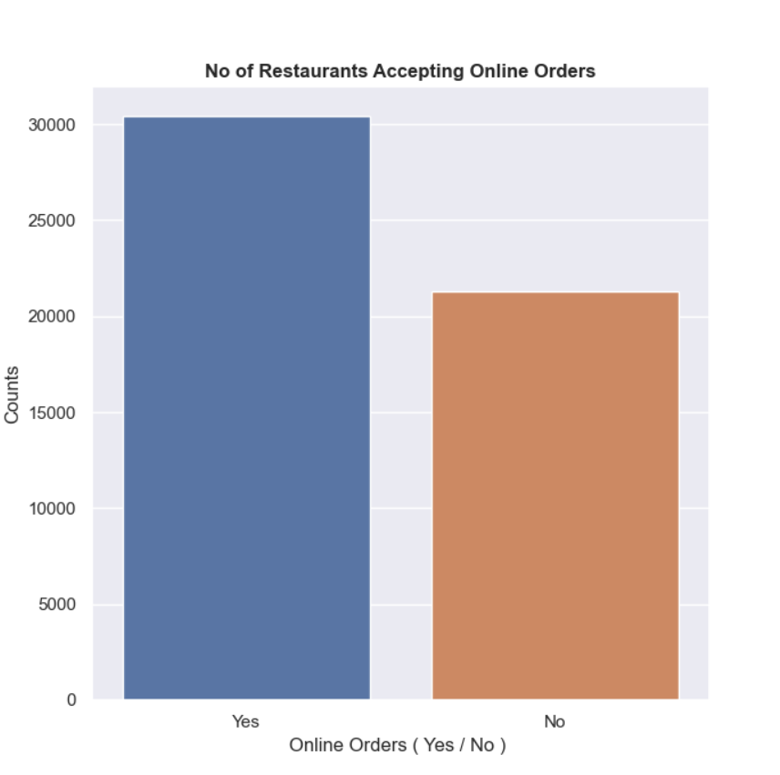

INFERENCE:

* We Can Say that Majority of the Restaurants has online Order facility i.e 30444 restaurants has Online Order Facility.

1. **Restaurants Having Book Table Facility**

PURPOSE

* To Know the Count of Restaurants Which are accepting Booking Table Facility

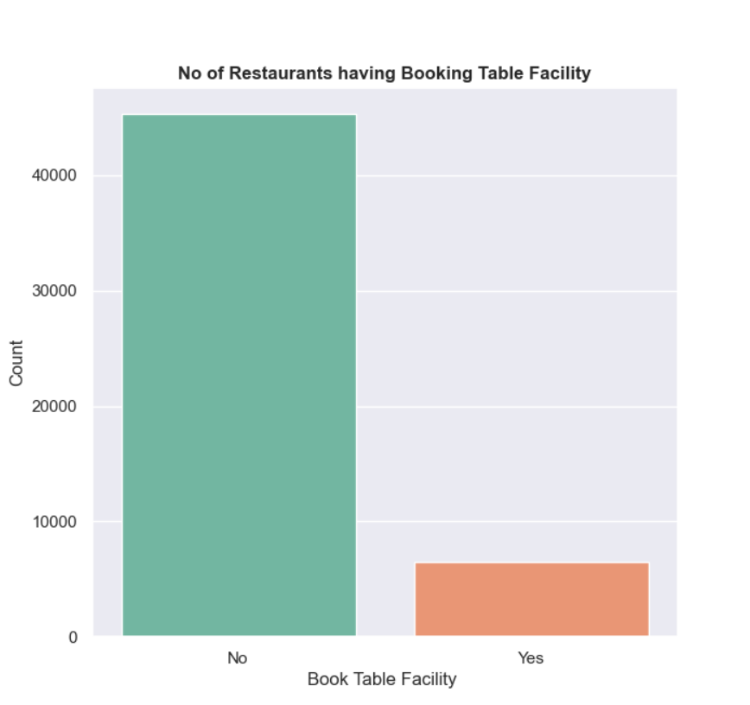

INFERENCE:

* We Can Say that Majority of the Restaurants Doesn't have book table facility i.e only 6449 restaurants has Book Table Facility.

1. **Most Popular Restaurant Types in Bangalore**

PURPOSE

* To Know the top 15 Most popular types of restaurant types in Bangalore

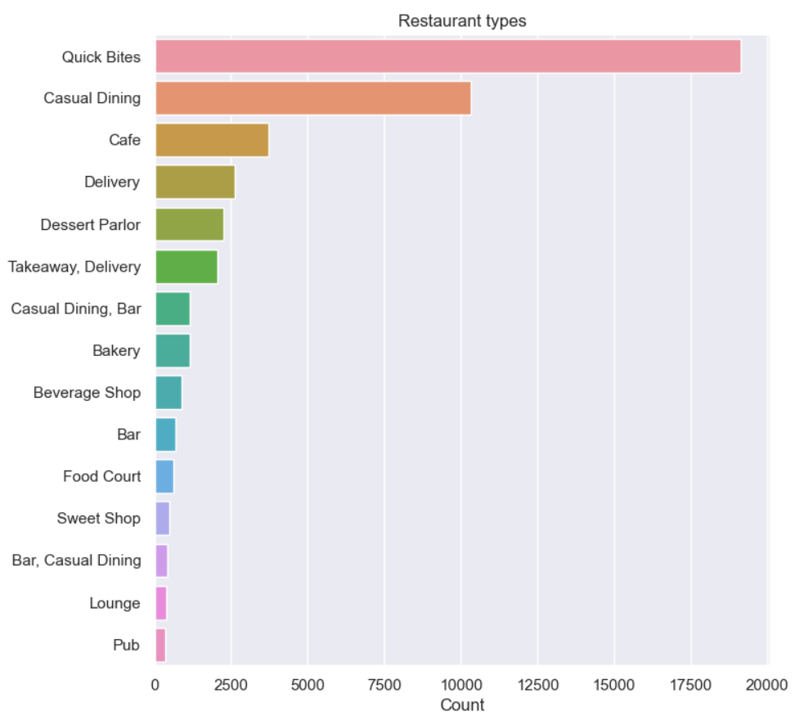

INFERENCE:

* We can Observe that Quick Bytes, Casual dining and Cafe are some top 3 Popular Restaurant Types

1. **Most Popular Cuisines in Bangalore**

PURPOSE

* To Know the Most Popular cuisines in Bangalore with respect to the count of restaurants.

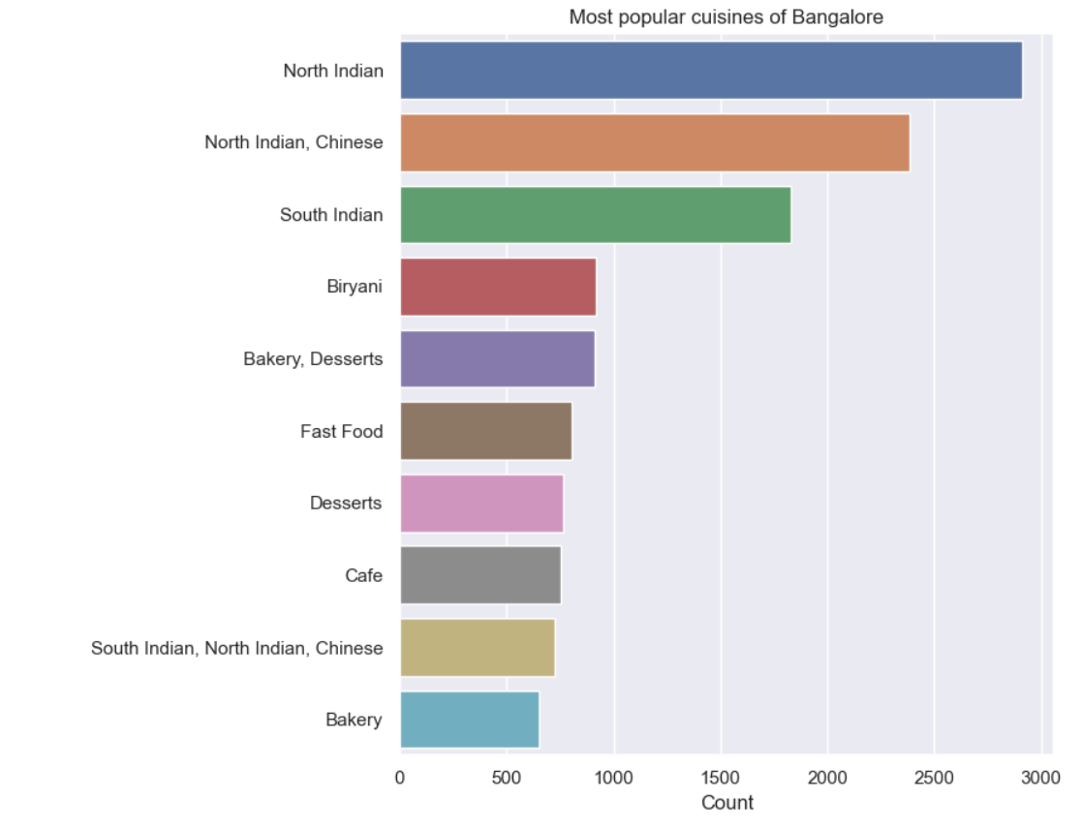

INFERENCE:

* We Can Say that Most popular Restaurants cuisines are of North Indian , Chinese , South Indian , Biryani , Desserts etc.

1. **Foodie Areas in Bangalore**

PURPOSE

* To Know the Most Popular Foodie Areas according to the restaurant counts in Bangalore.

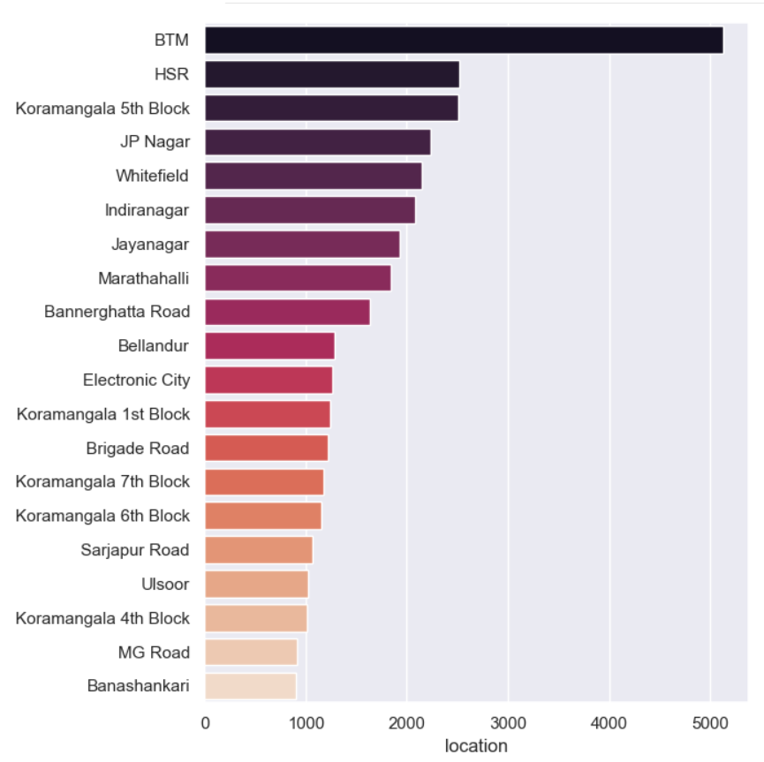

INFERENCE:

* By the above graph we can say that BTM , HSR , Karmangala 5th block are some of the top 3 popular foodie areas with respect to their counts in Bangalore

1. **Percentage of Restaurants in Foodie Areas in Bangalore**

PURPOSE

* To Know the Most Popular Foodie Areas according to the restaurant counts and their percentage.

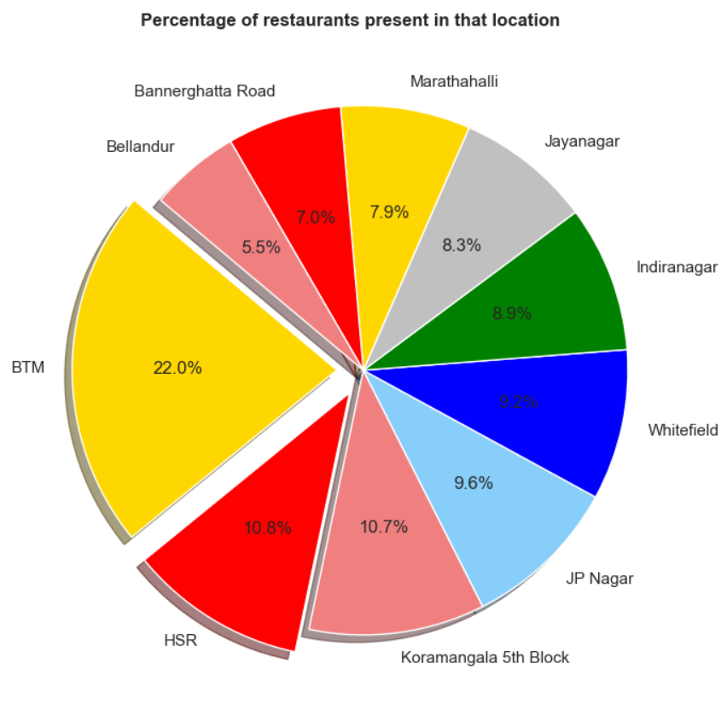

INFERENCE:

* By the above graph we can say that BTM with 22.0%, HSR with 10.8%, Karmangala 5th block with 10.7 % are some of the top 3 popular foodie areas with respect to their percentages in Bangalore

1. **Average Cost for Two People**

PURPOSE

* To Know the Average Cost for Two People with percentage.

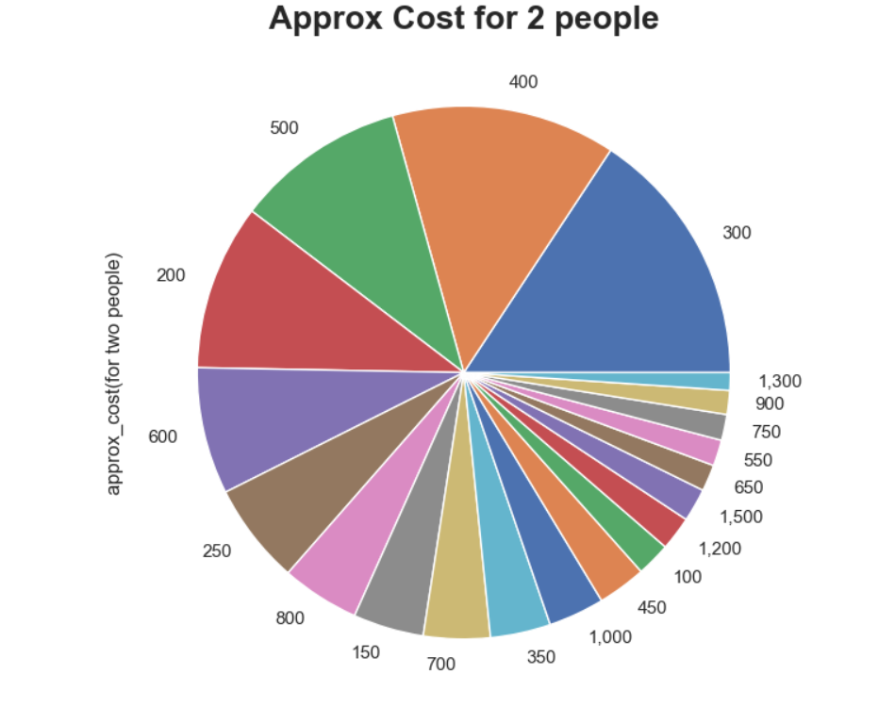

INFERENCE:

* By the above chart there is 17.86 percentage chances that for two persons the approximate cost will be 400 and 17.04 % chance that the cost will be 300 and so on.

1. **Average Rating Per Restaurant in Bangalore**

PURPOSE

* To Know the Average rating per restaurant and count of the restaurants having the same average rating in Bangalore

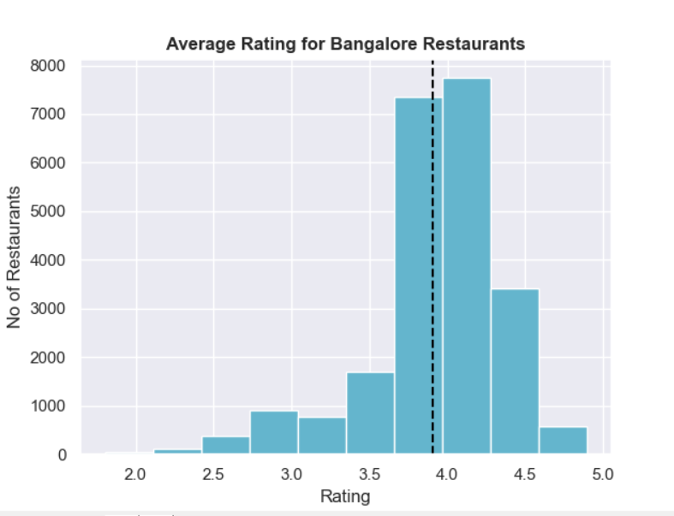

INFERENCE:

* The Average Rating for Bangalore Restaurants is 3.9 approximately.

1. **Type Of Restaurants and Percentage Bangalore**

PURPOSE

* To Know about the type of restaurants along with the percentage of its type in Bangalore.

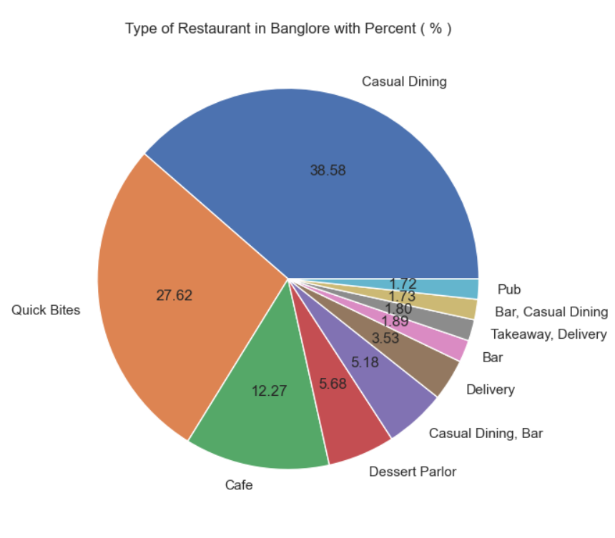

INFERENCE:

* The Restaurant type of casual Dining are of 38.58%, Quick bite are of 27.62 %, Café are of 12.27 % in Bangalore.

1. **Type Of Restaurant and Count in Bangalore**

PURPOSE

* To Know the count of different types of restaurants available in bangalore.

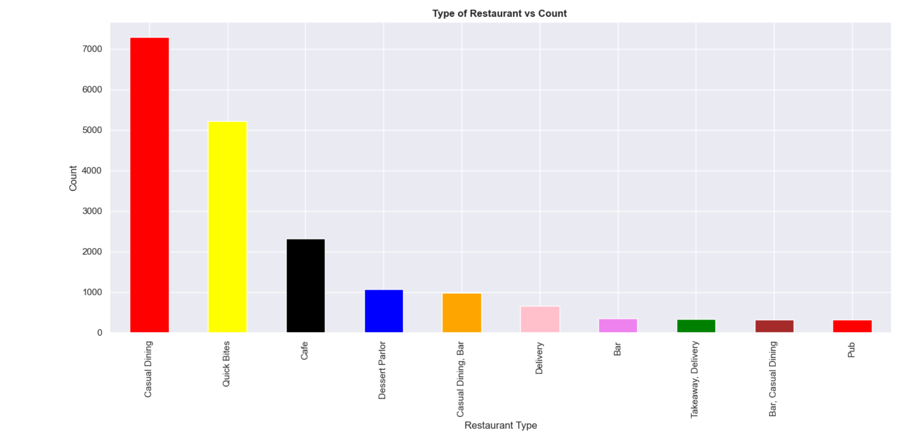

INFERENCE:

* From the above graph we can infer that more than 7000 restaurants are of casual dining type and below 1000 restaurants are of pub type.

1. **Ratio Between Rating and Restaurant Type in Bangalore.**

PURPOSE

* To Know the ratings for different type of restaurants.

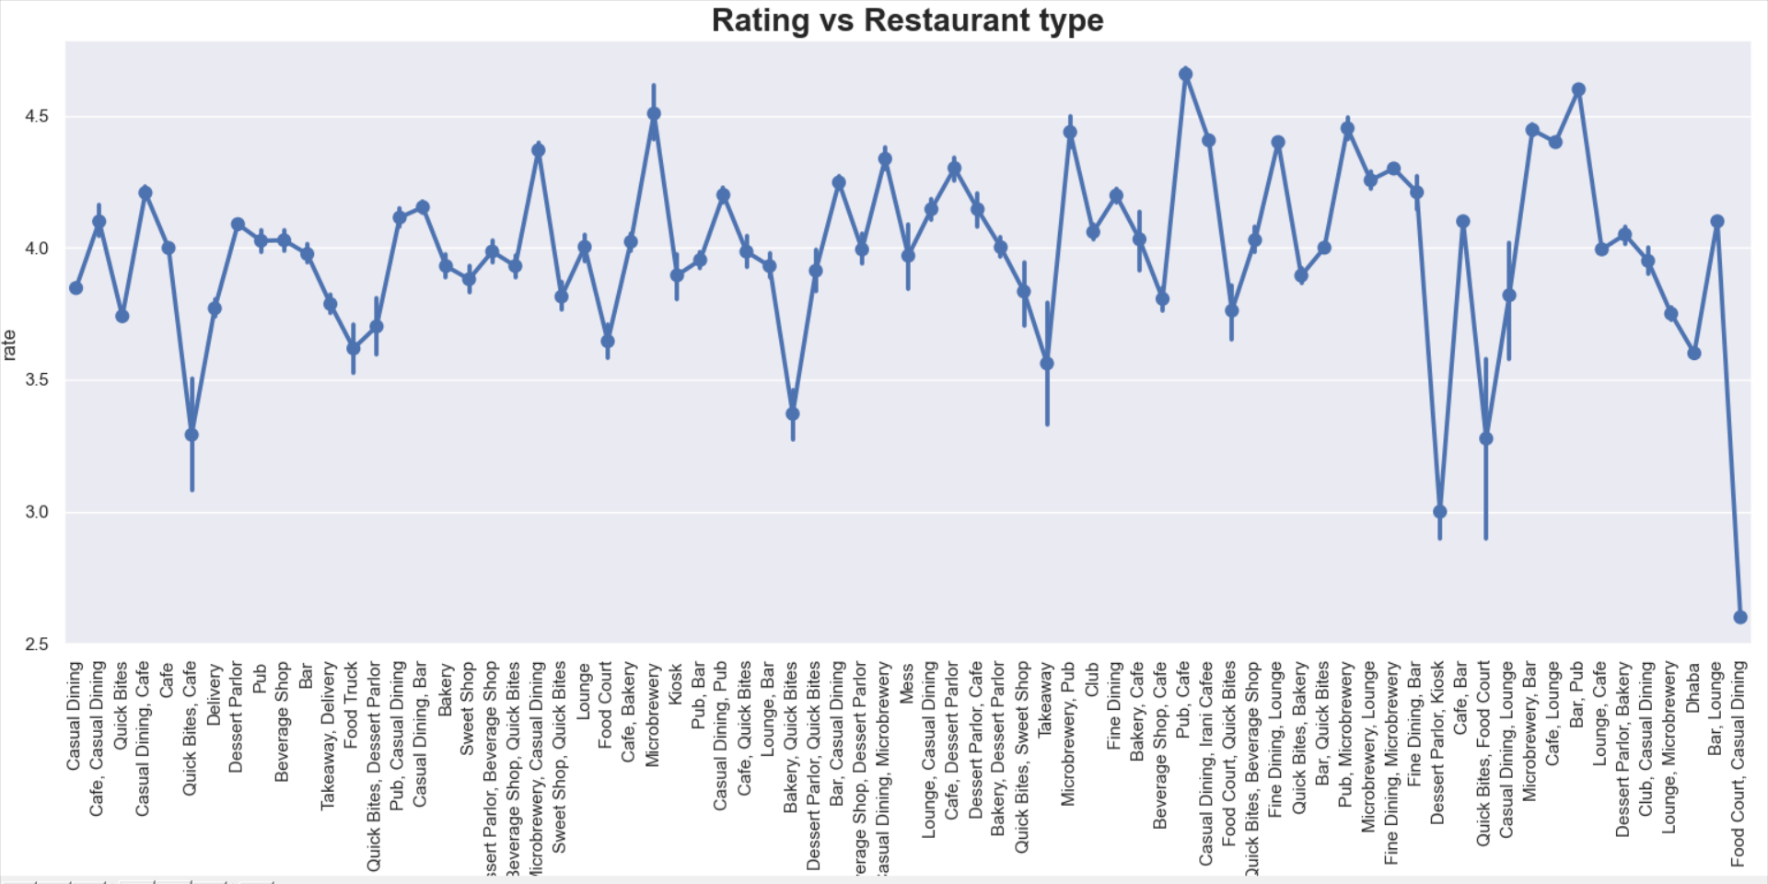

**BOX PLOT FOR RATING Vs RESTAURANT TYPE**

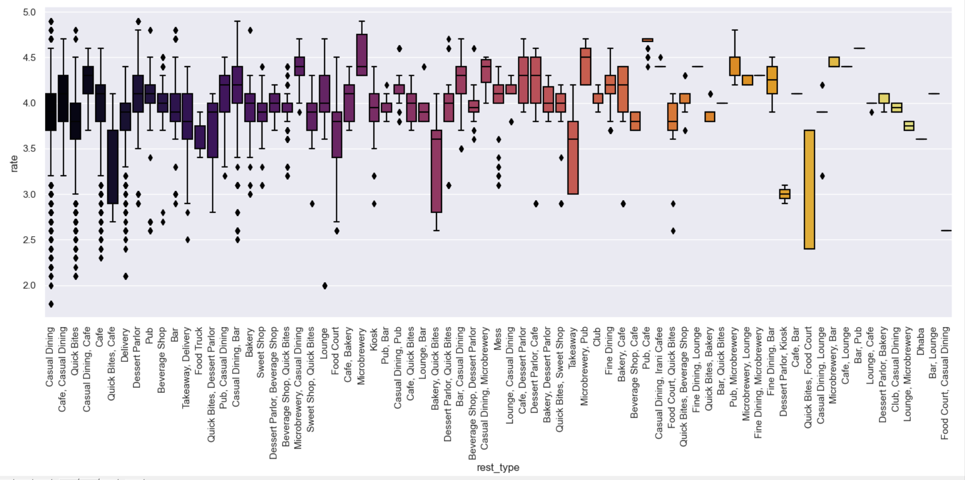

INFERENCE:

* From the above plot we can infer that, the peak value i.e., the rating of above 4.5 is obtained for the restaurant type of PUB, Café and lowest rating i.e. below 3.0 is obtained for food courts etc.

**CORRELATION BETWEEN DIFFERENT VARIABLES**

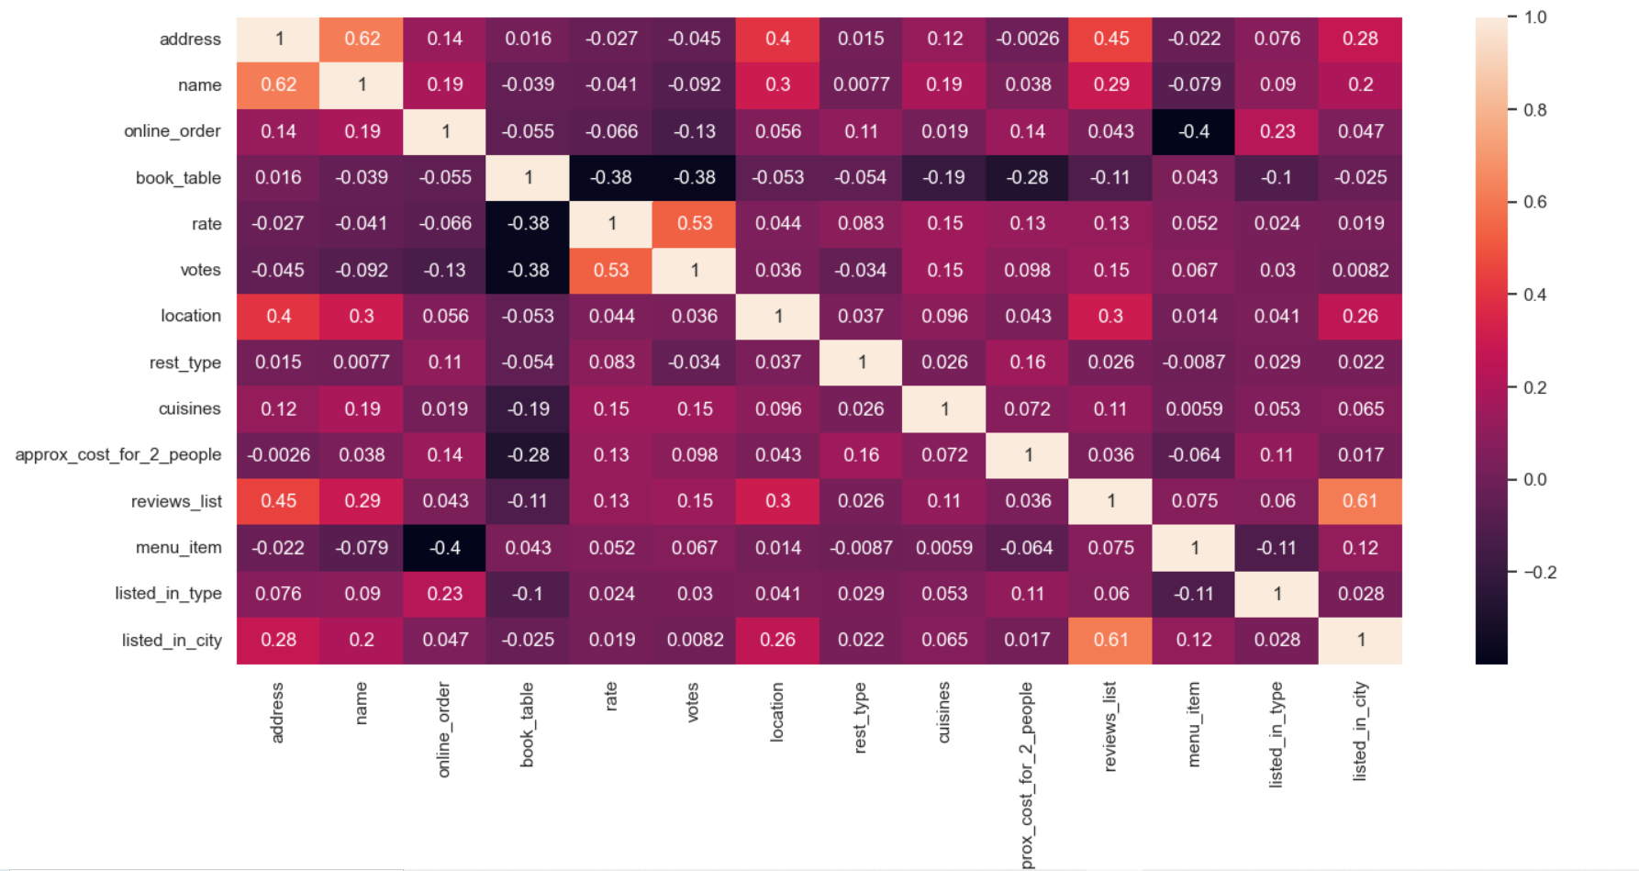

**CONCLUSION:**

The Zomato dataset was analysed to gain some insights of the food industry and food culture in Bangalore. We deduce some great results like which city has the greatest number of restaurants and hence highest number of foodies, we also saw that which city has high number of well-rated restaurants, what all cuisines are mostly preferred by people etc. This will help in future business persons to start their business.

**FUTURE SCOPE:**

For my future work I plan to :

* Implement machine training to predict which location is best for food business.
* Combine this dataset with specific data about different foods and people that visiting the restaurant for evaluating daily report.
* Making my own dataset by crawling data from website.
* Learn more about data sciences in general to improve my understanding.

**REFERNCES:**

1. <https://www.kaggle.com/himanshupoddar/zomato-bangalore-restaurants>
2. **https://www.ijmtst.com/volume6/issue08s/24.IJMTSTCIET69.pdf**