Coronaviruses (CoV) are a broad group of viruses that can cause everything from a typical cold to more serious illnesses. The phrase "novel coronavirus" refers to a new strain of coronavirus that has never been seen in humans before. The first cases of a novel coronavirus were reported in December 2019 in Wuhan, Hubei Province, China, and have since spread around the world. Human-to-human transmission has been found in epidemiological research in China. In terms of area and population density, India ranks second. In comparison to other developing countries throughout the world, India has a good handle on the corona virus.

Many pharmaceutical companies worked to develop the Covid Vaccine and were successful in controlling the virus's effect in the human body.

It would be fascinating to learn about the attack rate and the rate of finished cases (recovered and death).

**CONFIRMED COVID CASES WITH RESPECT TO TIME**

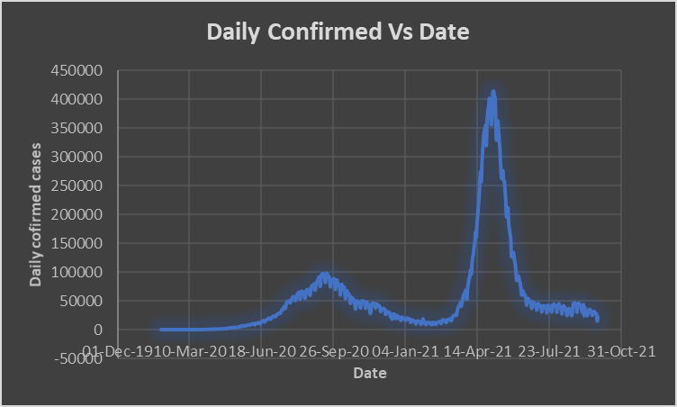

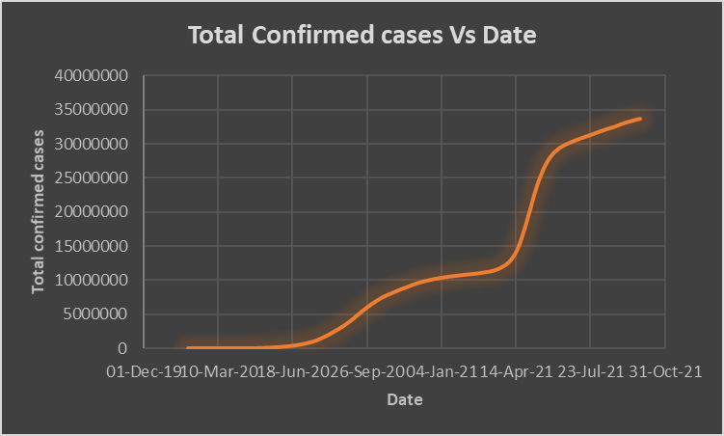

During the second wave of Covid, a massive outbreak occurred from April to June 2021, with confirmed cases reaching a peak of 4,00,000 confirmed cases per day. There are a number of variables that have led to the abrupt increase in cases, including a lack of hospital preparedness, the failure to build new facilities.

The Cases Started raising from the first week of march and abruptly there was a vast increment over the confirmed cases and it was recoded as highest in the month of April with a highest peat and by attaining Kurtosis value of -0.84796082 for the total Confirmed Cases.

The total maximum daily confirmed cases recorded till now are 4,14,280 and if we consider the skewness of the daily confirmed cases graph then it is recorded as 2.80327 > 1 so it can be termed as negatively skewed or left skewed. Considering the total Confirmed Cases, maximum cases recorded totally up to now are 33,714,828 and 0.768645198 is the measure of the skewness since 0.5<skewness<1.0 So the graph is Little skewed.

RECOVERED CASES RATE:

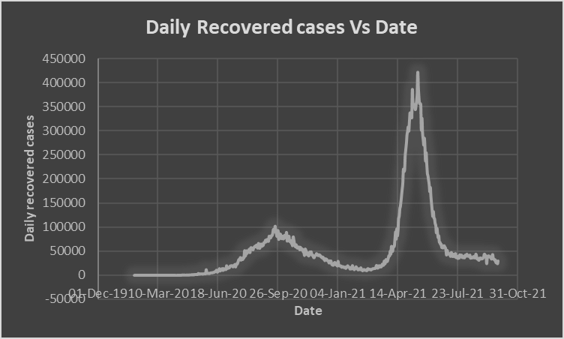

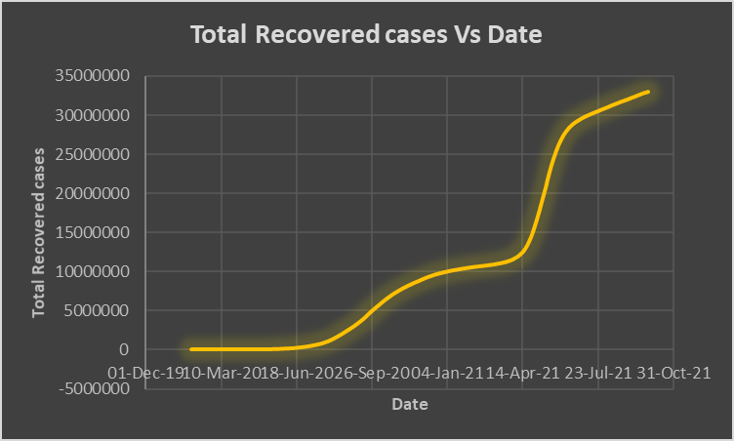

coMPARITIVELY

DECEASED CASES

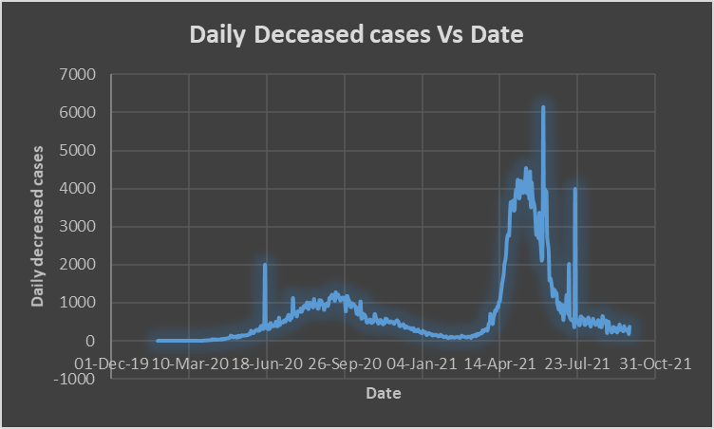 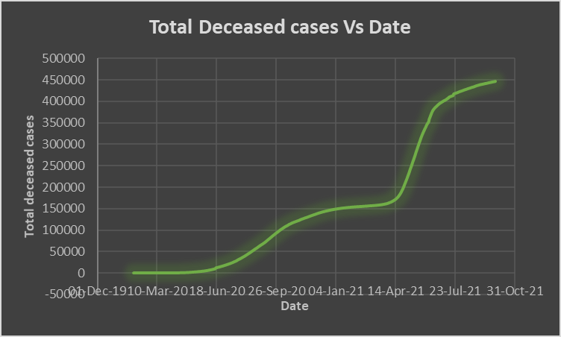

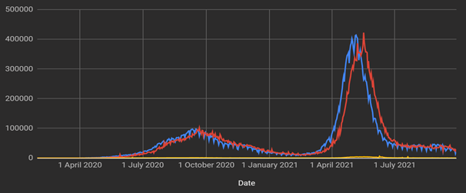

*The variables, new confirmed cases, daily deaths, and daily recovered are, respectively, the number of people who were confirmed with the infection, died, or recovered from the COVID-19 infection daily. The minimum statistic is simply the lowest number of cases per day, while the maximum statistic is the highest number of cases per day. The sum statistic is the total number of cases for the period under study which is obtained by adding (cumulative of) all the daily recorded cases throughout the period. The mean is obtained for each variable (new confirmed cases, daily deaths, and daily recovered) by dividing the sum for each variable by N, the total number of days of the study. The mean indicates the average number of new confirmed cases, deaths, and recoveries per day. The standard deviation shows the dispersion between the daily cases (confirmed, death, or recovered) and the mean. It is obtained as the sum of the squared differences between the daily cases and the mean divided by N. The bigger the standard deviation, the larger the dispersion between the mean and the daily cases and vice versa*