POWER BI DASHBOARD PROJECT REPORT ON – SUPER SALES ANALYSIS

1. INTRODUCTION

1.1 About the Project
In today’s data-driven world, organizations rely heavily on data analytics to make informed decisions. This project aims to develop an interactive dashboard for analyzing musical instrument sales using Power BI. The dashboard provides insights into sales performance, customer behavior, and product popularity.
The system utilizes a dataset containing details such as instrument types (string, percussion, wind, keyboard), brands, pricing, sales quantity, customer demographics, and purchase channels. By applying data transformation and visualization techniques, the project converts raw data into meaningful graphical representations.
The dashboard allows users to explore trends over time, compare different instruments, and analyze regional sales performance. It enhances decision-making by presenting complex data in a simplified and interactive manner.

1.2 Language Used
The project is implemented using the following tools and technologies:
- Power BI Desktop – for data visualization and dashboard creation
- Power Query – for data cleaning and transformation
- DAX (Data Analysis Expressions) – for creating measures and calculations
- CSV Dataset – used as the data source

2. SCOPE OF THE PROJECT

2.1 Problem Statement
Businesses dealing with musical instruments generate large volumes of sales data. However, analyzing this data manually is difficult and time-consuming. There is a need for an efficient system that can visually represent the data and provide meaningful insights.

2.2 Objectives
- To design an interactive dashboard using Power BI
- To analyze musical instrument sales data effectively
- To identify top-performing instruments and brands
- To visualize trends over time
- To provide user-friendly filtering and interactivity
- SYSTEM REQUIREMENTS

3.1 Functional Requirements
- Load dataset into Power BI
- Perform data cleaning using Power Query
- Create DAX measures (Total Revenue, Sales, etc.)
- Generate interactive visualizations
- Apply filters and slicers

3.2 Non-Functional Requirements
- Easy to use interface
- Fast performance
- Accurate data representation
- Interactive and responsive dashboard

3.3 Hardware Requirements
- Minimum 4GB RAM
- Intel i3 processor or higher
- Windows operating system

3.4 Software Requirements
- Power BI Desktop
- Microsoft Excel / CSV dataset
4: METHODOLOGY

4.1 Data Collection
The dataset used in this project contains approximately 2000 records related to musical instrument sales. It includes attributes such as instrument type, brand, price, quantity, customer age group, and purchase mode.

4.2 Data Preparation (Power Query)
Data cleaning is performed using Power Query. This includes:
- Removing null values
- Correcting data types
- Formatting date fields
- Ensuring data consistency

4.3 Data Visualization
Various charts such as bar charts, pie charts, line charts, and donut charts are used to represent data visually.

4.4 Filters and Interactivity
Slicers are added for:
- Country
- Instrument Type
- Brand
- Skill Level
These allow dynamic filtering of data.

4.5 Dashboard Design
The dashboard is designed with:
- KPI cards for summary
- Charts for analysis
- Clean layout for readability

4.6 Outcome
The final dashboard provides clear insights into sales performance and customer behavior.
5: IMPLEMENTATION

5.1 Dataset Description
The dataset consists of 2000 rows with fields such as:
- Transaction ID
- Date
- Instrument Name
- Instrument Type
- Brand
- Price
- Quantity
- Revenue
- Customer Age Group
- Skill Level
- Purchase Mode

5.2 Data Loading
The dataset is imported into Power BI using the “Get Data” option.

5.3 Data Transformation (Power Query)
Data is cleaned and formatted:
- Null values removed
- Data types corrected
- Columns structured properly

5.4 Data Modelling
Relationships are maintained within the dataset, and structured data is prepared for analysis.

5.5 DAX Measures (Key Calculations)
- Total Revenue = SUM(Revenue)
- Total Sales = SUM(Quantity)
- Average Rating = AVERAGE(Rating)
- Total Transactions = COUNT(Transaction ID)

5.6 Dashboard Visualization
Visuals used:
- Card (KPI)
- Bar Chart
- Pie Chart
- Line Chart
- Donut Chart

5.7 Filters / Slicers
Filters allow users to analyze data based on different conditions such as country and instrument type.

5.8 Dashboard Layout
The dashboard is structured with:
- KPI cards at the top
- Charts in the middle
- Filters on the side

5.10 Final Output
The final dashboard displays key insights such as:
- Top-selling instruments
- Revenue trends
- Customer preferences
6: RESULT
The dashboard successfully visualizes musical instrument sales data. It helps in identifying trends, understanding customer behavior, and improving decision-making. The interactive features enhance usability and provide a better analytical experience.
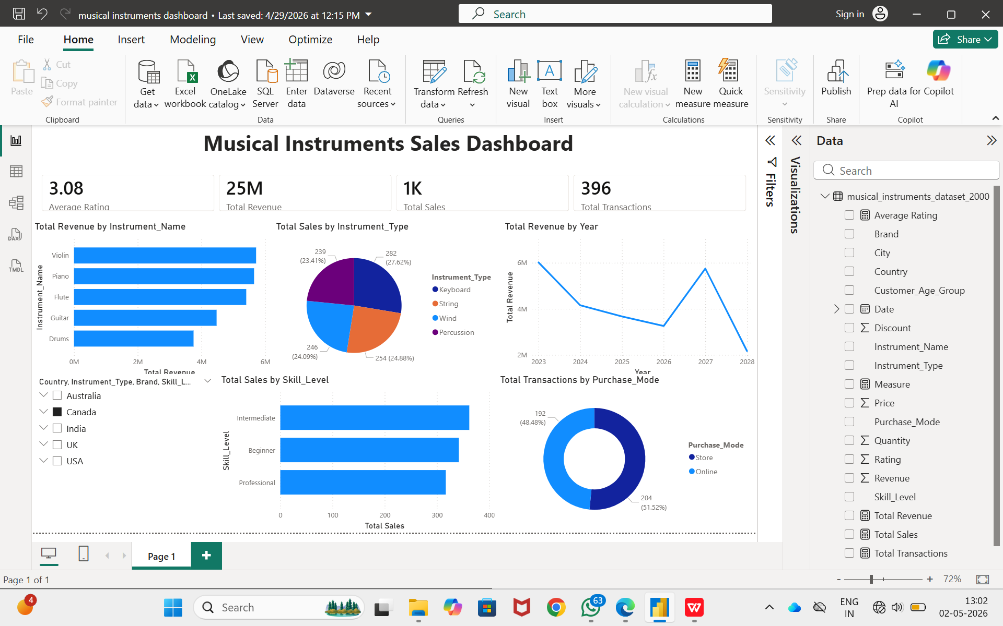

CONCLUSION
This project demonstrates the effective use of Power BI for data visualization. By transforming raw data into meaningful insights, the dashboard helps in analyzing sales performance and customer trends. The project highlights the importance of data analytics in modern business environments.

