ASSIGNMENT-10.4

Name: M.Preethi Meghana
Ht.no: 2303A51584
Batch: 05

Task 1: AI-Assisted Syntax and Code QualityReview
Scenario
You join a development team and are asked to review a juniordeveloper’s Python script that fails to run correctly due to basic codingmistakes. Before deployment, the code must be corrected andstandardized.
Prompt:
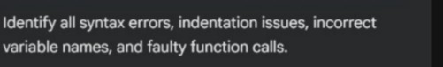
Code:
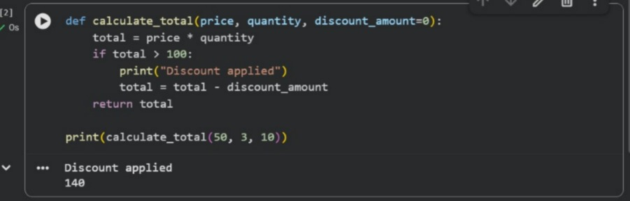
Error Explanation:
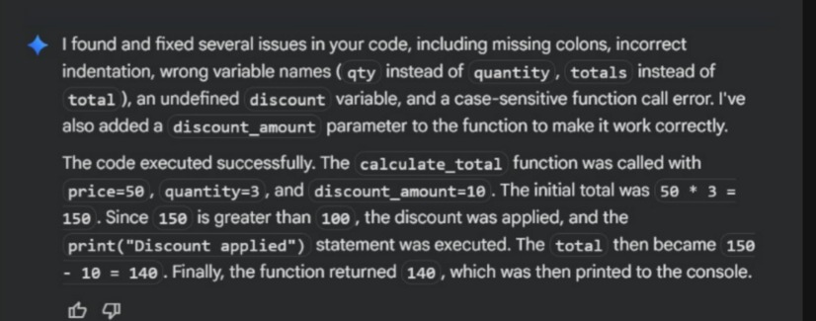
Task 2: Performance-Oriented Code Review
Scenario
A data processing function works correctly but is inefficient and slowsdown the system when large datasets are used.
Prompt:
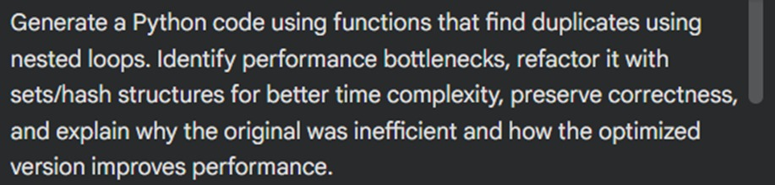

Code:
Without using functions:
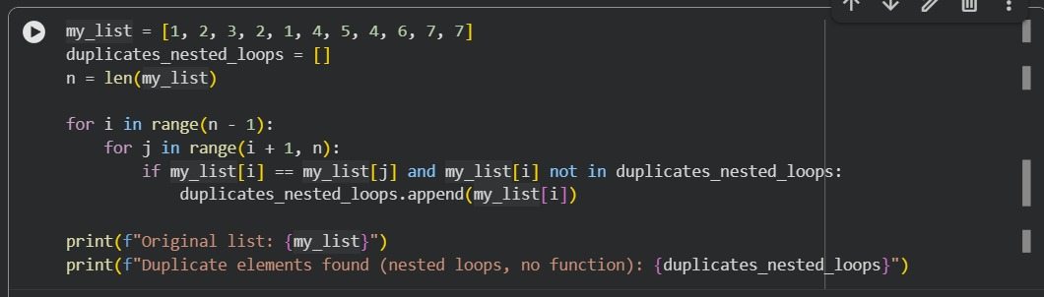
With using functions:
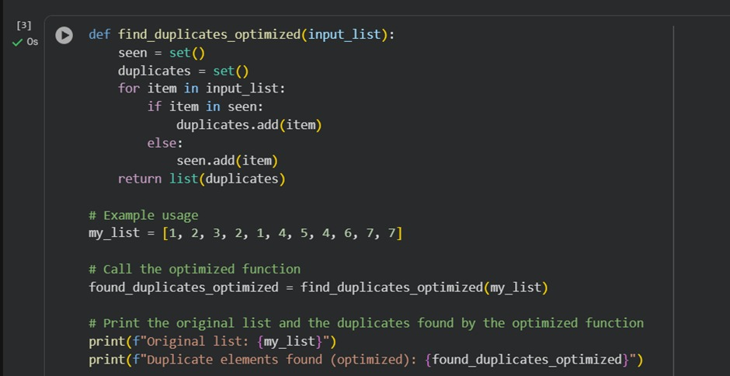
Output:
Why the original approach was inefficient:
The nested loop compares each element with every other element.
• This results in O(n²) time complexity, which grows very slow for large lists.
• Example: For a list of 10,000 items, it could require up to 100 million comparisons.
• It also repeatedly checks membership in the duplicates list (in operator), which itself is O(n), adding further inefficiency.
How the optimized version improves performance?
By using a set (hash-based structure), we can track seen elements in O(1) average time per lookup.
• We only need a single pass through the list, making the algorithm O(n).
• This drastically reduces runtime for large datasets while preserving correctness.
• Sets also automatically prevent duplicate entries, simplifying the logic.
Improved Time Complexity
• Original: O(n²) due to nested loops and repeated membership checks.
• Optimized: O(n) because each element is processed once, with O(1) average lookup in a set.
Task 3:Readability and Maintainability Refactoring
Scenario
A working script exists in a project, but it is difficult to understand due topoor naming, formatting, and structure. The team wants it rewritten forlong-term maintainability.

Prompt:
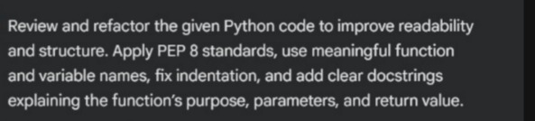
Code:
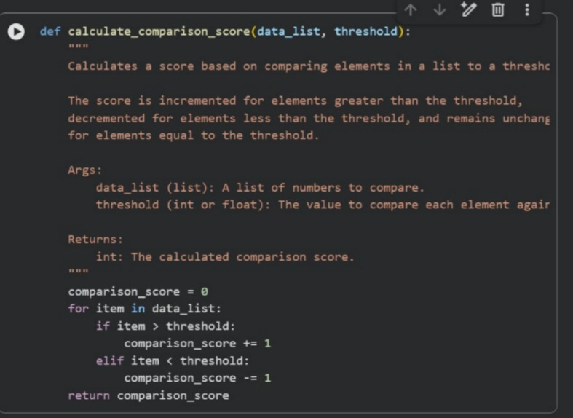
Explanation:
The original code was difficult to understand due to poor naming and formatting. After refactoring, clear names, proper indentation, and PEP 8 standards were applied. Docstrings were added to explain what the function does, its inputs, and outputs. This helps make the code clean, readable, and easy to reuse.
Task 4: Secure Coding and Reliability Review
Scenario
A backend function retrieves user data from a database but has securityvulnerabilities and poor error handling, making it unsafe for productiondeployment.
Prompt:
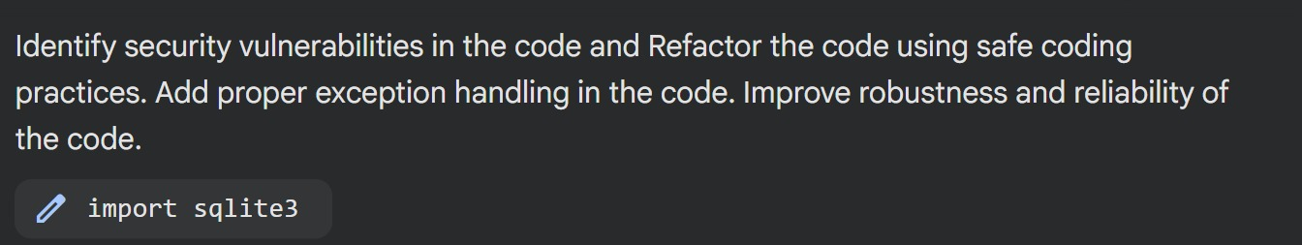
Unsafe:
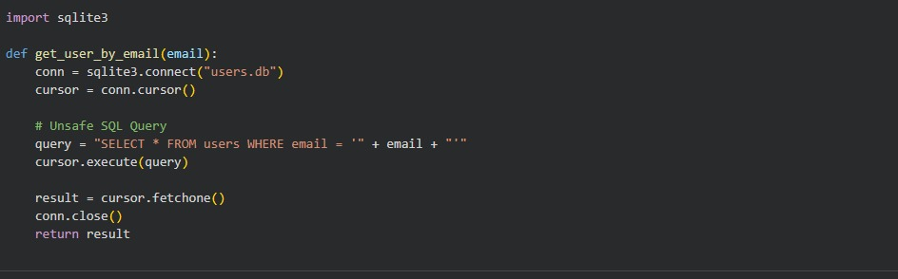
Analyze SQL Injection Vulnerability:
The get_user_by_email function in the provided code is vulnerable to SQL injection because it constructs the SQL query by directly concatenating user-supplied input (email) into the SQL string. This method does not sanitize or escape special characters, allowing an attacker to manipulate the query's logic.
Vulnerability Explanation:
The line query = "SELECT * FROM users WHERE email = '" + email + "'" is the source of the vulnerability. If the email parameter contains SQL keywords or special characters, they are interpreted as part of the SQL query rather than as literal string data.
Example of a Malicious Input:
Consider the following malicious email input: ' OR 1=1 --If this input is passed to the get_user_by_email function, the query variable will become: SELECT * FROM users WHERE email = '' OR 1=1 --'
Impact of the Malicious Input:
Let's break down what this malicious query does:
email = '': This part evaluates to false for any legitimate email.OR 1=1: This is always true. Because of the OR operator, the entire WHERE clause becomes true, regardless of the email field's actual content.
--: This is a SQL comment marker. Anything after -- is ignored by the database. In this case, it comments out the closing single quote (') that would normally terminate the email string, preventing a syntax error.
As a result, the query SELECT * FROM users WHERE email = '' OR 1=1 --' will return all rows from the users table, effectively bypassing any authentication or data access control that relies on the email address. An attacker could retrieve sensitive user information without knowing a valid email or password.
Refactor with Parameterized Queries:
Reasoning: The subtask requires refactoring the get_user_by_email function to use parameterized queries to prevent SQL injection. This involves changing the SQL query to use a ? placeholder and passing the email as a tuple to cursor.execute(), as well as ensuring the DATABASE_NAME variable is used for the database connection.
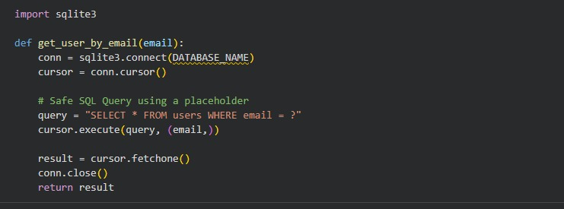

Implement Exception Handling
Subtask:
Add a try...except sqlite3.Error block to catch potential database errors during connection, query execution, or data fetching. Handle specific exceptions as needed.
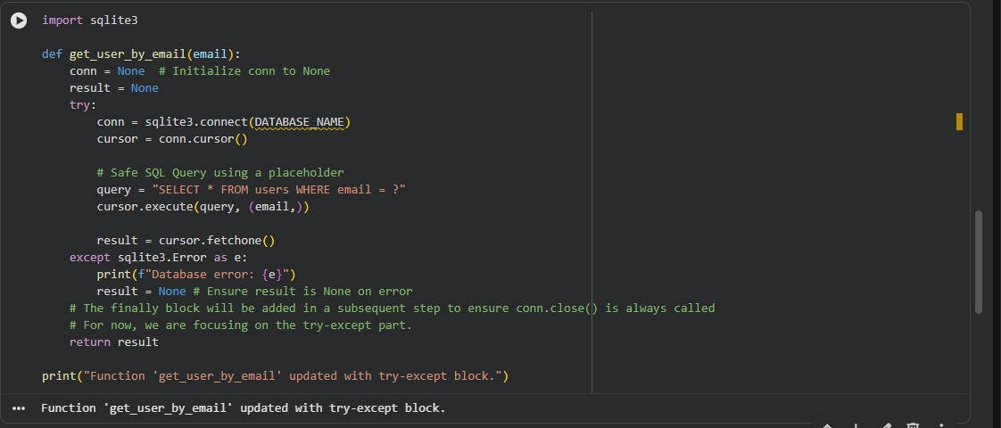
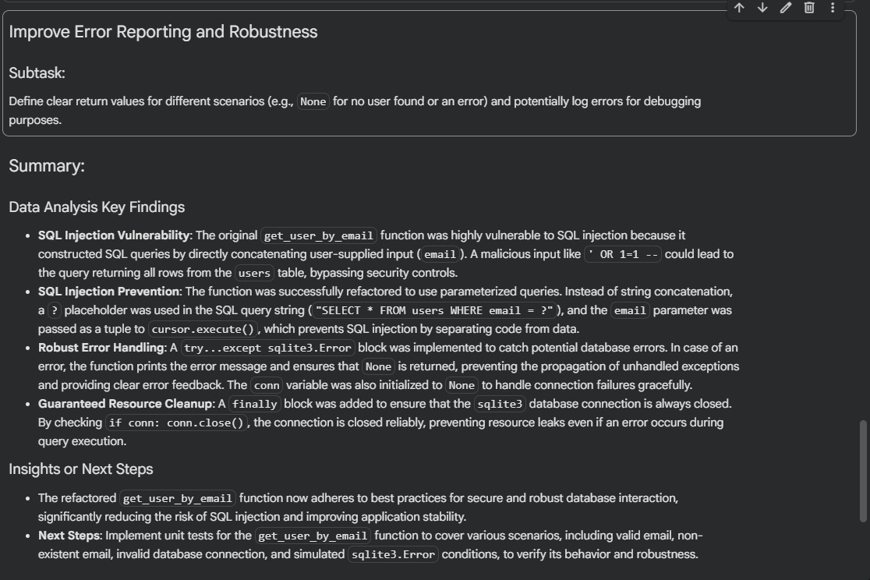
Task 5: AI-Based Automated Code Review Report
Scenario
Your team uses AI tools to perform automated preliminary code reviewsbefore human review, to improve code quality and consistency acrossprojects.
Prompt:
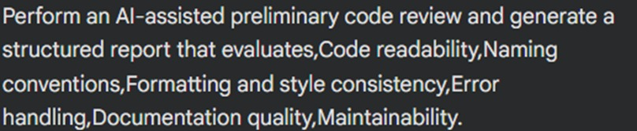

Code:
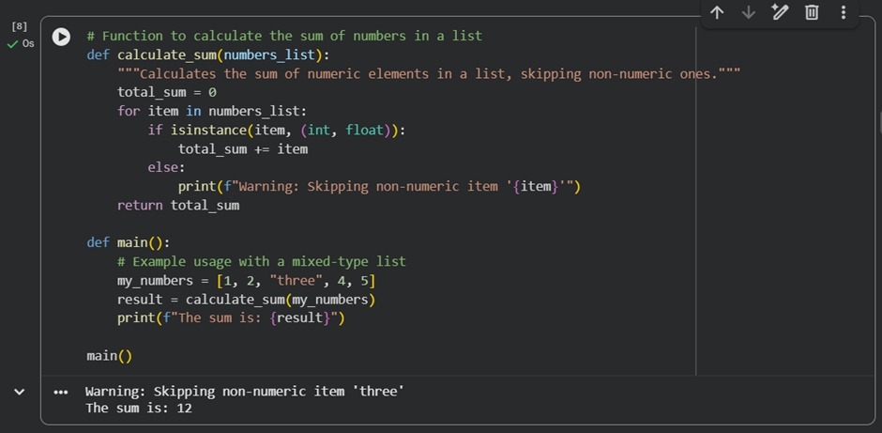
Error Explanation:
The primary error we encountered was a TypeError: unsupported operand type(s) for +: 'int' and 'str' within the SUM function.
This error occurred because the function tried to directly add an integer (the running total) with a string (like 'three') from the input list. Python's + operator cannot perform addition between these incompatible types, leading to the crash. The solution was to modify the function to explicitly check the type of each item and only add numeric values to the sum, skipping non-numeric ones.

