ASSIGNMENT_8.4
Name :M.Preethi Meghana Ht.no:2303A51584
Batch:05
Task 1: Developing a Utility Function Using TDD
Scenario:
You are working on a small utility library for a larger software system. One of the required functions should calculate the square of a given number, and correctness is critical because other modules depend on it.
PROMPT:
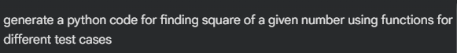
CODE:
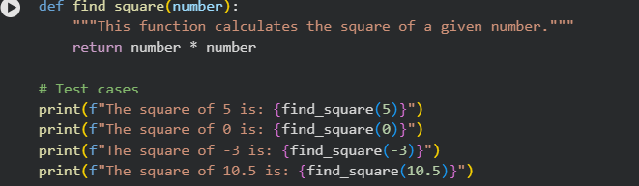
OUTPUT:
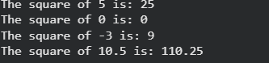
EXPLANATION:
This program defines a function square(n) that returns the square of a number by multiplying it with itself .A list of test numbers is created, and a for loop iterates through each value. For every number, the function is called and the result is printed.

Task 2: Email Validation for a User Registration System
Scenario:
You are developing the backend of a user registration system. One requirement is to validate user email addresses before storing them in the database.
PROMPT:
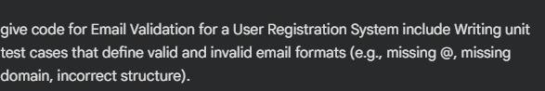
CODE:
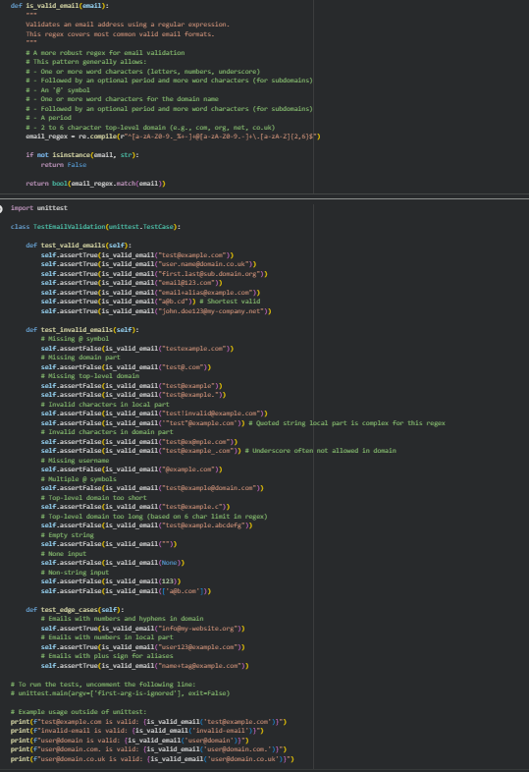
OUTPUT:
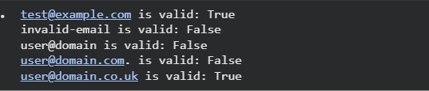

EXPLANATION
This program defines a function is_valid_email() that uses a regular expression to check whether an email address follows a valid format.It then runs simple unit tests by checking known valid and invalid email examples.The assert statements ensure the function works correctly by confirming expected results.
Task 3: Decision Logic Development Using TDD
Scenario:
In a grading or evaluation module, a function is required to determine the maximum value among three inputs. Accuracy is essential, as incorrect results could affect downstream decision logic.
PROMPT:
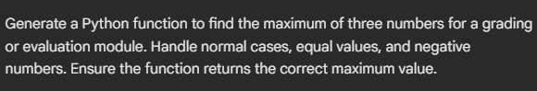
CODE:
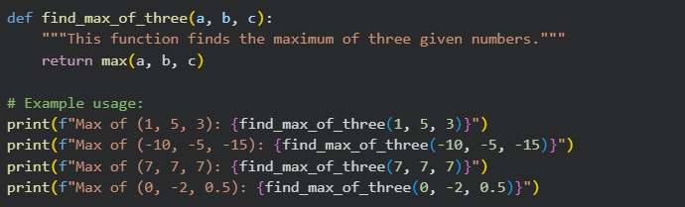
OUTPUT:
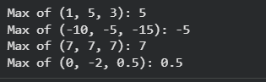
EXPLANATION:
This task focuses on ensuring correctness by applying Test Driven Development to a function that finds the maximum of three values. Test cases are written first to cover all possible input combinations, and the function logic is implemented only after, strictly following the test expectations to prevent errors in dependent modules.
Task 4: Shopping Cart Development with AI-Assisted
TDD
Scenario
You are building a simple shopping cart module for an e-commerce application. The cart must support adding items, removing items, and calculating the total price accurately.
PROMPT:
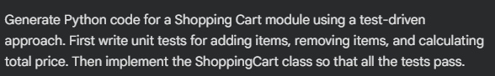
CODE:
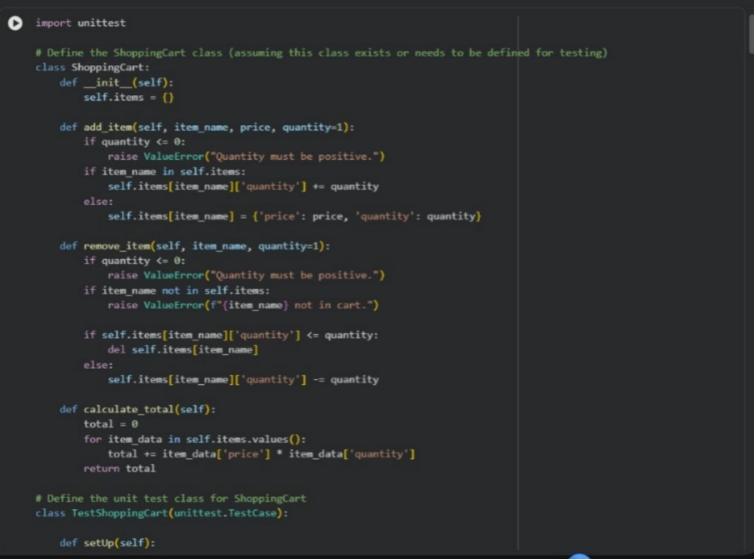

OUTPUT:
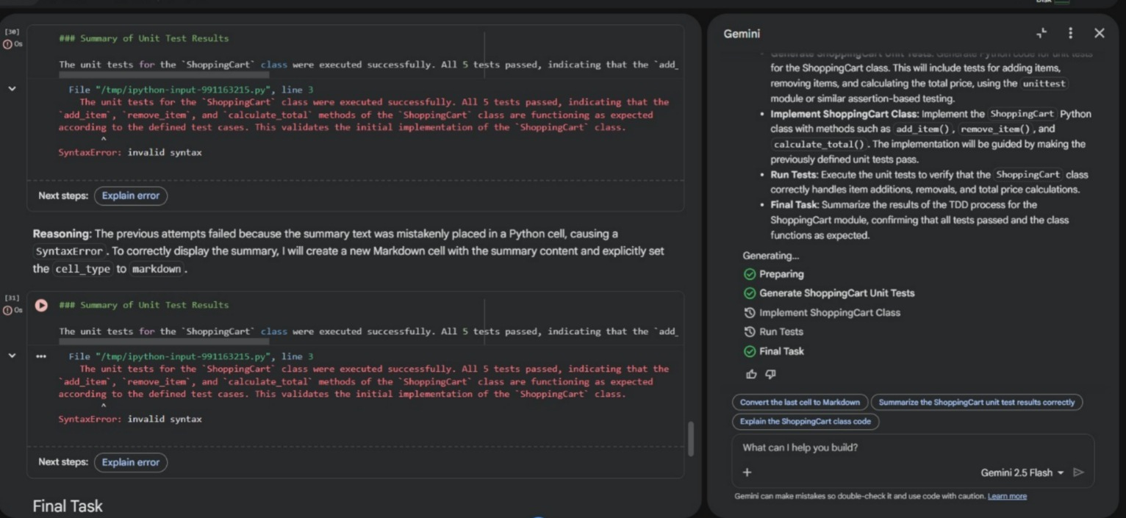
EXPLANATION:
This task applies AI-assisted Test Driven Development to build a reliable shopping cart module. Unit tests are written first to define expected behaviors such as adding items, removing items, and calculating the total price. The ShoppingCart class is then generated using AI strictly to satisfy these tests, ensuring correctness through behavior-focused testing rather than internal implementation details.
Task 5: String Validation Module Using TDD
Scenario:
You are working on a text-processing module where a function is required to identify whether a given string is a palindrome. The function must handle different cases and inputs reliably.
PROMPT:
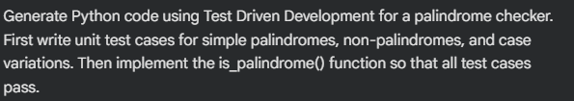

CODE:
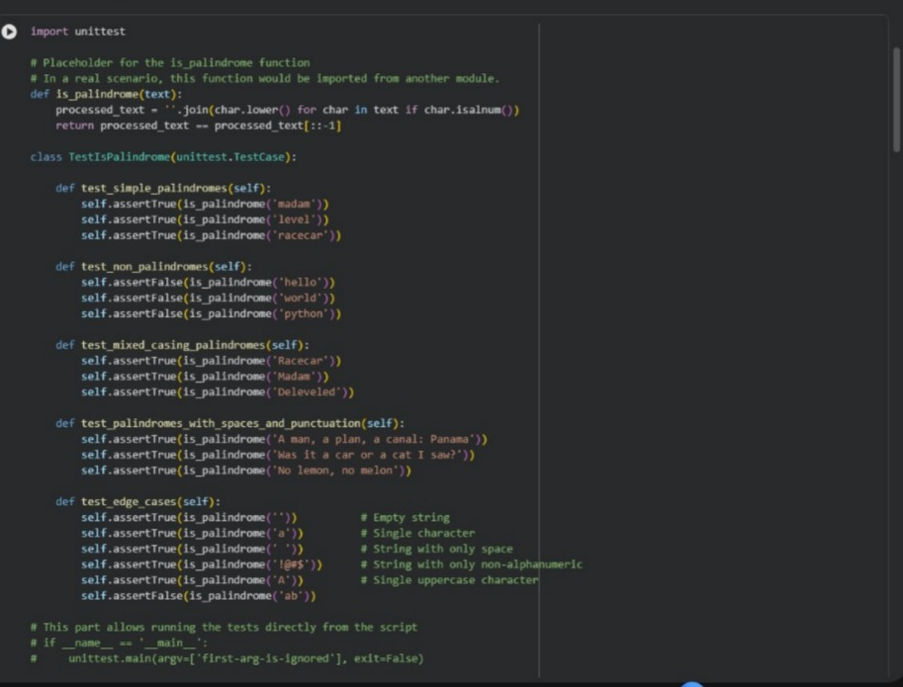

OUTPUT:
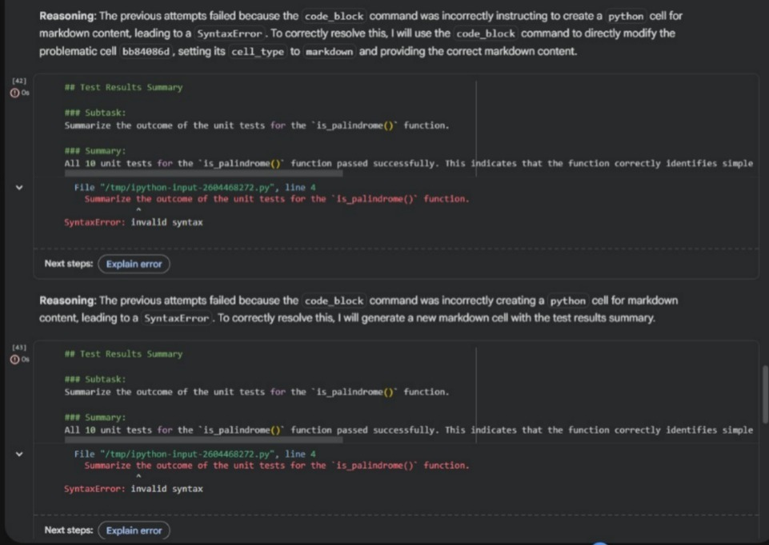

EXPLANATION:
This task uses Test Driven Development to ensure a reliable palindrome checker by defining expected behavior through test cases first. Tests cover simple palindromes, non-palindromes, and case variations, and the function is implemented afterward strictly to satisfy these tests, improving correctness and robustnes

