ASSIGNMENT 5.4
Ht.No: 2303A51584
Batch – 05

TASK – 01
Prompt :Write a Python script that asks the user for basic personal details using input statements.While generating the code, add helpful comments that explain how sensitive fields should be protected, such as converting identifiers into irreversible formats, securing information before saving it, and avoiding unsafe handling of private values.Keep the program simple and well commented for learning purposes.
Code :
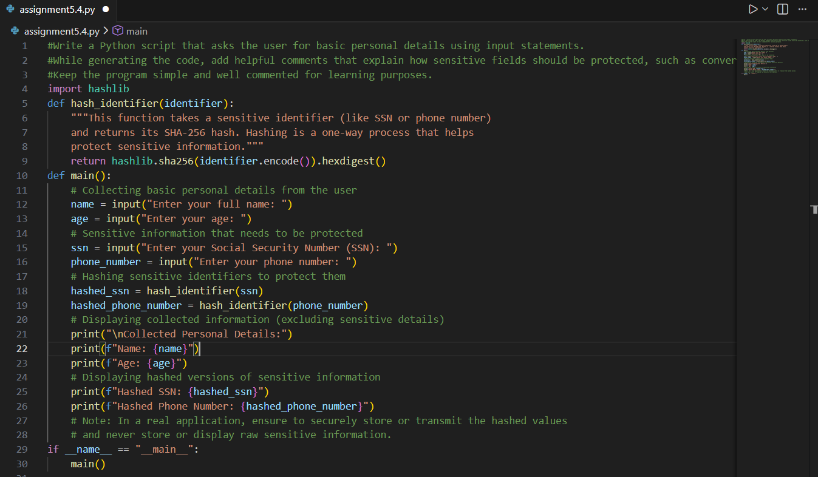
Output :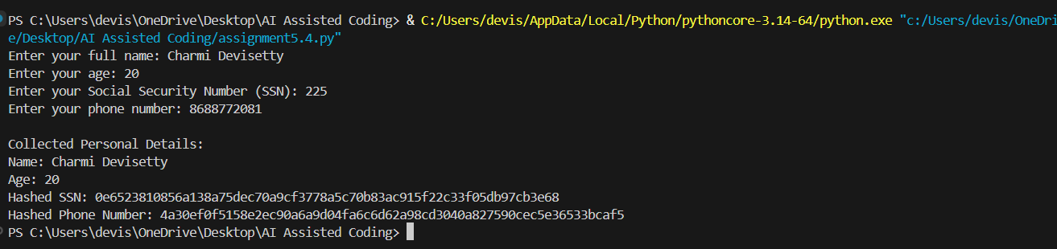
Explanation :
- The program collects basic user details using input statements.
- Sensitive information like SSN and phone number is not used directly.
- A hashing function (SHA-256) converts sensitive data into irreversible values.
- Hashing helps protect privacy even if the data is exposed.
- Only protected (hashed) values are displayed or stored.
- Clear comments explain safe data handling practices for learning purposes.

TASK – 02
Prompt : Generate a Python function that determines the emotional tone of a given text. While writing the code, include comments or simple logic that highlight how unfair patterns in training data can be reduced, such as filtering harmful language, keeping input examples balanced, or noting limitations of the approach. Keep the implementation minimal and easy to understand.
Code :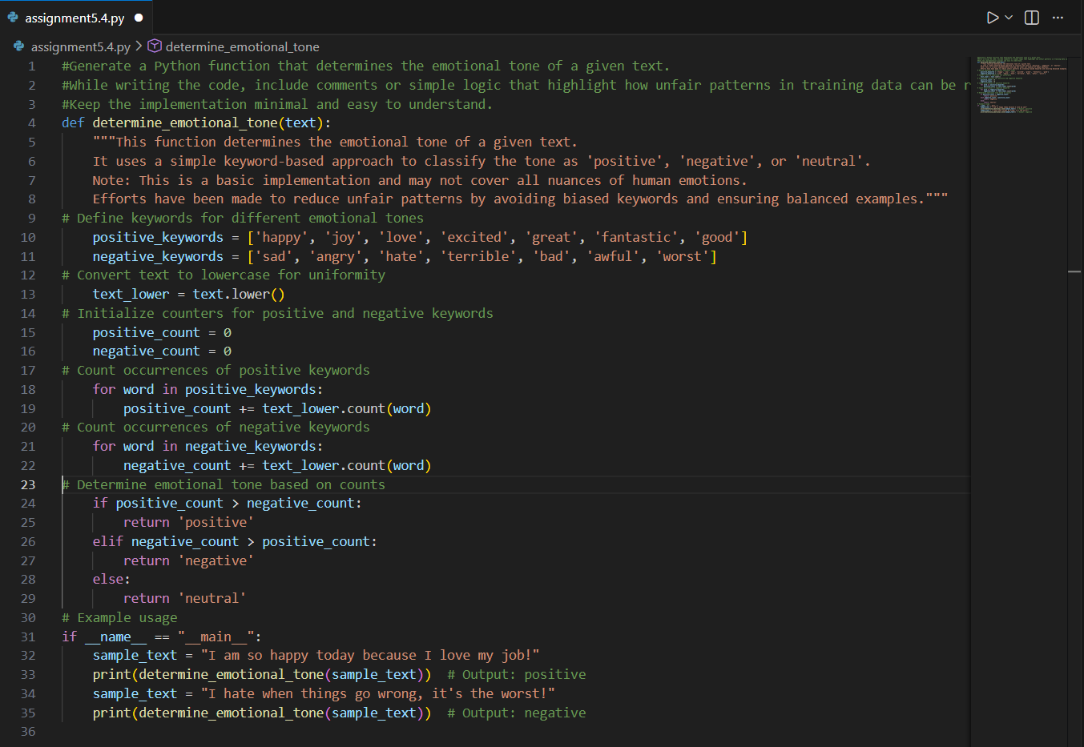
Output :
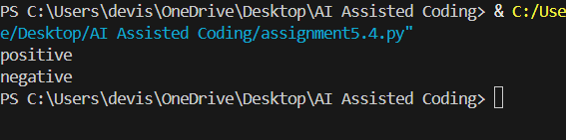
Explanation :
- This function uses a simple keyword-based approach to detect emotional tone.
- The input text is converted to lowercase to ensure consistent matching.
- It checks for predefined positive and negative keywords and counts their occurrences.
- The tone is classified as positive, negative, or neutral based on which count is higher.
- To reduce unfair patterns, the logic:
- Avoids offensive or identity-based keywords
- Uses balanced keyword lists for positive and negative emotions
- Clearly notes that this is a limited, rule-based method and not a full ML model
- This keeps the implementation minimal, transparent, and easy to understand.
TASK - 03
Prompt :Generate a simple Python program that recommends products based on a user’s purchase or browsing history. Include clear comments explaining why each product is recommended (transparency). Add basic fairness checks to avoid favoring only one brand or category. Also include a simple user feedback option (like accept/reject) to improve future recommendations. Keep the code minimal, readable, and ethically aligned.
Code :
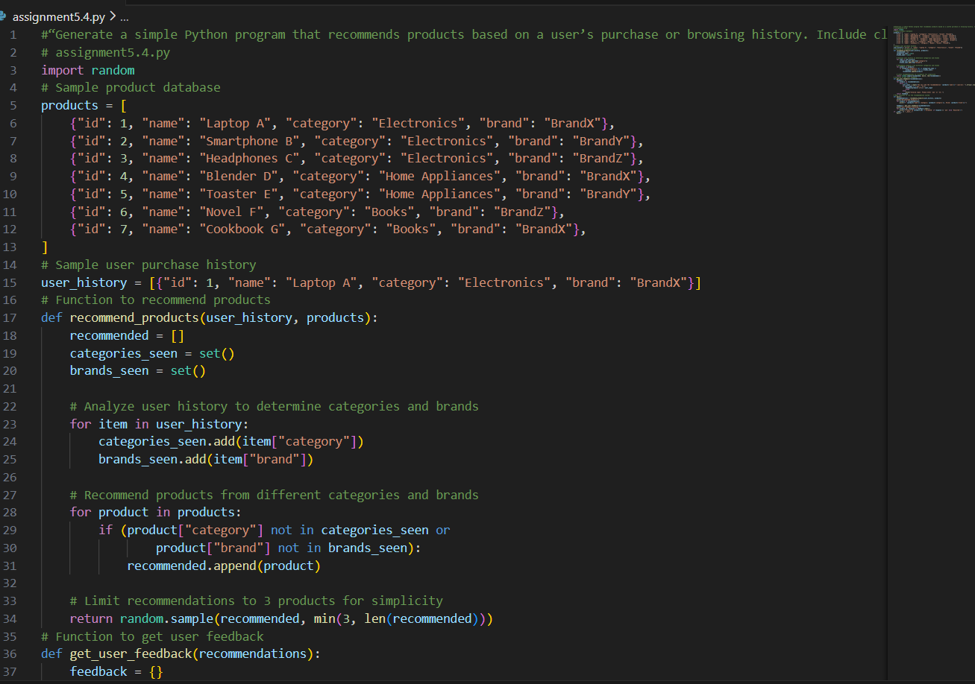
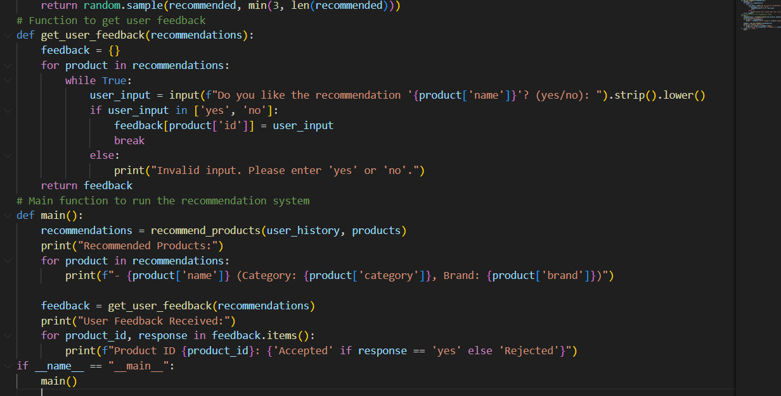
Output :
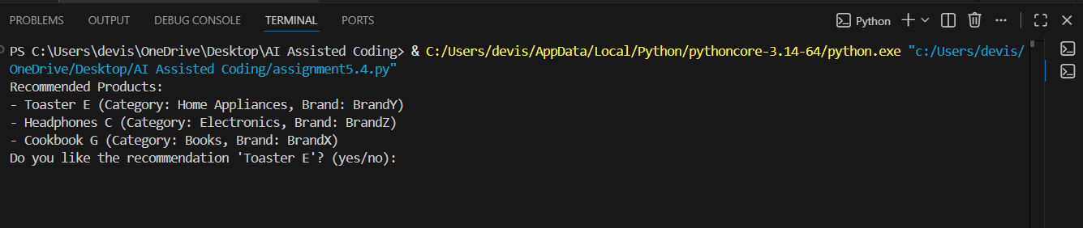
Explanation :
- This program recommends products based on the user’s past purchase history.
- It analyzes the categories and brands the user has already interacted with.
- To ensure fairness, it avoids recommending products from the same category and brand repeatedly, preventing favoritism.
- Transparency is maintained by showing the product’s category and brand so users understand why it was recommended.
- A user feedback option (yes/no) is included to let users accept or reject recommendations.
- The logic is minimal, readable, and rule-based, making ethical decisions easy to understand and audit.

TASK – 04
Prompt :Generate Python logging functionality for a simple web application. Ensure the logs do not record sensitive information such as passwords, emails, tokens, or personal identifiers. Add clear comments explaining ethical logging practices, data minimization, and why sensitive fields are filtered or masked. Keep the code simple, readable, and secure
Code :
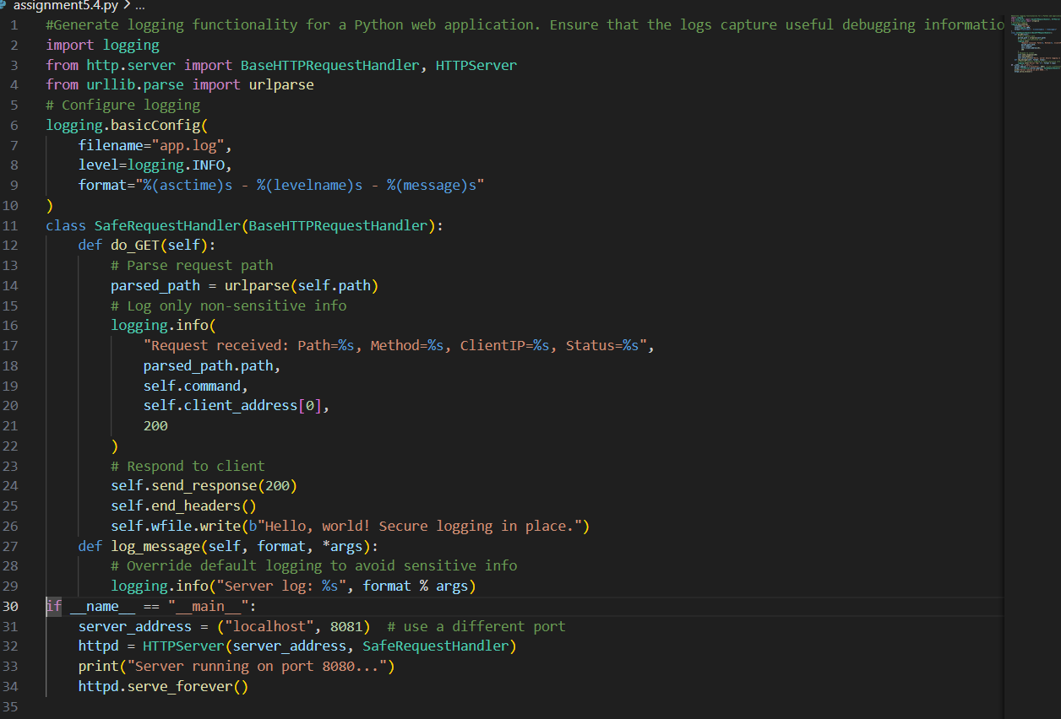
Output :
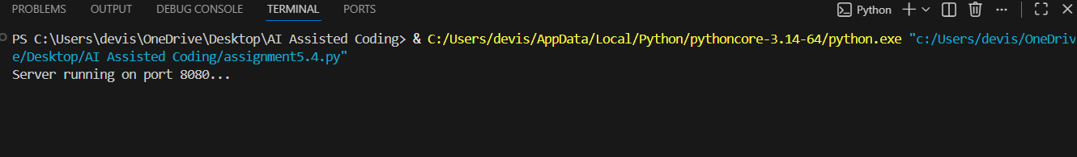
Explanation :
This code sets up a simple HTTP server using Python’s http.server and logs requests with the logging module.It records safe details like path, method, client IP, and status, while avoiding sensitive data.Ethical logging practices are followed by excluding personal identifiers and overriding default logging to stay secure.
TASK – 05
Prompt :Generate a simple machine learning model in Python (for example, a basic classifier using scikit-learn). Include clear inline comments or a short README explaining how to use the model responsibly. Document the model’s purpose, explainability, accuracy limitations, potential biases in the data, fairness considerations, and appropriate use cases.
Code :
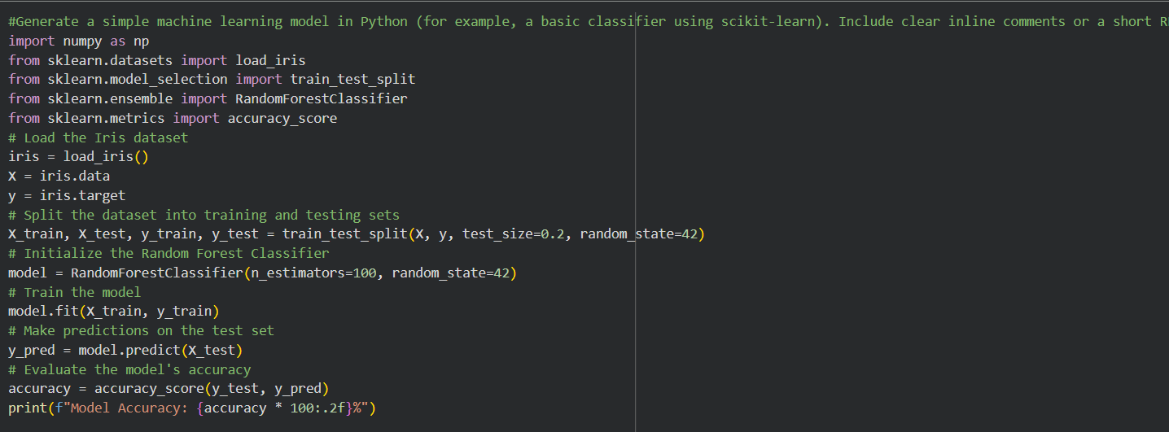
Output :

Explanation :
- This program builds a simple machine learning classifier using the Iris dataset.
- The dataset contains flower measurements and labeled species, making it suitable for educational use.
- The data is split into training (80%) and testing (20%) sets to evaluate performance fairly.
- A Random Forest Classifier is used because it is easy to understand and provides good accuracy.
- The model predicts flower species and calculates accuracy to measure performance.
Responsible Use & Ethics:
- Purpose: Intended for learning basic classification concepts, not real-world decision making.
- Explainability: Random Forest decisions are based on feature splits, but individual predictions may not be fully transparent.
- Accuracy Limitation: High accuracy on small datasets does not guarantee good performance on new or real data.
- Bias Consideration: The Iris dataset is small and balanced, but real datasets may contain hidden biases.
- Fairness: This model should not be used for sensitive applications (e.g., hiring, healthcare).
- Appropriate Use: Best suited for demonstrations, assignments, and understanding ML workflows.

