Assignment-9.3

Ht.No: 2303A51584
Batch: 05

Task 1: Basic Docstring Generation
Scenario
You are developing a utility function that processes numerical lists and must be properly
documented for future maintenance.
Requirements
• Write a Python function to return the sum of even numbers and sum of odd numbers in a
given list
• Manually add a Google Style docstring to the function
• Use an AI-assisted tool (Copilot / Cursor AI) to generate a function-level docstring
• Compare the AI-generated docstring with the manually written docstring
• Analyze clarity, correctness, and completeness
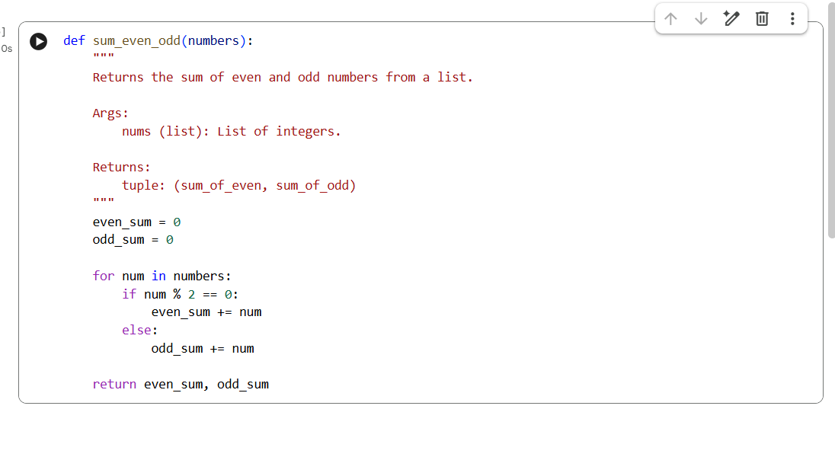
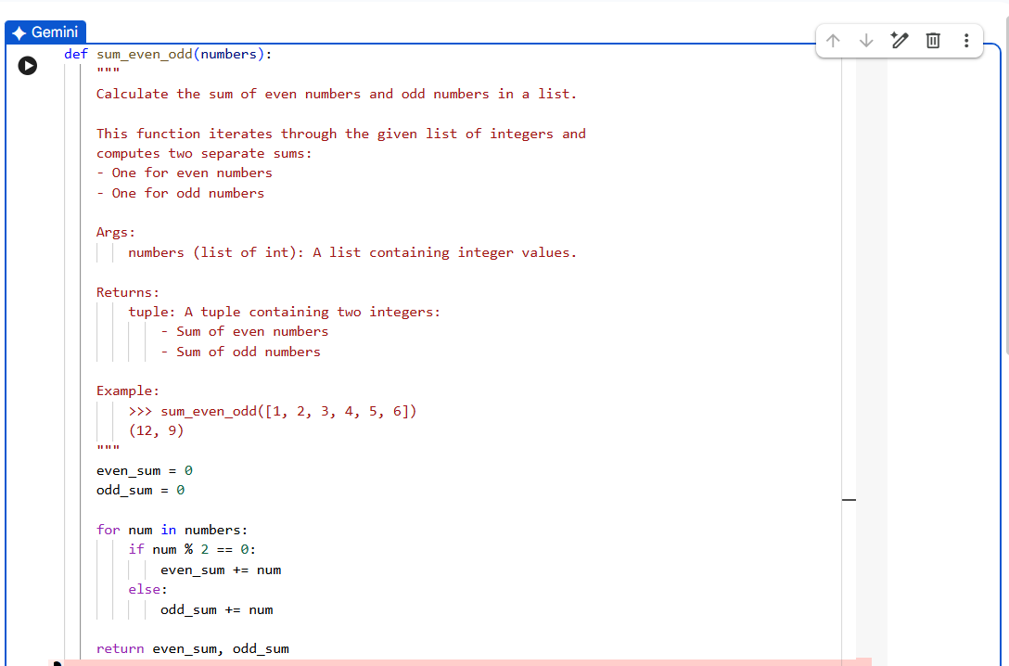

Comparison:
Manual doctstring:
- A manual docstring is written by the programmer in their own words.
- Manual docstrings may be short or long depending on the person.
- Writing a manual docstring takes more time.
- Manual docstrings show the programmer’s understanding of the code.
- Manual docstrings are commonly used in exams and learning.

AI-generated docstring:
- An AI-generated docstring is written automatically by an AI tool.
- AI-generated docstrings are usually well-structured and detailed.
- AI-generated docstrings save time and effort.
- AI-generated docstrings depend on the quality of the prompt given.
- AI-generated docstrings are useful in real projects for consistency.

Task 2: Automatic Inline Comments
Scenario
You are developing a student management module that must be easy to understand for new
developers.
Requirements
• Write a Python program for an sru_student class with the following:
– Attributes: name, roll_no, hostel_status
– Methods: fee_update() and display_details()
• Manually write inline comments for each line or logical block
• Use an AI-assisted tool to automatically add inline comments
• Compare manual comments with AI-generated comments
• Identify missing, redundant, or incorrect AI comments
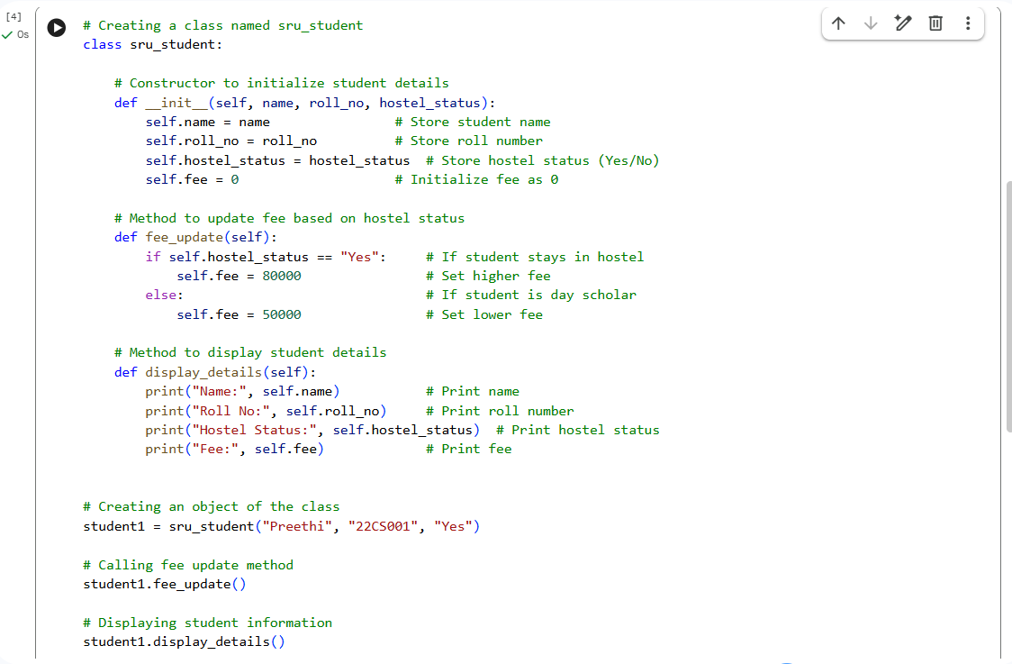

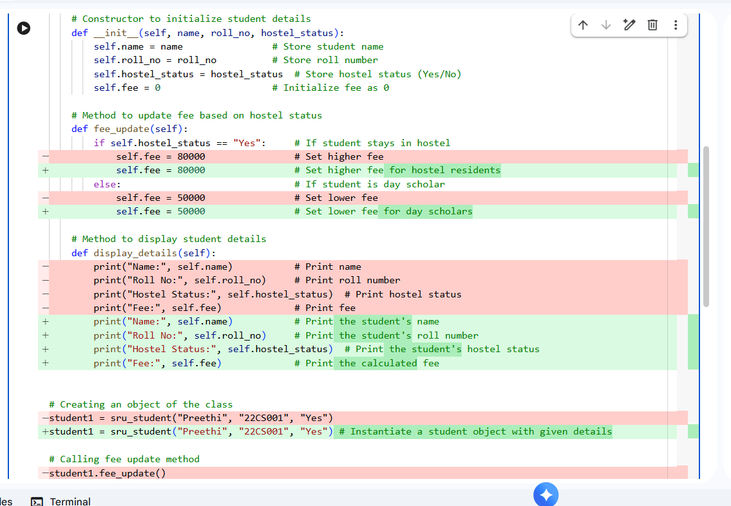

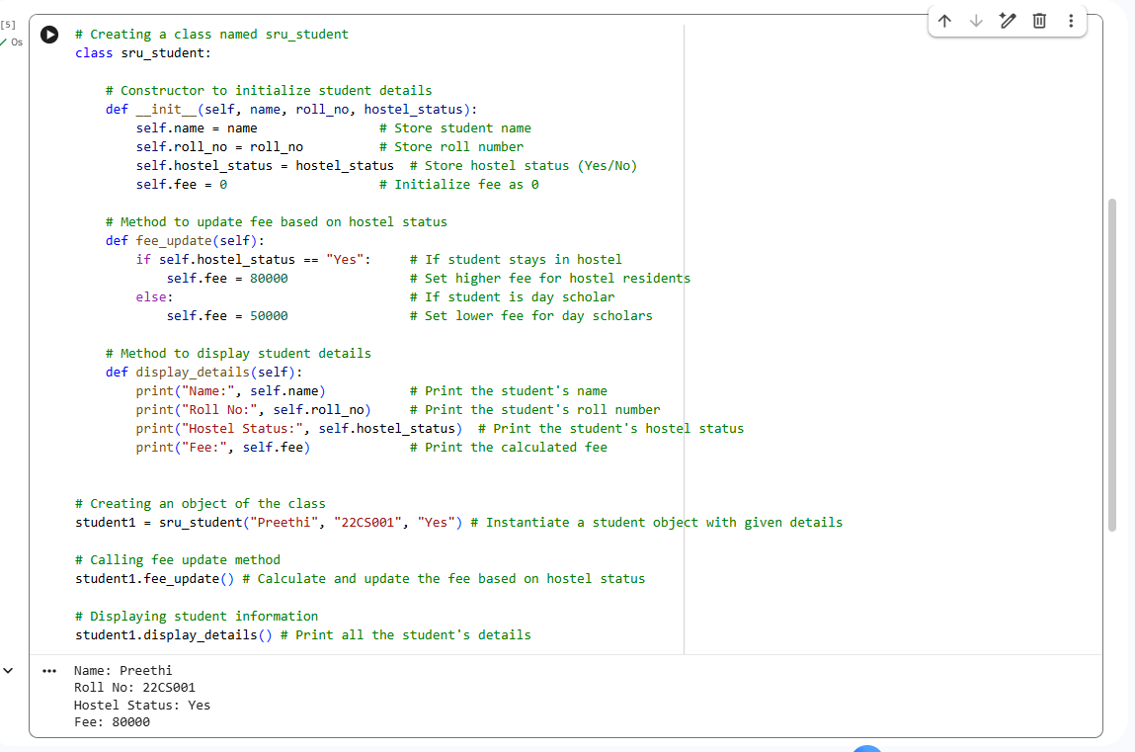

Comparision:
Manual comments:
- In the manual version, each line and block in the sru_student program is commented by the programmer to explain what it does.
- Manual comments clearly show the student’s understanding of class, constructor, and methods like fee_update() and display_details().
- Writing manual comments for the program takes more time, especially for constructors and methods.
- Manual comments may be simple and exam-oriented.
- Manual comments are preferred in academic submissions to prove learning.

AI-generated comments:
- AI comments explain the same logic but in a more standardized and polished way.
- AI-generated comments reduce effort and save time.
- In the AI-generated version, comments are added automatically based on code understanding.
- AI comments may be slightly more descriptive, sometimes more than required for exams.
- AI-generated comments are useful in real projects where clarity and consistency matter.

Task 3: Module-Level and Function-Level Documentation
Scenario
You are building a small calculator module that will be shared across multiple projects and
requires structured documentation.
Requirements
• Write a Python script containing 3–4 functions (e.g., add, subtract, multiply, divide)
• Manually write NumPy Style docstrings for each function
• Use AI assistance to generate:
– A module-level docstring
– Individual function-level docstrings
• Compare AI-generated docstrings with manually written ones
• Evaluate documentation structure, accuracy, and readability

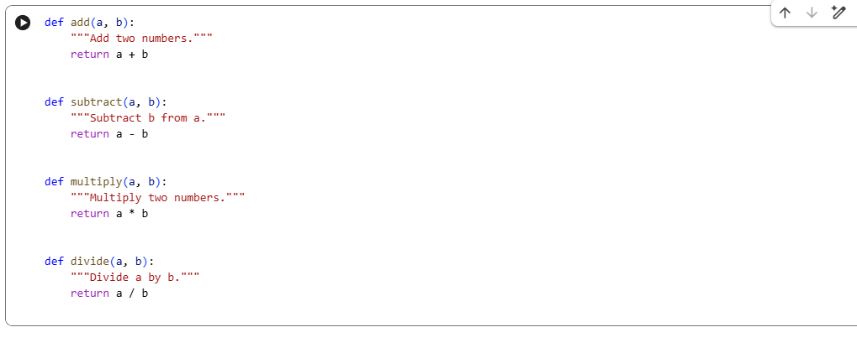

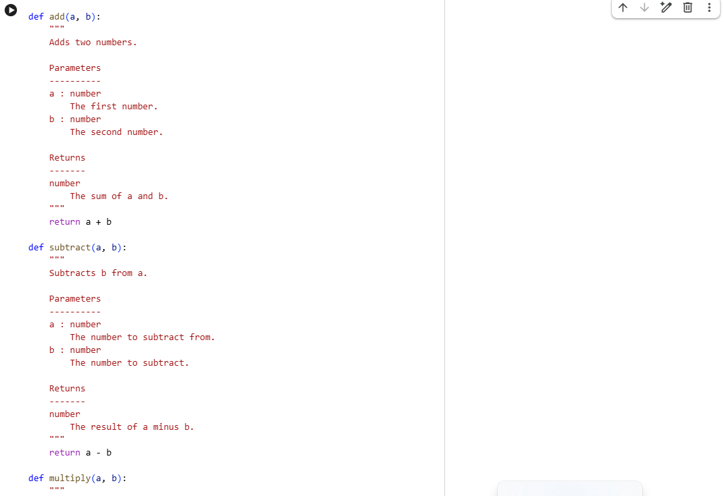

- 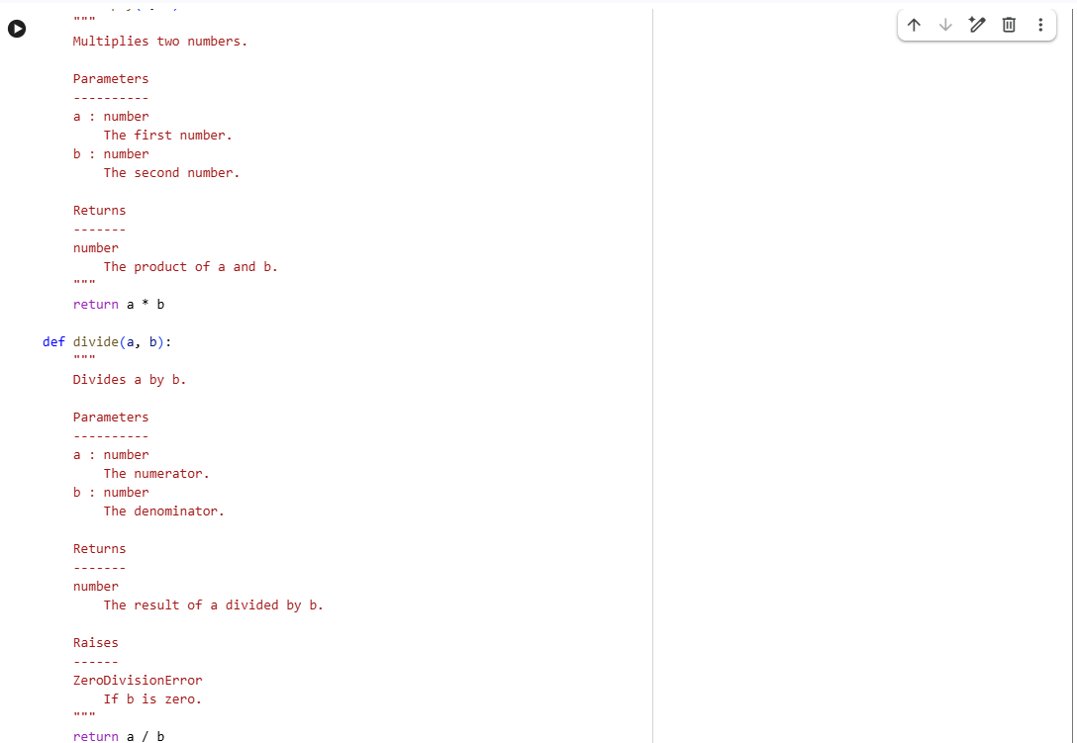

Comparsion:
Manual docstrings:
- Manual docstrings are written by the programmer.
- Manual docstrings show the programmer’s understanding of the code.
- Writing manual docstrings takes more time.
- Manual docstrings may differ in quality and style.
- Manual docstrings are preferred in learning and exams.

AI-generated docstrings:
- AI-generated docstrings are created automatically by AI tools.
- AI docstrings are usually clear and well-structured.
- AI-generated docstrings save time and effort.
- AI-generated docstrings are consistent and standard.
- AI-generated docstrings are useful in real-world projects.

