**SSN COLLEGE OF ENGINEERING**

**COMPUTER SCIENCE AND ENGINEERING**

**UCS1617-MINIPROJECT**

**LIBRARY MANAGEMENT SYSTEM**

**NAME : P.Preethi**

**REG : 185001115**

**CLASS : CSE-B**

**Problem Statement:**

Library Management System is a software for the purpose of monitoring and controlling the transactions in a library. Borrowing books, returning books or viewing the available books at the Library of the local University is currently done manually where in the student has to go to the Library and check the available books at the Library. To check the list of books available and borrow a book user must come to library but having an online library management system makes it easier as the user can access from anywhere. Our project aims in reducing time and making it much easier. The librarian can add or delete books, remove user and it’s easy to update the database. The user can request, renew, borrow, and return a book.

**Software Requirements Specification**

**1.Introduction:**

Borrowing books, returning books or viewing the available books at the Library of the local University is currently done manually where in the student has to go to the Library and check the available books at the Library. To check the list of books available and borrow a book user must come to library but having an online library management system makes it easier as the user can access from anywhere. Then the librarian checks the student id and allows the member to check out the book and the librarian then updates the member database and also the books database. This system would be used by members who may be students or professors of that University to check the availability of the books and borrow the books, and by the librarian to update the databases. The purpose of this document is to analyze and elaborate on the high-level needs and features of the Online Library Management System. It focuses on the capabilities and facilities provided by a Library. The details of what all are the needs of the Online Library System and if it fulfils these needs are detailed in the use-case and supplementary specifications.

**Purpose:**

The purpose of Software Requirements Specification (SRS) document is to describe the external behavior of the Online Library Management System. Requirements Specification defines and describes the operations, interfaces, performance, and quality assurance requirements of the Online Library System. The document also describes the nonfunctional requirements such as the user interfaces. It also describes the design constraints that are to be considered when the system is to be designed, and other factors necessary to provide a complete and comprehensive description of the requirements for the software. The Software Requirements Specification (SRS) captures the complete software requirements for the system, or a portion of the system. Requirements described in this document are derived from the Vision Document prepared for the Online Library System.

**Scope:**

The Online Library System is supposed to have the following features.

• The product provides the members with online blocking of books capabilities and the Online Library System is up and running all day.

• The system provides login facility to the users.

• The system provides the members with the option to check their account and/or change their options like password of the account whenever needed all through the day during the library hours.

• The system lets the library staff to check which all members have blocked the books and whether they can borrow any more books or not.

• The system allows the Librarian to create the books catalog, add/delete books and maintain the books catalog.

• The system updates the billing system as and when the member borrows or returns a book.

**2.Overall Description**:

Product Perspective:  
  
The planned Library Management Scheme would take care of the specifics of the latest book at any moment. The book dilemma, book return, would immediately update the new book information so that the user will have the latest book details updated.

Product function:  
  
The key goal of this initiative is to minimize the work done manually.  
Book Problems, Refunds, and Fine Calculation/Management can be handled by this program. Generating separate Record-Keeping Records according to end-user criteria.

User characteristics:  
  
We have 2 levels of users  
  
 Module: The user can verify the availability of the books in the user module.  
 Book return  
 Administration module: The sub-modules in the administration module are as follows.  
 Register user  
 Entry book details  
 Book issue

General Constraints:  
  
• The billing system is connected to the Online Library System and the database used by the billing system must be compatible with the interface of the Online Library System.

• The users must have their correct usernames and passwords to enter into the Online Library System.

• The information of all the users must be stored in a database that is accessible by the Online Library System.

Assumption and dependencies:  
  
• The users have sufficient knowledge of computers.

• The University computer should have Internet connection and Internet server capabilities.

• The users know the English language, as the user interface will be provided in English

• The product can access the university student database.

**3. Specific Requirements**

This section describes in detail all the functional requirements.

1. **Functionality:**

* Login Capabilities: The system shall provide the users with logon capabilities.
* Alerts: The system can alert the Librarian or the administrator in case of any problems.

1. **Usability:**

* The system shall allow the users to access the system from the Internet using HTML
* or it’s derivative technologies. The system uses a web browser as an interface.
* Since all users are familiar with the general usage of browsers, no specific training is required.
* The system is user friendly and self-explanatory.

**3. Reliability :**

The system has to be very reliable due to the importance of data and the damages incorrect or incomplete data can do.

* Availability: The system is available 100% for the user and is used 24 hrs a day and 365 days a year. The system shall be operational 24 hours a day and 7 days a week.
* Mean Time Between Failures (MTBF) The system will be developed in such a way that it may fail once in a year.
* Mean Time to Repair (MTTR) Even if the system fails, the system will be recovered back up within an hour or less.
* Accuracy The accuracy of the system is limited by the accuracy of the speed at which the employees of the library and users of the library use the system.
* Maximum Bugs or Defect Rate Not specified.
* Access Reliability The system shall provide 100% access reliability.

**4.Performance :**

* Response Time : The system would respond in minimum time.
* Administrator/Librarian Response : The system shall take as less time as possible to provide service to the administrator or the librarian.
* Throughput : The number of transactions is directly dependent on the number of users, the users may be the Librarian, employees of the Library and also the people who use the Library for checking-out books, returning books and checking online library account.
* Resource Utilization : The resources are modified according the user requirements.

**5.Supportability:**

The system designers shall take in to considerations the following supportability and technical limitations.

* Internet Protocols : The system shall be comply with the TCP/IP protocol standards and shall be designed accordingly.
* Billing System Data Compatibility : The member balance amount that will be calculated and sent to the billing system shall be compatible with the data types and design constraints of the billing system.
* Maintenance : The maintenance of the system shall be done as per the maintenance contract.

**6.Design Constraints**

* Software Language Used : The languages that shall be used for coding the Online Library System are Active Server Pages (ASP), Java Servlets, Java Server Pages (JSP), HTML, JavaScript, and VBScript. For working on the coding phase of the Online Library System, the Internet Information Services (IIS) Server needs to be installed.
* Development Tools : Will make use of the available Java Development Tool kits for working with Java Beans and Java Server Pages. Also will make use of the online references available for developing programs in ASP, HTML and the two scripting languages, JavaScript and VBScript.
* Class Libraries : Will make use of the existing Java libraries available for JSP and Servlets. Also we need to develop some new libraries for the web-based application. Also will develop new programs using ASP and scripting languages.

**7. On-line User Documentation and Help System Requirements**

Online help is provided for each of the feature available with the Online Library System. All the applications provide an on-line help system to assist the user. The nature of these systems is unique to application development as they combine aspects of programming (hyperlinks, etc) with aspects of technical writing (organization, presentation). Online help is provided for each and every feature provided by the system.

The User Manual describes the use of the system to Librarian and Employees. It describes the use of the system on mobile systems. The user manual should be available as a hard copy and also as online help.

An installation document will be provided that includes the installation instructions and configuration guidelines, which is important to a full solution offering. Also, a Read Me file is typically included as a standard component.

**8. Interfaces**

* User Interfaces

Will make use of the existing Web Browsers such as Microsoft Internet Explorer or Netscape. The user interface of the system shall be designed as shown in the user-interface prototypes.

* Login Screen Prototype
* Home Page
* Member Registration Screen
* Member Information once Logged in
* Main Search Page of Library Catalog.
* Software Interfaces : A firewall will be used with the server to prevent unauthorized access to the system.
* Communications Interfaces : The Online Library System will be connected to the World Wide Web.

**USE CASE DIAGRAM**

**Aim**

Creation of an UML Use case model for a problem domain for library management system.

**Notations**

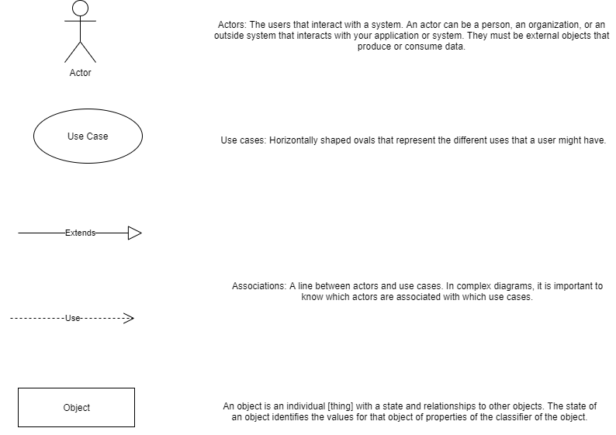

**Identification of Actors**

* User – staff ,student
* Librarian

**Identification of Objects**

* Library management system

**Use cases**

* Validate user
* Check book availability
* Check renewal availability
* Check request validity
* Request for book issue
* Return book
* Add book
* Remove book
* Request for reserve book
* Renew book
* Check out book
* Pay fine
* Make Payment
* Check user account details
* Remove user
* Check book history
* Check book quantity

**Use case diagram**

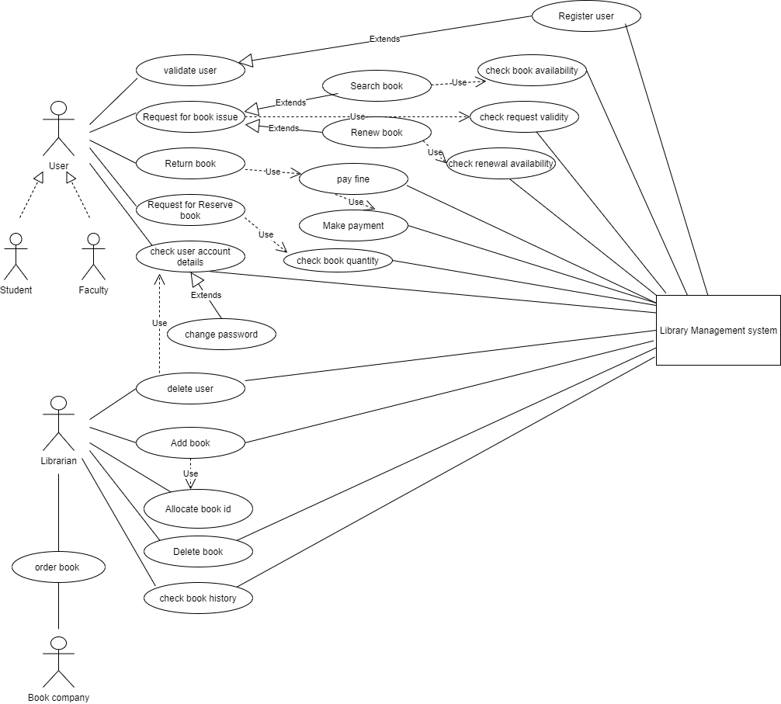

**Subfunctions**

**1)New user sign up**

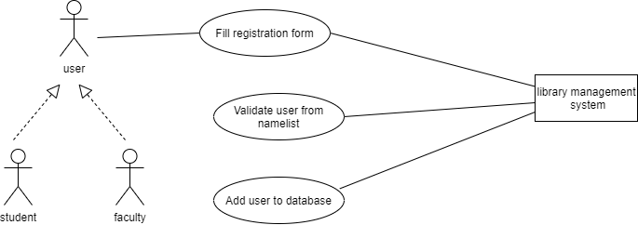

**2)Search a book**

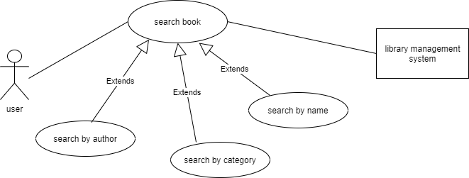

**3) Pay fine**

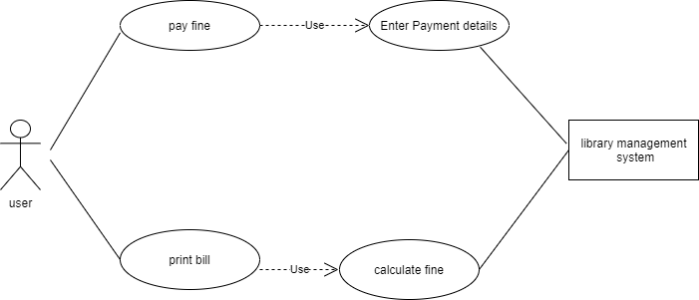

**4)Forgot password**

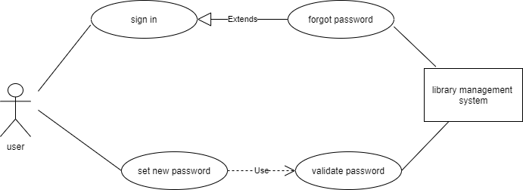

**5) Add book**

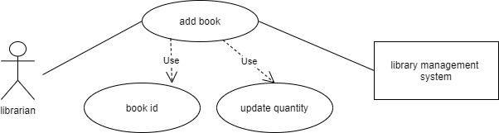

**Fully Dressed Use case**

**Main success scenario:**

The user logs into the website and the log in box pops up. User ID, password, forgot password, new sign up options are displayed to the user. Then the user enters the required details and the library management system validates it and it takes the user to the home page. If the user needs any book he searches for a book by using either the book ID or the author name or the book category. If he wants the book he requests for the book. The library management system will issue or reserve a book depending on its availability based on user request. Before issuing a book the library management system also validates the request. If the user wants to renew a book he enters the book ID of that particular book and then the library management system renews the book based on the renewal availability. If a user wants to return a book and if he has any overdues he pays the fine and returns the book. The system prints the receipt and the user logs out.

**Alternative flows:**

1)At any time, the system fails: The user restarts the page, logs in and requests recovery of prior state.

* The system reconstructs the prior state
* The system detects anomalies preventing recovery: The system signals error to the user, records the error and enters a clean state.
* The user starts from home page again.

2)System signals error message if user enters invalid book ID while searching for a book.

3)The system throws an error message if the user makes an invalid book request.

**Subfunctions:**

1)New user sign up:

If it is a new user, the user should fill the registration form. The librarian or the admin validates the user information with available name list. After validating it he adds the user into the database.

2) Search a book:

The user can search a book in 3 ways:

* By author name
* By book name
* By book category

3) Pay fine:

The user pays fine while returning the book if he has any overdues. The library management system calculates the fine amount and prints the bill.

4) Password:

If the user forgets the password the library management system allows to reset his password by verifying the user mail. Once the user confirms the mail he can set a new password and is validated by the system.

5) Add book:

The librarian can add new books by allocating its book ID and updating the book information in the database. If it is an already existing book the quantity is alone updated using its book ID.

**DOMAIN AND CLASS MODEL**

**AIM:**

To draw the domain model diagram and class diagram.

**UML NOTATIONS FOR CLASS DIAGRAM:**

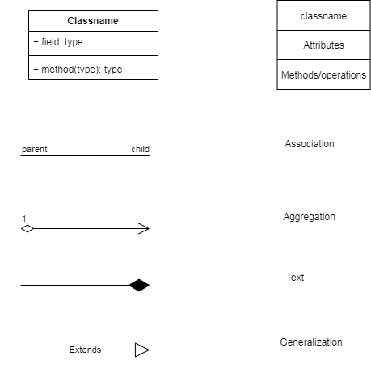

**UML NOTATIONS FOR DOMAIN MODEL DIAGRAM:**

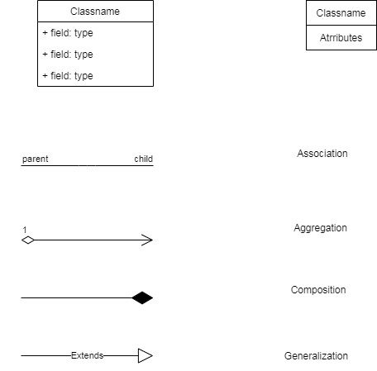

**IDENTIFICATION OF CLASSES:**

**Conceptual Category List:**

|  |  |
| --- | --- |
| Conceptual Category | Example |
| Physical objects | book |
| Specification,design/description of things | Book description |
| Transactions/updations | Library management system |
| Roles of people | User  Librarian |
| External systems | Book company |

**Identification of nouns:**

* Library management system
* User
* User id
* Password
* Register
* Librarian
* Book id
* Overdues
* Fine
* Book
* Receipt
* Payment

IDENTIFICATION OF ASSOCIATIONS:

Association category List:

|  |  |
| --- | --- |
| A is a logical part of B | Borrow book-book |
| A is a description of B | Book description -Book |
| A is a member of B | Librarian,User-Library management system |
| A uses or manages B | User-Library management system |
| A communicates with B | Librarian-Book company  User-Library management system |
| A is related to transaction B | User-fine payment |
| A is a event related to B | Borrow,renew,return book- User  Add,delete user-Librarian |
| A is known/logged/reported/captured to B | User(student,faculty)- Library management system |

Definitions:

ASSOCIATION:

Association is a group of links having common structure and common behavior. Association depicts the relationship between objects of one or more classes.

GENERALIZATION:

Generalizationis the process of extracting shared characteristics from two or more classes, and combining them into a generalized superclass. Shared characteristics can be attributes, associations, or methods.

AGGREGATION:

Aggregation implies a relationship where the child can exist independently of the parent.

COMPOSITION:

Composition is a special case of aggregation. In a more specific manner, a restricted aggregation is called composition. When an object contains the other object, if the contained object cannot exist without the existence of container object, then it is called composition.

ASSOCIATION MULTIPLICITIES:

Library management system

user

*__________1

Library management system

Book company

1…*________ 1

1________*

Books

Library database

1________1

Library database

Librarian

1________*

Book

Librarian

Librarian

Library management system

1_______1

Domain model diagram:

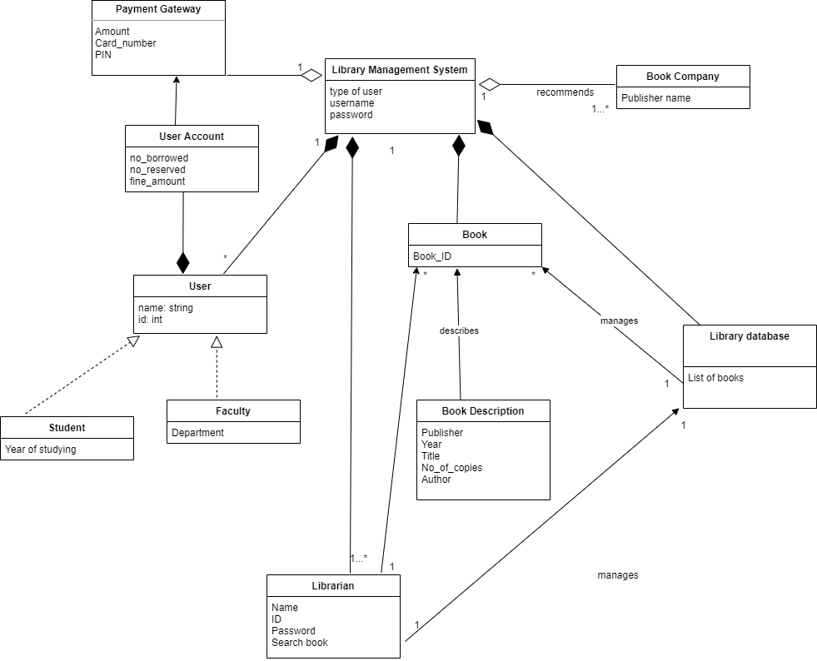

Class diagram:

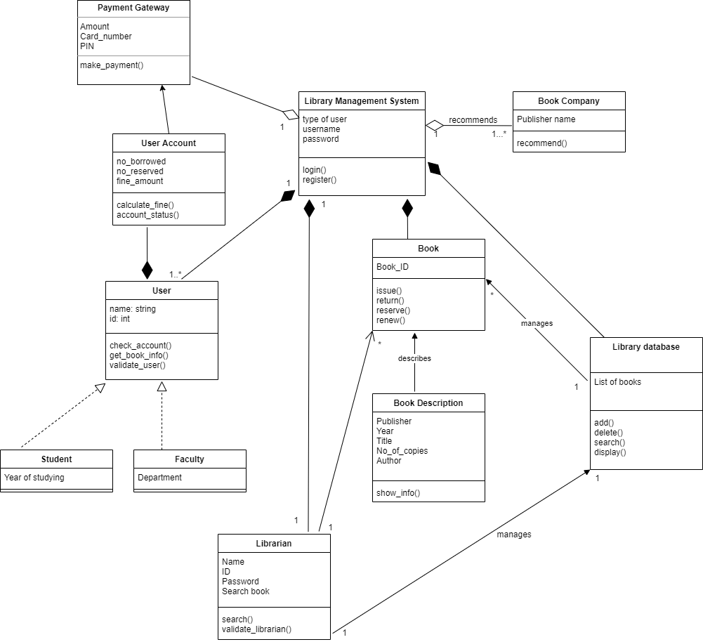

SEQUENCE DIAGRAM

**AIM:**

To draw sequence diagram.

**UML NOTATIONS FOR SEQUENCE DIAGRAM:**

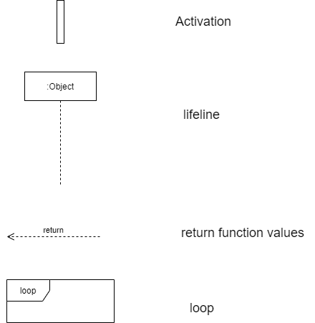

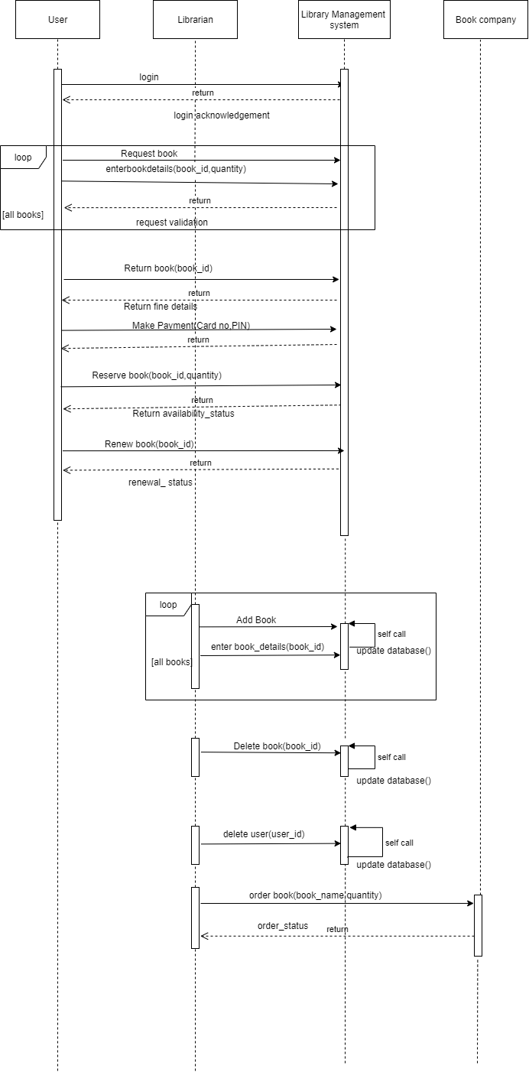

STATE MACHINE DIAGRAM

**AIM:**

To draw state machine diagram.

**UML NOTATIONS FOR STATE MACHINE DIAGRAM:**

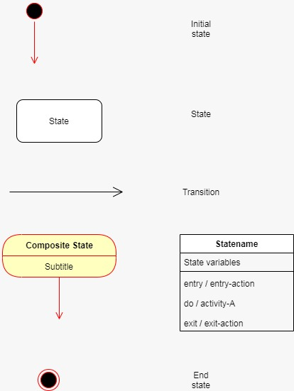

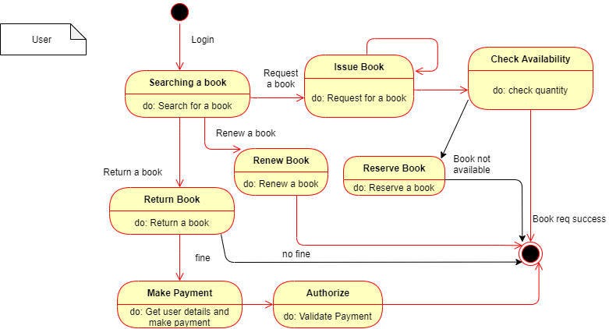

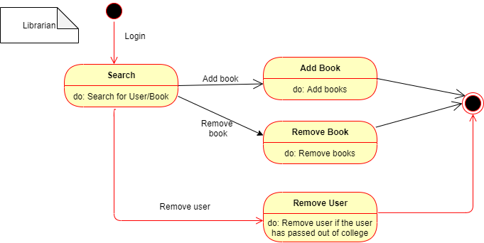

ACTIVITY DIAGRAM

**AIM:**

To draw Activity diagram.

**UML NOTATIONS FOR ACTIVITY DIAGRAM:**

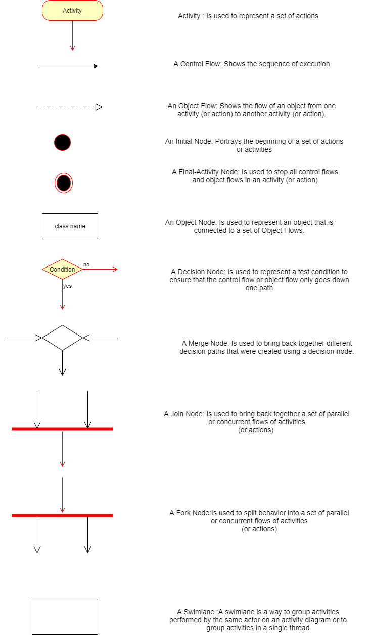



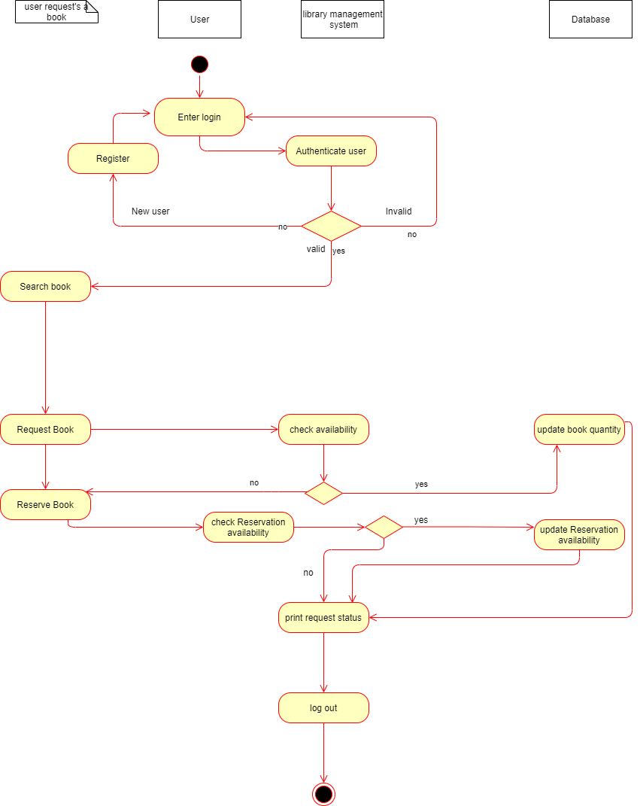

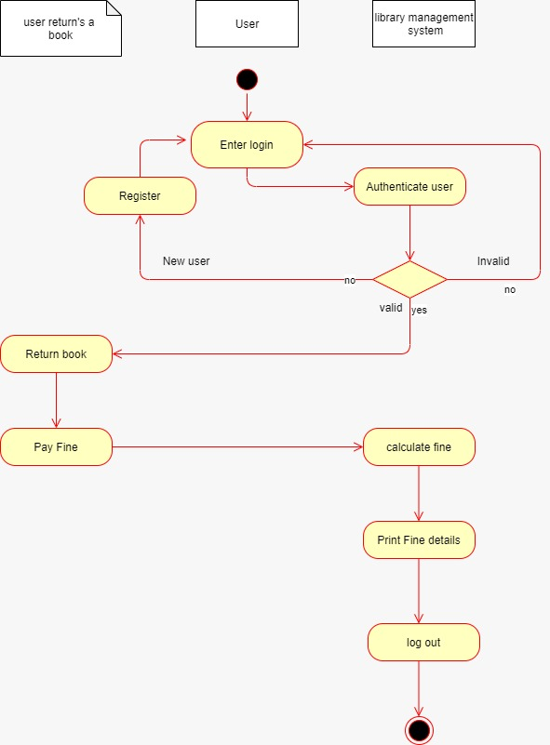

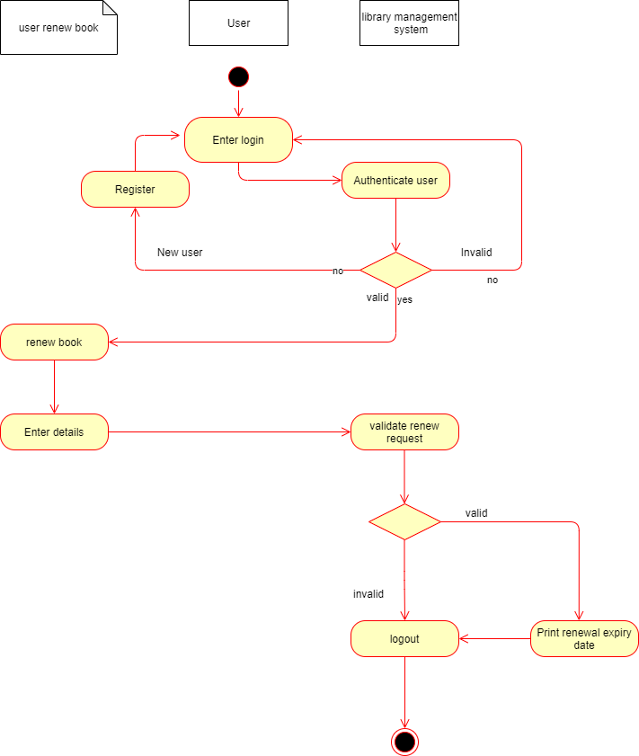

PACKAGE DIAGRAM

**AIM:**

To draw Package diagram.

**UML NOTATIONS FOR PACKAGE DIAGRAM:**

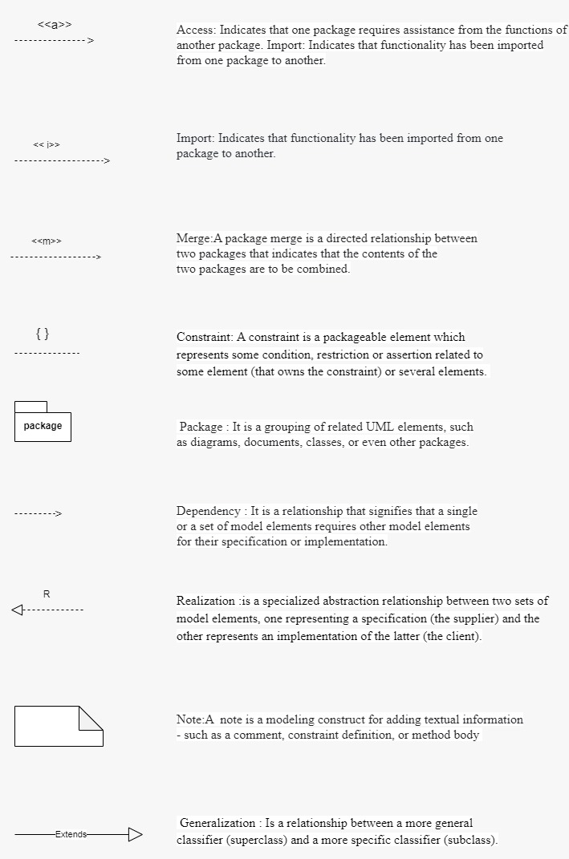

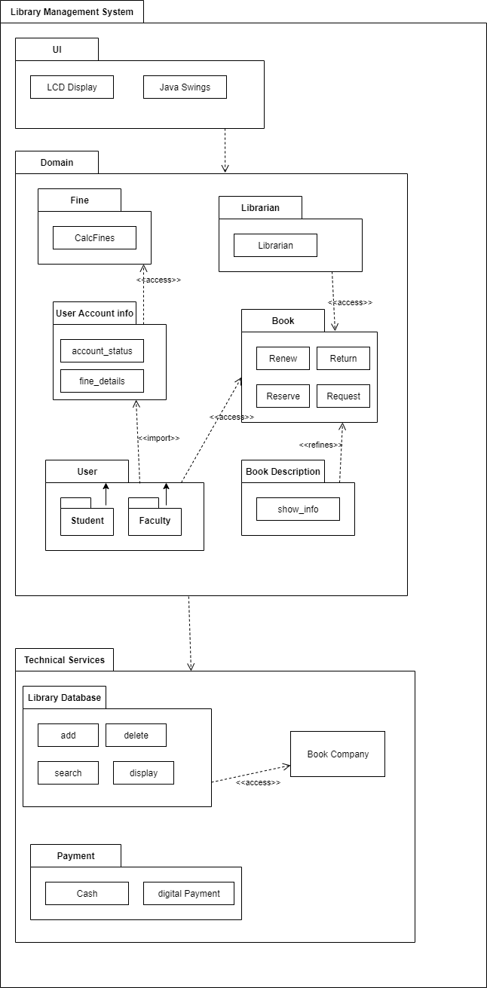

DOCUMENTATION:

The package diagram is high level view of Library management system and represents different layer of software system. Package diagram helps in tracking the dependencies and divides complex systems into simpler modules.

The package diagram consists of three layers namely UI, Domain and technical. In the UI services

In Domain layer, there are packages such as book, book description, user account info, user, fine and librarian. The dependencies in domain layer are:

• The user package imports user account info

• The book description refines the book package.

• User account info package access fine package.

In technical layer, there are packages namely Library database, Payment, Library management system.

The UI layer depends on the domain and the domain layer depends on the technical layer.

COMPONENT DIAGRAM

**AIM:**

To draw Component diagram.

**UML NOTATIONS FOR COMPONENT DIAGRAM:**

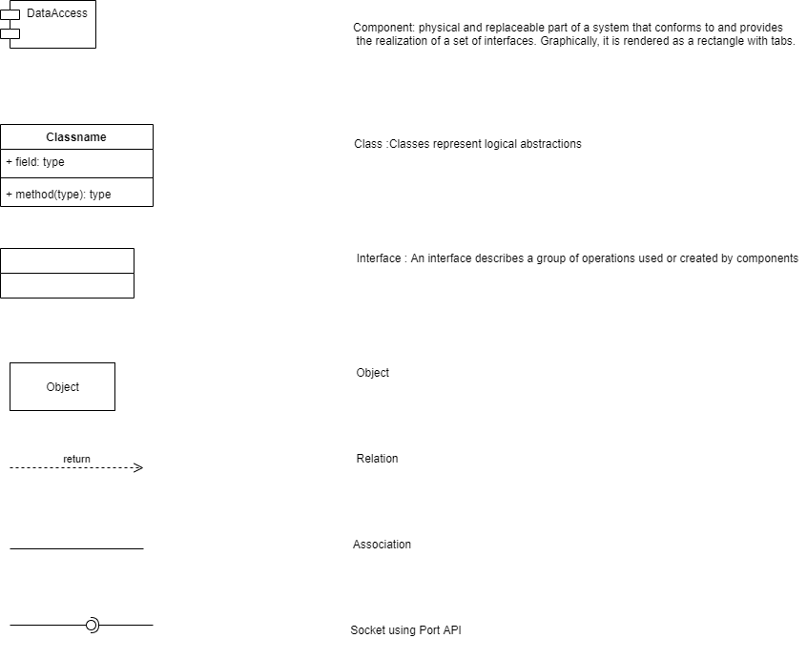

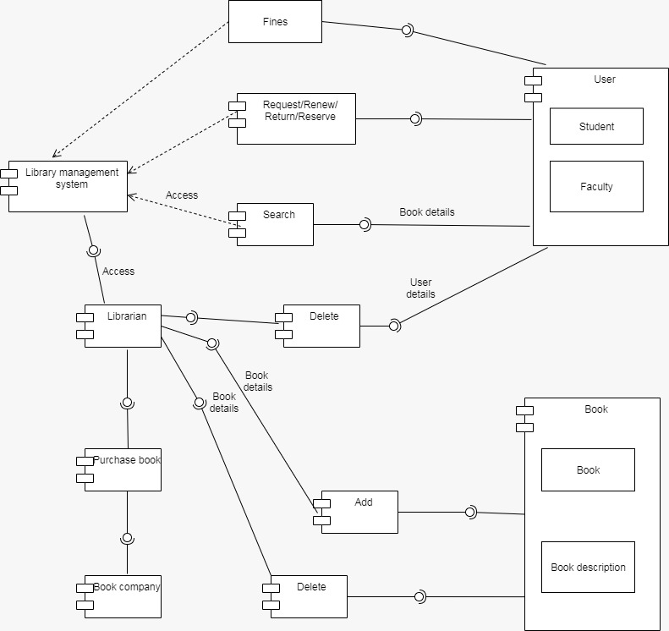

DEPLOYMENT DIAGRAM

**AIM:**

To draw Deployment diagram.

**UML NOTATIONS FOR DEPLOYMENT DIAGRAM:**

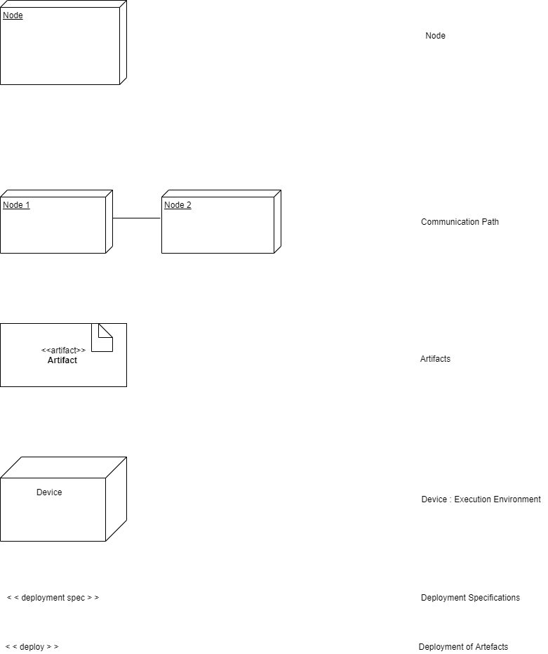

mana

y

LIbrar

ement

g

System

/Student

y

Facult

Librarian

pany

Book Com

Database

Book

JDBC

ment

Pa

y

HTTP

HTTP

HTTP

HTTP

LIST OF NODES IN DEPLOYMENT DIAGRAM:

* Database
* Book
* Librarian
* Book company
* Payment
* User
* Library management system

LIST OF COMPONENTS:

* Library management system
* Librarian
* Book company
* Book
* User

DOCUMENTATION:

COMPONENT DIAGRAM:

Component diagrams are used in modelling the physical aspects of object-oriented systems that are used for visualizing, specifying, and documenting component-based systems and also for constructing executable systems through forward and reverse engineering.

The librarian and the search component can access the library management system. The librarian can add, delete the book details in the book component. The user can search the book details, request, return, renew and pay fines.

DEPLOYMENT DIAGRAM:

A deployment diagram is a UML diagram type that shows the execution architecture of a system, including nodes such as hardware or software execution environments , and the middleware connecting them.

Deployment diagrams are typically used to visualize the physical hardware and software of a system.

*******************************************************************