**CS20B030 Preethi Varsha Marivina**

**Case Study 2**

**Designing an ATM using OOP concepts in java**

1. **Design Decision taken for your ATM system. Applications of OOP concepts in the ATM.**

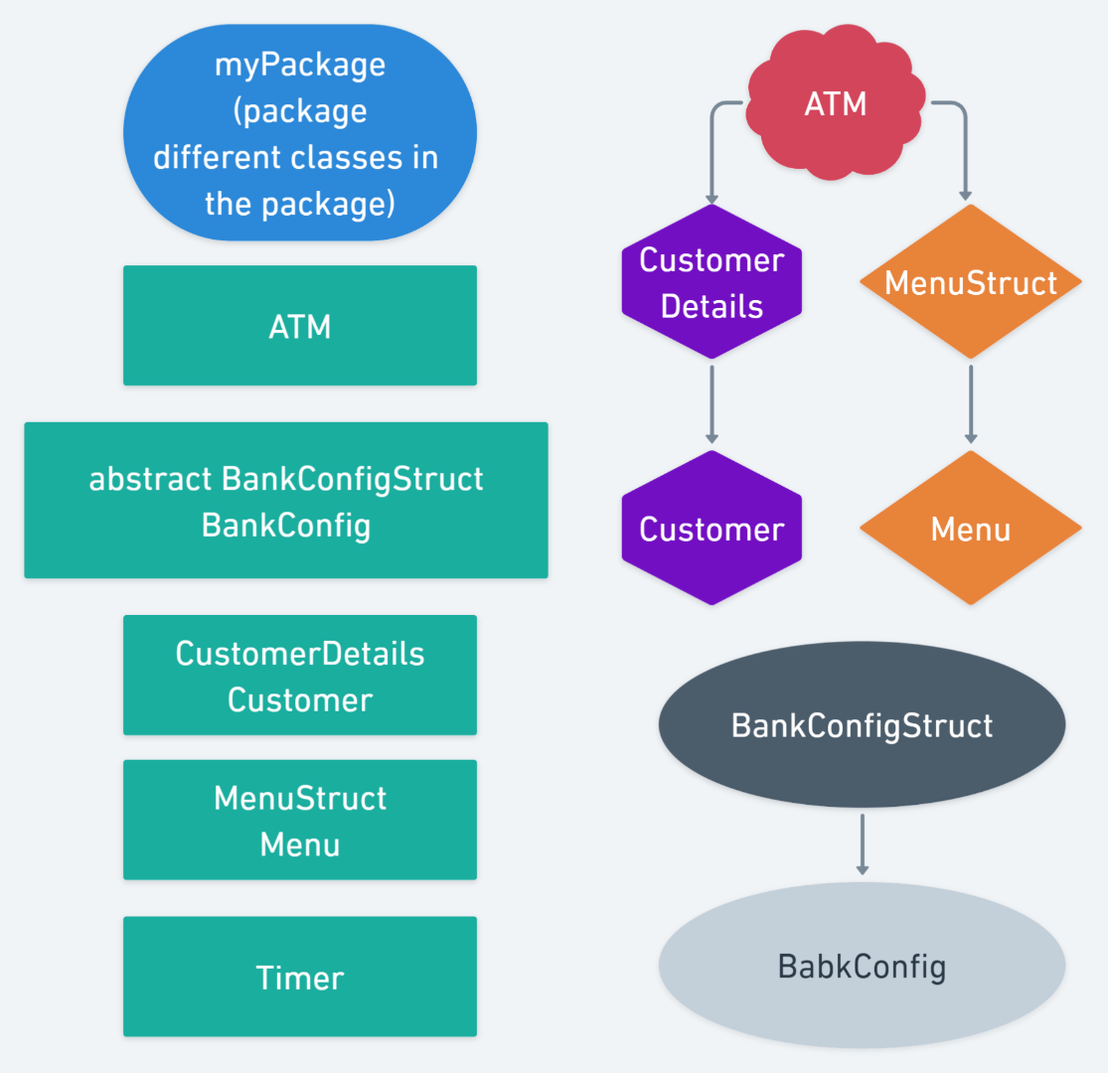

**Design decision:**

1. Universality – i.e., code should be adaptable to different types of requirements of various banks
2. Sensitive information like OTP generation, customer data and transaction process should be abstracted.
3. Various methods should be used for different functions that enables recursive usage and encapsulates the process inside the method.
4. User friendly – giving information in detail on how to proceed to the next step in the transaction.

**OOPS concepts:**

1. **Abstraction:**
   1. Abstract classes – **MenuStruct** (contains sensitive process of menu like pin and OTPverification), **BankConfigStruct** (contains ATM default details and reset functions) and **CustomerDetails** (defines all functions and stores data related to the user).
   2. All the above classes contain important information, so they are accessible only through objects or within the domain to class to which they are extended.
2. **Encapsulation:**
   1. Abstract classes mentioned above also account to encapsulation- i.e., hiding unnecessary info from user.
   2. All the methods used the code account for encapsulation. They can be used again and again with worrying about the process inside the methods.
3. **Inheritance:**
   1. Abstract class **CustomerDetails** extends **ATM**
   2. Class **Customer** extends **CustomerDetails**
   3. Abstract class **MenuStruct** extends **ATM**
   4. Class **Menu** extends **MenuStruct**
   5. **BankConfig** extends abstract class **BankConfigStruct**
4. **Polymorphism:**
   1. In Menu class, **display ()** is used to display and input options for new user or existing user but **display (Customer c)** is used to display all the transaction options available for the customer.
5. **Functionalities in your ATM system.**
   1. Can edit ATM configuration based on bank requirements
   2. OTP and pin verification
   3. Viewing balance
   4. Withdrawal of cash
   5. Deposit of cash using denominations
   6. Change pin and user name of customer
   7. Certain amount is added to the ATM daily and not added if the ATM is already at its maximum capacity.
   8. **Assumptions made:**
      1. 1 minute == 1 day (for adding money to the ATM)
      2. OTP is displayed on the screen itself
      3. Account number can be given as input by the customer itself
      4. New customer can create the account in the ATM is not done in reality
      5. ATM can be configured only once at the start depending on requirements.
6. **Advantages of using your ATM system.**
   1. Incorrect username, pin, etc are handled.
   2. Flexibility to configure ATM specification based on requirement.
   3. Reset pin and username
   4. Can add amount into the ATM daily
   5. User friendly – All instructions are provided as clear as possible for transactions.
   6. Sensitive information like user data, OTP and pin verification is abstracted for security
   7. Methods (provide encapsulation) can be reused to extend the code.
7. **Limitations of your ATM system.**
   1. Can’t check whether Aadhaar number, phone number are valid or not.
   2. OTP is displayed on the screen.
   3. Account balance and account number are taken from the user.

**xxx- ThankYou -xxx**