An Efficient Driver Drowsiness Detection Using

Deep Learning

***Abstract*—Most of the accidents that happens that happens nationwide is due to the drowsiness. Drowsy driving causes 21% of all fatal collisions. About 168 million adult drivers, or 60% of all drivers, admitted to driving while fatigued in the previous year. Drowsiness is an inattentive state. Drowsiness makes the individual to loss of their control during their driving state, thus leading to devastating accidents. To avoid such catastrophic accidents, a sleep detection system is proposed by which the model embeds an EEG sensor, to detect sleep onset while driving and a CNN based hybrid model is developed which is used to track the**

**progress of the drivers’ mental and physiological conditions.** **The activities of brain is evaluated using EEG signal. The EEG signals identifies the fatigue which remains to be the primary reasons for accidents. The model aims to attain the terminology of detecting the driver drowsiness by EEG signals with the high accuracy and efficiency. All the signals are transmitted to the mobile of the driver thereby the CNN algorithm monitors the state of driver. Whenever the driver is in sleepy or fatigue state, then these results are sent to the Car system and the car gives an alert to the driver in the form of an alarm. The combination of CNN based model and EEG sensor will give accurate and optimized results with respect to the driver’s condition. This was the scenario that were oftenused in the previous works which seems to be a tedious task to wear a hand band and drive for the drivers. So, we are proposing a model that only focuses on the eyes of the driver to detect the onset of the fatigue and drowsiness.**

***Keywords—Drowsiness detection, EEG, CNN, Accuracy, Machine learning, Deep learning.***

# I. INTRODUCTION

|  |  |
| --- | --- |
| **Suriya M**  Assistant Professor,  Artificial Intelligence and Data  Science  Sri Eshwar College of Engineering  Coimbatore, India  suriya13.ms@gmail.com    **Sumithra M**  Artificial Intelligence and Data  Science  Sri Eshwar College of Engineering  Coimbatore, India sumithra.m20122002@gmail.com | **Preethie K** **Amitha M**  Artificial Intelligence and Data Artificial Intelligence and Data  Science Science  Sri Eshwar College of Engineering Sri Eshwar College of Engineering  Coimbatore, India Coimbatore, India  kpreethie@gmail.com amithaamitha816@gmail.com    **Sumaiya Fathima I**  **Vishnu M**  Artificial Intelligence and Data Artificial Intelligence and Data  Science Science  Sri Eshwar College of EngineeringSri Eshwar College of Engineering  Coimbatore, India Coimbatore, India  sumaiyafathima907@gmail.com vishnu.m2020eee@sece.ac.in |

Due to the traffic accidents, about 1.3 million persons die at an annual rate and also 50 million people get injuries at non-fatal level and according to the information from the Administration of Highway Traffic Safety, the police made a conservative estimation upon the reports that the drowsiness in drivers causes nearly 100,000 vehicle crashes

in a year and above 1000 fatalities, nearly 71,000 accidental injuries, and losses for the drivers up to $12.5 billion rupees.

54% of adult drivers admitted to driving while feeling sleepy in 2009, according to the Foundation of US in the National Sleep and 28% are those who drives actually fell asleep behind the wheel. The Foundation also reported that in 2009, 28% of adult who drives actually dozed off while operating a vehicle, and 54% of them have done so while feeling sleepy.

According to the Council of Road Safety from the Germany, fleeting driver fatigue causes one in four fatal highway crashes. Inattention is a symptom of being sleepy. It is a very frequent and brief phase that happens as you go from being awake to being sleepy. A person's alertness can be decreased by being sleepy, which raises the risk of accidents. By monitoring drowsiness and raising an alert when inattentiveness, we can improve safety. Several drowsiness detection techniques, including vehicle-based and behavior-based, are available to achieve this. As a result of the development of biological systems that can sense physical conditions and by the sensors development, and also by the techniques as physiological based scenarios for gathering state in physical and the data from mentally are taken into account while they are sleepy which have emerged as more reliable and effective than other DD methods.

The signals that is physiological based like (EOG), Electrooculography, (ECG) Electrocardiography or (EEG) Electroencephalography, were used in physiologically based DD methods. A driver loses control of the vehicle if they fall asleep at the wheel, which frequently leads to collisions with other vehicles or objects. The drowsiness level needs to be kept an eye in order to avoid these fatal collisions.

# II. LITERATURE SURVEY

The model in this study [1] predicted two states: the driver's active state and their state of fatigue. And over the LeNet5 architecture framework, the driver drowsiness model was proposed with the highest accuracy range of 93.57%, F1 score of 94%, and area of ROC curve of approximately 0.936. By confusion matrix, the drowsiness accuracy in this study[2] was discovered. The analysis of the driver's eye-closure ratios and frequency of yawning habits allowed the model to predict drowsiness over a time range of more than 2 seconds. The main disadvantage, however, was that this method of accurately predicting the driver's hypo vigilance did not continue to be used.

The model used in this study [3] was based on the VIG Net deep CNN-based drowsiness detection framework. This feature combined a joint feature of deep learningbased representation, a feature extraction method with machine learning, and a decision-making process to enable the highest level of prediction accuracy. However, the realworld application did not use the generalization capability, which was independent of session-variability. In this study [4], the model was put forth using a combination of CNN framework and machine learning techniques. Since machine learning was used to account for the high accuracy values in the prediction, the CNN framework. i.e. The maximized size of the model did not exceed 75KB base level, the average model predictability was 83.33%. However, this technology had a few drawbacks, including the inability to see features that is considered to be in the state of facial, when using sunglasses and lighting conditions in the poor state that may require extreme precautions.

The model used in this study [5] was an embeddedbased model that predicted drowsiness using EEG signals. To show that sleepiness and alertness signals can be distinguished with a sufficient margin by extracting the right features from the input, the model was fed with EEG signals. The driver's performance in relation to their brain activity can be detected by the model, which simultaneously modifies the EEG recording. The system's accuracy was poor, and it was unable to detect the driver's eye closure. Its insufficient reaction time frequencies were also out of range, which was the model's biggest drawback. In contrast to the Power Spectral Density features from the earlier works, the H-parameter features in this study[6] were proposed with a higher and stronger performance. Up to radio frequencies, parameters in h are real numbers. It was done using the transistor static characteristic curves to gauge how sleepy the user was. It was easy for analyzing and designing circuits. To assess the AD brain's abnormalities, spectral density with respect to the power, which is termed to be a representation of the EEG series distribution in the range of frequency was used. Mobility and complexity-based features were discovered to be superior in the base of spectral in terms of density and also the features for the prediction of a person's drowsy states with the variety of datasets taken into consideration.

While drowsiness was detected in this study [7] using a two-stage convolutional neural network mechanism, the methodology used did not include the extraction of face features, is a general step used in the majority case of drowsiness dealing with vision detection systems. However, the experiments and custom dataset produced encouraging findings regarding a person's range of drowsiness. In order to avoid using more expensive GPUs, the suggested algorithm was also used for real life driver drowsy detections. The system was suggested in this study[8] on synchronous method to monitor the beginning of driver's behaviour. This strategy was based on the highly accurate convolutional neural network that was used in the android applications. In addition to CNN, computer vision also had a significant impact on identifying drowsiness patterns of the individual. Consequently, by CNN with this framework, a deep learning-based algorithm attained an accuracy range of 90%.

Since all the previous works were based on the EEG sensors and CNN framework. The pre-trained deep learning models that were used were VGG16, LeNet-5, AlexNet, GoogLeNet, VGG-FaceNet, FlowImageNet, VIGNet, D2CNN-FLD., D2MLP-FLD, Faster RCNN, YOLO (You Only Look Once) version 3, Inception-v3, ResNet-50, Imagenet, These are the models that were used to attain accuracy dealing with detecting the onset of drowsiness. Some of the performance metrics used were SGD, Adagrad, AdaDelta, RMSProp, Adam etc. to monitor the range of efficiency in the prediction.

Also the EEG sensor is a type of sensor that monitors the brain activity of the individual and tracks their state of behavior. So a device that monitored the brain was fixed on their head of the drivers. This is an inconvenient and complication case for the drivers to often wear and drive and also most of the drivers doesn’t prefer the range of devices which is not portable to use.

Hence, the model that is with the deep learning framework that overcomes the above issues and detects the drowsiness level with high accuracy.

# III. IDENTIFICATION OF DROWSINESS

Real-time drowsiness feedback is challenging to obtain. It is inappropriate and potentially dangerous to collect drowsiness/alertness indicators by relying solely on driver response because it could impair driving and overestimate the driver's actual performance. Because of this, the approach cannot be used in actual conditions in case of driving. There are a few of the solutions that is considered and manipulated to monitor the state of fatigue and drowsiness that combines sleep with subjective and perception given by subjects through a set of volunteers, and measures that are related to vehicle state, behavioral state or signals of psychological the driver’s monitored recordings which are objective. The often-used drowsiness prevention methodologies may be used as various principles.

## A. Behavioural Measures in Driving

This entails keeping an eye on the car and its surroundings while examining how drivers behave behind the wheel. The level of drivers' alertness is estimated using a variety of integrated sensors indicators provided in the vehicles.

The above methodology focuses on driver’s behaviour by observing their movements and facial expressions rather than driving activities. Some of these movements may be seen as in case of the signs of drowsiness and fatigue conditions.

## B. Driver Physiological Signals Measures

The method totally depends upon taking measurements from the several signals based on physiological that visually correlate on driver fatigue and drowsy states [9].

IV. MEASURES ON THE DETECTION OF DROWSINESS

The aim is on the basis of the activities of the driver and about gathering indicator metrics which are in the work of gauging alertness/drowsiness level but not on of concentrating on the behavior of the driver and also on the movements of the vehicle. When a driver becomes drowsy, visible signs of fatigue and sleepiness can be seen by measuring their abnormal behaviors. Three main metrics were the focus of research on detecting fatigue and drowsiness while monitoring driver’s states. [10]:

1. Movement of Eye
2. Expressions of the face (iii) Head position.

## A. Steering Wheel

Monitoring steering wheel movements (SVM) is a useful tool for analysing driving style. In fact, some unnatural steering wheel movements are the result of a distracted driver and may be a sign of fatigue or drowsiness.

## B. Vehicle Deviation

Another sign of driver fatigue and sleepiness is how the car is positioned. In actuality, this method is based on metrics like the car's position in relation to the centre lane of the road, also referred to as the standard error of lane positioning, the car's departure from the laterally lane, the car's yaw deviation, and the car's heading divergence..

## C. Speed and Acceleration

Another method for identifying unnatural driving behavior is vehicle speed. According to research, vehicle speed and acceleration are related to the driver's level of alertness, and drowsy drivers tend to accelerate their vehicles more quickly. This method depends on metrics like the rate of vehicle acceleration at speed and the force applied to the accelerator pedal.

## D. Eye Ball Movement

This measurement focuses on tracking the speed at which the eyes blink, the slow eye movements (SEM), and closure activities of the eye that characterize metric and the average eye closure speed (AECS). The unusual blink of the eye and closure serve as a drowsiness indicator.

## E. Face Expression

Drowsy drivers exhibit various facial expressions that can be utilized to gauge their level of tiredness. Facial monitoring detects facial expressions and movements, such as yawning, drooping jaws, and lip stretching. Face landmark detection is shown in Fig. 1.

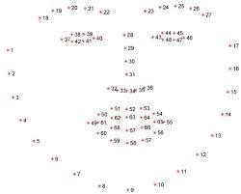

Fig. 1. Face landmark detection

## F. Head Position

Another sign of fatigue and sleepiness is how the head is positioned. In advanced stages of drowsiness, drowsy drivers typically scaling of head. Other methods, such as changes in the pressure distribution on seats, for drowsiness detection in addition to head monitoring, eye, face.

## G. Eye Aspect Ratio (EAR)

The eye length : eye width ratio, or EAR, is exactly what its name indicates. The distance of the eyeballs is calculated by calculating the average across 2 unique vertical stripes that pass across them, as shown in Equ (1). Eye Aspect Ratio is shown in Fig. 2.

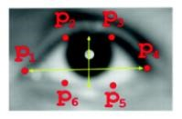

### Fig. 2. Eye Aspect Ratio

||𝑝2−𝑝6||+||𝑝3−𝑝5||

𝐸𝐴𝑅 = (1)

2||𝑝1−𝑝4||

Equ 1. Eye aspect ratio

Our statements predicts that the tired individuals' eyes would likely get smaller and blink more frequently. This hypothesis predicted that our model would identify a person as drowsy if their eye aspect ratio fell with time, i.e., if driver’s eyes started to close more often or their blink rate increased.

# V. BIOLOGICAL SENSOR ANALYSIS

Since biological sensor signals come from the organs of human like the brain, the eyes, the muscles, and the heart enable early detection of the different types of states like drowsiness and the conditions like fatigue, they will be used to measure the level of an operator's attention. Organs that exhibit a clear correlation with driver fatigue can provide physiological signals that can be recorded. This comprises either electroencephalography (EEG) or nearinfrared spectroscopy can measure brain activity (NIRS).

* Ocular activity: Electrooculography is for measuring eye movement
* Muscle tone: an electromyography that can be captured.
* Electrocardiography sensor and the signals that monitors blood pressure and cardiac activity.
* Measurement of blood gas levels and snoring, respiratory effort, nasal and oral airflow during sleep.
* The esophageal is used to measure the gastrointestinal parameters.
* Electro-dermal activity is produced by the galvanic skin response as well as by the conductance and resistance of the skin. The body's core temperature can provide information about a person's actual circadian phase.

Above all measurements, research community has focused most of its attention on the signals from the EEG,

EOG, EMG, and ECG, which have demonstrated significant signs of fatigue and the beginnings of drowsiness.

## A. Types of Sensors

Sensors are used to monitor the physiological signals to detect drowsiness. The list of sensors that were mostly used in producing signals and detecting are as follows:

1. *Electroencephalography:* Variations in signal amplitude between 20 and 200 V and frequency 1 to 50 Hz are both visible. A certain frequency range is known as delta waves (0.5 to 3.5 Hz, 75-200 V), theta waves (4-7 Hz, 20-120 V), alpha waves (8 to 12 Hz, 25-100 V), and beta waves (faster over Thirteen Hz and well below Forty V) and they are used to distinguish specific mental states.

There is disagreement in the research on the consistency of improvements in band activity across studies. The highest Delta action during sleep and the transition to drowsiness, the presence of Theta activity and the elimination of Alpha activity during stress relief (the onset of sleep), and the association of these changes with the early stages of drowsiness (early stages of drowsiness) with Beta activity are the three band changes most commonly observed. Theta spindles and K-complex, which are irregular and coordinated low frequency waves having high amplitude patterns, can be seen during sleep.

1. *Electrooculography:* The voltage difference between the corneal and the retina is recorded and the blink will be through vertically EOG may be seen by affixing electrode to the eye skin, whereas ocular velocity is a sign of awareness. Researchers found that data supplied, EOG is not sufficient to provide reliable results. When a person is falling sleepy, rapid movements are replaced by slow rolling motions, and eye flashes become greater and less frequent, which indicate more drowsiness. Therefore, they defined driver alertness as EOG was used to measure eye movement, with an accurate point of 80%.
2. *The Electromyography (EMG):* EMG is a measurement of the electrical line of muscles, and it is frequently obtained from the chin part. After doing repetitive driving activities, researchers saw, which they utilized as indicators of exhaustion and sleepiness. EMG from during a more than 15 minute drive simulation.
3. *The Electrocardiography (ECG):* ECG is a quick test that may be performed to examine the electrical activity and rhythm of your heart. The average prediction accuracy for driver tiredness identification using (PPG) and ecg wave spectral and related experimental results was 96%. Along using the well-known PERCLOS measure, several research studies employed a camera to offer to EOG data while recordings were being made. The classification of EOG signals as being sleepy or not was then done using a criterion of Periodic Eye Movements (REM), which had an accuracy of 80%. The study cannot be directly compared to other research since it would be impossible to determine the participants' mental states during driving simulations in the absence of a reliable benchmark. Driving clearly depends on your ability to see the road, dangers, signs, and signals. Although it may not appear evident, the other senses are very significant.

VI. PROJECT DESCRIPTION

In this section let’s see about the project in detail.

## A. Methodology

On the Kaggle website, a dataset for drowsiness detection is taken. The collection comprises the Eye and Yawn sample photos, which total 2900 images. The model is builded up in the train test ratio of 70:30 with 726 closed and open eye image labels and 725 and 723 no yawn and yawn image labels respectively. Then, the CNN model is built using the keras for the detection of drowsiness which consists of the following measures:

In this model we have used 4 convolution layer, 1 flatten layer, 1 dropout layer, 2 dense layer. For multi class classification we have used popular multi class classifier that is relu, softmax. This model also developed using Loss as categorical cross-entropy and adam as optimizer. Here the learning rate is 0.0001.

Thus the classification report obtained in terms of precision, recall, f1-score and support values to measure the accuracy of the prediction.

## B. Convolutional Neural Networks (CNN)

Convolutional Layers (CNN) is frequently used to map pictures to independent variable and interpret image data. We decided to build a 1-D CNN and enter numerical characteristics as consecutive input data in an effort to understand the spatial relationship between every feature for the two states. Our CNN model consists of five layers: one convolution layers, 1 flattening latter level, two completely connected packed layer upon layer, one and dropout layer before we reach the output units. The result from the convolution layers is made linear and flat in the flatten layer before being fed into the initial dense layer. The dropout layer eliminates 20% of the output units at random from the next dense layer in order to prevent our model from being overfit to the training data. There is only one output node in the last dense layer, and it produces 0 for alertness and 1 for sleepy. Proposed CNN model is shown in Fig. 3.CNN Parameters is shown in Table I.

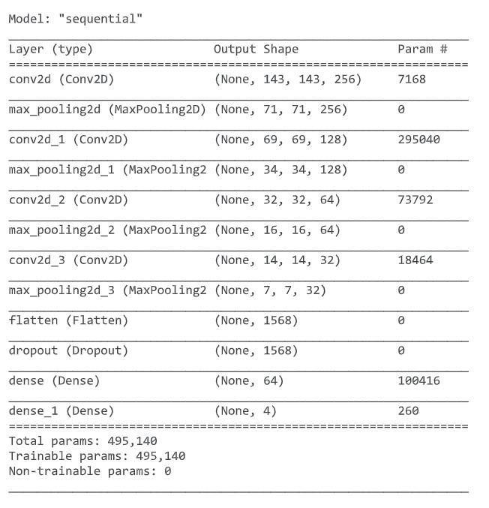

### Fig. 3. Proposed CNN model

TABLE I. CNN PARAMETERS

|  |  |
| --- | --- |
| Activation function used | Relu /sigmoid |
| Optimizer used | Adam |
| Loss function activated | Binary cross entropy |
| Number of Epochs used | 100 |
| Learning rates | 0.00001 |

## C. Keras

Google created the high-level Keras deep learning API to implement neural networks. It is used to simplify the development of neural nets simple and is developed in Python. Additionally, various background neural network computation is supported.

## D. Tensorflow

TensorFlow is entirely an open-source framework used to build machine learning applications. It is a math toolkit that executes numerous operations focused at deep neural network training and inference exploiting data flow and distinguishable programming. It enables the creation of machine learning applications by developers utilising a variety of tools, frameworks, and online community resources.

A tensor of outputs is produced by the 2D Convolution Layer by winding a convolution with the layers' input.

Convolution matrices or masks are used in image processing to blur, brighten, emboss, identify edges, and perform other operations by convolution of a core and an image.

## E. Max-Pooling Layer

A tensor range outputs is produced by the 2D Convolutional Layer by windup a convolution kernel with the layers' layer input. Convolution matrices or masks are used in computer vision to blurring, sharpening, embossing, identifying edges, and perform other operations by convolution Ing core and images.

## F. Flatten Layer

Here the input is flattened up employing the use of flatten. Such as, the layer's output shape will be in the range of (batch size, 4) if flattened-up is given to a layer with an input of (batch size, 2,2).

## G. Dropout Layer

To avoid overfitting, the Dropout level uses an arbitrary sets output to with probability of rate at every step in training range of period. The Inputs aren't set to zero are upscaled to 1/(1 - rate) so that the sums up of all inputs which remains constant.

## H. Dense Layer

Each neuron in the basic layers of neurons known as the thick layer receives information from every cell in the layer below it. Based on the results of convolution layer, a picture is classified using a thick network.

# VII. RESULT S AND DISCUSSION

Driving clearly depends on your ability to see the roadway, dangers, signs, and signals. This approach focuses on the eyes to identify driver tiredness because the other senses may not be as clear.

## A. Performance Metrics

1. *Precision:* The Accuracy is defined as the proportion of properly classified data instances over all data instances.
2. *Recall:* It is determined by splitting the total lot of Positive samples by the proportion of Samples tested that were correctly classified as Positive. The model's recall measures its capacity for identifying positive samples. The recall increases with the number of positive samples found.
3. *F1 score*: Using this number, we may determine the natural log of recall and accuracy; Theoretically speaking, is known weighted combination of the correctness, recall.
4. *Accuracy:* Accuracy aids to determine the correlation and patterns between the variables in a dataset which helps to assess which model is more effective.

The performance measure of yawn, no-yawn, eyes closed, eyes open of the model is given below:

precision recall f1-score support

|  |  |  |  |  |
| --- | --- | --- | --- | --- |
| yawning | 0.83 | 0.95 | 0.89 | 63 |
| no-yawn | 0.89 | 0.88 | 0.88 | 74 |
| Eye - Closed | 0.99 | 0.94 | 0.96 | 215 |
| Eye - Open | 0.96 | 0.97 | 0.96 | 226 |

Accurate rate 0.94 578 Macro average 0.92 0.93 0.93 578 weighted average 0.95 0.94 0.95 578

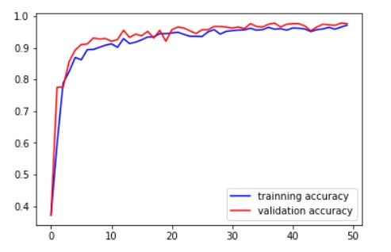

### Fig. 4. Training and validation accuracy

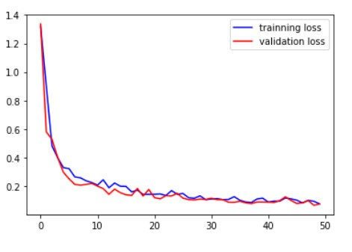

### Fig. 5. training and validation loss

Training and validation accuracy is shown in Fig. 4 and training and validation loss is shown in Fig. 5. Value of training loss: 0.0758, value of training accuracy: 0.9710 , value of validation loss: 0.0749 value od validation accuracy: 0.9758.With a few more tweaks and export to a different device, this program might be used in real-world scenarios and possibly save lives.

### REFERENCES

1. Islam, M.R., Matin, A. and Kamruzzaman, T., 2020, December. Automatic Identification of Driver Inattentiveness Using Convolutional Neural Networks. In *2020 IEEE International Women in Engineering (WIE) Conference on Electrical and Computer Engineering (WIECON-ECE)* (pp. 21-24). IEEE.
2. Houssaini, A.S., Sabri, M.A., Qjidaa, H. and Aarab, A., 2019, April. Real-Time Driver's Hypovigilance Detection using Facial Landmarks. In 2019 International Conference on Wireless Technologies, Embedded and Intelligent Systems (WITS) (pp. 1-4). IEEE.
3. Ko, W., Oh, K., Jeon, E. and Suk, H.I., 2020, February. Vignet: A deep convolutional neural network for eeg-based driver vigilance estimation. In *2020 8th International Winter Conference on BrainComputer Interface (BCI)* (pp. 1-3). IEEE.
4. Jabbar, R., Shinoy, M., Kharbeche, M., Al-Khalifa, K., Krichen, M. and Barkaoui, K., 2020, February. Driver drowsiness detection model using convolutional neural networks techniques for android application. In *2020 IEEE International Conference on Informatics, IoT, and Enabling Technologies (ICIoT)* (pp. 237-242). IEEE.
5. Stanley, P.K., Prahash, T.J., Lal, S.S. and Daniel, P.V., 2017, September. Embedded based drowsiness detection using EEG signals. In *2017 IEEE International Conference on Power, Control, Signals and Instrumentation Engineering (ICPCSI)* (pp. 25962600). IEEE.
6. Phanikrishna, V.B. and Chinara, S., 2020. Time domain parameters as a feature for single-channel EEG-based drowsiness detection method. In *2020 IEEE International Students' Conference on Electrical, Electronics and Computer Science (SCEECS)* (pp. 1-5).
7. Biju, A. and Edison, A., 2020, December. Drowsy driver detection using two stage convolutional neural networks. In *2020 IEEE Recent Advances in Intelligent Computational Systems (RAICS)* (pp. 7-12). IEEE.
8. Bajaj, P., Ray, R., Shedge, S., Jaikar, S. and More, P., 2021, March. Synchronous System for Driver Drowsiness Detection Using Convolutional Neural Network, Computer Vision and Android Technology. In *2021 7th International Conference on Advanced Computing and Communication Systems (ICACCS)* (Vol. 1, pp. 340-346). IEEE.
9. Sahayadhas, A., Sundaraj, K. and Murugappan, M., 2012. Detecting driver drowsiness based on sensors: a review. *Sensors*, *12*(12), pp.16937-16953./
10. Doudou, M., Bouabdallah, A. and Berge-Cherfaoui, V., 2020. Driver drowsiness measurement technologies: Current research, market solutions, and challenges. *International Journal of Intelligent Transportation Systems Research*, *18*(2), pp.297-319./