Job Market Skill Demand Analyzer
IBM Data Analytics with AI — Internship Project Report
Dataset: Data Analyst Job Postings — Kaggle (asaniczka), December 2023
1. Introduction
The data analytics job market has grown rapidly, yet entry-level candidates often struggle to identify which skills are genuinely in demand. Job descriptions vary widely — some list over thirty tools, while others list just a handful. Without a systematic analysis across a large number of real postings, it is difficult to separate high-value skills from noise.
This project addresses that gap by analyzing 12,894 real LinkedIn job postings for Data Analyst and related roles, scraped across the United States, United Kingdom, Canada, and Australia. The analysis extracts, normalizes, and ranks individual skills, then uses IBM watsonx.ai to generate a plain-language summary and a targeted recommendation for fresher job seekers.
The project is particularly relevant from a personal standpoint: as a fresher Data Analyst actively job hunting, the insights produced are directly actionable, grounding the analysis in real career stakes rather than academic exercise.
2. Objective
The primary objectives of this project are:
- To identify the most in-demand skills for Data Analyst roles based on real job postings.
- To break down skill demand by job level (Associate vs. Mid-Senior), work arrangement (Onsite, Hybrid, Remote), and geography (US, UK, Canada, Australia).
- To leverage IBM watsonx.ai to generate a natural-language narrative summary of findings and a personalized skill-gap recommendation for a fresher job seeker.
- To present findings through clean, professional visualizations that make insights immediately interpretable.
3. Dataset Description
The dataset used in this project is the "Data Analyst Job Postings" dataset published on Kaggle by asaniczka (https://www.kaggle.com/datasets/asaniczka/data-analyst-job-postings). It contains job postings scraped from LinkedIn on December 20, 2023.
3.1 Dataset Attributes
Column | Description | Sample Value
job_title | Job posting title | Data Analyst - SQL, Tableau
company | Employer name | Zortech Solutions
job_location | City and country of the role | Chicago, IL
job_link | LinkedIn URL for the posting | https://linkedin.com/...
first_seen | Date the posting was scraped | 2023-12-20
search_city/ search_country | Location used in the search query | Chicago / United States
job level | Seniority of the role | Associate / Mid senior
job_type | Work arrangement | Onsite / Hybrid / Remote
job_summary | Full job description text (scraped) | Free text, up to several paragraphs
job_skills | Comma-separated skill list | SQL, Tableau, Python, Excel
skills_flagged (engineered) | Boolean flag for malformed skill entries | True / False
3.2 Key Characteristics
Raw row count: 12,894 postings across four countries. After removing 449 duplicate rows, 43 rows where both job_summary and job_skills were null, and flagging 10 malformed skill entries, the cleaned dataset contains approximately 12,407 usable rows. The dataset is a single-day snapshot — all rows share first_seen = 2023-12-20 — so time-series trend analysis is not applicable.
4. Methodology
The project is structured as a single Jupyter Notebook (Preethi_job_market_skill_analyzer.ipynb) divided into four sequential sections.
4.1 Data Cleaning
Five data quality issues were identified and resolved:
- Duplicate rows: 449 rows sharing the same job_title, company, and job_location were removed using pandas drop_duplicates().
- LinkedIn UI boilerplate: The text "Show more / Show less" was appended to 12,832 job summaries during scraping. A regex substitution stripped this artifact from all affected rows.
- Null handling: 43 rows with null job_summary and 189 rows with null job_skills were identified. The 43 rows where both fields were null were dropped. Rows where at least one field contained data were retained.
- Column renaming: 'job level' (with a space) was renamed to 'job_level' for consistency and attribute-style access.
- Malformed skill flags: 10 job_skills entries containing LLM extraction-failure messages, company names, or job titles instead of skills were flagged with a boolean skills_flagged column and excluded from skill rankings.
4.2 Skill Extraction and Analysis
Skills are stored as comma-separated strings in the job_skills column. Each entry was split on commas, and individual skill tokens were normalized (lowercased, whitespace stripped) to merge case variants such as "Data analysis" and "Data Analysis" into a single canonical token. A Python Counter object tallied total frequency across all clean postings. Breakdowns by job_level, job_type, and search_country were produced by filtering the dataset before extraction.
4.3 Visualization
Five charts were generated using matplotlib and seaborn with a consistent IBM-aligned color scheme (accent blue #3b82d4, secondary purple #7c5cd8, green #22a06b).
5. AI Component Explanation
The AI layer uses IBM watsonx.ai to transform the statistical findings into human-readable narrative text — bridging the gap between raw numbers and actionable insight.
5.1 Model and API
The IBM Granite model (ibm/granite-13b-instruct-v2) is called via the ibm-watsonx-ai Python SDK. Configuration parameters: MAX_NEW_TOKENS = 600, TEMPERATURE = 0.7, REPETITION_PENALTY = 1.1. The model was chosen for its strong instruction-following capability and IBM's enterprise-grade data privacy commitments.
5.2 Prompt Design
A structured prompt is assembled programmatically from the live analysis results — top 10 skills with counts, top 5 skills for each job level, and dataset context. The prompt requests two outputs: (1) a 3–4 sentence narrative summary of the top skills and their significance, and (2) a 4–5 sentence skill-gap recommendation paragraph addressed directly to a fresher Data Analyst job seeker.
5.3 Fallback Design
If WATSONX_API_KEY or WATSONX_PROJECT_ID are not set, the notebook does not fail. Instead, it generates an equivalent fallback summary by interpolating live skill_series values directly into pre-written template strings. This ensures the notebook always produces correct, up-to-date output regardless of API availability — the fallback text is data-driven, not hardcoded.
6. Results and Insights
6.1 Top Skills Overall (Chart 1 — Horizontal Bar)
Data Analysis leads with 4,540 mentions across cleaned postings, followed by SQL (4,143), Project Management, Communication, and Data Visualization. Tableau, Excel, Power BI, and Python round out the top ten. The dominance of visualization tools (Tableau, Excel, Power BI appearing in four of the top ten positions) confirms that dashboards and reporting are the primary deliverables employers hire analysts to produce. The presence of Communication in the top three is notable — soft skills are explicitly listed requirements, not background assumptions.
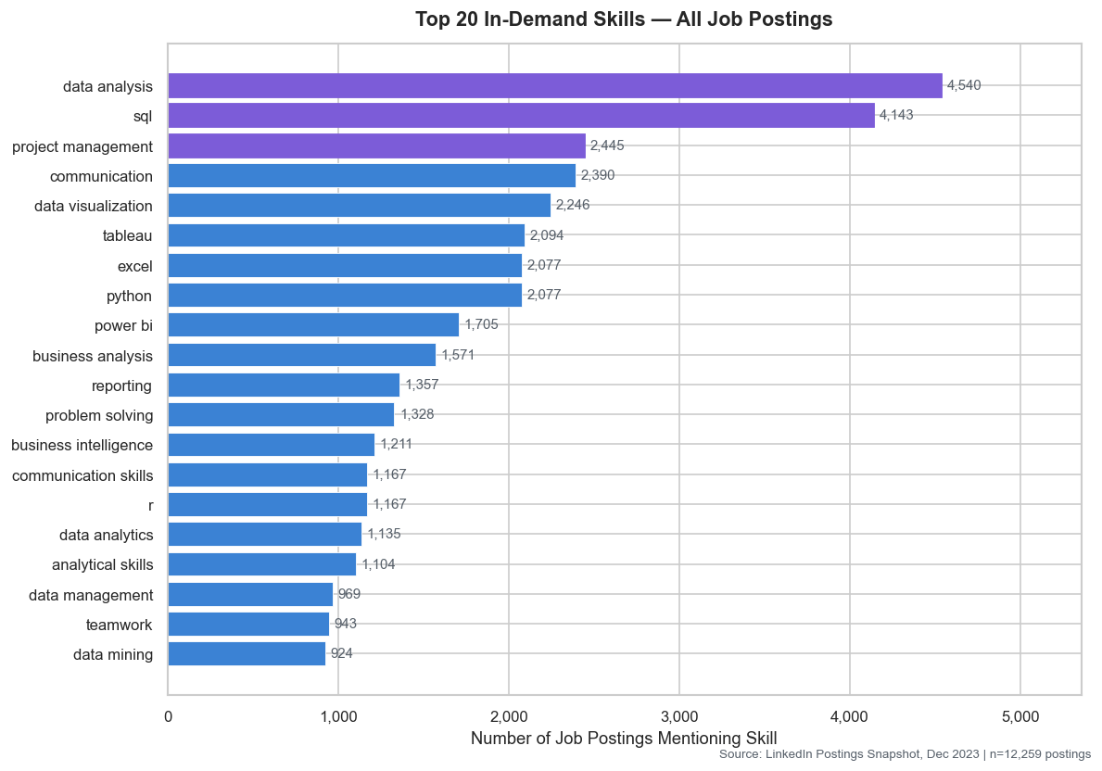
6.2 Posting Split by Job Level (Chart 1b — Donut)
Mid-Senior postings account for approximately 75% of all listings (9,321), with Associate postings comprising the remaining 25% (3,086). This distribution is important context for job seekers: while the absolute number of Associate roles is smaller, the skill gap between the two levels is narrower than expected — SQL, Data Analysis, and Communication are top-ranked at both levels.
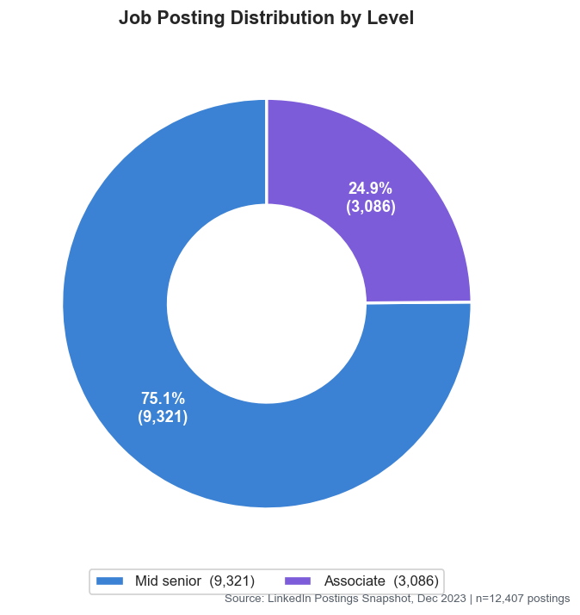
6.3 Skills by Job Level (Chart 2 — Grouped Bar)
Associate-level roles show higher relative emphasis on Excel and SQL, reflecting hands-on data handling tasks. Mid-Senior roles show elevated demand for Python, project management, and business intelligence tools, reflecting the expectation of autonomous analysis and stakeholder communication. A fresher targeting Associate roles should prioritize the Excel + SQL + Tableau stack before investing heavily in Python or BI architecture skills.
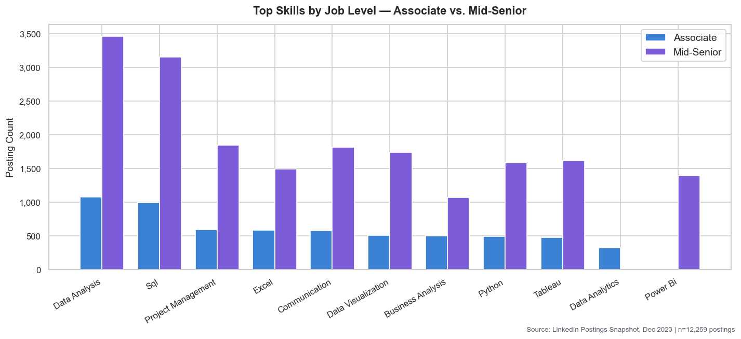
6.4 Skills by Job Type (Chart 3 — Grouped Bar)
The top skills are remarkably consistent across Onsite, Hybrid, and Remote work arrangements — SQL, Data Analysis, Communication, and Tableau appear in the top five for all three. Remote roles show a slightly higher emphasis on Communication and Python, likely reflecting the need for clear written communication and self-sufficient scripting in distributed teams. This consistency is good news for job seekers: the same skill stack is relevant regardless of work arrangement preference.
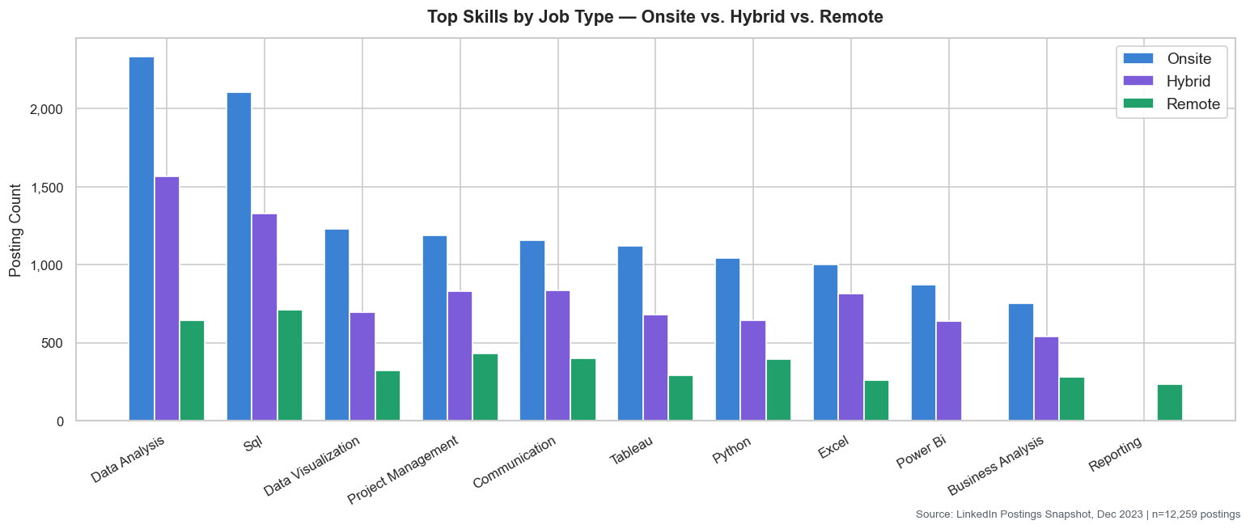

6.5 Posting Volume by Country and Work Type (Chart 4 — Stacked Bar)
The United States dominates with 9,971 postings (~80% of total), followed by the United Kingdom (1,187), Canada (876), and Australia (445). Hybrid work arrangements are prominent in the US and UK, while Onsite roles are proportionally higher in Canada and Australia. For job seekers targeting remote work, the US market offers the largest absolute number of Remote postings.
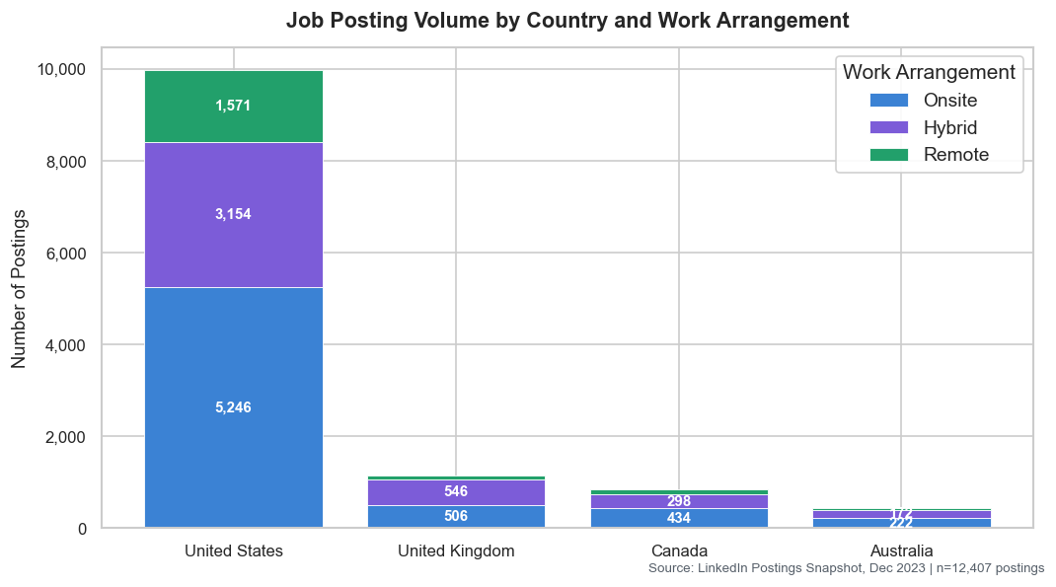
7. Conclusion
This project successfully demonstrates the end-to-end application of data analytics and AI to a real-world career problem. By analyzing nearly 12,500 cleaned job postings, a clear, evidence-based picture of skill demand emerges: SQL and Data Analysis are universal requirements; visualization tools (Tableau, Excel, Power BI) are the primary deliverables; and Communication is a first-class skill, not an afterthought.
The integration of IBM watsonx.ai adds a layer of interpretability that raw statistics alone cannot provide — transforming frequency tables into actionable guidance that a fresher job seeker can act on immediately. The graceful fallback design ensures the AI layer never becomes a single point of failure.
The project also demonstrates good data engineering practice: transparent cleaning steps with before/after summaries, normalized skill extraction, and dynamic outputs that will not go stale if the underlying data changes.
8. Future Scope
Several directions would significantly extend the value of this analysis:
- Time-series analysis: Collecting postings over multiple months would enable trend detection — identifying which skills are rising, plateauing, or declining in demand. A weekly or monthly scrape pipeline using the same Kaggle dataset structure would make this feasible.
- Salary correlation: Many job postings include salary ranges. Mapping skill demand against compensation bands would answer a follow-up question: which skills command the highest salary premium?
- NLP on job summaries: The job_summary column contains rich free-text. Applying topic modelling (LDA) or sentence transformers to cluster role descriptions could reveal sub-categories within "Data Analyst" — e.g. Marketing Analyst vs. Financial Analyst vs. Operations Analyst — each with distinct skill profiles.
- Interactive dashboard: Converting the static matplotlib charts into an interactive Plotly or Streamlit dashboard would allow hiring managers and job seekers to filter by country, job level, or date range dynamically.
- Expanded AI integration: Fine-tuning or prompting the IBM Granite model with more detailed findings (e.g. salary data, company size) could generate richer, role-specific career roadmaps rather than a single universal recommendation.
References
- asaniczka. (2023). Data Analyst Job Postings [Dataset]. Kaggle. https://www.kaggle.com/datasets/asaniczka/data-analyst-job-postings
- IBM watsonx.ai Documentation. IBM Granite Foundation Models. https://www.ibm.com/products/watsonx-ai
- pandas Documentation. https://pandas.pydata.org/docs/
- matplotlib Documentation. https://matplotlib.org/stable/contents.html

