EXP- 2
Bus Ticket Booking Prototype (Figma)
Aim
To design a simple Bus Ticket Booking System prototype using Figma.
Procedure
1. Open Figma and create a new design file.
2. Design screens:
- Home Page
- Search Bus
- Seat Selection
- Payment Page
3. Add navigation links.
4. Present prototype mode.
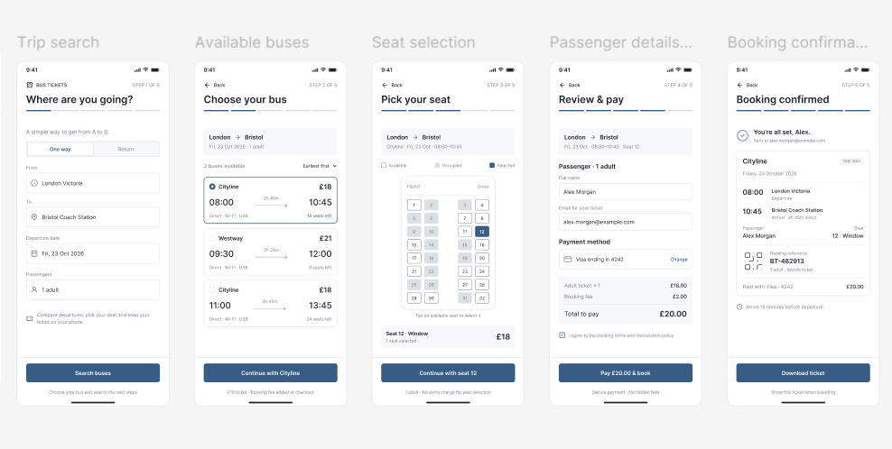
Result: Thus, The clickable prototype of Bus Ticket Booking System was
created successfully.

