EXP -4
Scrum Project in Jira
Aim
To create and manage a Scrum project in Jira.
Procedure
1. Create Scrum project.
2. Add 5 backlog items.
3. Prioritize backlog.
4. Create 1- week sprint.
5. Move tasks to sprint.
6. Start sprint.
7. Update task status until completion.
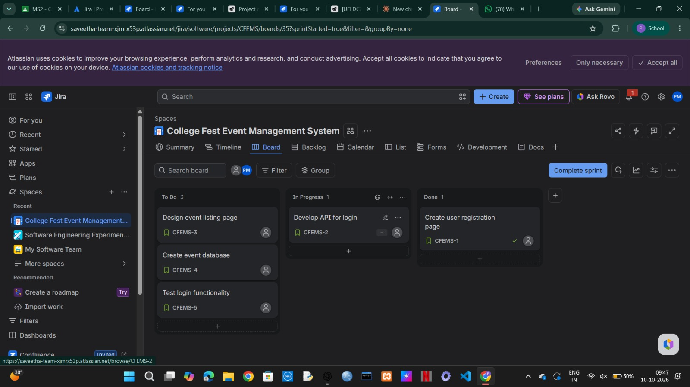
Result: Thus, The Scrum sprint executed successfully and sprint board tracked
progress.

