EXP- 7
Task Management System – MoSCoW & Kano (Jira)
Aim
To prioritize system requirements using MoSCoW and Kano models.
Procedure
1. Create Jira project.
2. Add features as issues.
3. Categorize using MoSCoW. 4. Apply Kano model classification.
5. Document priority results.
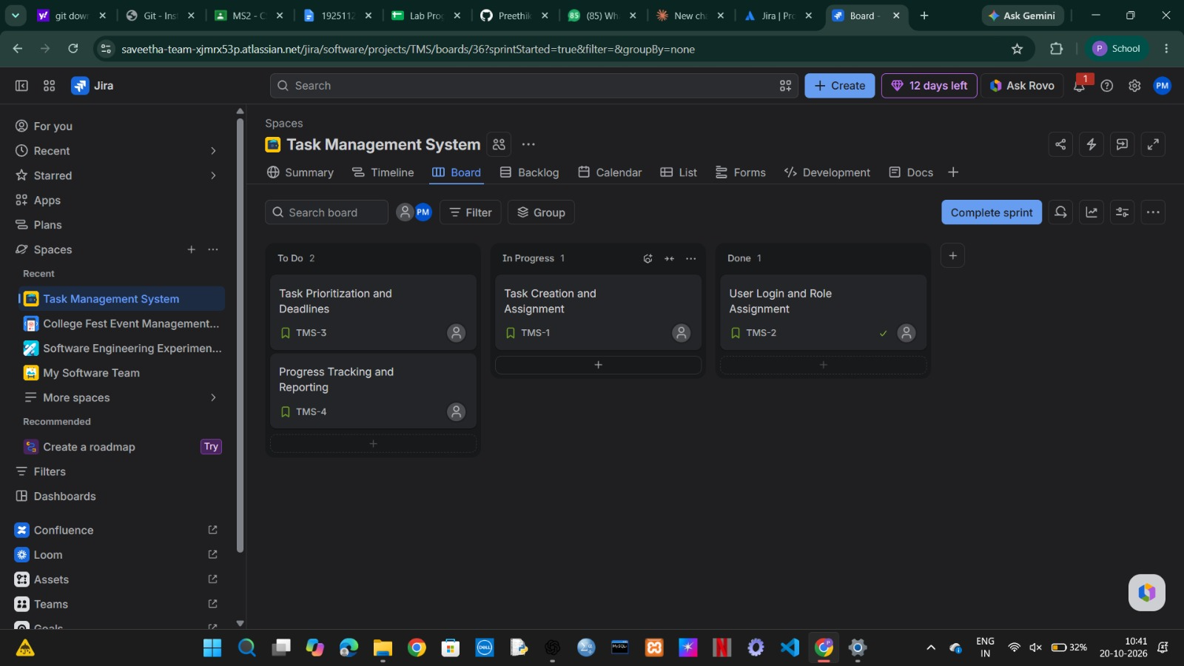
RESULT: Thus, The Requirements prioritized effectively using both models.

