EXP- 8
Online Learning Platform – MoSCoW & Kano
Aim
To categorize and prioritize platform requirements.
Procedure
1. Create Jira backlog.
2. Add all 6 features.
3. Categorize using MoSCoW. 4. Classify using Kano.
5. Prioritize accordingly.
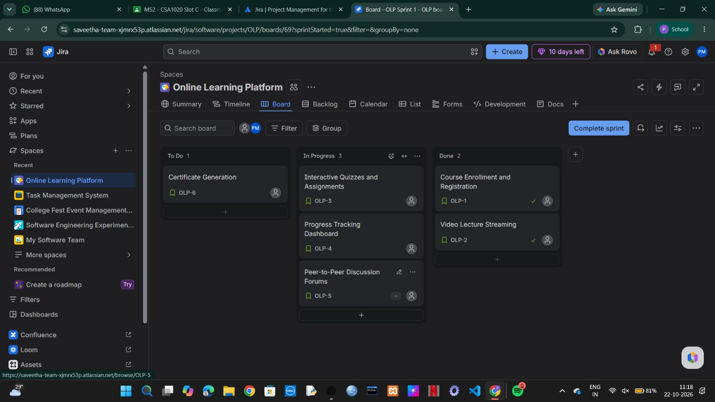
Result: Thus, The Features prioritized based on stakeholder value and
satisfaction.

