EXPERIMENT 3
TRIPLE DES (3DES) – SIMPLIFIED VERSION
AIM
To implement a simplified Triple DES (3DES) encryption and decryption using Python.
ALGORITHM
- Read the plaintext from the user.
- Read three secret keys.
- Encrypt the plaintext using the first key.
- Encrypt the result using the second key.
- Encrypt the result again using the third key.
- Display the encrypted text.
- Decrypt using the third, second, and first keys in reverse order.
- Display the original plaintext.
CODE
plain = input("Enter Plain Text: ")
key1 = input("Enter First Key: ")
key2 = input("Enter Second Key: ")
key3 = input("Enter Third Key: ")

# First Encryption
temp1 = ""
for i in range(len(plain)):
temp1 += chr(ord(plain[i]) ^ ord(key1[i % len(key1)]))

# Second Encryption
temp2 = ""
for i in range(len(temp1)):
temp2 += chr(ord(temp1[i]) ^ ord(key2[i % len(key2)]))

# Third Encryption
encrypted = ""
for i in range(len(temp2)):
encrypted += chr(ord(temp2[i]) ^ ord(key3[i % len(key3)]))

print("Encrypted Text:", encrypted)

# First Decryption (Key 3)
temp2 = ""
for i in range(len(encrypted)):
temp2 += chr(ord(encrypted[i]) ^ ord(key3[i % len(key3)]))

# Second Decryption (Key 2)
temp1 = ""
for i in range(len(temp2)):
temp1 += chr(ord(temp2[i]) ^ ord(key2[i % len(key2)]))

# Third Decryption (Key 1)
decrypted = ""
for i in range(len(temp1)):
decrypted += chr(ord(temp1[i]) ^ ord(key1[i % len(key1)]))

print("Decrypted Text:", decrypted)

OUTPUT
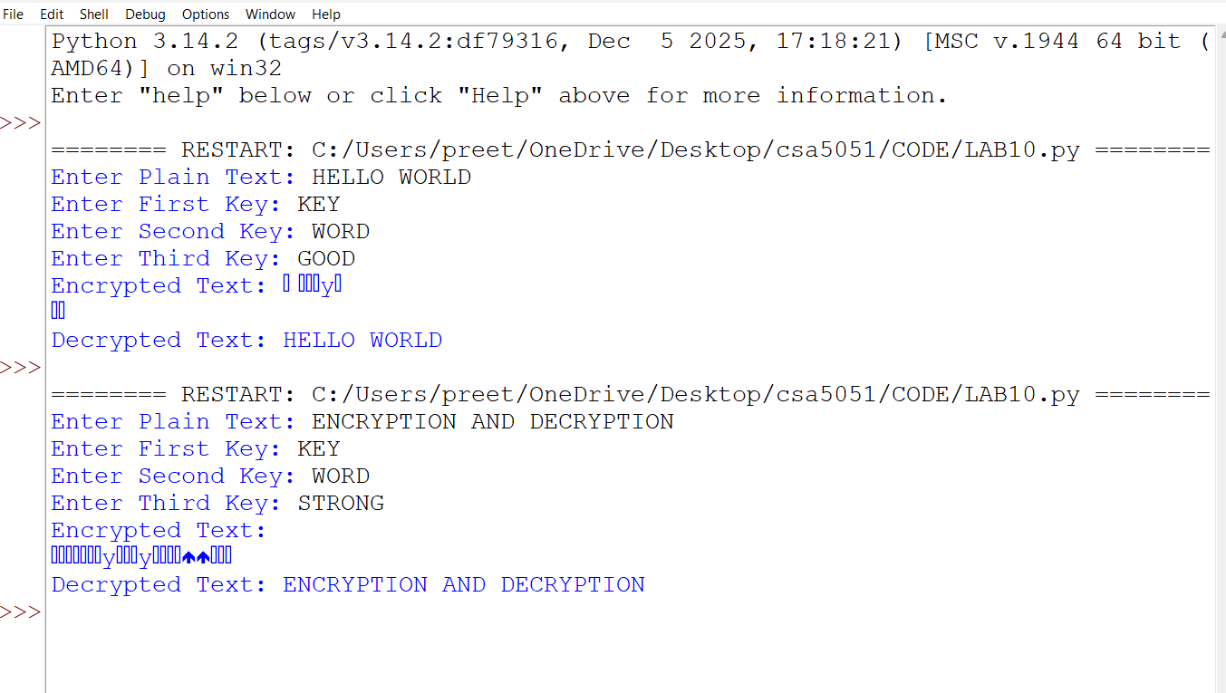
RESULT
Thus, a simplified Triple DES (3DES) encryption and decryption process was implemented successfully using Python.

