EXPERIMENT 11
DES MODES (ECB, CBC, CFB, OFB, CTR)
AIM
To implement different DES modes (ECB, CBC, CFB, OFB, and CTR) using basic Python with a simplified XOR-based encryption technique.
ALGORITHM
- Read the plaintext, key, and mode from the user.
- Read the initialization vector (IV) or counter value when required.
- Perform XOR encryption based on the selected mode.
- Generate the encrypted text.
- Display the encrypted text.
- Apply the corresponding decryption process.
- Recover the original plaintext.
- Display the decrypted text.
CODE
plain = input("Enter Plain Text: ")
key = input("Enter Key: ")
mode = input("Enter Mode (ECB/CBC/CFB/OFB/CTR): ").upper()

encrypted = ""
decrypted = ""

if mode == "ECB":
for i in range(len(plain)):
encrypted += chr(ord(plain[i]) ^ ord(key[i % len(key)]))

for i in range(len(encrypted)):
decrypted += chr(ord(encrypted[i]) ^ ord(key[i % len(key)]))

elif mode == "CBC":
iv = input("Enter IV (one character): ")
prev = iv

for i in range(len(plain)):
c = chr(ord(plain[i]) ^ ord(prev) ^ ord(key[i % len(key)]))
encrypted += c
prev = c

prev = iv
for i in range(len(encrypted)):
p = chr(ord(encrypted[i]) ^ ord(prev) ^ ord(key[i % len(key)]))
decrypted += p
prev = encrypted[i]

elif mode == "CFB":
iv = input("Enter IV (one character): ")
prev = iv

for i in range(len(plain)):
c = chr(ord(plain[i]) ^ ord(prev))
encrypted += c
prev = c

prev = iv
for i in range(len(encrypted)):
p = chr(ord(encrypted[i]) ^ ord(prev))
decrypted += p
prev = encrypted[i]

elif mode == "OFB":
iv = input("Enter IV (one character): ")
stream = iv

for i in range(len(plain)):
stream = chr(ord(stream) ^ ord(key[i % len(key)]))
c = chr(ord(plain[i]) ^ ord(stream))
encrypted += c

stream = iv
for i in range(len(encrypted)):
stream = chr(ord(stream) ^ ord(key[i % len(key)]))
p = chr(ord(encrypted[i]) ^ ord(stream))
decrypted += p

elif mode == "CTR":
counter = int(input("Enter Counter: "))

for i in range(len(plain)):
stream = counter + i
c = chr(ord(plain[i]) ^ stream)
encrypted += c

for i in range(len(encrypted)):
stream = counter + i
p = chr(ord(encrypted[i]) ^ stream)
decrypted += p

else:
print("Invalid Mode")
exit()

print("Encrypted Text:", encrypted)
print("Decrypted Text:", decrypted)
OUTPUT
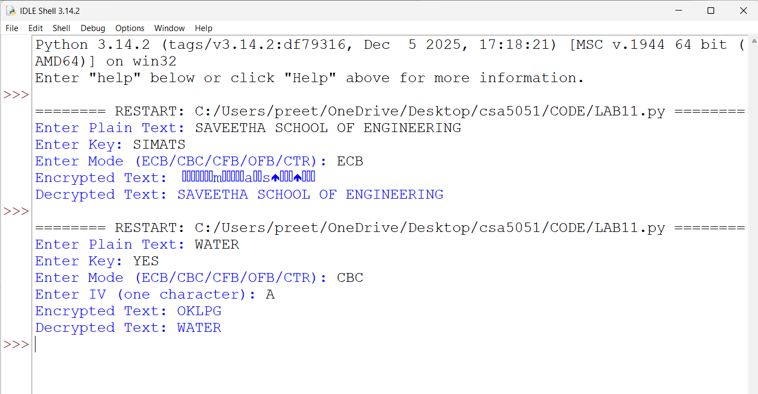
RESULT
Thus, the simplified implementation of DES modes (ECB, CBC, CFB, OFB, and CTR) was successfully performed using basic Python.

