EXPERIMENT 12
RSA ALGORITHM
AIM
To implement the RSA algorithm for encryption and decryption using Python.
ALGORITHM
- Enter two prime numbers.
- Calculate $n=p×q$.
- Calculate $ϕ\left(n\right)=\left(p-1\right)×\left(q-1\right)$.
- Choose a public key $e$.
- Calculate the private key $d$.
- Enter the message.
- Encrypt the message using the public key.
CODE
p = int(input("Enter first prime number: "))
q = int(input("Enter second prime number: "))

n = p * q
phi = (p - 1) * (q - 1)

e = int(input("Enter public key (e): "))

d = 1
while (d * e) % phi != 1:
d += 1

message = int(input("Enter the message: "))

cipher = pow(message, e, n)
print("Encrypted Message:", cipher)

plain = pow(cipher, d, n)
print("Decrypted Message:", plain)
OUTPUT
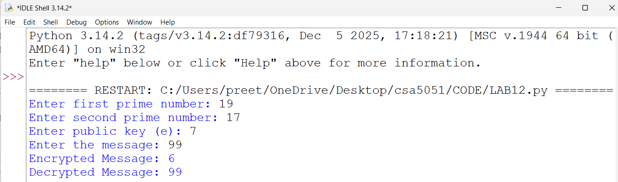
RESULT
Thus, the RSA algorithm was implemented successfully using Python.

