EXPERIMENT 13
DIFFIE-HELLMAN KEY EXCHANGE
AIM
To implement the Diffie-Hellman Key Exchange algorithm using Python.

ALGORITHM
- Enter the prime number and primitive root.
- Enter the private keys of User A and User B.
- Calculate the public keys of both users.
- Exchange the public keys.
- Compute the shared secret key for User A.
- Compute the shared secret key for User B.
- Verify that both shared keys are equal.
- Display the public keys and the shared secret key.

CODE
p = int(input("Enter the prime number: "))
g = int(input("Enter the primitive root: "))

a = int(input("Enter private key of User A: "))
b = int(input("Enter private key of User B: "))

A = pow(g, a, p)
B = pow(g, b, p)

keyA = pow(B, a, p)
keyB = pow(A, b, p)

print("Public Key of User A:", A)
print("Public Key of User B:", B)

print("Shared Key for User A:", keyA)
print("Shared Key for User B:", keyB)

if keyA == keyB:
print("Key Exchange Successful")
else:
print("Key Exchange Failed")
OUTPUT
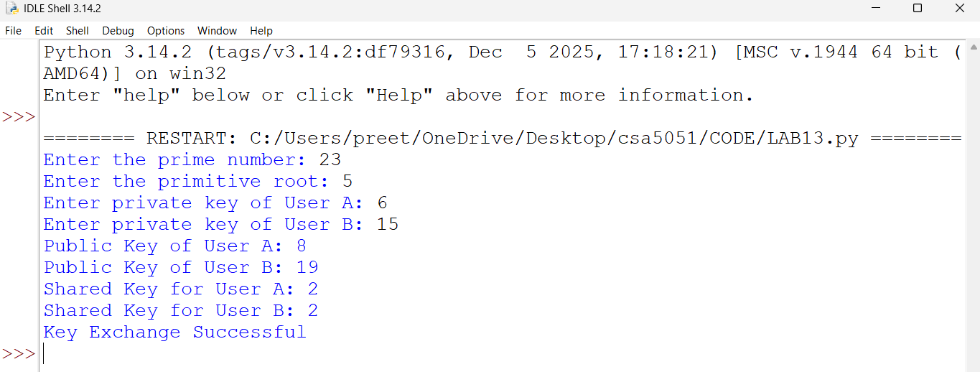
RESULT
Thus, the Diffie-Hellman Key Exchange algorithm was implemented successfully using Python.

